# Estimation results v3.0

**This version**: Results after updating the parameterization of the model and estimating discount factor distributions separately for the three education groups.

**Targets:** For each group the targets are the median LW/PI ratio and the [20,40,60,80] Lorenz Pts for that group’s liquid wealth distribution.

## Dropouts

Estimated (beta, nabla) = **[0.79939338, 0.2279055 ]**

|  |  |  |
| --- | --- | --- |
|  | Median LW/PI ratio | Lorenz points |
| Data | 4.64 | [0., 0.01, 0.6, 3.58] |
| Model | 4.64 | [0.0, 0.0, 0.5387, 3.5920] |

## Highschool

Estimated (beta, nabla) = **[0.93744293, 0.06607694]**

|  |  |  |
| --- | --- | --- |
|  | Median LW/PI ratio | Lorenz points |
| Data | 30.2 | [ 0.06, 0.63, 2.98, 11.6 ] |
| Model | 30.16 | [ 0.04332, 0.9496, 3.7131, 11.3065] |

## College

Estimated (beta, nabla) = **[0.98525333, 0.01241598]**

|  |  |  |
| --- | --- | --- |
|  | Median LW/PI ratio | Lorenz points |
| Data | 112.8 | [ 0.15, 0.92, 3.27, 10.3 ] |
| Model | 112.79 | [0.3221, 1.4856, 3.9947, 9.8545] |

## Discount factor distributions

With the above estimates, the actual discount factor distributions we are using that are generated via the command   
Uniform(beta-nabla, beta+nabla).approx(DiscFacCount)   
(where DiscFacCount = 7 in our case)  
have the following end points:



## Overall population (not targeted)

With the discount factor distributions estimated for each group as above, we can calculate statistics for the overall population which were **not targeted** in the estimation.

|  |  |  |  |
| --- | --- | --- | --- |
|  | (Median LW/PI ratios) | Lorenz points | Wealth shares |
| Data | [4.64, 30.2, 112.8] | [0.03, 0.35, 1.84, 7.42] | [ 0.8, 17.9, 81.2] |
| Model | [4.64, 30.2, 112.5] | [0.04006, 0.6354, 2.6259, 8.5616] | [1.55, 21.17, 77.29] |

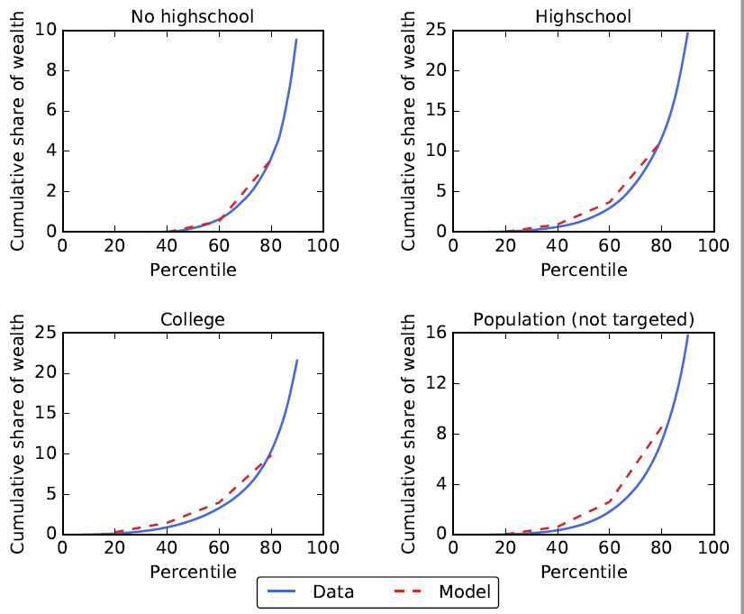

## Average MPCs

With these estimates we also get the following average MPCs for each of the education groups:

|  |  |
| --- | --- |
| Group | Average MPC |
| Droupouts | 0.63 |
| Highschool | 0.38 |
| College | 0.14 |