Christopher D Carroll  
Department of Economics  
Johns Hopkins University  
Baltimore, MD 21218

Maryland, July 25, 2023

The Editor  
Quantitative Economics

**Disclosure statement for the paper “Welfare and Spending Effects of Consumption Stimulus Policies”**

* I hereby declare that I have no relevant or material financial interests that relate to the research described in this paper.
* The disclosures above apply to my close relatives.
* No party had the right to review the paper prior to its circulation.
* I have no relevant potential conflicts of interest with this article.

Sincerely,

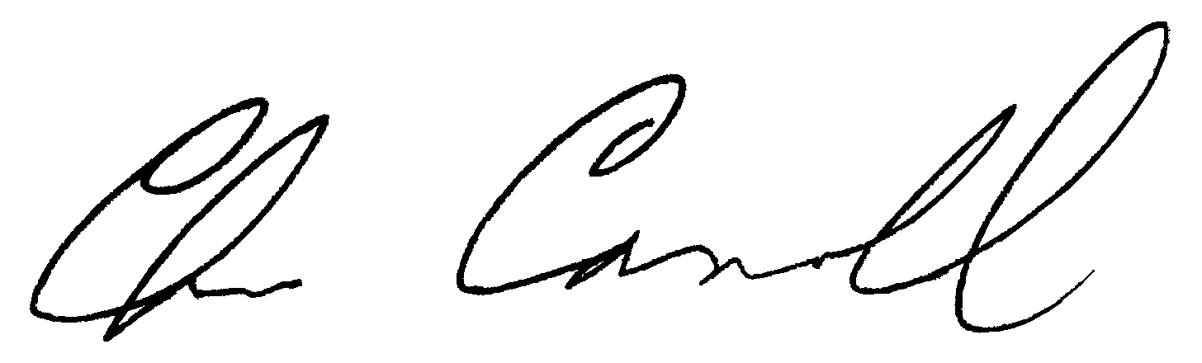

Chris Carroll