Estimation results v3.0
This version: Results after updating the parameterization of the model and estimating discount factor distributions separately for the three education groups.
Targets: For each group the targets are the median LW/PI ratio and the [20,40,60,80] Lorenz Pts for that group’s liquid wealth distribution.

Dropouts
Estimated (beta, nabla) = [0.79939338, 0.2279055 ] (Estimated with 30,000 agents)
 | Median LW/PI ratio | Lorenz points
Data | 4.64 | [0., 0.01, 0.6, 3.58]
Model | 4.64 | [0.0, 0.0, 0.5387, 3.5920]

Highschool
Estimated (beta, nabla) = [0.93744293, 0.06607694] (Estimated with 50,000 agents)
 | Median LW/PI ratio | Lorenz points
Data | 30.2 | [ 0.06, 0.63, 2.98, 11.6 ]
Model | 30.16 | [ 0.04332, 0.9496, 3.7131, 11.3065]

College
Estimated (beta, nabla) = [0.98525333, 0.01241598] (Estimated with 50,000 agents)
 | Median LW/PI ratio | Lorenz points
Data | 112.8 | [ 0.15, 0.92, 3.27, 10.3 ]
Model | 112.79 | [0.3221, 1.4856, 3.9947, 9.8545]

Discount factor distributions
With the above estimates, the actual discount factor distributions we are using that are generated via the command
Uniform(beta-nabla, beta+nabla).approx(DiscFacCount)
(where DiscFacCount = 7 in our case)
have the following end points:


Overall population (not targeted)
With the discount factor distributions estimated for each group as above, we can calculate statistics for the overall population which were not targeted in the estimation.
 | (Median LW/PI ratios) | Lorenz points | Wealth shares
Data | [4.64, 30.2, 112.8] | [0.03, 0.35, 1.84, 7.42] | [ 0.8, 17.9, 81.2]
Model | [4.64, 30.2, 112.5] | [0.04006, 0.6354, 2.6259, 8.5616] | [1.6, 21.2, 77.3]
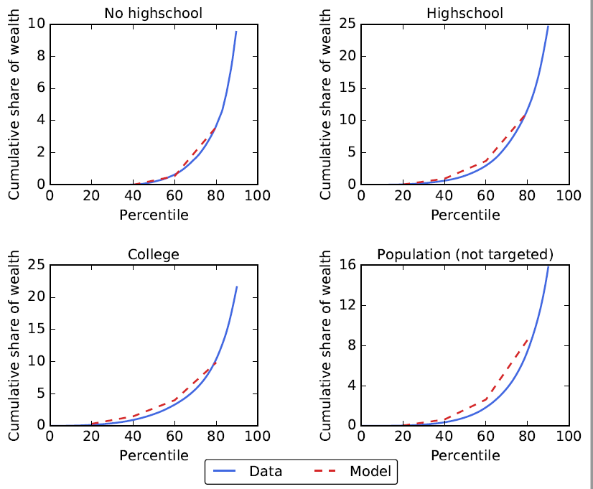

Average MPCs
With these estimates we also get the following average annual MPCs (incl. splurge in Q1) for each of the education groups:
Group | Average MPC
Droupouts | 0.88
Highschool | 0.79
College | 0.57
Population | 0.71

