Table of Contents

- Buy-Now-Pay-Later (BNPL) has grown rapidly, with 86.5 million U.S. users in 2024
- The sector processed over 277 million loans worth $34 billion in 2022
- 61% of BNPL users are subprime or deep subprime
- BNPL firms operate with thin margins (~4% of GMV)
- This creates vulnerability to interest rate changes
- The BNPL sector presents a fundamental puzzle in financial economics
- Question: Why did valuations collapse so dramatically during a period when these companies were still growing?
- Despite massive GMV growth (2019-2021), Klarna's valuation fell ~70% from peak to IPO
- Research Focus: How do BNPL firms' stock returns respond to changes in monetary policy?
- Key Question: Are Buy-Now-Pay-Later companies disproportionately vulnerable to interest rate increases given their reliance on short-term funding and razor-thin profit margins?
- Sample Period: February 2020 to August 2025 (67 monthly observations)
- User Growth: BNPL adoption grew from 86.5 million U.S. users in 2024 to projected 91.5 million in 2025
- Market Scale: The sector processed over 277 million loans worth approximately $34 billion in 2022
- Risk Profile: Approximately 61% of BNPL users fall into subprime or deep subprime credit categories
- Thin Margins: BNPL firms operate with provider revenues of only about 4% of gross merchandise volume
import pandas as pd
# Create summary statistics table
summary_data = {
'Metric': [
'U.S. Users (2024)',
'Projected Users (2025)',
'Loans Processed (2022)',
'Total Volume (2022)',
'Subprime/Deep Subprime Users',
'Provider Revenue Margin'
],
'Value': [
'86.5 million',
'91.5 million',
'277 million',
'$34 billion',
'61%',
'~4% of GMV'
]
}
summary_df = pd.DataFrame(summary_data)
print(summary_df.to_string(index=False))
- Most BNPL firms rely on three primary funding mechanisms:
  - Warehouse lines of credit
  - Commercial paper markets
  - Securitization
- All three are directly influenced by the Federal Funds Rate
- Traditional financial institution models focus on deposit bases and diversified revenue streams
- None of these apply to BNPL firms, suggesting fundamentally different sensitivity to interest rates
Direct Channel: Funding Costs
- When Fed Funds Rate increases by 1 percentage point
- Warehouse line costs increase by approximately the same amount
- Commercial paper rates increase correspondingly
- This directly compresses already-thin profit margins
Indirect Channels:
- Consumer Demand: Higher rates reduce purchasing power, fewer transactions
- Credit Market Conditions: Higher rates tighten credit availability for subprime users
- Empirical Approach: Multi-factor regression framework
- Dependent Variable: Log-transformed monthly BNPL stock returns
- Sample Period: February 2020 to August 2025 (67 monthly observations)
- BNPL Firms: PayPal, Affirm, Sezzle, Block/Afterpay, Klarna (representing ~95% of U.S. market share)
Base Model: log(BNPL_Returnt) = β₀ + β₁(∆Federal_Funds_Ratet) + εt
Full Model: log(BNPL_Returnt) = β₀ + β₁(∆Fed_Funds_Ratet) + β₂(∆Consumer_Confidencet) + β₃(∆Disposable_Incomet) + β₄(∆Inflationt) + β₅(Market_Returnt) + εt
- Interest Rate Coefficient: β = -12.51 (SE: 13.27, p-value: 0.346)
- R²: 2.24% (only 2.24% of variation explained)
- Interpretation: The coefficient magnitude of -12.51 is economically substantial even though not statistically significant
- This suggests genuine effect that may be obscured by small sample size and high volatility
- R² improved from 2.24% to 50.98%
- A 2,179% increase in explanatory power!
- Adding control variables dramatically improves model fit
- Interest rate coefficient remains stable: β = -12.68 (SE: 9.95, p-value: 0.202)
import pandas as pd
import os
# Load regression results
results_path = '../Paper_YM/regression_results_table.csv'
if os.path.exists(results_path):
results_df = pd.read_csv(results_path)
# Format for display
display_df = results_df[['Model', 'Coefficient', 'Std Error', 'p-value', 'R²', 'N']].copy()
display_df['Coefficient'] = display_df['Coefficient'].round(2)
display_df['Std Error'] = display_df['Std Error'].round(2)
display_df['p-value'] = display_df['p-value'].round(3)
display_df['R²'] = (display_df['R²'] * 100).round(2).astype(str) + '%'
print(display_df.to_string(index=False))
else:
print("Results file not found. Please ensure regression_results_table.csv exists.")
Comparison of Base Model vs Full Model regression results
import pandas as pd
import json
import os
# Load extracted results
results_path = '../Paper_YM/extracted_results.json'
if os.path.exists(results_path):
with open(results_path, 'r') as f:
results = json.load(f)
# Extract key findings from Model 2 (Full Model)
model2 = results['model2']
findings_data = {
'Variable': [
'Market Return',
'Inflation Change',
'Interest Rate Change',
'Consumer Confidence Change',
'Disposable Income Change'
],
'Coefficient': [
f"{model2['market_return']['coef']:.2f}",
f"{model2['inflation_change']['coef']:.2f}",
f"{model2['fed_funds_change']['coef']:.2f}",
f"{model2['consumer_conf_change']['coef']:.2f}",
f"{model2['disposable_income_change']['coef']:.2f}"
],
'p-value': [
f"{model2['market_return']['pval']:.3f}",
f"{model2['inflation_change']['pval']:.3f}",
f"{model2['fed_funds_change']['pval']:.3f}",
f"{model2['consumer_conf_change']['pval']:.3f}",
f"{model2['disposable_income_change']['pval']:.3f}"
],
'Significance': [
'***' if model2['market_return']['pval'] < 0.001 else '**' if model2['market_return']['pval'] < 0.01 else '*' if model2['market_return']['pval'] < 0.05 else '',
'***' if model2['inflation_change']['pval'] < 0.001 else '**' if model2['inflation_change']['pval'] < 0.01 else '*' if model2['inflation_change']['pval'] < 0.05 else '',
'***' if model2['fed_funds_change']['pval'] < 0.001 else '**' if model2['fed_funds_change']['pval'] < 0.01 else '*' if model2['fed_funds_change']['pval'] < 0.05 else '',
'***' if model2['consumer_conf_change']['pval'] < 0.001 else '**' if model2['consumer_conf_change']['pval'] < 0.01 else '*' if model2['consumer_conf_change']['pval'] < 0.05 else '',
'***' if model2['disposable_income_change']['pval'] < 0.001 else '**' if model2['disposable_income_change']['pval'] < 0.01 else '*' if model2['disposable_income_change']['pval'] < 0.05 else ''
]
}
findings_df = pd.DataFrame(findings_data)
print(findings_df.to_string(index=False))
print("\n*** p<0.001, ** p<0.01, * p<0.05")
print(f"\nModel R²: {(model2['r2'] * 100):.2f}%")
else:
print("Results file not found. Please ensure extracted_results.json exists.")
- BNPL returns exhibit substantial volatility over the sample period
- Major movements coincide with monetary policy changes and market-wide events
import matplotlib.pyplot as plt
import json
import os
import numpy as np
# Load extracted results
results_path = '../Paper_YM/extracted_results.json'
if os.path.exists(results_path):
with open(results_path, 'r') as f:
results = json.load(f)
# Extract coefficients from Model 2 (Full Model)
model2 = results['model2']
# Prepare data for forest plot
variables = []
coefficients = []
ci_lower = []
ci_upper = []
# Order: exclude constant, order by coefficient magnitude
var_order = ['market_return', 'inflation_change', 'fed_funds_change',
'consumer_conf_change', 'disposable_income_change']
var_labels = ['Market Return', 'Inflation Change', 'Interest Rate Change',
'Consumer Confidence', 'Disposable Income']
for var, label in zip(var_order, var_labels):
if var in model2:
variables.append(label)
coefficients.append(model2[var]['coef'])
ci_lower.append(model2[var]['ci_low'])
ci_upper.append(model2[var]['ci_up'])
# Create forest plot
fig, ax = plt.subplots(figsize=(10, 6))
y_pos = np.arange(len(variables))
# Plot confidence intervals
for i, (coef, low, high) in enumerate(zip(coefficients, ci_lower, ci_upper)):
ax.plot([low, high], [i, i], 'k-', linewidth=2, alpha=0.7)
ax.plot(coef, i, 'ko', markersize=10)
# Add vertical line at zero
ax.axvline(x=0, color='red', linestyle='--', linewidth=1, alpha=0.5)
ax.set_yticks(y_pos)
ax.set_yticklabels(variables)
ax.set_xlabel('Coefficient Estimate', fontsize=12)
ax.set_title('Regression Coefficients with 95% Confidence Intervals', fontsize=14, fontweight='bold')
ax.grid(True, alpha=0.3, axis='x')
plt.tight_layout()
plt.show()
else:
print("Results file not found. Please ensure extracted_results.json exists.")
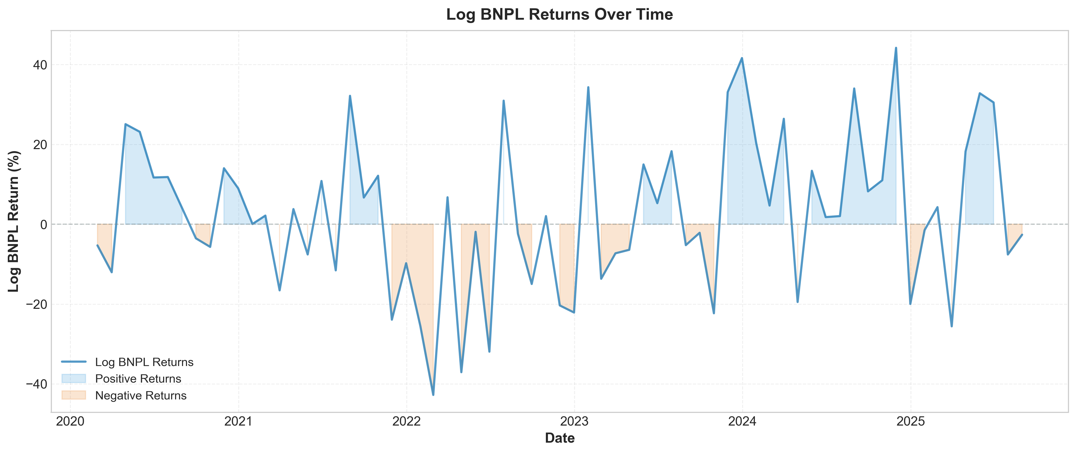
Time series of BNPL stock returns showing volatility patterns and key events
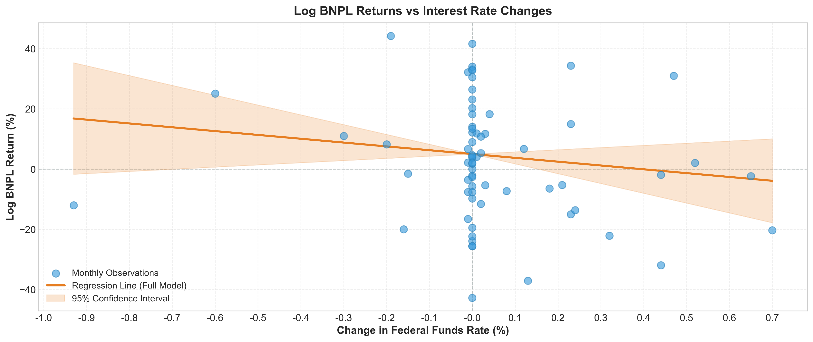
Scatter plot showing relationship between BNPL returns and interest rate changes
Forest plot showing coefficient estimates and 95% confidence intervals for all variables
Finding 1: Market Risk Exposure (β = 2.38, p < 0.001)
- BNPL stocks move approximately 2.4 times as much as the broader market
- This makes sense as BNPL firms are growth stocks primarily valued on growth expectations
Finding 2: Inflation Pressure (β = -12.94, p = 0.049)
- Higher inflation is statistically significantly associated with lower BNPL returns
- Inflation erodes purchasing power, particularly affecting subprime BNPL users with limited financial buffers
Finding 3: Interest Rate Sensitivity (β = -12.68, p = 0.202)
- Coefficient is economically substantial but not statistically significant
- The magnitude suggests genuine effect that may be obscured by small sample size and high volatility
- Economic Magnitude: 12.68% return decline per 1pp rate increase
- Over sample period (500bp increase), this implies economically massive effects
- Multicollinearity: Condition number = 27.1 (below concerning threshold)
- Heteroskedasticity: Addressed with HC3 robust standard errors
- Serial Correlation: Durbin-Watson = 2.005 (no correlation detected)
- Normality: Residuals approximately normal with minor tail deviations typical for financial data
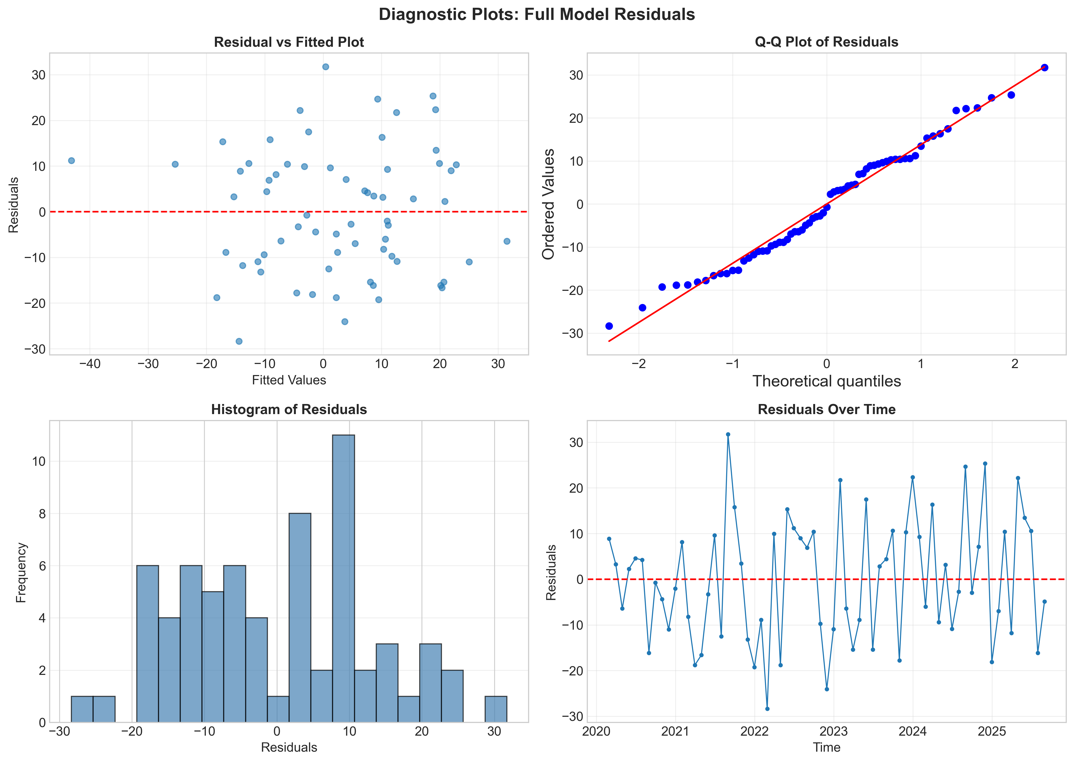
Comprehensive diagnostic plots: residuals vs fitted, Q-Q plot, scale-location, and leverage
- Critical Finding: BNPL exhibits significantly higher volatility (20.46%) compared to credit card companies (9.93%)
- Volatility Ratio: 2.06x higher than credit card companies
- This suggests investors perceive BNPL business model as riskier than established credit infrastructure
- Reflects multiple concerns:
  - Interest rate sensitivity concerns
  - Business model uncertainty
  - Regulatory uncertainty
  - Competitive threats
- Small Sample Size: Only 67 monthly observations limit statistical power
- Time Period: Covers only one interest rate cycle (accommodative to tightening)
- Omitted Variables: Firm-specific news, regulatory changes, competitive dynamics not captured
- Statistical Significance: Interest rate coefficient economically meaningful but not statistically significant
- Main Finding: BNPL firms exhibit sensitivity to interest rate changes through multiple channels:
  - Funding costs
  - Consumer demand
  - Credit market conditions
- The research provided nuanced evidence that BNPL firms are affected by monetary policy but through complex transmission mechanisms rather than simple direct funding cost pass-through
- This research demonstrates that Buy-Now-Pay-Later firms represent a distinct asset class with unique sensitivity patterns to macroeconomic conditions
- The sector's rapid growth and concentration among financially vulnerable consumers suggests continued monitoring and research as monetary policy environment evolves
- BNPL sector's rapid growth creates need for close monitoring
- Thin margins and wholesale funding create vulnerabilities
- Consider how monetary policy and regulation interact to affect consumer credit access

