**Course3: Data science methodology**

**Module 1: From Problem to Approach and From Requirements to Collection**

* Video: Course Introduction
* Reading: Helpful Tips for Course Completion
* Reading: Syllabus

**Lesson 1: From Problem to Approach**

* Video: Data Science Methodology Overview
* Video: Business Understanding
* Video: Analytic Approach
* Hands-on Lab: From Problem to Approach
* Reading: Lesson 1 Summary: From Problem to Approach
* Practice Quiz: From Problem to Approach
* Glossary: From Problem to Approach
* Graded Quiz: From Problem to Approach

**Lesson 2: From Requirements to Collection**

* Video: Data Requirements
* Video: Data Collection
* Hands-on Lab: From Requirements to Collection
* Reading: Lesson 2 Summary: From Requirements to Collection
* Practice Quiz: From Requirements to Collection
* Glossary: From Requirements to Collection
* Graded Quiz: From Requirements to Collection

**Module 2: From Understanding to Preparation and from Modeling to Evaluation**

**Lesson 1: From Understanding to Preparation**

* Video: Data Understanding
* Data Preparation - Concepts
* Data Preparation - Case Study
* Hands-on Lab: From Understanding to Preparation
* Reading: Lesson 1 Summary: From Understanding to Preparation
* Practice Quiz: From Understanding to Preparation
* Glossary: From Understanding to Preparation
* Graded Quiz: From Understanding to Preparation

**Lesson 2: From Modeling to Evaluation**

* Video: Modeling - Concepts
* Video: Modeling - Case Study
* Video: Evaluation
* Hands-on Lab: From Modeling to Evaluation
* Reading: Lesson 2 Summary:From Modeling to Evaluation
* Practice Quiz: From Modeling to Evaluation
* Glossary: From Modeling to Evaluation
* Graded Quiz: From Modeling to Evaluation

**Module 3: From Deployment to Feedback**

* Video: Deployment
* Video: Feedback
* Video: Storytelling
* Video: Course Summary
* Reading: Module 3 Summary:From Deployment to Feedback
* Practice Quiz: From Deployment to Feedback
* Glossary: From Deployment to Feedback
* Graded Quiz: From Deployment to Feedback

**Module 4: Final Project and Assessment**

**Final Project**

* Video: Introduction to CRISP-DM
* Reading: Final Assignment Overview
* Peer Review: Final Assignment

**Course Summary and Final Quiz**

* Reading: Review What You Learned
* Graded Quiz: Final Quiz

**Course Wrap Up**

* Reading: Congratulations and Next Steps
* Reading: Thanks from the Course Team
* Reading: IBM Digital Badge

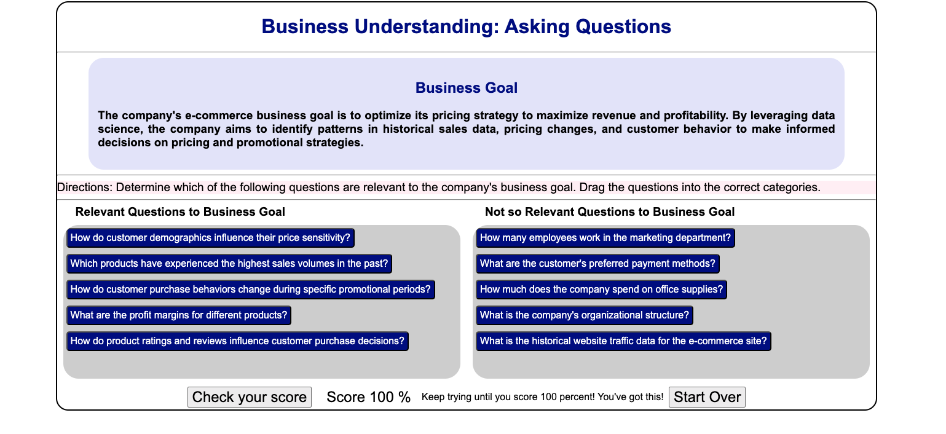

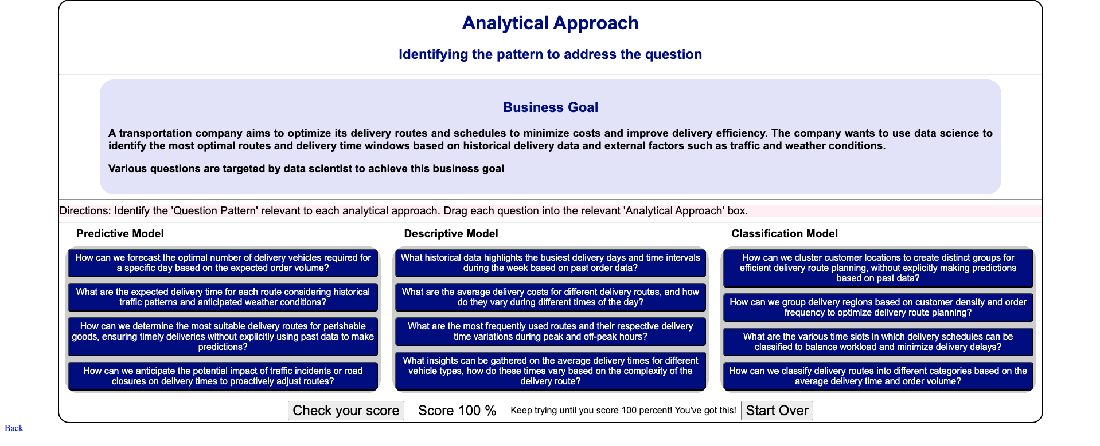

**Lesson summary**

**Module 1 Lesson 1: From Problem to Approach**

* Foundational methodology, a cyclical, iterative data science methodology developed by John Rollins, consists of 10 stages, starting with Business Understanding and ending with Feedback.
* The primary goal of the Business Understanding stage is to understand the business problem and determine the data needed to answer the core business question.

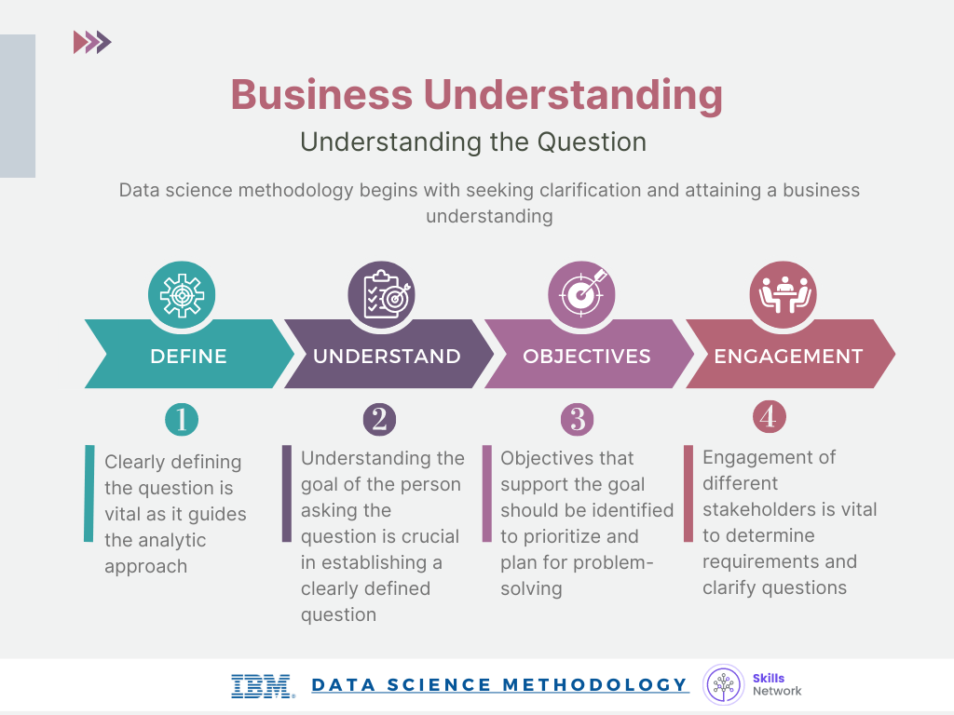

* During the Analytic Approach stage, you can choose from descriptive, diagnostic, predictive, and prescriptive analytic approaches, whether to use machine learning with clustering associations.

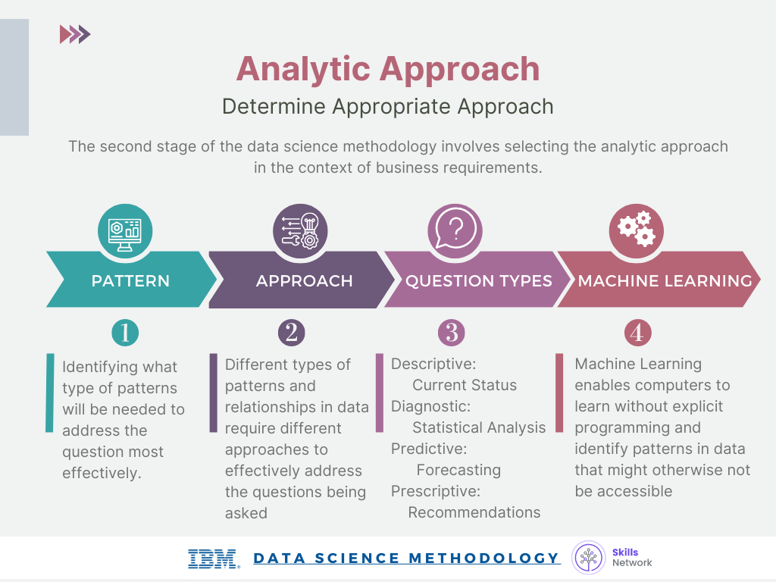

* Decision tree classification is a predictive analytics approach that's easy for non-data scientists to implement

Week 2:

**Lesson summary**

**Module 2 Lesson 2: Modeling to Evaluation**



**Congratulations! You have completed this lesson. At this point in the course, you know:**

* The end goal of the Modeling stage is that the data model answers the business question.
* The data modeling process uses a training data set. Data scientists test multiple algorithms on the training set data to determine whether the variables are required and whether the data supports answering the business question. The outcome of those models are either descriptive or predictive.

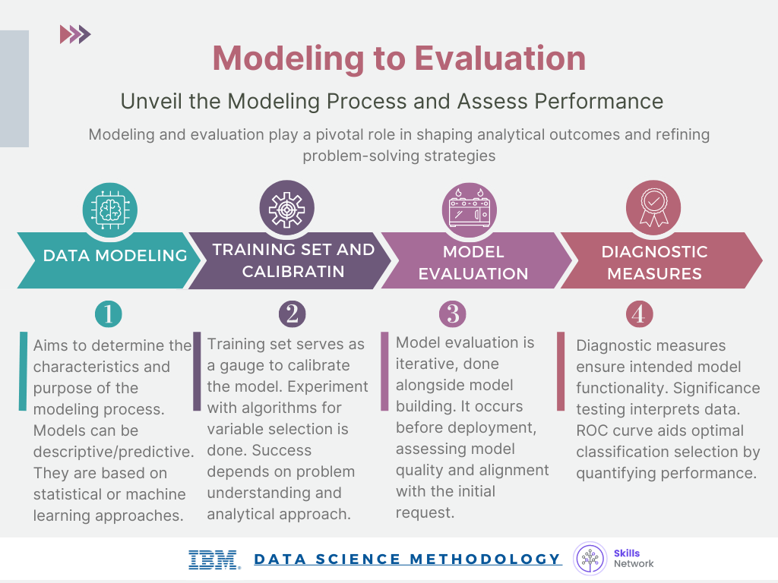

* The Evaluation phase consists of two stages, the diagnostic measures phase, and the statistical significance phase.
* During the Evaluation stage, data scientists and others assess the quality of the model and determine if the modelanswers the initial Business Understanding question or if the data model needs adjustment.
* The ROC curve, known as the receiver operating characteristic curve, is a useful diagnostic tool for determining the optimal classification model. This curve quantifies how well a binary classification model performs, declassifying the yes and no outcomes when some discrimination criterion is varied.

**Lesson summary**

**Module 3 Lesson 1: Deployment to Feedback**



**Congratulations! You have completed this lesson. At this point in the course, you know:**

* Stakeholders, including the solution owner, marketing staff, application developers, and IT administration evaluate the model and contribute feedback.
* During the Deployment stage, data scientists release the data model to a targeted group of stakeholders.
* Stakeholder and user feedback help assess the model's performance and impact during the Feedback stage.
* The model's value depends on iteration; that is, how successfully the data model incorporates user feedback.

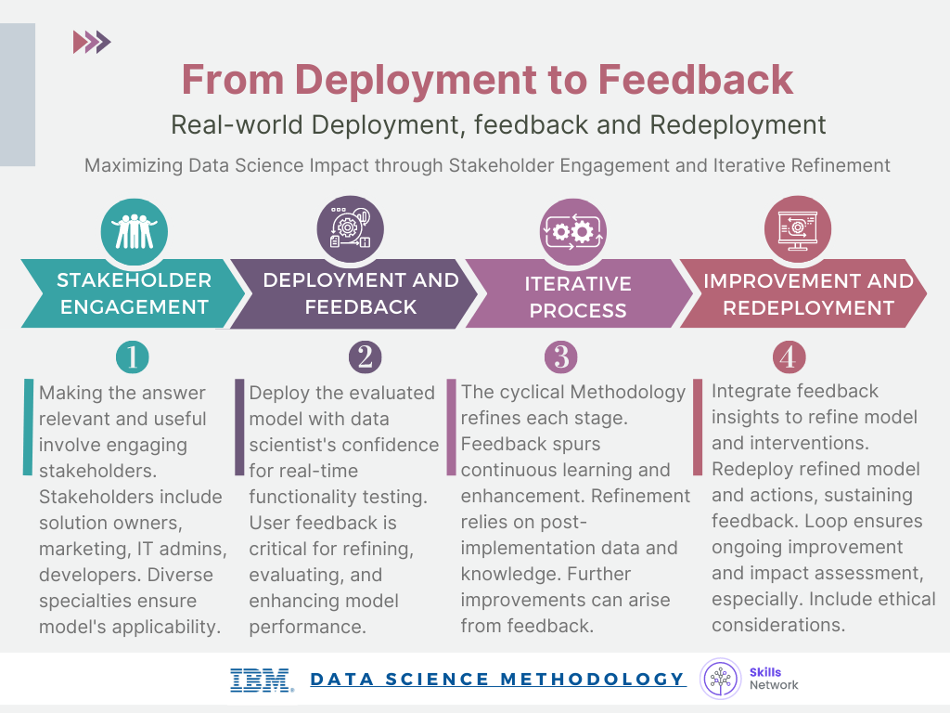

**Summary this course:**

**Review what you learned**

After completing this course, you learned many facts about data science methodology. Here are 14 key, high-level takeaway facts you’ll want to remember from this course.

* Foundational methodology, a cyclical, iterative data science methodology developed by John Rollins, consists of 10 stages, starting with Business Understanding and ending with Feedback.
* CRISP-DM, an open source data methodology, combines several data-related methodology stages into one stage and omits the Feedback stage resulting in a six-stage data methodology.
* The primary goal of the Business Understanding stage is to understand the business problem and determine the data needed to answer the core business question.
* During the Analytic Approach stage, you can choose from descriptive diagnostic, predictive, and prescriptive analytic approaches and whether to use machine learning techniques.
* During the Data Requirements stage, scientists identify the correct and necessary data content, formats, and sources needed for the specific analytical approach.
* During the Data Collection stage, expert data scientists revise data requirements and make critical decisions regarding the quantity and quality of data. Data scientists apply descriptive statistics and visualization techniques to thoroughly assess the content, quality, and initial insights gained from the collected data, identify gaps, and determine if new data is needed, or if they should substitute existing data.
* The Data Understanding stage encompasses all activities related to constructing the data set. This stage answers the question of whether the collected data represents the data needed to solve the business problem. Data scientists might use descriptive statistics, predictive statistics, or both.
* Data scientists commonly apply Hurst, univariates, and statistics such as mean, median, minimum, maximum, standard deviation, pairwise correlation, and histograms.
* During the Data Preparation stage, data scientists must address missing or invalid values, remove duplicates, and validate that the data is properly formatted. Feature engineering and text analysis are key techniques data scientists apply to validate and analyze data during the Data Preparation stage.
* The end goal of the Modeling stage is that the data model answers the business question. During the Modeling stage, data scientists use a training data set. Data scientists test multiple algorithms on the training set data to determine whether the variables are required and whether the data supports answering the business question. The outcome of those models is either descriptive or predictive.
* The Evaluation stage consists of two phases, the diagnostic measures phase, and the statistical significance phase. Data scientists and others assess the quality of the model and determine if the model answers the initial Business Understanding question or if the data model needs adjustment.
* During the Deployment stage, data scientists release the data model to a targeted group of stakeholders, including solution owners, marketing staff, application developers, and IT administration.,
* During the Feedback stage, stakeholders and users evaluate the model and contribute feedback to assess the model’s performance.
* The data model’s value depends on its ability to iterate; that is, how successfully the data model incorporates user feedback.

Mark as completed

Like

Dislike

Report an issue