**LINUX COMMANDS**

**EXPT NO: 1 DATE:**

**AIM**

To study and execute Linux Commands.

**THEORY:**

All the Linux commands run in the terminal provided by the Linux system. This terminal is just like the command prompt of the Windows OS. Linux commands are case sensitive. The terminal can be used to accomplish all administrative tasks. This includes installation, file manipulation, and user management. Linux terminal is user-interactive. The terminal outputs the results of commands which are specified by the user itself. Execution of typed command is done only after you press the Enter key.

|  |  |  |
| --- | --- | --- |
| **Sr No** | **Commands** | **Description** |
| 1 | date | Displays current date and time of the system |
| 2 | tput clear | Clears the terminal script |
| 3 | who | Displays information about system users |
| 4 | whoami | Currently logged user information |
| 5 | ps | Shows details about processes running in the system |
| 6 | ls | List all files and directories in the current working directories |
| 7 | cal | Displays the calendar  cal <year>: Display calendar of the mentioned year  cal <month ><year>: Displays the specified month of that year. |
| 8 | cat | Creates a new file with specified name |
| 9 | wc | Word Count  No of chars, words and lines in that particular file. |
| 10 | exit | Closes the terminal |
| 11 | echo | Used to display a message |
| 12 | cd | Used to change the directory |
| 13 | echo $path | Gives the sequence of directories |
| 14 | piping | Piping is used to combine two or more commands, and in this, the output of one command acts as input to another command, and this command’s input may act as input to the next command and so on |
| 15 | uname | For explaining the features of OS |
| 16 | man | Gives the manual of a particular command |
| 17 | tty | Displays identity of the currently working terminal |
| 18 | stty | Used for changing the settings of a terminal |
| 19 | pwd | Present working directory |
| 20 | script | It records the session |
| 21 | mkdir | To create a directory |
| 22 | rmidr | To remove a directory |
| 23 | rm | To delete a file |
| 24 | mv | To rename a file |
| 25 | cp | To copy a file  Eg: cp <src.txt><dest.txt> |
| 26 | cmp | To compare a file  Returns first position of difference in the file |

**OUTPUT:**

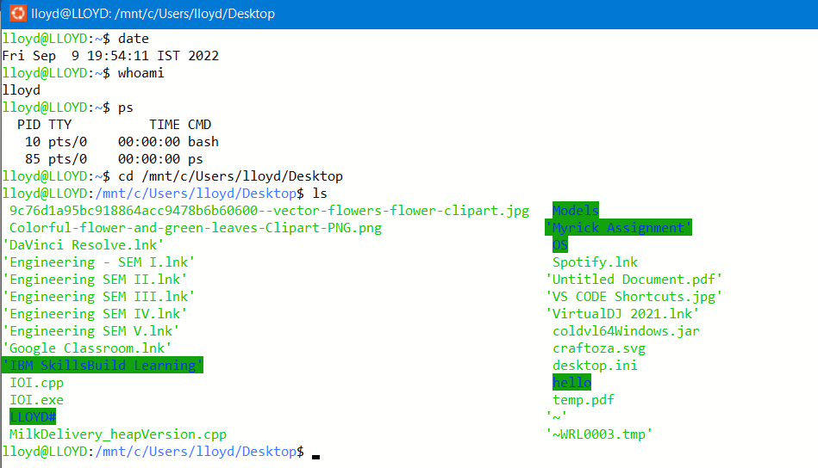

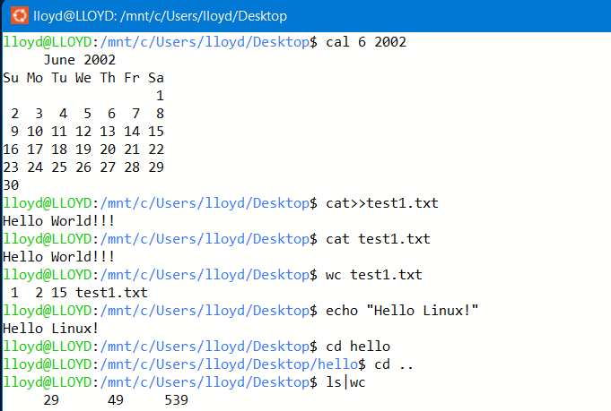



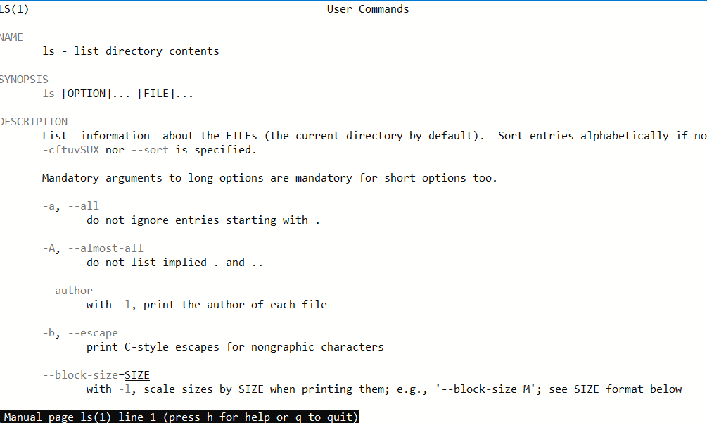

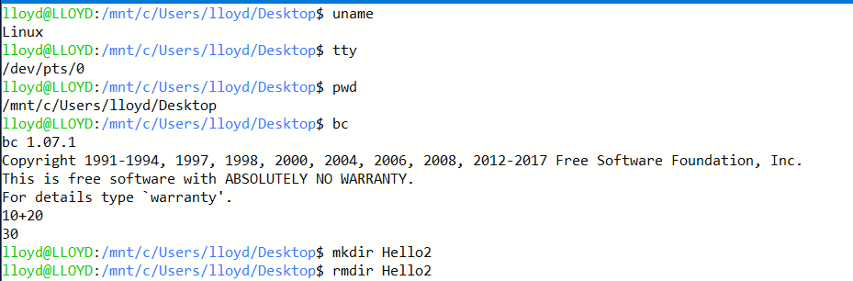

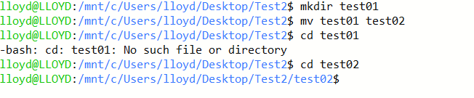

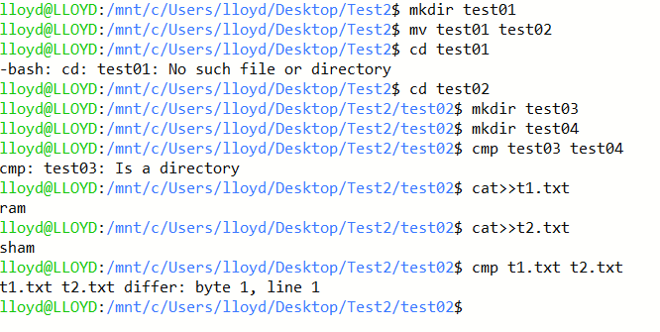

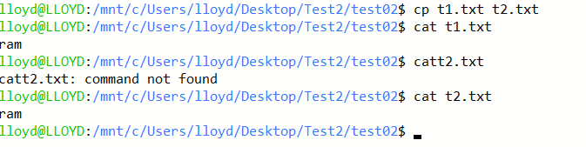

**CONCLUSION:**

All the Basics Linux commands were successfully executed in the Linux Terminal.