University of Cebu - Main College of Computer Studies

Final Project Documentation

Project Title: System Flow Documentation Course Name: 01669 Information Management (INTPROG32)

Faculty Name: Mr. Wilson Gayo Group Members:

Lloyd Butanas

Jeff Kirk Vincent Aliganga Cyril Cabaron

Kharlwin Zen Cabarrubias Luis Reyes

Date: May 29, 2023

# System Overview

The system is designed to manage various aspects of a company's operations, including employee, office, and role management, products and product lines management, inventory and returns management, customers management, customer orders and order details management, customer payments, and transaction handling. The system is built using MySQL and incorporates MySQL basics such as querying, sorting, filtering, joining tables, grouping, subqueries, set operators, modifying, transactions, and stored procedures.

The system's foundation is the classicmodels.sql sample database, which is frequently used to teach and practice MySQL and serves as a useful illustration. An imaginary business that sells models of historic cars is represented by the classicmodels database. There are various tables in it, including "employees" for managing personnel, "offices" managing offices, "products" managing items, "customers" managing customers, and "orders" managing orders.

Information on the company's employees, including their employee numbers, names, jobs, and contact information, are kept in the "employees" table. Office codes, addresses, and phone numbers are all included in the "offices" table's information about various office locations.

Information on the company's goods and product lines may be found in the "products" table. It contains information such product names, codes, descriptions, and prices. The company's inventory is managed and tracked using this table.

Information on customers, including customer numbers, names, contact information, and credit limits, is kept in the "customers" table. This table is necessary for handling customer interactions and maintaining a database of clients for the business.

Customer orders and their information are managed in the "orders" table. Order numbers, order dates, needed dates, and statuses are all mentioned in this data. The table also keeps track of information on the products ordered, their quantities, and their costs.

In general, the system created using the classicmodels example database provides a comprehensive answer for managing a variety of business activities, including people and office management, product inventory, customer interactions, and financial transactions.

# ERD :

Modules

Employee, Office, and Role Management (Assigned to Luis Reyes assist Butanas)

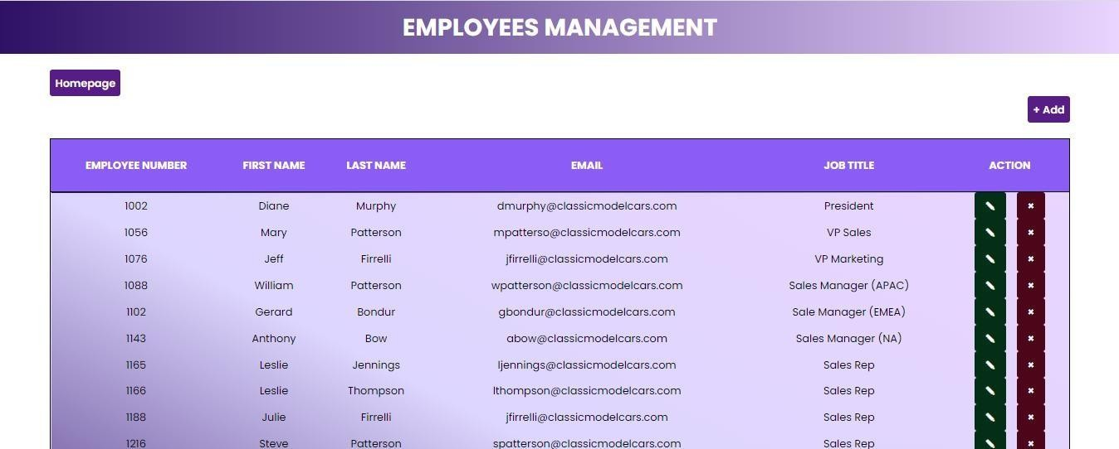.

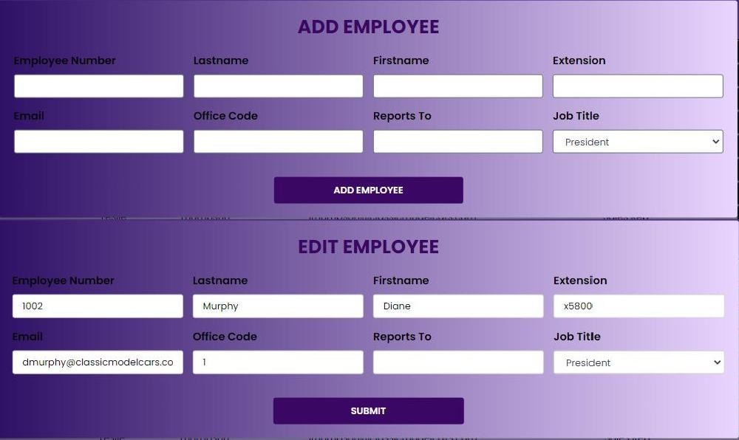

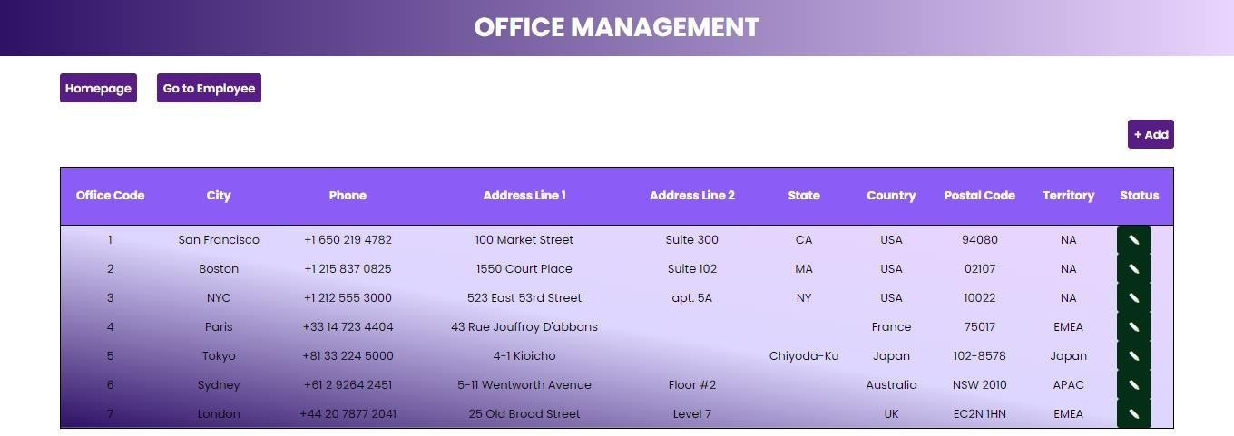

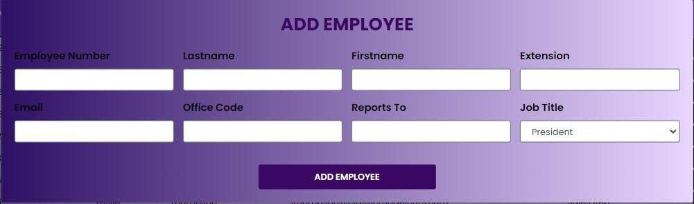

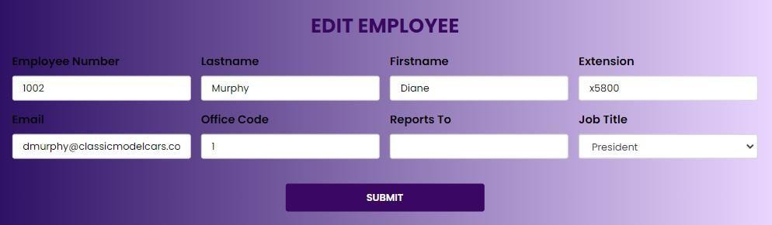

Products and Product Lines Management (Assigned to Luis Reyes assist Cabaron)

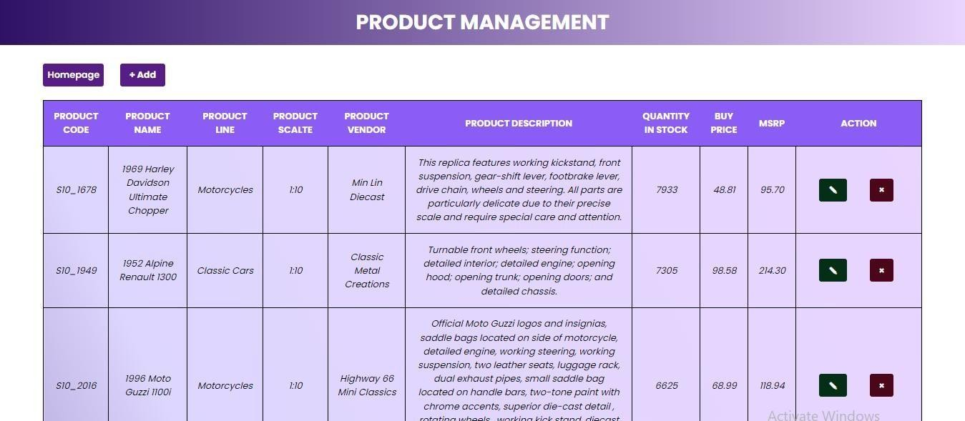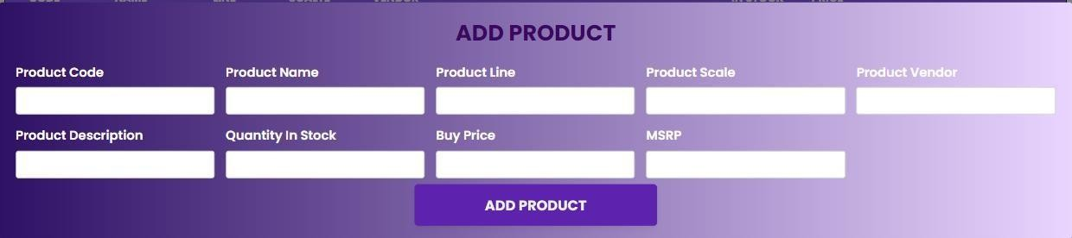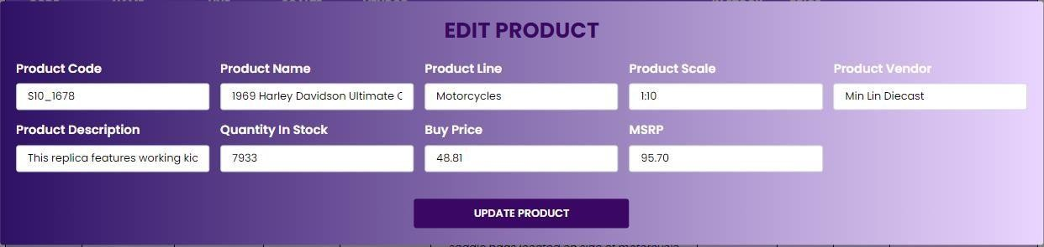

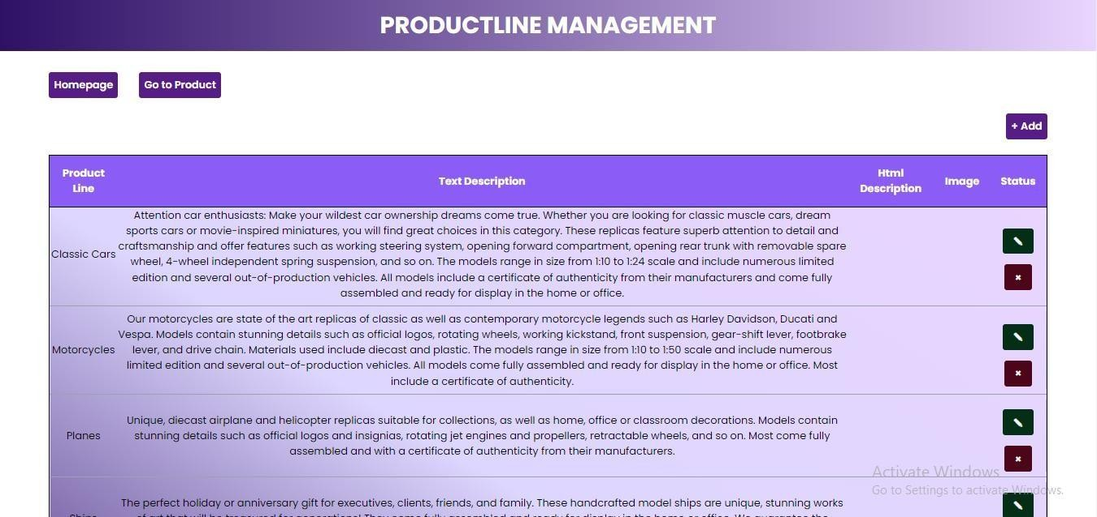

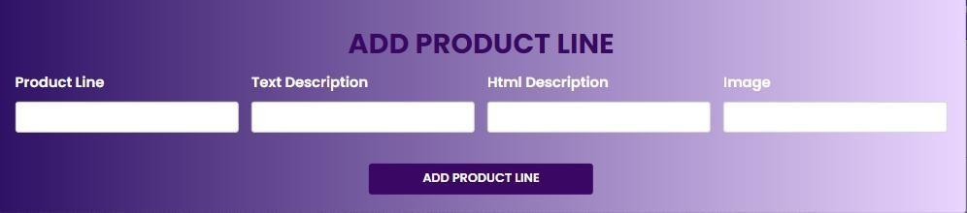

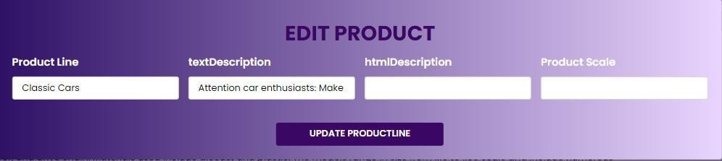

Inventory and Returns Management (Assigned to Kharl Cabarrubias)

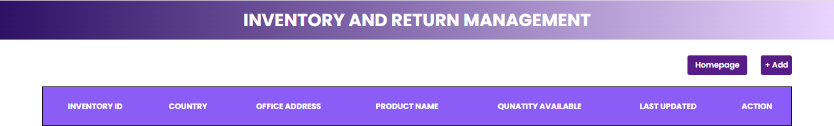

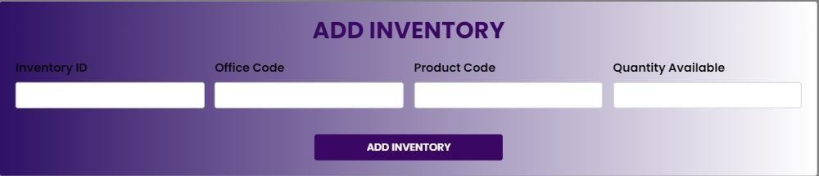

Customers Management

(Assigned to Cyril Cabaron)

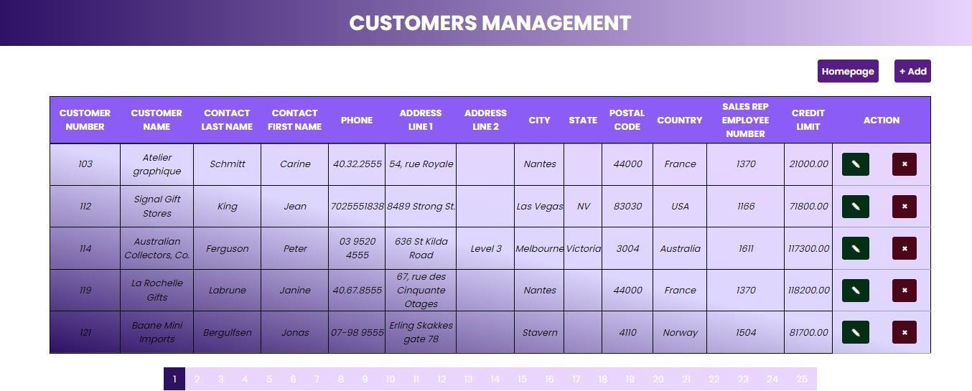

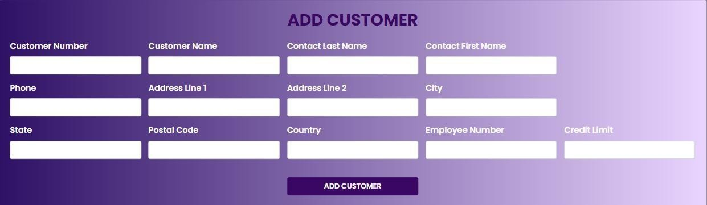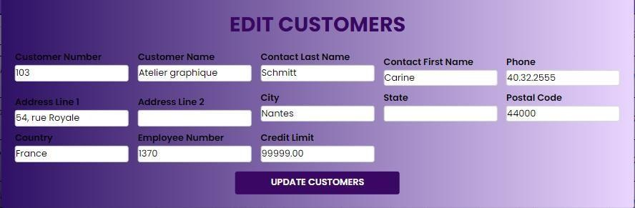

Customers Orders and Order Details Management (Assigned to Lloyd Butanas)

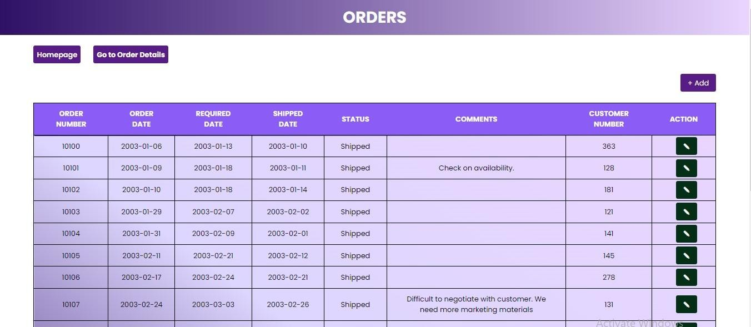

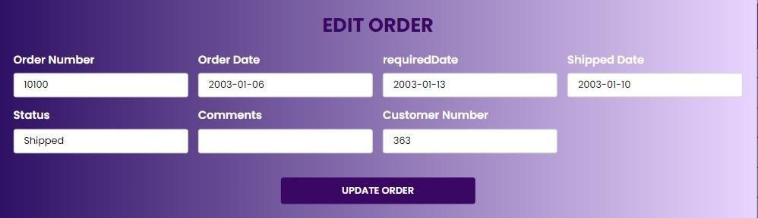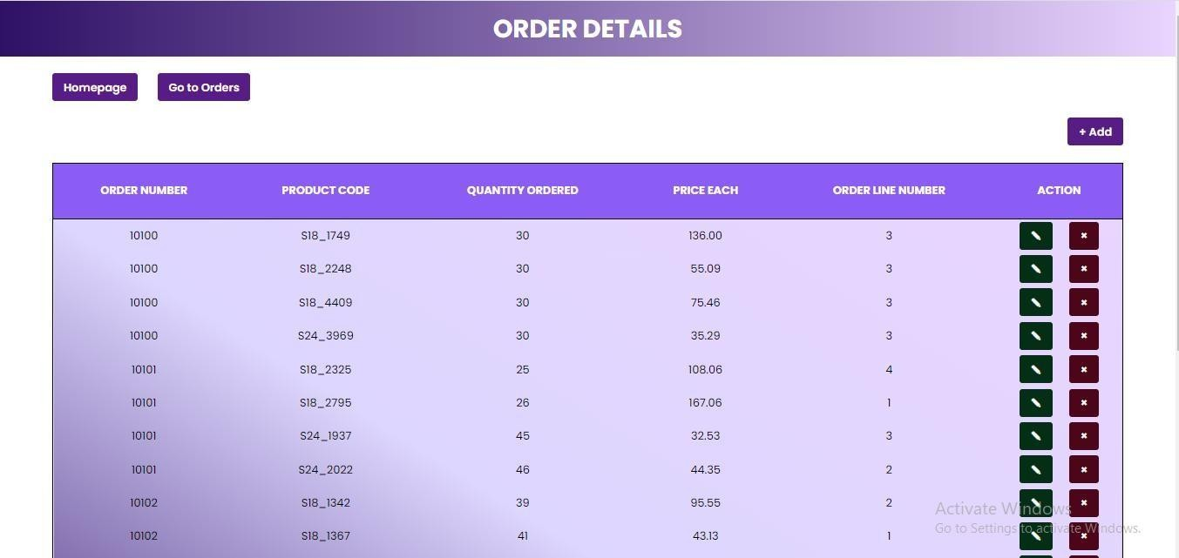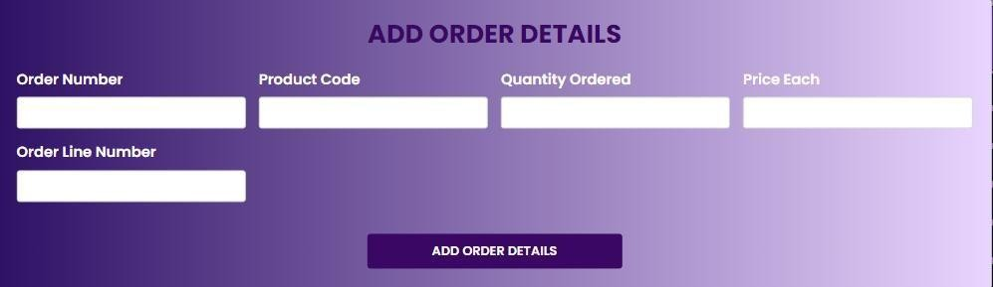

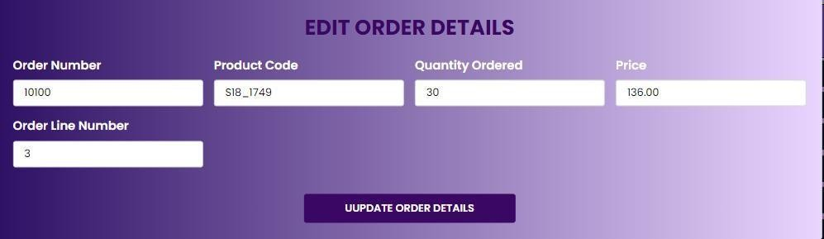

Customer Payments

(Assigned to Jeff Kirk Vincent Aliganga)

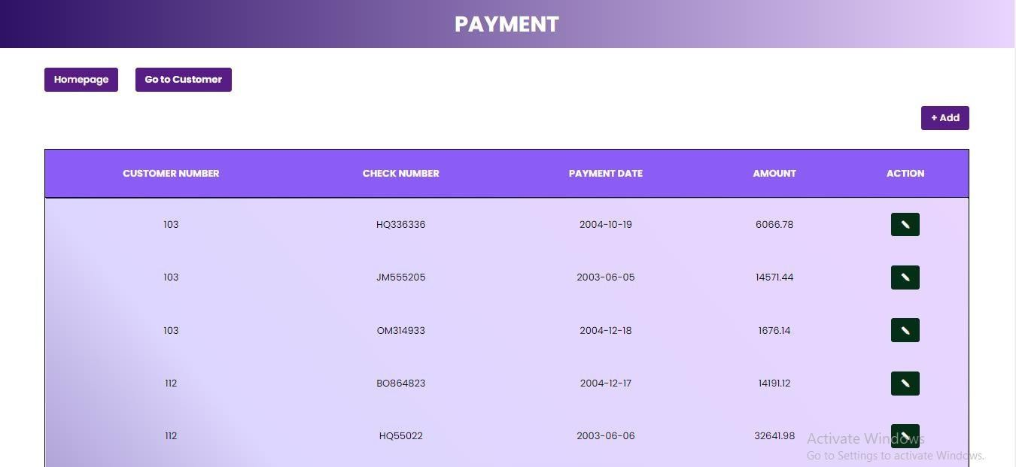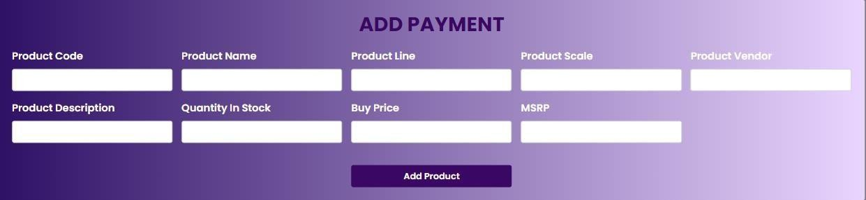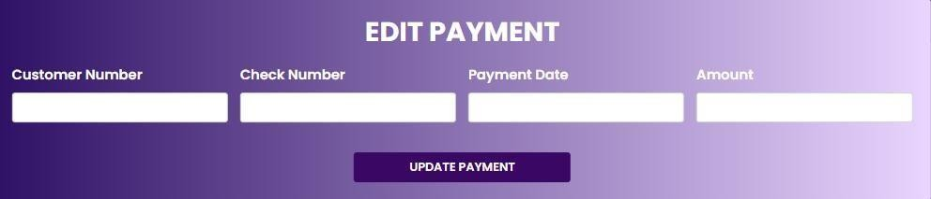

Transaction Handling

( Assigned to Kharl Cabarrubias )

ROUTES

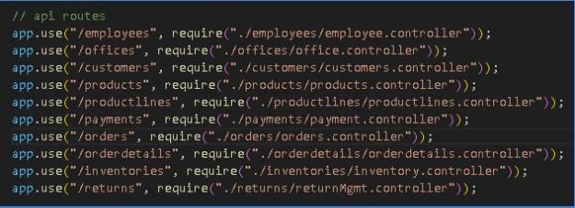

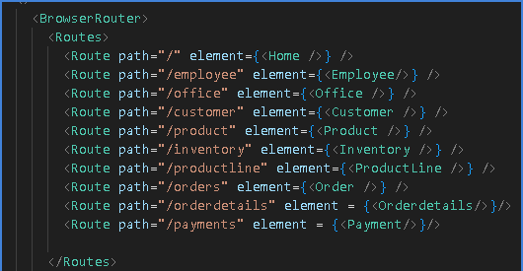

**Conclusion**

The system flow described above provides a comprehensive solution for managing employee, office, product, customer, order, and payment-related operations. The system offers

powerful querying, sorting, filtering, joining, and modifying capabilities by leveraging MySQL basics and incorporating essential SQL queries. The utilization of transactions ensures data consistency and reliability during payment processing. The system's structure is based on the classicmodels.sql sample database, allowing seamless integration and easy adoption for organizations using MySQL.

Terminal

API – npm run start:dev FrontEnd – npm run dev

GitHub Link

<https://github.com/lloydButanas/IPT_FinalsProject.git>