Name: Marcus Henson L. Garcia Date Created: November 25,2021

Course/Section: BSCS – 1A Date Submitted: November 25,2021

Professor: Mr. Lee Samonte

Questions:

1. What is a Pseudo Code?

Pseudocode is an informal way of describing the steps of how an algorithm works or how a system works. It is mainly used for creating the outline of a program.

2. What is a Flow Chart?

It is a type of diagram that represents a workflow or process. It also shows the step-by-step by showing a diagram presented by shape and connected by arrows to show the workflow.

3. Give an example of a Pseudo Code with a corresponding Flowchart and Explain the Step-by-Step program flow.

Problem: Get the average of three numbers.

Pseudocode:

BEGIN

DOUBLE num1, num2, num3, average

OUTPUT (“Input Number 1:”)

INPUT num1

OUTPUT (“Input Number 2:”)

INPUT num2

OUTPUT (“Input Number 3:”)

INPUT num3

average = (num1+num2+num3) /3

OUTPUT average

END

Flowchart: On next page

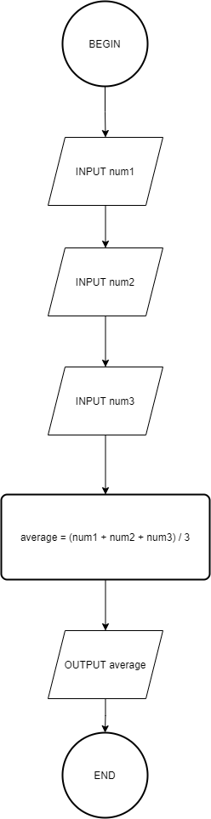

Explanation: The flowchart will start at “begin”, next the user will input the number or variables in order: num1, num2, num3. Then the system will process the average of the three numbers by this formula: average = (num1 + num2 + num3) / 3. Finally, the system will output the processed average and will end.