**ITEC 101 – Introduction to Computing**

**Quiz One**

**Submitted to**

**Mrs. Margarita R. Villanueva**

**Submitted by**

**Marcus Henson L. Garcia**

**BSCS – 1A**

**October 25, 2021**

Quiz #1:

Answer each of the following questions, essay type. AVOID copying from the internet. Your own words

will be greatly appreciated and scored.

1. In your own understanding, how can you define COMPUTER? (5 Points)

2. What is the impact of the discovery of computer especially now that we are in the middle of a health crisis which is COVID-19 pandemic. (5 points)

3. In your own opinion, differentiate Hardware, Software, and Peopleware (5 POINTS)

4. Give at least 5 examples of input and output devices and DRAW each of them, and explain its use. (5 points)

5. Differentiate System software from Application Software (5 points)

Answers to Quiz #1:

1. Based on my knowledge, a computer is an electronic device or machine that follows a set of instructions depending on its program. Aside from following instructions, it can also manipulate data by storing, retrieving, and using it for processes.

2. The discovery of computers had a huge impact on society even before the pandemic, it became an everyday device used by people; it just became more noticeable when the pandemic started. Electronic devices became in demand on the market because of the new normal like work-from-home and online classes issued by different countries. Computer became the main medium for connecting to other people, it helped a lot to cope with the pandemic.

3. Hardware is the physical components of a computer or other device. Software is the exact opposite of hardware and can be seen installed in devices in most cases. Lastly, Peopleware is completely different from the first two, it can be defined as someone or something that’s related to computer some examples are developers, end users, and project teams.

5. System software is a software that is created for the devices itself mostly for maintenance and to ensure the device are working properly. Meanwhile, application software is a software that is created for the device users and used for their services, example are Microsoft word, Google Chrome, Spotify, and Netflix.

**(Answer for question no.4 are on the next page)**

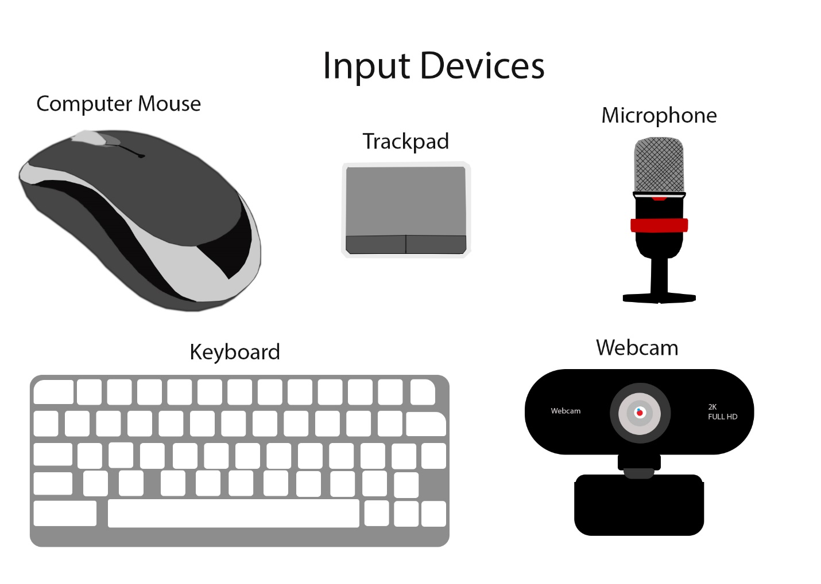

4.

Computer Mouse – controls the cursor in a GUI or graphic user interface

Trackpad – a touchscreen pad that controls the cursor in a GUI or graphic user interface mostly used in laptops.

Microphone – device used to translate sound vibrations in the air into electronic signals comprehensible by people.

Keyboard – device used by users to input letter, numbers, or symbol in a device.

Webcam – a device that streams an image or video in real time.

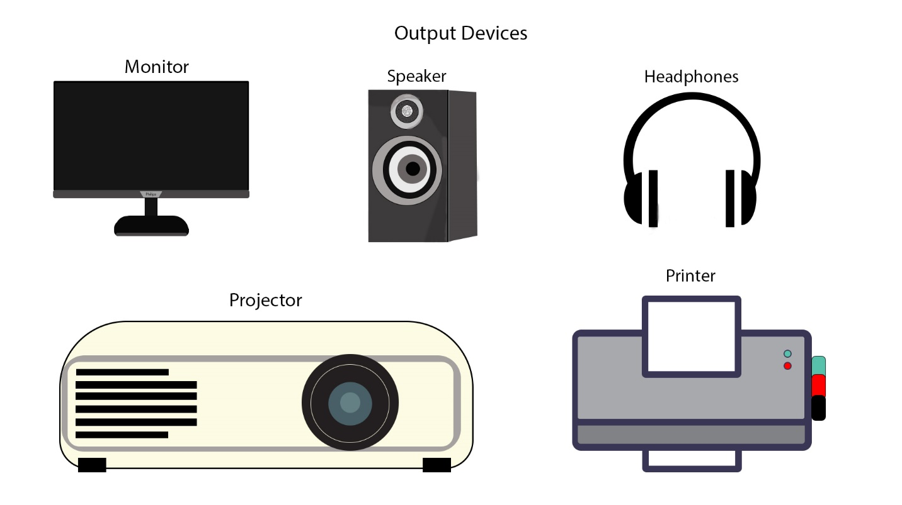

4.

Monitor – a device used for displaying object or data processes in most computers.

Speaker – a device that is connected to another device to generate sounds in an open area.

Headphones – a device that is also connected to another device to generate sounds but in a close area.

Projector – a device used for displaying object or data processes but by the use of lights.

Printer – a machine used for printing texts or images onto a paper.