**Get the Look: Antiquing Your Windows**

Creating an antique look for your home can be done in a variety of ways through the use of color, texture, and décor. One of the most important aspects of an antique home is the windows, because they tend to stand out as the “face” of a home and therefore are one of the first things typically noticed by passersby. Luckily, you don’t have to hire a consultant or contractor in order to get the look you’re after. [Modernize](http://modernize.com/) suggests making the following easy changes to create a unique antique look that is sure to stand out from the crowd:

**Apply Some Window Film**

A great way to antique your windows is to apply some window film to each one of them. Most window film comes with a tint that helps block harmful UV rays from entering your home and fading your walls, counters, furniture, and flooring. While a variety of modern and eclectic designs are available, you will find many options made to create an antique look and feel for your home—consider stained glass, faded glass, or scratched glass varieties.

**Stress the Window Frames**

Another awesome option for antiquing your windows is to make their frames look distressed by painting them in a fresh coat and then using a crumbled piece of paper or a rough sponge to rub the paint in up and down strokes just before it fully dries. When it’s ready to be distressed, the paint should be dry to your light touch yet smudgeable when a little elbow grease is used. When wiping the almost dry paint, use such a light touch so that you can barely feel your hand against the frame. Otherwise you may end up with large smudges that look sloppy as opposed to small streaks that look antique.

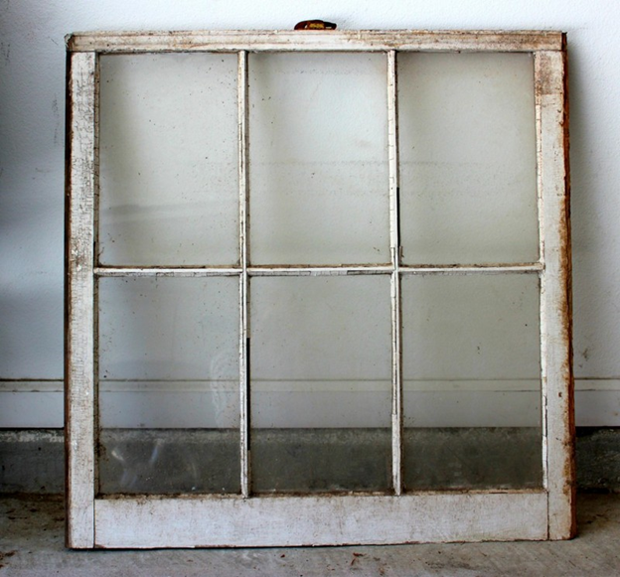

Via [Satisfaction Through Christ](http://www.satisfactionthroughchrist.com/wp-content/uploads/2014/08/window1.jpg)

**Install Plantation Shutters**

Not only do plantation shutters offer an antique look to take advantage of, but they are typically less costly than drapes and they should also increase the overall value of your home once installed. Plantation shutters are especially helpful in warm areas because they can be positioned in a way that allows air to flow freely without sacrificing shade protection indoors. These shutters are typically custom made to fit the specific window they’ll be installed on, so they can be used on any shape, style, and size of window your home may be sporting.

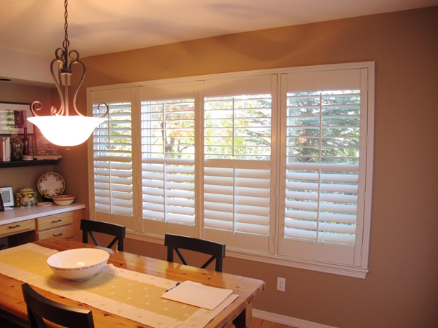

Via [Shy Blakeman](http://decor.shyblakeman.com/wp-content/uploads/2015/06/Plantation-Shutters-Lowes.jpg)

These cost effective ideas can be used alone or in combination with one another depending on the overall look and feel you’re going for.