Cyclistic Bike-Share
Data Analysis Documentation

Phase: Analyze • Data Period: March 2025 – February 2026 • Prepared: March 2026
Business Question
How do annual members and casual riders use Cyclistic bikes differently?
This document records the complete analytical workflow performed in the analysis phase of the Cyclistic bike-share case study. It presents the methodology, key findings, and business interpretations derived from a cleaned dataset of 5,439,162 trips spanning twelve months.

Tool: Python (Pandas, Matplotlib, Seaborn, Folium)

1. Overview

The Analyze phase is the analytical core of the Cyclistic case study. Its purpose is to transform the cleaned, validated dataset produced during the Process phase into a structured set of findings that directly answer the primary business question: how do annual members and casual riders use Cyclistic bikes differently?

Business Context
The goal of this analysis is to understand how annual members and casual riders use Cyclistic bikes differently, to design a data-driven marketing strategy aimed at converting casual riders into annual members. The Analyze phase is the step where raw data patterns are turned into that evidence.

Handoff from the Process Phase
The Process phase produced a cleaned, analysis-ready dataset of 5,439,162 rows and 28 columns, covering March 2025 through February 2026. Key characteristics of this dataset relevant to the analysis include:
- All critical fields — ride_id, timestamps, rider type, and ride duration — are 100% complete.
- Station name and ID fields retain approximately 20% null values due to electric bikes being lockable outside traditional docking stations. Station-level analysis therefore represents a partial spatial view, not a complete census.
- Ten derived columns were created during processing, including ride_length (minutes), day_name, ride_hour, is_weekend, and is_round_trip. These columns are the primary analytical instruments in this phase.
- Ride durations are bounded between 1 minute and 240 minutes, removing false starts and unreturned bikes.

2. Analytical Approach

All analysis was performed in Python using Pandas and visualized with Matplotlib, Seaborn, and Folium. The analyses performed span the following dimensions:

Core KPIs by Rider Type
The analysis begins with a rider-level summary that establishes baseline comparisons: total trips, average and median ride duration, weekend share of trips, and round-trip rate. Median ride length is included alongside the mean because ride duration data is right-skewed — a small proportion of very long trips can inflate the average. Calculating both values gives a reliable picture of typical behavior.

Monthly and Seasonal Patterns
Trip volume and average ride duration are aggregated by month (year_month) and rider type. This reveals the seasonal rhythm of the network, identifies which months constitute peak casual activity, and quantifies how volatile each group’s demand is relative to the other.

Day-of-Week Behavior
Total trips and average ride duration are calculated for each day of the week, segmented by rider type. Days are ordered Sunday through Saturday. This analysis is central to distinguishing “utility” riders (weekday, routine) from “leisure” riders (weekend, recreational).

Hour-of-Day Heatmaps
A pivot table is constructed crossing hour of day (0–23) against day of week for each rider type. The resulting heatmap reveals whether activity clusters in the AM/PM commute windows or spreads across midday and evening hours. This is the most granular behavioral dimension in the analysis and the most diagnostic for identifying commuter patterns.

Ride Duration Distribution
Trips are bucketed into seven duration bands: 1–5, 6–10, 11–20, 21–30, 31–60, 61–120, and 121–240 minutes. Comparing the distribution shapes for each rider type reveals whether members cluster in short bursts and whether casual riders have a heavier tail of long-duration rides — a key signal for the pricing argument.

Bike Type Preference and Seasonal Variation
The share of classic versus electric bike trips is calculated per rider type and by month. This identifies whether one group disproportionately relies on electric bikes, and whether that reliance shifts with weather.

Round-Trip Behavior
The is_round_trip field (True when start and end station names match) is aggregated as a percentage by rider type. A higher round-trip rate is an indicator of recreational loop riding rather than point-to-point transit.

Station-Level Spatial Analysis
The top 15 start stations are identified for each rider type from the subset of trips with non-null station names. A station mix table is also produced showing the casual share at the highest-volume dual-use locations. An interactive Folium map is generated to visualize the geographic distribution of member vs. casual hubs across Chicago.

Conversion Opportunity Segmentation
A rule-based segmentation is applied to casual riders to identify those whose trip behavior most closely resembles annual members. Five behavioral segments are defined using logical conditions on ride characteristics, producing a ranked view of conversion potential within the casual rider population.

3. Key Findings

3.1 Core KPI Summary
The table below captures the headline metrics that characterize each rider group across the full twelve-month period.

Metric | Member | Casual
Total Trips | 3,514,089 | 1,925,099
Share of All Trips | 64.61% | 35.39%
Average Ride Length | 11.81 min | 18.55 min
Median Ride Length | 8.75 min | 11.86 min
Weekend Trip Share | 23.22% | 37.12%
Round-Trip Rate | 9.87% | 15.45%
Electric Bike Share | 63.65% | 65.33%

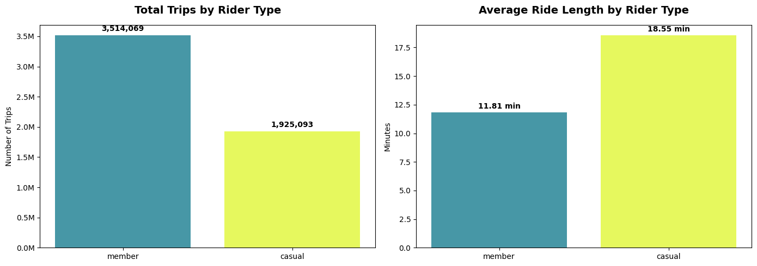
Volume vs. Value. Members dominate the network by trip count — nearly 1.6 million more trips than casual riders over the twelve months. However, casual riders extract significantly more time from each trip. The average casual ride is 57% longer than the average member ride (18.55 vs. 11.81 minutes), and the gap is even more striking at the median: the typical casual rider’s trip (11.86 minutes) is almost as long as the average member’s trip. This means casual riders are already experiencing member-level usage time, but paying for it at per-minute rates.

3.2 Monthly and Seasonal Patterns
Ridership for both groups tracks the Chicago seasonal calendar, but casual ridership is dramatically more volatile.

Month | Total Trips | Member Share | Casual Share
Mar 2025 | 291,016 | 71.58% | 28.42%
May 2025 | 489,070 | 64.17% | 35.83%
Jun 2025 | 657,315 | 57.71% | 42.29%
Jul 2025 | 737,735 | 58.29% | 41.71%
Aug 2025 | 765,794 | 57.84% | 42.16%
Oct 2025 | 627,580 | 65.91% | 34.09%
Dec 2025 | 136,180 | 80.15% | 19.85%
Jan 2026 | 133,391 | 82.16% | 17.84%

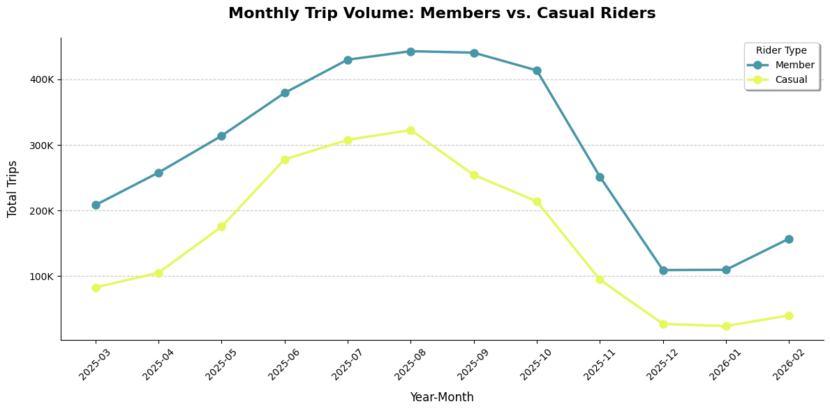
Seasonal Surge. Casual ridership grows from a winter floor of 23,800 trips in January 2026 to a summer peak of 322,855 trips in August 2025 — a 14-fold increase. Member ridership over the same span shows a much more moderate 4-fold increase. The result is a dramatic seasonal compression of the member share: from 82% of all trips in January to just 58% in August, as casual riders flood the network.
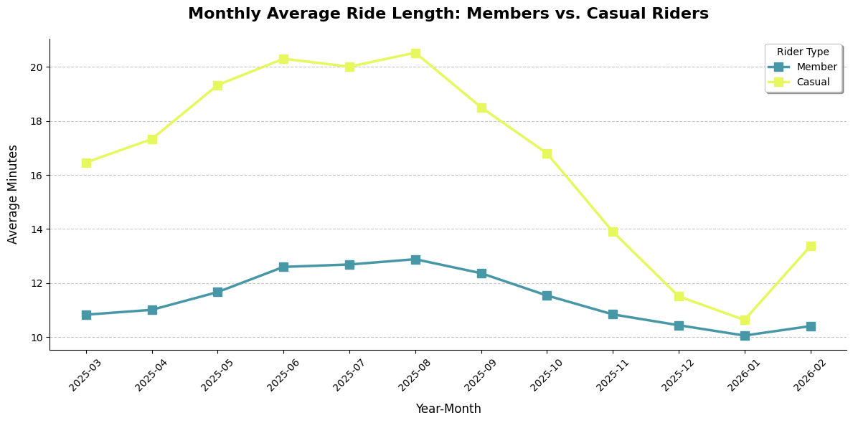

Ride Duration Seasonality. Average casual ride length nearly doubles from winter to summer, rising from 10.63 minutes in January to 20.53 minutes in August. Member ride duration, by contrast, remains almost perfectly flat across all twelve months — hovering between 10 and 12 minutes year-round. This consistency is a hallmark of routine commuting behavior.

Winter Convergence. In January, the two groups converge toward a near-identical 10-minute average ride length (10.63 casual vs. 10.05 member). This suggests that winter trips are utility-focused for both groups, with casual riders temporarily abandoning leisure patterns in cold weather.

3.3 Day-of-Week Patterns
Day-of-week analysis produces the clearest behavioral split in the entire dataset.
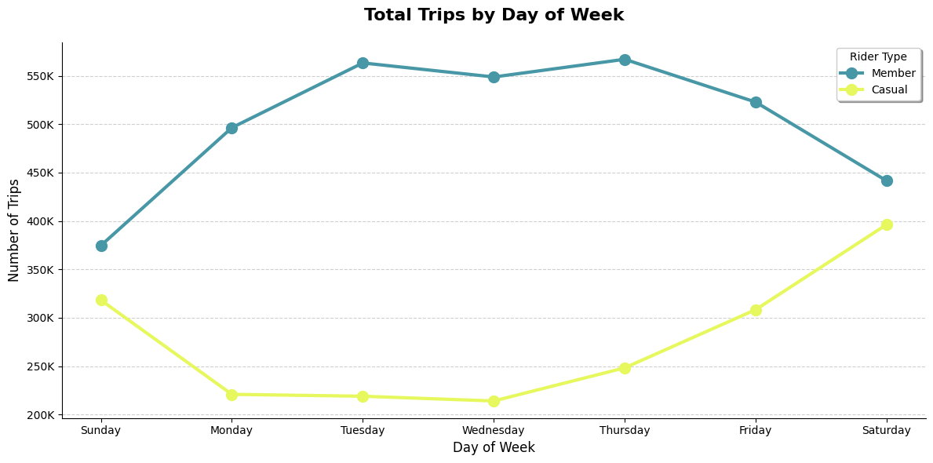

Day | Member Trips | Casual Trips | Member Avg (min) | Casual Avg (min)
Sunday | 374,594 | 318,209 | 12.96 | 21.51
Monday | 496,329 | 220,900 | 11.45 | 18.54
Tuesday | 563,203 | 218,954 | 11.45 | 16.32
Wednesday | 548,727 | 214,053 | 11.34 | 15.44
Thursday | 566,987 | 248,272 | 11.45 | 16.28
Friday | 522,778 | 308,397 | 11.74 | 18.25
Saturday | 441,451 | 396,308 | 12.87 | 20.74

A Complete Behavioral Inversion. Member trip volume is highest Tuesday through Thursday, with a peak of 566,987 trips on Thursday, and tapers off significantly as the weekend approaches. Casual ridership does the opposite: it is lowest mid-week and surges on Friday and Saturday, with a peak of 396,308 trips on Saturday — nearly twice the mid-week casual volume.

The Saturday Equilibrium. Saturday is the only day of the week where the gap between members and casual riders narrows substantially (441,451 vs. 396,308). It is the closest the network comes to a balanced rider mix on any single day.

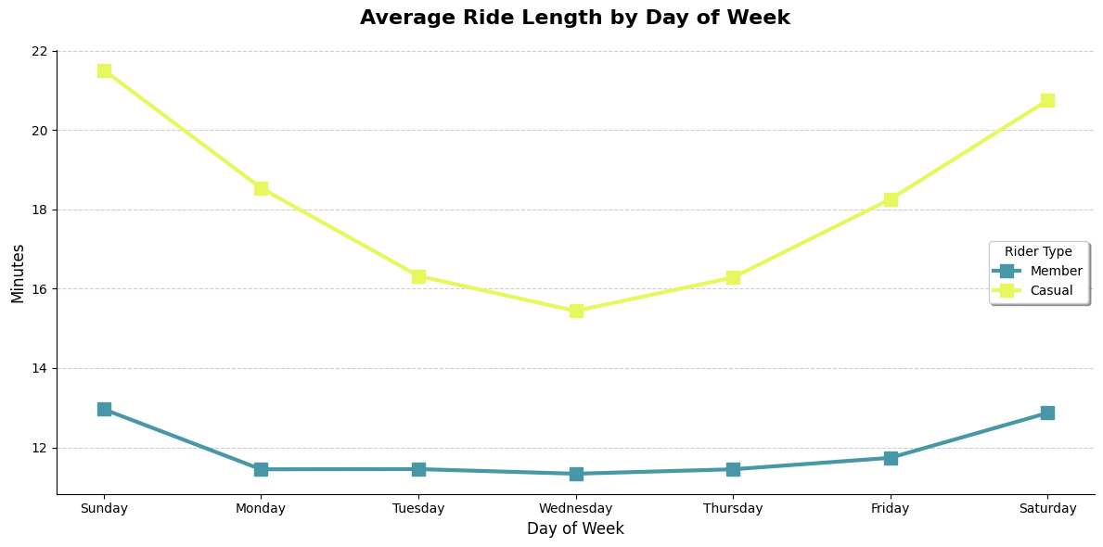
Duration Consistency as a Commute Marker. Members maintain a remarkably stable average ride duration of 11.3 to 11.7 minutes from Monday through Friday — a consistency that is characteristic of people traveling the same route every day. Casual riders show much wider variation, with weekday durations that are already 4–7 minutes longer than members, rising further on weekends.

3.4 Hour-of-Day Behavior
The hourly heatmaps are the most diagnostic tool in the analysis for identifying commuter behavior.

The Member Commuter Profile. On weekdays, members exhibit a classic bimodal distribution — sharp spikes at 8 AM and 5 PM. The 5 PM peak is particularly pronounced, reaching 70,943 rides on Tuesdays. On weekends, these sharp peaks disappear entirely, replaced by a gradual midday rise. This pattern is virtually textbook commuting behavior.

The Casual Leisure Profile. Casual riders have very low activity at 8 AM on weekdays — on a typical Tuesday, only about 11,262 casual rides occur at that hour, compared to over 50,000 member rides. Instead, casual usage builds gradually through the morning and remains broadly elevated from midday into the evening. On weekends, casual activity peaks between 12 PM and 3 PM, with the absolute system peak at 2 PM on Saturdays (34,337 rides).

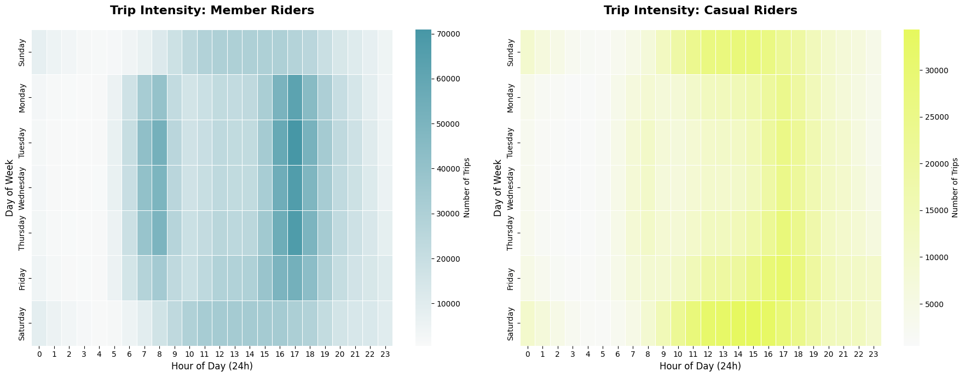

3.5 Ride Duration Distribution
Bucketing rides into seven duration bands reveals the shape of behavior for each group — not just the average.
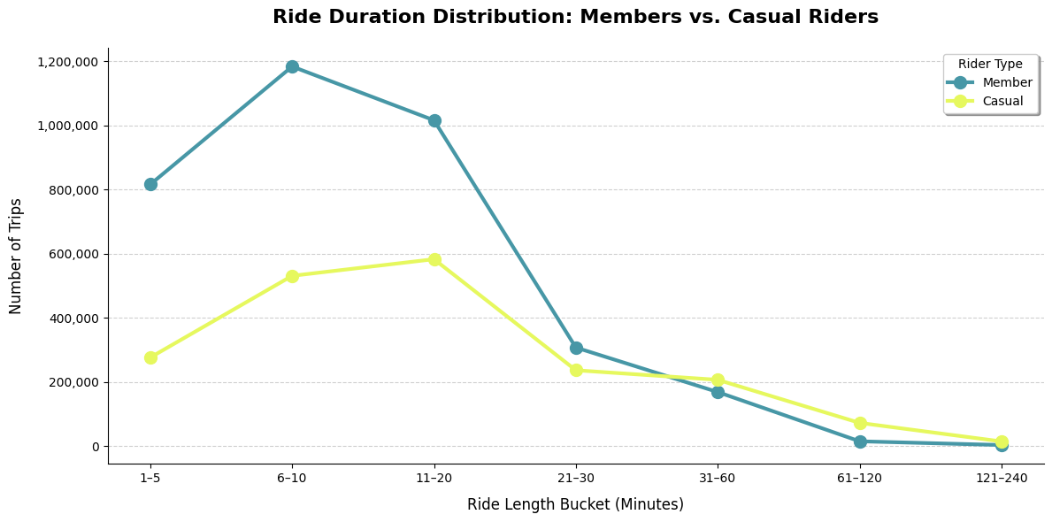

Duration Bucket | Member Trips | Casual Trips | Casual Surplus / Deficit
1–5 min | 816,449 | 276,991 | −1,539,458 (deficit)
6–10 min | 1,184,093 | 531,642 | −652,451
11–20 min | 1,016,439 | 583,383 | −433,056
21–30 min | 307,978 | 237,202 | −70,776
31–60 min | 169,247 | 207,401 | +38,154 (surplus)
61–120 min | 15,750 | 73,128 | +57,378
121–240 min | 4,113 | 15,346 | +11,233

The 30-Minute Crossover. For every duration band under 30 minutes, members have more trips. At the 31–60 minute mark, that relationship flips: casual riders complete 207,401 trips compared to 169,247 for members. Beyond 60 minutes, casual riders dominate decisively — taking nearly five times as many trips in the 61–120 minute band.

Member Short-Burst Concentration. The vast majority of member activity is concentrated in the 6–10 minute (1,184,093 trips) and 11–20 minute (1,016,439 trips) bands. This is a distribution consistent with people traveling fixed commute distances at predictable times.

The Casual Fat Tail and the Pricing Implication. Casual riders exhibit a ‘fat-tail’ duration distribution. A significant portion of their trips extend into the 30–240 minute range. These riders are paying per minute for every one of those trips. A casual rider completing a 90-minute lakefront ride is incurring a cost that an annual membership would substantially reduce.

3.6 Bike Type Preference and Round-Trip Behavior
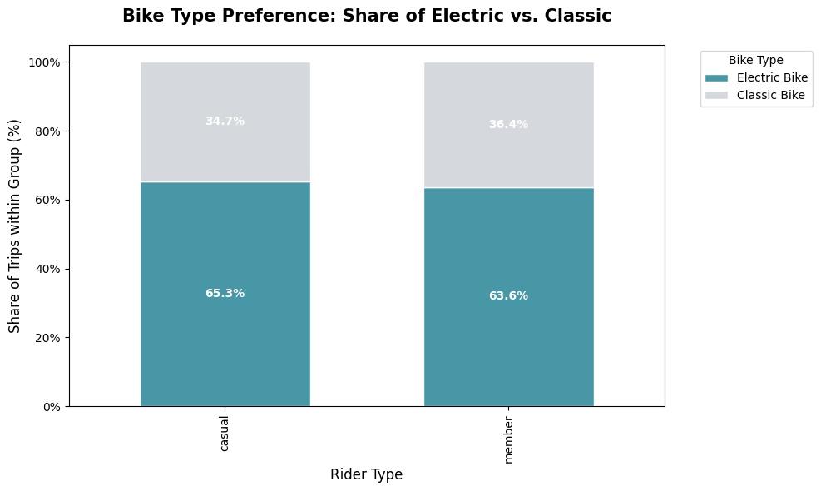
Electric Bike Dominance Across Both Groups. Electric bikes are the preferred vehicle for both members (63.65% of their trips) and casual riders (65.33%). Classic bikes are used significantly less by both groups, though members use them slightly more often than casual riders. This rules out the hypothesis that casual riders are disproportionately the electric-bike audience — both groups show a strong and similar preference for electric assist.
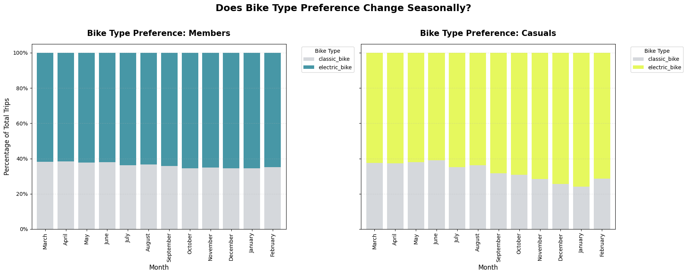
Seasonal Hardware Shift for Casual Riders. While member bike-type preference remains relatively stable across months, casual riders show a clear shift toward electric bikes in colder months — likely to minimize time spent in the elements by trading physical effort for motor assist. This winter reliance on electric bikes creates a specific pricing exposure: casual riders are already paying a premium for electric minutes in exactly the months when they are most dependent on that capability.

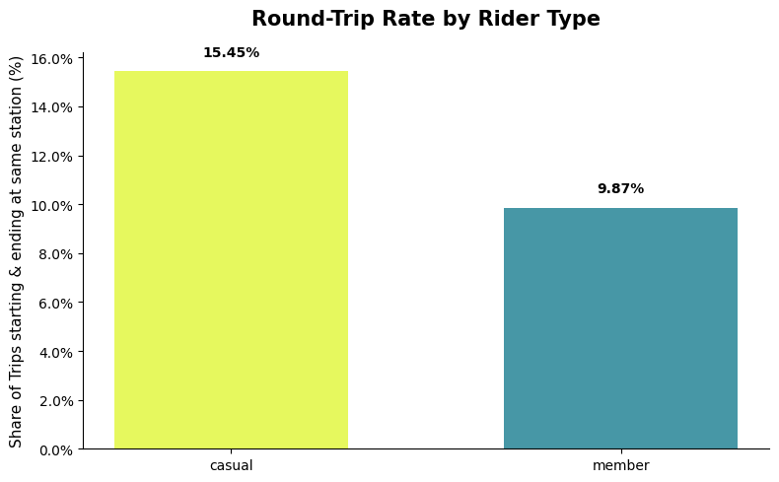
Round Trips and Recreational Intent. Casual riders have a round-trip rate of 15.45%, compared to 9.87% for members. A round trip — where the bike is returned to its starting station — is a strong behavioral indicator of recreational or sightseeing use. Members overwhelmingly use the system for A-to-B transit; casual riders are roughly 56% more likely to be completing a leisure loop.

3.7 Station-Level Spatial Analysis
Station-level analysis reveals a stark geographic segregation between the two rider groups. All figures below are derived from the subset of trips with non-null start station names (approximately 80% of total trips).
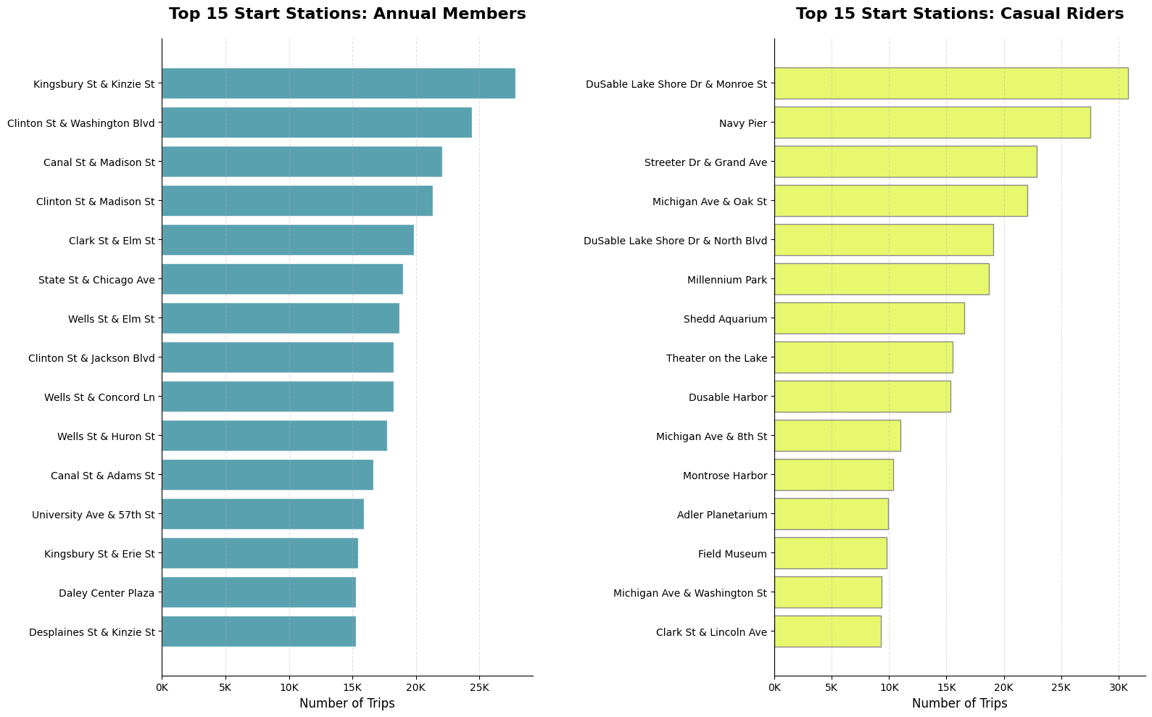

Top Start Stations: Annual Members
Station Name | Total Trips
Kingsbury St & Kinzie St | 27,849
Clinton St & Washington Blvd | 24,443
Canal St & Madison St | 22,079
Clinton St & Madison St | 21,319
Clark St & Elm St | 19,867
State St & Chicago Ave | 18,980
Wells St & Elm St | 18,690

Top Start Stations: Casual Riders
Station Name | Total Trips
DuSable Lake Shore Dr & Monroe St | 30,808
Navy Pier | 27,548
Streeter Dr & Grand Ave | 22,862
Michigan Ave & Oak St | 22,054
DuSable Lake Shore Dr & North Blvd | 19,099
Millennium Park | 18,719
Shedd Aquarium | 16,558

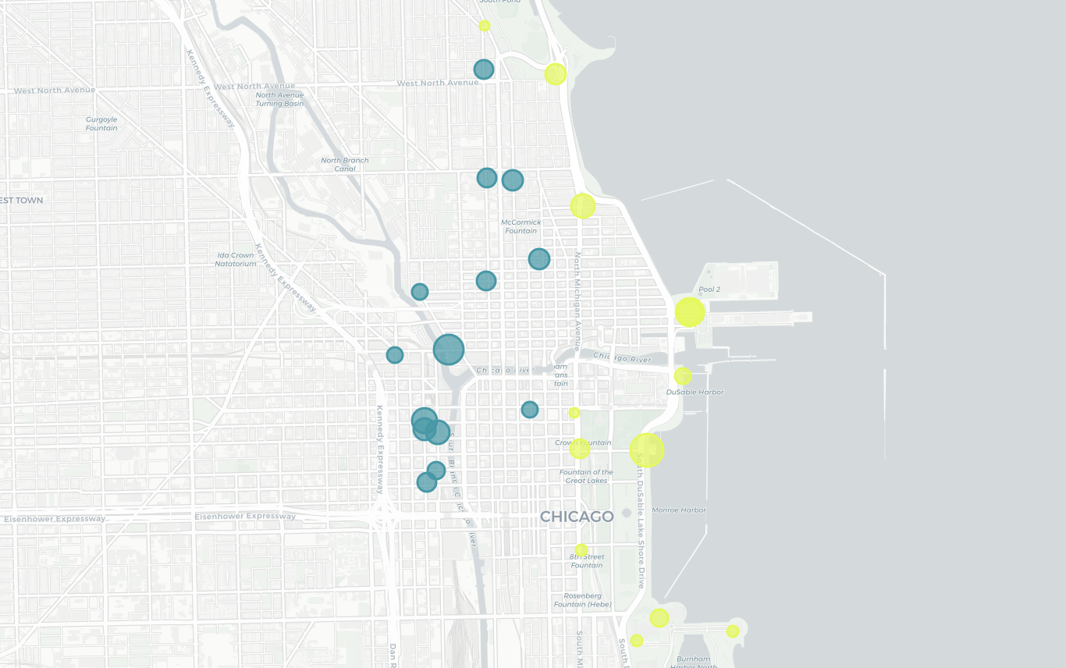

The Inland vs. Coastal Divide. Member top stations are concentrated in the West Loop and River North business corridors, with several located directly adjacent to major commuter rail terminals (Ogilvie Transportation Center and Union Station). These are “last-mile” connections for professional commuters. Casual top stations are a near-complete inventory of Chicago’s major lakefront landmarks and tourist destinations — Navy Pier, Millennium Park, Shedd Aquarium, Adler Planetarium, and the Field Museum all appear in the top fifteen.

High Casual-Share Stations (Conversion Targets). The following stations have the highest casual share and represent the most valuable locations for physical membership marketing:

Station | Casual % | Total Trips | Strategic Note
Shedd Aquarium | 81.82% | 20,236 | Tourist magnet
Field Museum | 81.28% | 12,065 | Tourist magnet
Streeter Dr & Grand Ave | 79.45% | 28,773 | High volume, high casual
DuSable Lake Shore Dr & Monroe | 78.89% | 39,051 | Highest overall volume
Michigan Ave & Oak St | 63.31% | 34,834 | Hybrid zone, local residents

Note: The station analysis is partial. An estimated 20.24% of all trips have no start station recorded, primarily electric bike trips that were locked outside traditional docking stations. The true spatial distribution of casual rider activity is likely broader than the station data suggests, particularly along the lakefront corridor.

3.8 Conversion Opportunity Segmentation
A rule-based segmentation was applied to the casual rider population to identify the proportion of casual trips that most resemble annual member behavior. The segmentation used a combination of time-of-day, day-of-week, trip duration, round-trip status, and station proximity to member hubs to classify each casual trip into one of five behavioral segments.

Segment | Total Trips | Avg Duration | Electric % | Opportunity %
High-Priority Target (Commuter Mimic) | 30,144 | 8.88 min | 68.92% | 1.57%
Standard Commuter (Non-Hub) | 307,304 | 9.47 min | 71.60% | 15.96%
Round-Trip Explorer | 258,203 | 15.99 min | 79.68% | 13.41%
Weekend Leisure | 239,457 | 43.12 min | 48.18% | 12.44%
Occasional / Other | 1,089,985 | 16.58 min | 63.84% | 56.62%

Commuter Mimic. These 30,144 trips represent casual riders who are effectively already behaving like members — short rides (average 8.88 minutes, nearly identical to the member median of 8.75 minutes), starting from the same hubs, during peak commute hours, on weekdays. They require the least behavioral change to convert; they simply need a financial incentive.
Standard Commuter (Non-Hub). This segment represents a much larger opportunity: 307,304 trips from riders taking short, weekday, peak-hour trips from non-hub residential stations. They are acting like commuters but are likely unaware that a membership would be more cost-effective for their usage pattern.
Weekend Leisure. At an average of 43 minutes per trip, these riders are almost certainly among the highest per-trip spenders on the platform. While they are less behaviorally similar to members, they have the most to gain financially from a membership that offers unlimited-duration sessions.

CONVERSION FOCUS
Together, the Commuter Mimic and Standard Commuter segments account for 337,448 trips (17.5% of all casual trips) that are already behaviorally identical to member usage.
Converting this segment does not require changing their behavior — it requires showing them a more cost-effective way to continue what they are already doing.

4. Summary

Members Are Routine Commuters. Casual Riders Are Leisure Explorers.
Every dimension of the data points to the same behavioral split. Members ride on weekdays in tight commute windows — their trip volume peaks Tuesday through Thursday (up to 566,987 trips on Thursdays) and spikes sharply at 8 AM and 5 PM. Their average ride duration is stable at 11.3–11.7 minutes regardless of day, month, or season, which is the signature of someone traveling a fixed route on a fixed schedule. Casual riders show the opposite pattern: low mid-week volume, a surge on Saturdays (396,308 trips — nearly double their Tuesday volume), midday and afternoon peaks, and a 57% longer average ride. Their round-trip rate is also 56% higher than members’ (15.45% vs. 9.87%), confirming that a significant share are completing recreational loops rather than traveling from A to B.

Casual Riders Are Already Paying for Member-Level Usage.
The casual rider’s median ride is 11.86 minutes — nearly as long as the average member trip (11.81 minutes). Yet casual riders pay per minute for every trip. The duration distribution makes this gap concrete: for every bucket under 30 minutes, members have more trips. At the 31–60 minute mark, casual riders take more (207,401 vs. 169,247 for members), and in the 61–120 minute band they take nearly five times as many trips. A casual rider who completes a 90-minute lakefront ride is paying a cost that an annual membership would substantially reduce. This pricing exposure is the single strongest argument for conversion, and it is most acute in summer, when casual average ride duration peaks at 20.5 minutes — nearly double the January figure of 10.6 minutes.

Casual ridership is highly seasonal, while member usage is much more stable.
Casual ridership rises sharply in summer, growing from a winter low of about 23,800 trips in January 2026 to a peak of 322,855 trips in August 2025, while member ridership changes far less dramatically. Casual ride length also nearly doubles from winter to summer, while member ride duration remains consistently around 10–12 minutes year-round. This suggests casual riders are far more influenced by weather and recreational demand.

The Two Groups Occupy Different Geographies.
Member and casual activity is geographically segregated in a way that directly mirrors the behavioral split. Member top stations cluster in the West Loop and River North business corridors — several are within a short walk of Ogilvie Transportation Center and Union Station, confirming “last-mile” commuter use. Casual top stations are an inventory of Chicago’s lakefront landmarks: DuSable Lake Shore Dr & Monroe St (30,808 casual starts), Navy Pier, Millennium Park, Shedd Aquarium (81.8% casual share), and the Field Museum (81.3% casual share). Not a single top member station appears on the casual top-fifteen list. This “inland vs. coastal” divide tells the marketing team exactly where to place physical advertising for maximum impact on the conversion target audience.

A Meaningful Minority of Casual Riders Are Already Behaving Like Members.
Not all casual riders are leisure users. A rule-based segmentation of the casual population identified two sub-groups whose trip behavior is functionally indistinguishable from annual members: the “Commuter Mimic” (short weekday peak-hour trips from member hub stations, average duration 8.88 minutes — nearly identical to the member median of 8.75 minutes) and the “Standard Commuter” (same pattern from non-hub residential stations). Together these two segments account for 337,448 casual trips, or 17.5% of all casual activity. Converting them requires no change in behavior — only a pricing realization. They are the highest-return target in the entire casual population.

5. Business Relevance

The behavioral differences identified in this analysis directly inform marketing strategy in three ways.

The Savings Argument
Casual riders who take longer-than-average trips — particularly those in the 31–240-minute duration bands — are paying per-minute for usage that an annual membership would cover at a flat cost. Marketing targeted at these riders should lead with a concrete cost-comparison message, calculating how much they would save given their actual average trip duration. This argument is most compelling in summer, when casual ride durations peak and casual riders are most active.

Targeting by Time and Place
The analysis provides precise guidance on where and when to deploy marketing resources:
- When: Summer months (June–August) for volume; Saturday afternoons for peak casual engagement; Tuesday–Thursday for the commuter-like casual sub-segment.
- Where: Lakefront stations (DuSable Lake Shore Dr, Navy Pier, Shedd Aquarium, Field Museum) for the broadest casual reach; Michigan Ave & Oak St for the “hybrid zone” where locally-resident casual riders congregate; member hub stations for the commuter mimic segment.

The Electric Bike Perk
Both groups are heavily electric-bike oriented, and casual riders already pay a premium for electric minutes in cold weather. A membership campaign that specifically highlights cost savings on electric bike usage — or priority access to the electric fleet — addresses a tangible, demonstrated pain point for the casual audience.

6. Analytical Limitations

- Trip-level data only. The dataset contains one row per trip, not one row per rider. It is not possible to distinguish whether high casual trip counts come from a small number of very frequent casual riders or a large number of one-time users.
- No demographic data. Rider age, home ZIP code, and occupation are unavailable. It is not possible to confirm whether commuter-like casual riders are Chicago residents or tourists who happen to ride during peak hours.
- No direct motivation data. The dataset records trip behavior but not the reasons behind it. The “leisure vs. commute” interpretation is inferred from behavioral patterns, not stated by riders.
- Station null values. Approximately 20% of trips have no station name recorded, primarily electric bike trips docked outside traditional stations.
- No conversion outcome data. The dataset cannot link any casual rider’s behavior to a subsequent membership purchase. It is not possible to directly measure which trip patterns historically predict conversion.
- Single-year window. The analysis covers March 2025 through February 2026. Long-term trends, multi-year growth patterns, and pandemic recovery effects are not visible in this data.

