**Supplementary**

**Figure S4.** (A) Swarm plot demonstrating computational hyperlinearity scores by age group, with filaggrin loss-of-function mutations indicated by hue of each case. (B) Swarm plots demonstrating computational hyperlinearity for each filaggrin group presented separately by each age group.

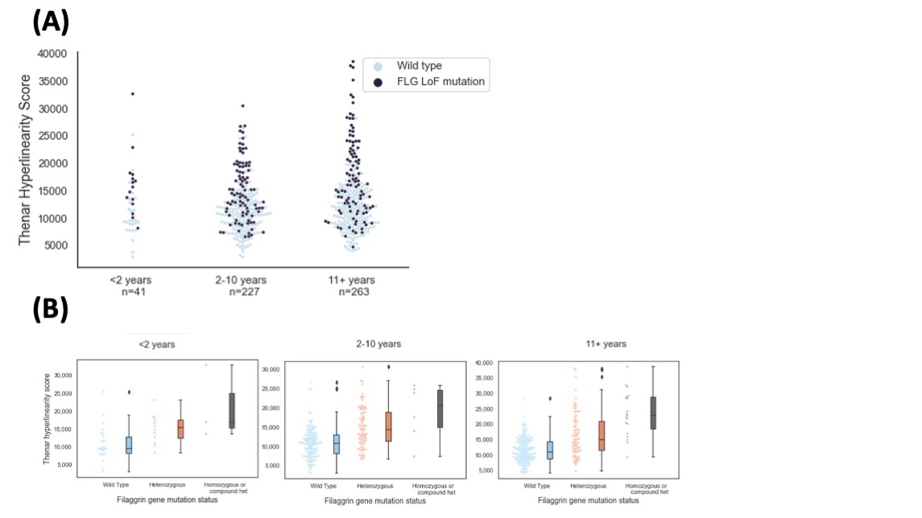

FLG LoF= filaggrin gene loss-of-function mutation