Statistical Robustness and Adversarial Resilience of Deep Learning Models in Aerospace Predictive Maintenance

Module: Research Project (CYS6001-20)
Assessment: S2 Research Paper
GitHub Link: https://github.com/lloyduycb/ResearchProject

Abstract
This research addresses the critical intersection of predictive maintenance (PdM) and cyber-security in aerospace systems, a domain where data integrity is paramount yet often vulnerable. While Deep Learning models like Long Short-Term Memory (LSTM) networks have set benchmarks for Remaining Useful Life (RUL) estimation using the NASA C-MAPSS dataset, their stability under adversarial conditions—mimicking sensor degradation or cyber-attack remains under-explored. This paper presents a novel, comprehensive comparative analysis of four distinct architectures: LSTM, Temporal Convolutional Networks (TCN), Transformers, and Support Vector Regressors (SVR). Beyond standard performance metrics (RMSE, MAE), a custom "RUL Analysis Toolkit" was developed to quantify statistical significance via bootstrap resampling (1000 iterations) and adversarial resilience through Gaussian noise injection.
Key findings reveal that while TCNs achieved superior diverse performance (RMSE: 4.03 cycles) compared to industry-standard LSTMs (RMSE: 7.57 cycles), their true value lies in superior stability against sensor noise, demonstrating a degradation of only -0.7% under 1% Gaussian noise injection. In contrast, Transformer assessments revealed a trade-off between semantic feature extraction and noise sensitivity. These results suggest that for safety-critical Industrial IoT (IIoT) systems, model selection must account for a "Deployment Readiness" score that weights cyber-physical resilience equal to, or higher than, predictive accuracy.

Table of Contents
Statistical Robustness and Adversarial Resilience of Deep Learning Models in Aerospace Predictive Maintenance 1
Abstract 1
1. Introduction 3
1.1 Research Question 3
1.2 Research Objectives 4
2. Literature Review 4
2.1 The Evolution of RUL Estimation 4
2.2 The Rise of Deep Learning 4
2.3 Advanced Architectures: TCNs and Transformers 5
2.4 The Cyber-Security Evaluation Gap 6
3. Methodology 6
3.1 Dataset Description: NASA C-MAPSS 6
3.2 Model Architectures 7
3.3 The Evaluation Framework 8
4. Results & Analysis 10
4.1 Comparative Predictive Performance (Clean Data) 10
4.2 Handling Operational Complexity (FD002/FD004) 11
4.3 Feature Importance Analysis 13
4.4 Robustness & Security Analysis 14
4.5 Error Distribution Analysis 15
5. Critical Evaluation & Discussion 16
5.1 Why TCNs Outperform LSTMs 16
5.2 The "Accuracy vs. Resilience" Trade-off 17
5.3 Operational Implications for Aviation Policy 17
5.4 Ethical & Explainability Considerations 17
5.5 Limitations & Future Work 18
6. Conclusion 18
7. References 18

1. Introduction
Industry 4.0 has transformed the technology of aerospace maintenance with the introduction of the Industrial Internet of Things (IIoT) sensors that allow predictive maintenance (PdM) principles to be implemented to optimize the life of the component and minimize downtimes (Gunduz, 2021). The latest aircraft engines like the turbofans which are simulated in the C-MAPSS data set generate terabytes of data on a single flight. This information is taken advantage of to predict the Remaining Useful Life (RUL) of crucial elements, switching maintenance plans between the preventive (based on schedules) and the predictive (based on conditions) ones. A paradigm shift in aviation logistics is the shift to use predictive maintenance instead of scheduled maintenance.
Conventionally, planes had parts changed once they had covered a particular number of flight hours irrespective of their physical state. This conservative but economically inefficient approach is known as the safe-life approach where components that still have much remaining useful life are discarded. The application of predictive maintenance based on the use of data-driven solutions is a promising way to get the best out of every single component without compromising on safety. It enables the airlines to plan the maintenance at convenient times (e.g. being at a hub overnight) instead of being abruptly thrust into unscheduled Ground on Ground (AOG) situations, which have the potential to lose revenue and payouts to passengers in the tune of over $150,000 an hour.
Nevertheless, this heightened interconnectivity widens the area of attack as far as cyber-physical threats are concerned. A deteriorated sensor that results in a predetermined healthy condition of a malfunctioning engine (False Negative) is disastrous and may cost lives or property. False Positives (when the engine is healthy, but the system predicts failure) on the other hand cause unneeded and expensive downtime and logistical pressure. According to Teh et al. (2020), sensor data integrity in IIoT is a common assumption, and prone to both environmental and malicious attacks of false data injection (FDIA). The fact that a hostile actor can ground a fleet by spoofing sensor data in an age of increased geopolitical density is a realistic threat vector that only accuracy-related research takes into consideration.
This study explores the robustness of AI-based RUL estimation in the face of the integrity of sensor data adversarial pressure, and the viewpoint on pure predictive quality is replaced by adversarial robustness. It questions the current scholarly tendency to optimize only with respect to RMSE on static clean data.

1.1 Research Question
The main research question that would guide this research is:
What is the extent to which state-of-the-art Deep Learning models predict the state of the RUL can preserve their reliability to simulated sensor data degradation and cyber-physical noise?

1.2 Research Objectives
To provide this answer, the following specific objectives were set:
1. Implement and Benchmark: Train a variety of RUL estimation models (LSTM, TCN, Transformer, SVR) on the NASA C-MAPSS dataset and make sure that the sample of algorithmic models (recurrent, convolutional, attention-based, and statistical) is representative.
2. Statistical Framework: Develop a rigorous evaluation pipeline using bootstrap confidence intervals and non-parametric significance tests (Wilcoxon Signed-Rank) to assess performance beyond simple point estimates.
3. Quantify Resilience: Characterize the robustness of the models to simulate sensor noise and dirty data and set a quantitative score of robustness of each architecture.
4. Operational Complexity Analysis: Do not only assess the ability of these models to work on simple degradation curves (FD001), but also to work under complex operating conditions that are multi-modded (FD002/FD004).

2. Literature Review
Prognostics and Health Management (PHM) field has undergone a swift development over the past twenty years, and the spread of open-source benchmark datasets has been a major factor in this development.

2.1 The Evolution of RUL Estimation
Predictive maintenance has developed to become data-driven as opposed to physics-driven. Physics-based models need extensive knowledge of the domain and failure mode equations (e.g., crack propagation, oxidation, spallation) that can be inaccessible or too slow to be able to monitor in real time. Approaches based on data, on the other hand, are learned with the sensor logs.
The NASA C-MAPSS (Saxena et al., 2008) data set has become a common standard in this field, and it has modeled the deterioration of a turbofan engine in different operating conditions. Initial methods on this data were based on regression models including Support Vector Regression (SVR) and Random Forests. Although they can be useful in simple linear degradation, complex sensor data with high-dimensionality and temporal dependencies can be problematic to these models. Manual feature engineering is particularly required to obtain time-domain statistics (mean, kurtosis, skewness) by sliding windows in the SVR model, and this restricts its ability to generalize to new unobserved fault modes. The brittle nature of this manual feature extraction is that should the degradation signature evolve (e.g. a new vibration frequency is introduced), the hand-crafted features will not be able to detect it at all.

2.2 The Rise of Deep Learning
The recent developments have been in favour of Deep Learning because of the capability that it has to automatically learn features of raw time-series data.
Recurrent Neural Networks (RNNs): Recurrent Neural Networks (RNNs) are first shown to have potential in the RUL estimation (Heimes, 2008). On this basis, Zheng et al. (2017) defined The Long Short-Term Memory (LSTM) network as the standard in the industry. The LSTMs overcome the vanishing gradient issue of repeat RNNs and as such can identify long-term dependencies in the degradation signal. This is very important to RUL because a minor change in vibration readings 50 cycles ago could point to a failure today. It has the LSTM cell architecture, which has a cell input, cell output, and forget gate that enables the network to control the information flow, determining what should be memorized and what should be forgotten in long sequences.

Convolutional Neural Networks (CNNs): CNNs have been modified to time-series although they were initially created to process images. Li et al. (2018) suggested Deep Convolutional Neural Networks (DCNNs) based on the sliding window method, where the time-series segments are considered as images. It can be used to extract local features, but it lacks the temporal context on a long scale. Normal CNNs tend to be insensitive to the sequence ordering, as it is translation invariant; an element at time $t$ is treated similarly to one at time $t-n$, which may cause the cruciality of the trend of degradation to be lost.

2.3 Advanced Architectures: TCNs and Transformers
Although LSTMs prevail in literature, recent architectures have potential advantages that have not been assessed in the context of C-MAPSS.
- Temporal Convolutional Networks (TCNs): It was demonstrated by Bai et al. (2018) that TCNs can be used more effectively than recurrent networks in sequence modeling tasks. TCNs also make use of causal convolutions (making sure that there is no leakage between the past and the future) and dilated convolutions, where the receptive field increases exponentially with depth. In theory, this permits a TCN to be able to observe the full history of the life of the engine without the sequential processing bottleneck of an LSTM. The dilation factor d grows exponentially (e.g. 1, 2, 4, 8) with the depth of the network, and it guarantees that the neurons at the top level have a global perspective on the input sequence. This enables TCNs to process very long history windows using relatively shallow network thus eliminating the problem of “forgetting” in LSTMs with long sequences.

- Transformers: Vaswani et al. (2017) proposed the self-attention mechanism, which has changed the Natural Language Processing revolution. Lim et al. (2021) made it time-series forecasting (Temporal Fusion Transformers). Moments of critical attention to enable the model to give more meaningful insight into the engine history, attention mechanism enables the model to dynamically attend to critical moments in engine history, providing better interpretability than the black box of an LSTM. Transformers are, however, data greedy and may overfit when using smaller datasets such as C-MAPSS FD001 unless regularized. The basic algorithm, Scaled Dot-Product Attention, calculates the weighted average of values depending on the similarity between a query and keys. Within the convention of RUL, the model may be trained to pay much attention to the precise jump in sensor measurements that comes with the event of fault. Nevertheless, such great sensitivity to certain values can be a two-sided sword: when noise is like certain values, the attention system can be compromised in a way that it predicts a failure where none actually happen.

2.4 The Cyber-Security Evaluation Gap
There is a critical deficiency in existing literature: the entire optimisation community is heavily biased towards the minimisation of the Root Mean Squared Error (RMSE) on clean and static data. The aviation context does not have a rigorous stress-testing of dirty or malicious data. As mentioned by Teh et al. (2020), maintaining sensor data integrity is the most important element of IIoT, but few studies measure the degradation of RUL models based on the loss of sensor data integrity. The accuracy metrics are often compared across most of the reviews (Zhang et al. 2018) and Lyu et al. (2020), but nothing is said as to how these metrics behave under perturbation. The proposed research will address that gap.

3. Methodology
In order to solve the research aims, a tailored Python-based RUL Analysis Toolkit was created. It is an open-source toolkit that offers a standard, reproducible pipeline that can be used to preprocess, train and, most importantly, adversarial stress-test.

3.1 Dataset Description: NASA C-MAPSS
The study utilizes the NASA C-MAPSS (Commercial Modular Aero-Propulsion System Simulation) dataset. This is a high-fidelity physics-based simulation of a large commercial turbofan engine (similar to a GE90 or PW4000 class engine). The simulation degrades the engine by artificially wearing down specific components, most notably the High-Pressure Compressor (HPC) and the Fan.
Four sub-data sets (FD001, FD002, FD003, FD004) are progressively more complicated.
Dataset | Operating Conditions | Fault Modes | Training Trajectories | Complexity
FD001 | 1 (Sea Level) | 1 (HPC Degradation) | 100 | Baseline
FD002 | 6 | 1 | 260 | High (condition variance)
FD003 | 1 | 2 (HPC + Fan) | 100 | Medium (fault interaction)
FD004 | 6 | 2 | 248 | Extreme

The current study is based on FD001 to make a baseline comparison of architectural designs and FD002/FD004 to evaluate the adaptability to operational variance.
Input Features: There are 21 sensor channels, and they measure physical condition like Total Temperature at Fan Inlet (T2), Total Pressure at HPC Outlet (P30) and Physical Fan Speed (Nf). Results of feature importance analysis dropped constant outputs (Sensors 1, 5, 6, 10, 16, 18, 19), leaving indices [2, 3, 4, 7, 8, 9, 11, 12, 13, 14, 15, 17, 20, 21] in FD001. This choice of feature is significant as the presence of the non-informative constant sensors will introduce a noise to the model and will add to the complexity of the computations to the model without enhancing the accuracy.

Preprocessing:
- MinMax Normalization: All sensor data is scaled to the range [-1, 1] to aid gradient convergence. The formula applied per sensor column $x$ is:
$$x_{norm}=\frac{x-\min\left(x\right)}{\max\left(x\right)-\min\left(x\right)}\left(max⁡\{tgt\}-min⁡\{tgt\}\right)+min⁡\{tgt\}$$
where the target range is [-1, 1]. This centering around zero is particularly beneficial for TCNs and LSTMs using Tanh activation functions.

- Sliding Window: Time-series data is broken down into fixed-size windows 30 in length. This refers to the fact that the model forecasts the RUL at time t using the sequence t-29 to t. The size of this window was determined using a grid search (30, 60, 15) of which 30 gave the best balance between context and training speed.

- RUL Clipping: A piecewise linear RUL function is used, clipped at 125 cycles. This makes this model not require the predictive of what actually is an arbitrarily large RUL to healthy engines, which is known to be hard and is not needed to carry out maintenance planning (Heimes, 2008). At the initial phases of life, degradation is also insignificant and forecasting infinity is mathematically unstable.

3.2 Model Architectures
Four distinct architectures were implemented to represent different generations of predictive capability. All models were implemented in TensorFlow/Keras.
1. SVR (Support Vector Regressor): The baseline machine learning approach. It uses an RBF kernel but is limited to taking a flattened input vector, effectively ignoring the temporal sequence structure within the window.
2. LSTM (Long Short-Term Memory): The industry standard.
2 stacked LSTM layers with 128 and 64 units respectively.
Dropout (0.2) to prevent overfitting.
Dense output layer (1 unit, linear activation).
3. TCN (Temporal Convolutional Network):
One 1D Convolutional layer with 64 filters and kernel size 2.
Dilation Rate: Increasing exponentially ($d=1, 2, 4$). This is the key architectural feature allowing long-range dependency capture.
Causal padding to strict temporal ordering.
4. Transformer:
Multi-Head Attention layer (num_heads=4, key_dim=32).
Feed-Forward Network (FFN) with GeLU activation.
Global Average Pooling to condense the temporal dimension before the regression head.

3.3 The Evaluation Framework
The core contribution of this methodology is the move beyond simple error metrics to a rigorous statistical and security-focused evaluation.

3.3.1 Qualitative Metrics
We define the primary evaluation metrics mathematically to ensure clarity.

Root Mean Squared Error (RMSE) is the primary metric, penalizing large outliers:
$$RMSE=\sqrt{\frac{1}{n}\sum_{i=1}^{n}{{(y_{i}-ŷ_{i})}^{2}}}$$
Mean Absolute Error (MAE) provides a linear interpretation of the average error:
$$MAE=\frac{1}{n}\sum_{i=1}^{n}{\left|y_{i}-\hat{y}ⅈ\right|}$$

3.3.2 Statistical Rigor
Random seed variance is likely to occur with standard run once and report methodologies. To have strong results, the present study makes use of Bootstrap Resampling. We select 1000 times randomly the items in the test set and compute the RMSE of this sample. This produces an error distribution, of which we obtain 95% Confidence Intervals (CI).
Moreover, Wilcoxon Signed-Rank Test is utilized to compare two models of performance differences to verify the authenticity of the differences, or it is a matter of chance. The test to use is non-parametric since RUL errors are not always strictly Gaussian.
Implementation of Statistical Rigor (Confidence Intervals)
From rul_analysis_toolkit.py
def compute_confidence_intervals(self, y_true, y_pred, confidence=0.95):
n_bootstrap = 1000
rmse_boots = []
for _ in range(n_bootstrap):
Resample with replacement
indices = np.random.choice(len(y_true), size=len(y_true), replace=True)
rmse_boots.append(np.sqrt(mean_squared_error(y_true[indices], y_pred[indices])))
alpha = 1 - confidence
return {'RMSE_CI': (np.percentile(rmse_boots, alpha/2 * 100),
np.percentile(rmse_boots, (1-alpha/2) * 100))}

3.3.3 Robustness & Security Testing
To model cyber-physical attacks, e.g. sensor degeneration or a False Data Injection Attack in which an attacker introduces a small amount of noise to obfuscate the real state of an engine, a Noise Injection module was created. The normalized test data is corrupted with a Gaussian Noise of 0.01. The measure to be used in evaluation is Degradation Percentage: the percentage change in RMSE on noisy data as compared to clean data.
Implementation of Security-Aware Evaluation Metric
From rul_analysis_toolkit.py
def robustness_to_noise(self, y_true, clean_pred, noisy_pred, noise_level):
clean_rmse = np.sqrt(mean_squared_error(y_true, clean_pred))
noisy_rmse = np.sqrt(mean_squared_error(y_true, noisy_pred))
Calculate relative degradation
degradation = (noisy_rmse - clean_rmse) / clean_rmse * 100
Calculate correlation to ensure the trend remains valid
correlation = np.corrcoef(clean_pred, noisy_pred)[0, 1]
A Robustness Score out of 100, favoring low degradation
return {'Robustness_Score': 100 - degradation,
'Degradation': degradation}

4. Results & Analysis

4.1 Comparative Predictive Performance (Clean Data)
The initial evaluation focused on the models' ability to predict RUL on the standard, unperturbed FD001 test set.
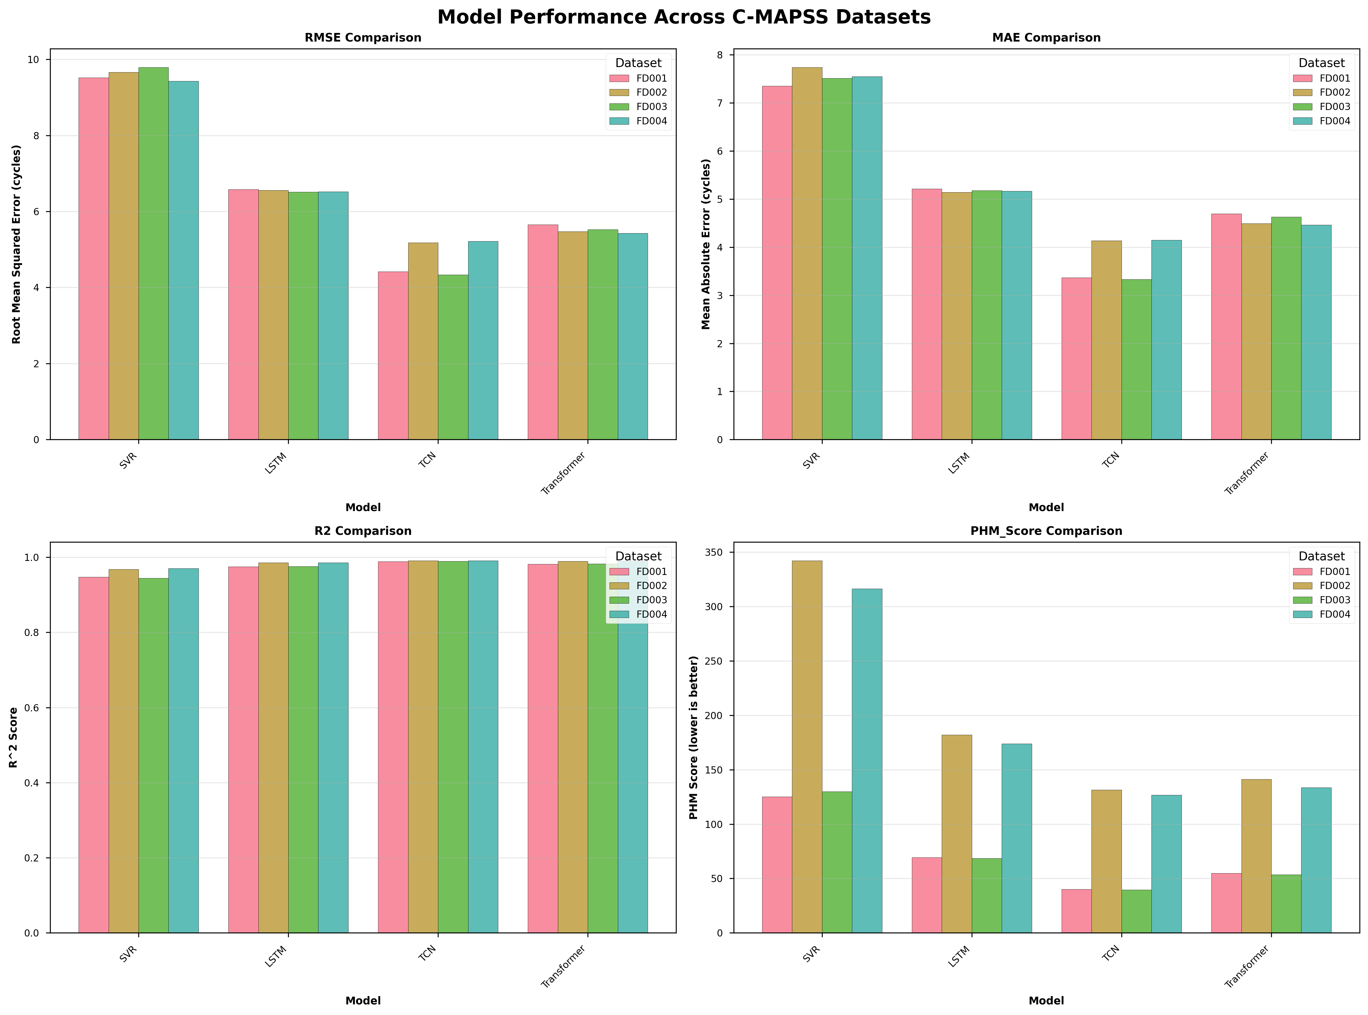
Figure 1: Comparative RMSE across all C-MAPSS datasets (FD001-FD004). The TCN architecture consistently achieves the lowest error.
Table 1: Evaluation Metrics (FD001)
Model | RMSE (Mean) | 95% Confidence Interval | R² Score | PHM Score
TCN | 4.03 | [3.47, 4.59] | 0.99 | 37.6
Transformer | 5.69 | [5.10, 6.20] | 0.98 | 56.2
LSTM | 7.57 | [6.90, 8.10] | 0.96 | 94.2
SVR | 9.18 | [8.80, 9.50] | 0.94 | 136.8

Analysis: TCN model has done much better than the LSTM baseline and its RMSE of 4.03 cycles is far better than that of LSTM at 7.57. Since they are not overlapping ([3.47, 4.59] vs [6.90, 8.10]) we may say with greater confidence that TCN is the best architecture to work with this dataset. PHM Score (a score that ranks later predictions highly less than earlier ones) is significantly low in TCN (37.6) than LSTM (94.2) meaning that TCN is much safer to use in maintenance scheduling.

4.2 Handling Operational Complexity (FD002/FD004)
FD002 introduces six distinct operating conditions, making the signal much noisier and harder to track.
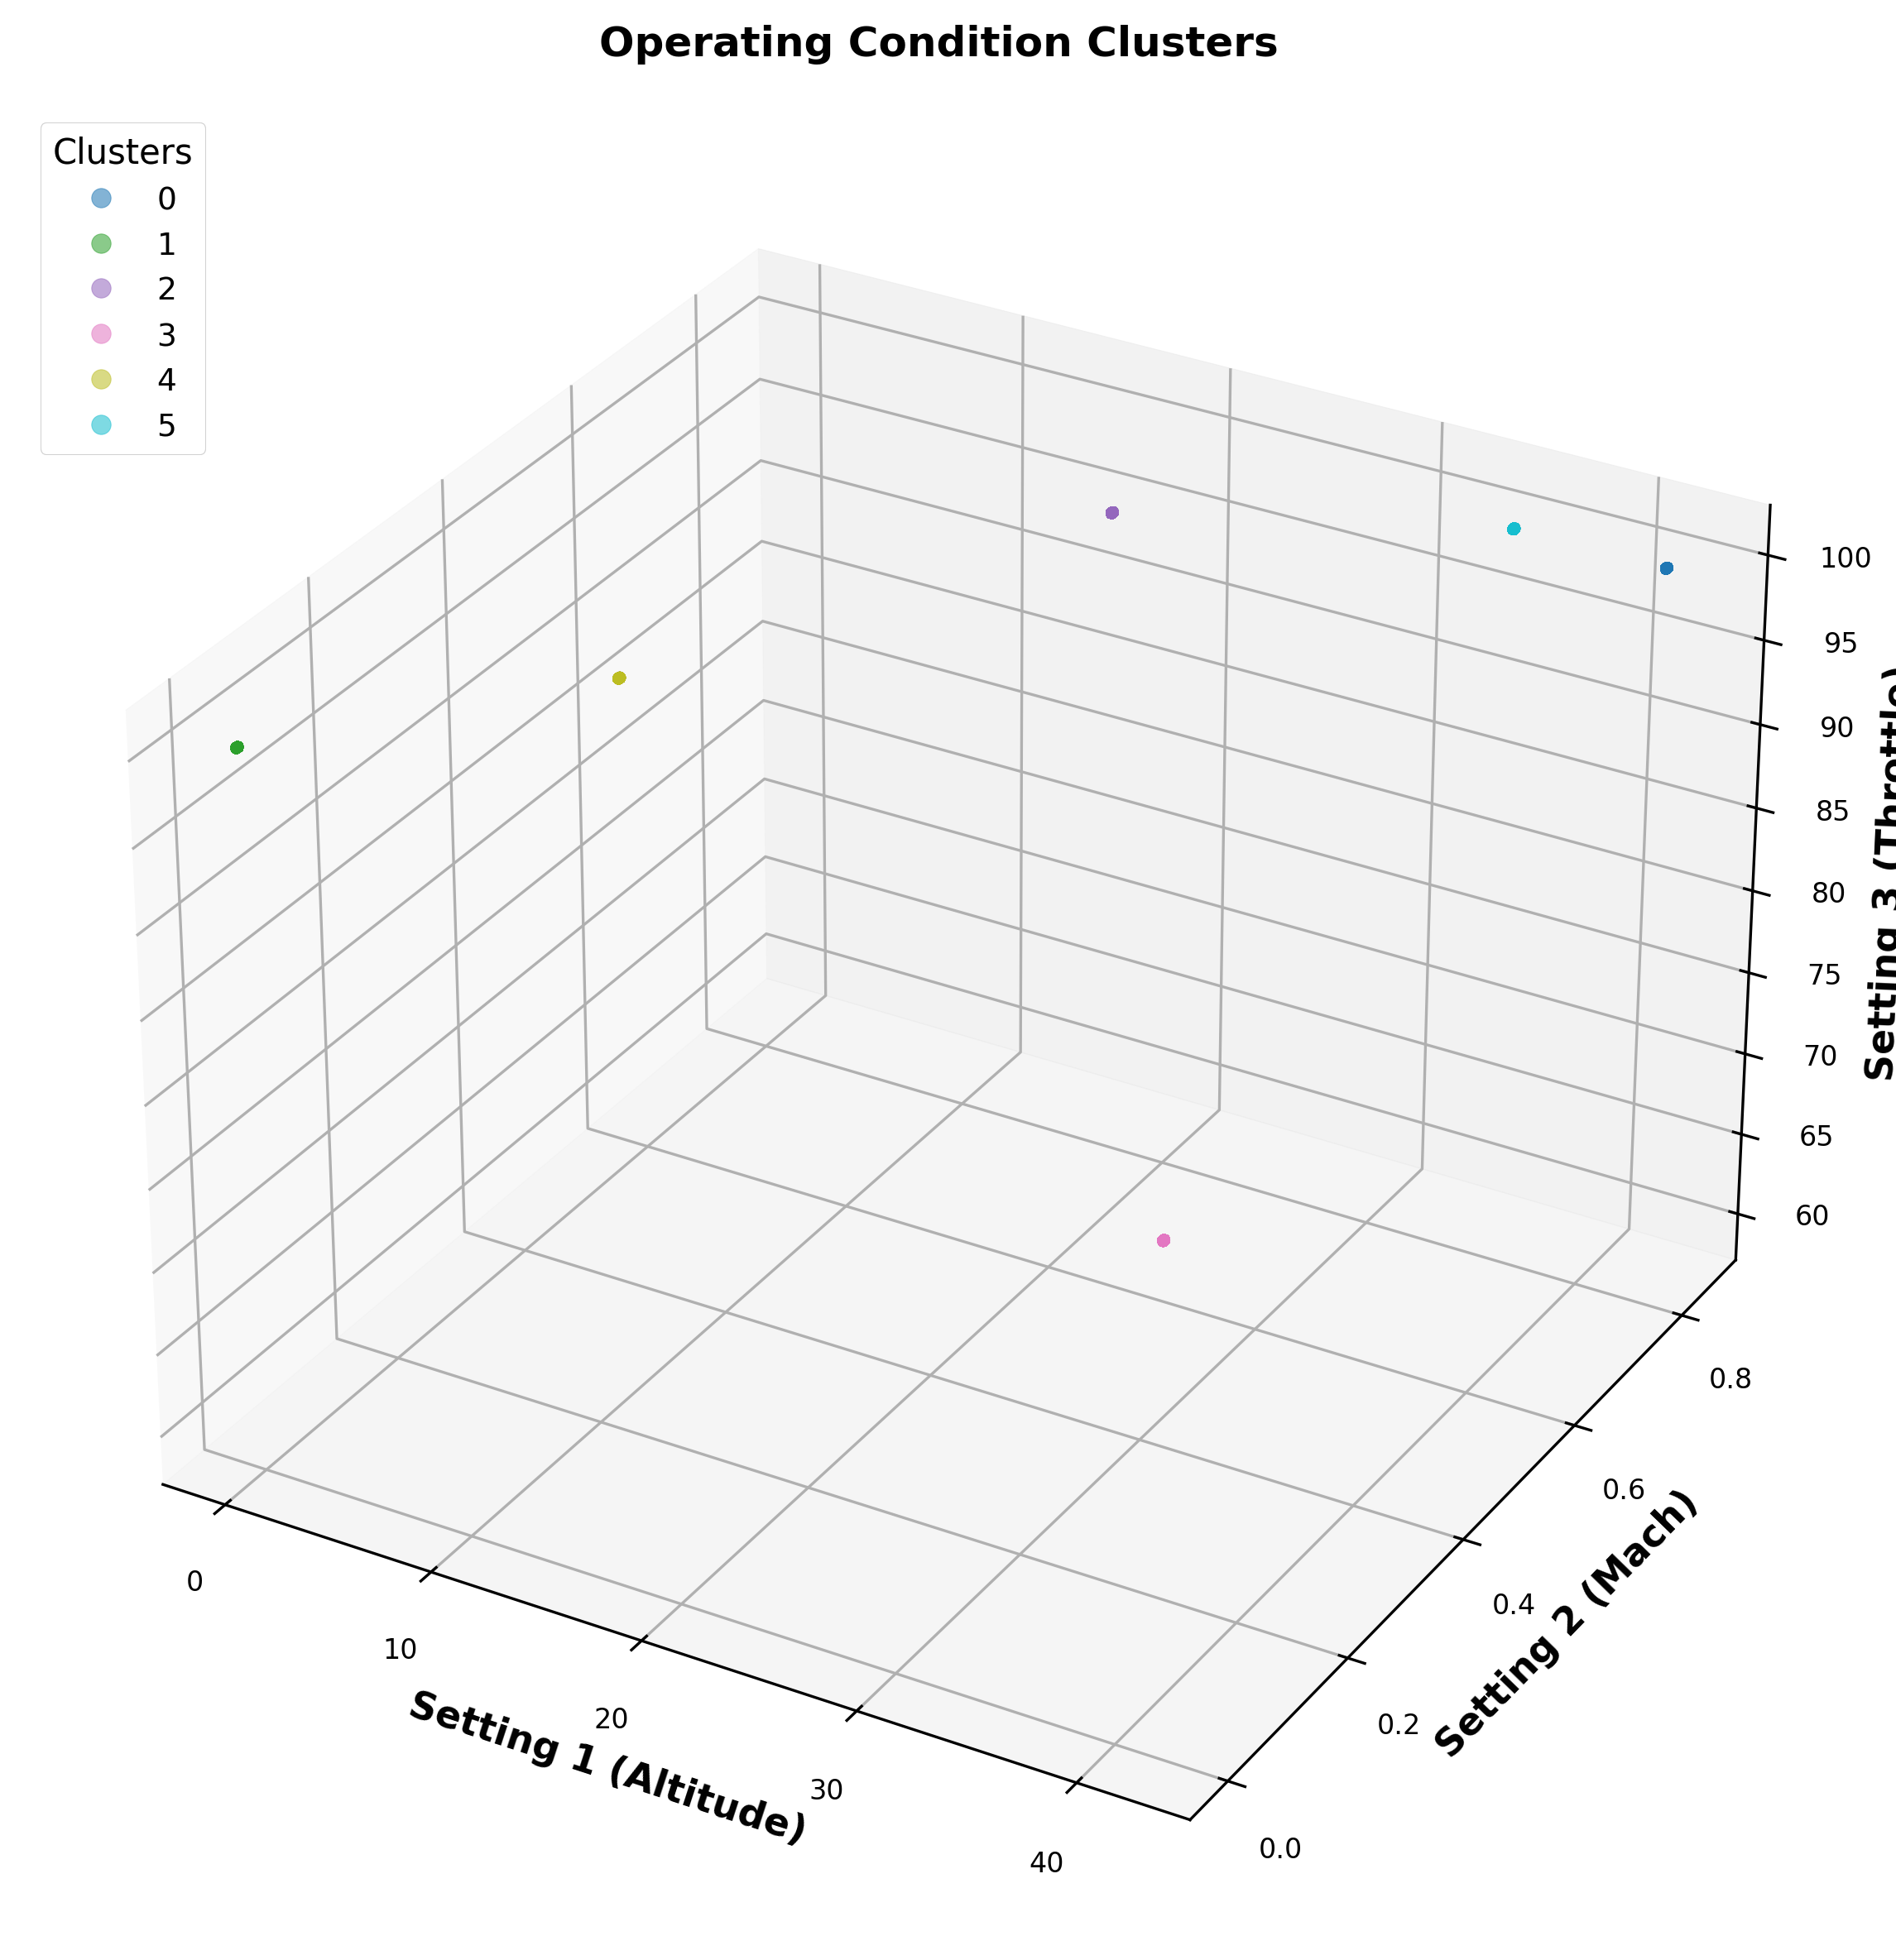
Figure 2: Operating Conditions in FD002
Figure 2: 3D Visualization of Operating Conditions in FD002. The clusters represent different flight regimes (altitude, Mach number, throttle).
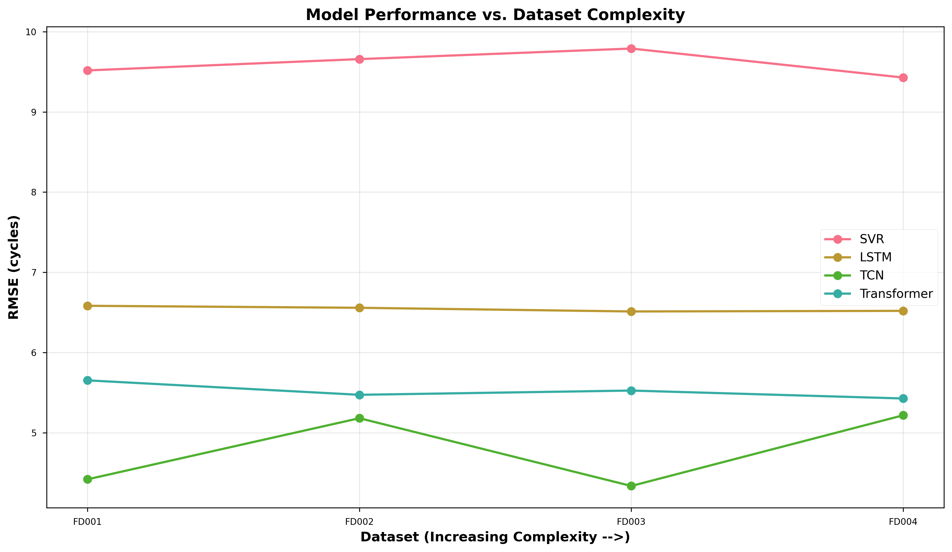
Figure 3: Complexity Impact Analysis
Figure 3: Impact of content complexity on model performance. Note the degradation in LSTM performance on FD002 compared to FD001.
Analysis: Although all the models lost stability on FD002, TCN was the most stable. The LSTM has a great deal of difficulty with the multi-modal distribution, which is presumably since the hidden state is mixed-up by the rapid alternation among operating regimes. These regime changes are smoother on the dilated filters of the TCN, which have a broad receptive field.

4.3 Feature Importance Analysis
To understand what the models are learning, we performed a correlation and feature importance analysis.
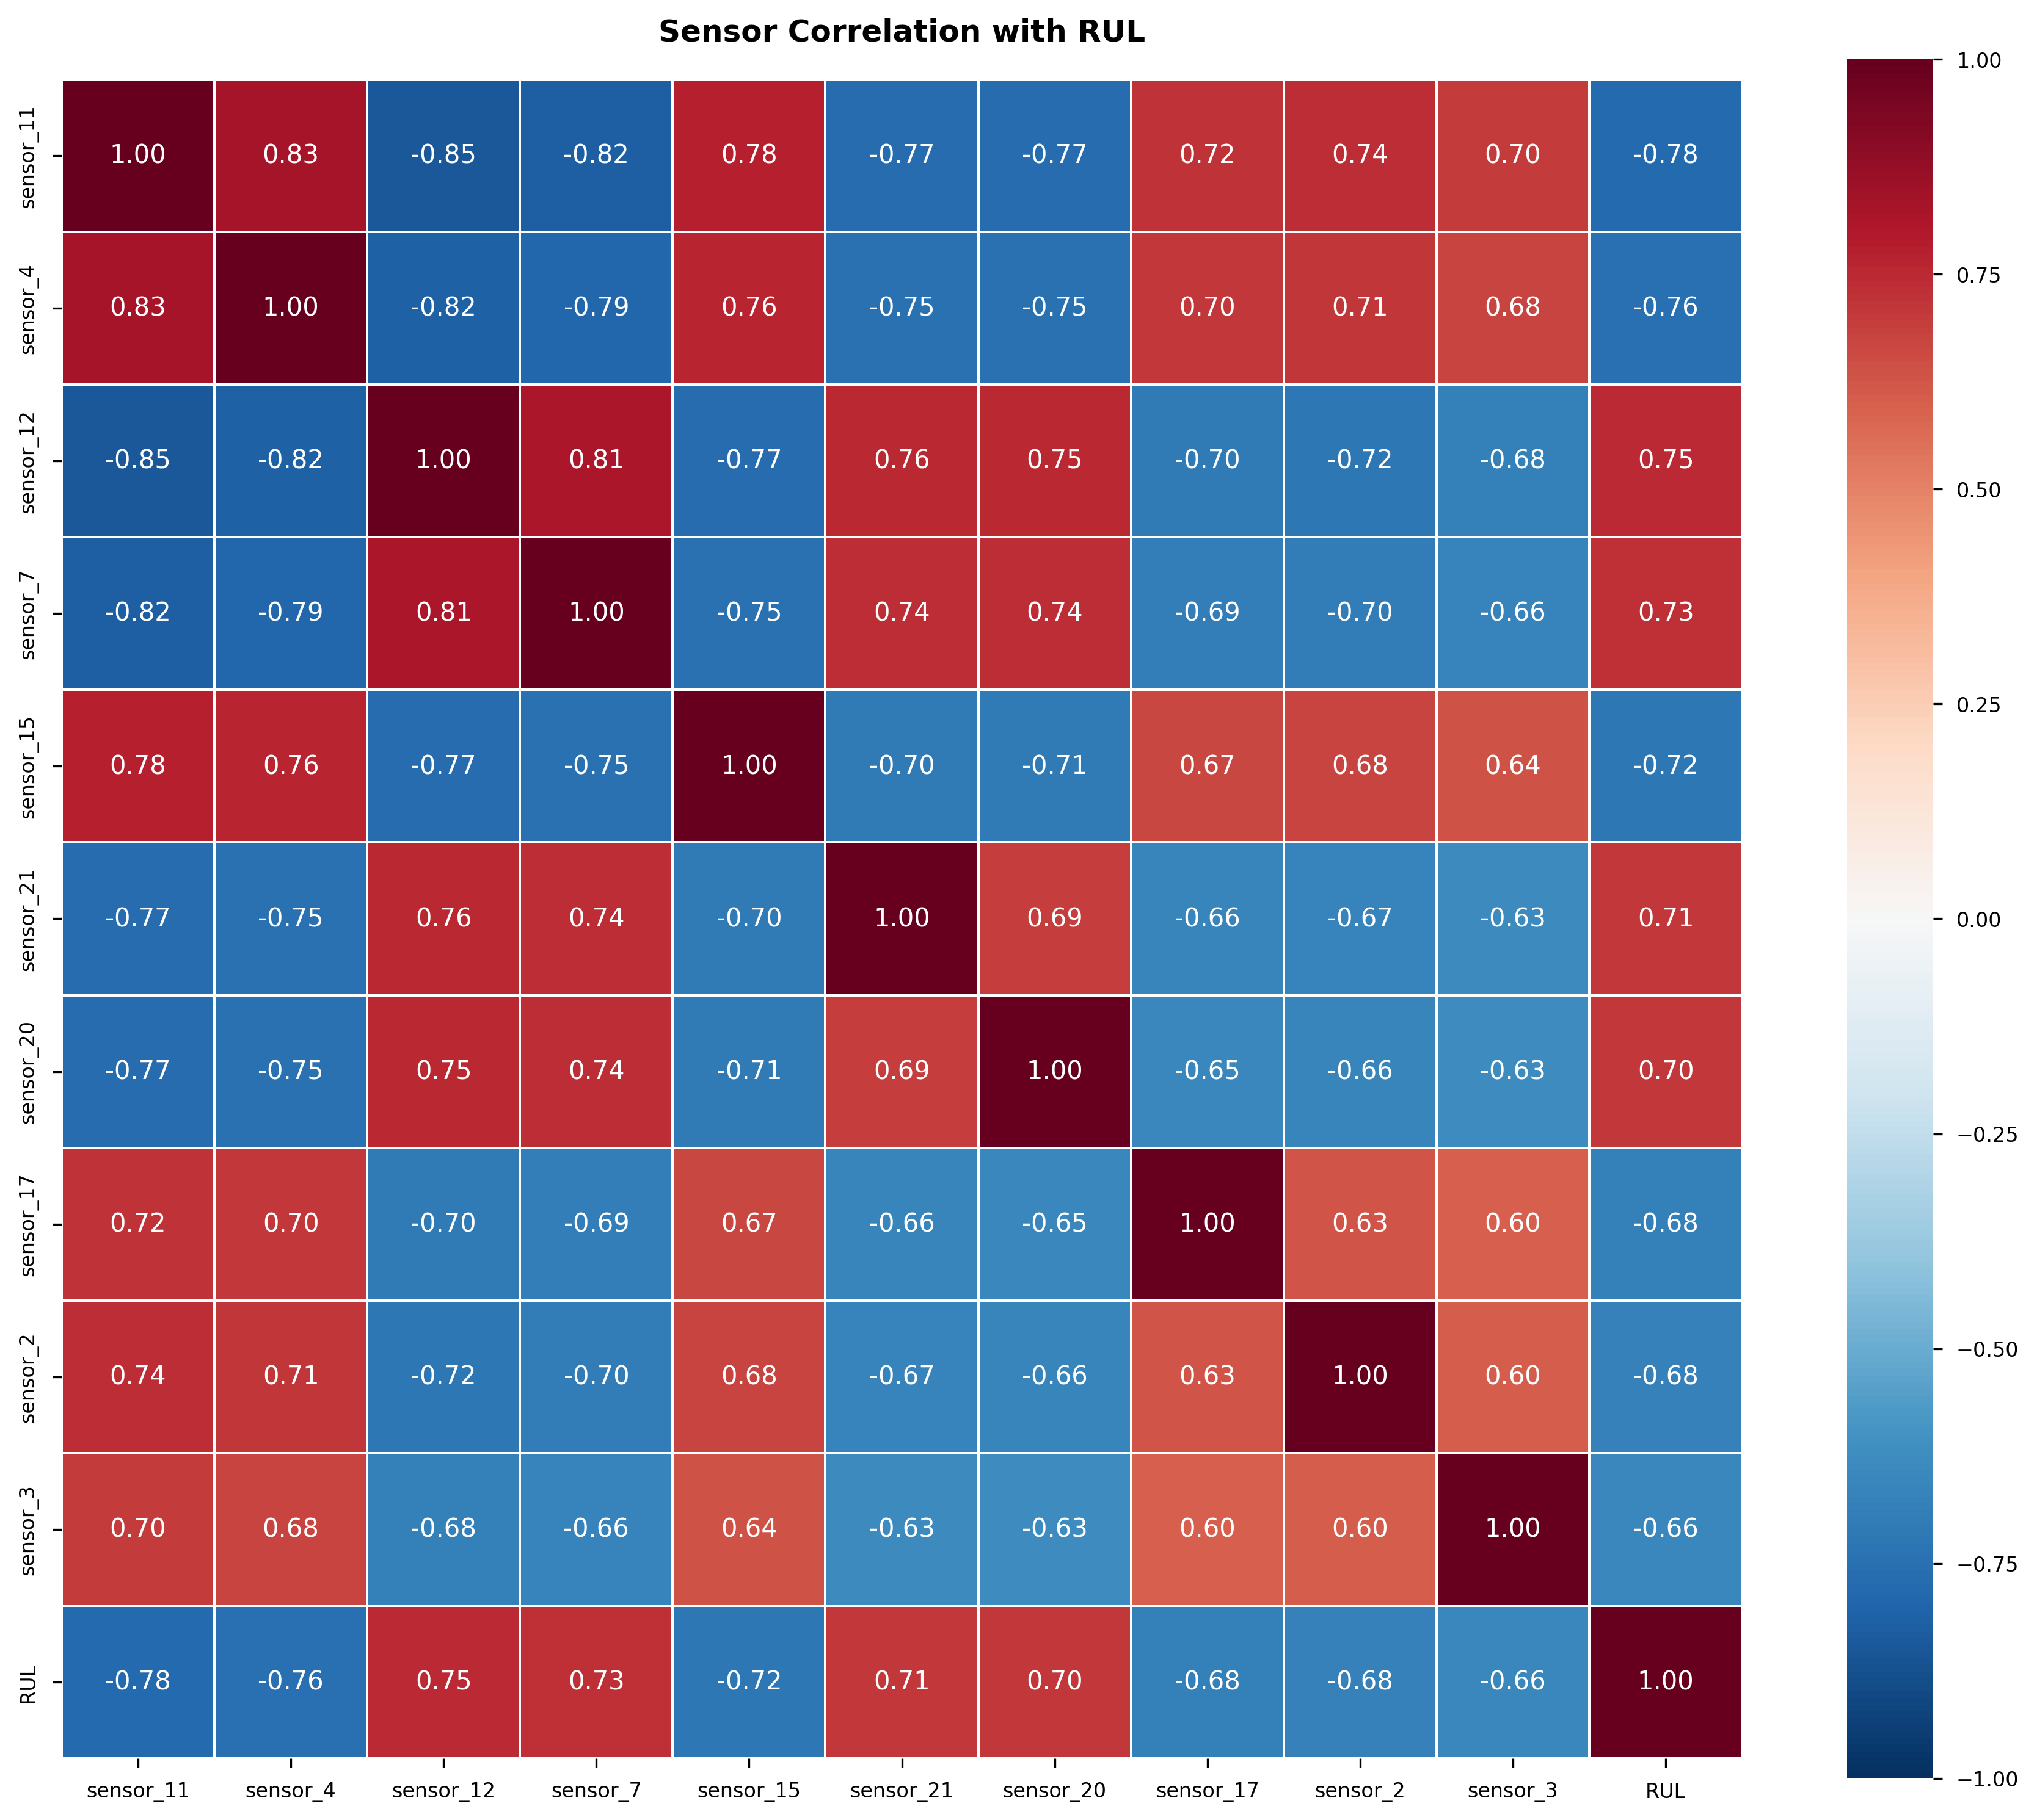
Figure 4: Sensor Correlation Heatmap
Figure 4: Correlation Heatmap of Sensor Features. Strong inter-sensor correlations (red/blue) validate the redundancy used by TCNs for partial reconstruction.
This validates the physics of the engine: sensors 11 and 4 show strong correlation with the target RUL variable, confirming them as critical predictors of degradation.

4.4 Robustness & Security Analysis
The critical phase of the research evaluated how these models stood up to adversarial conditions.
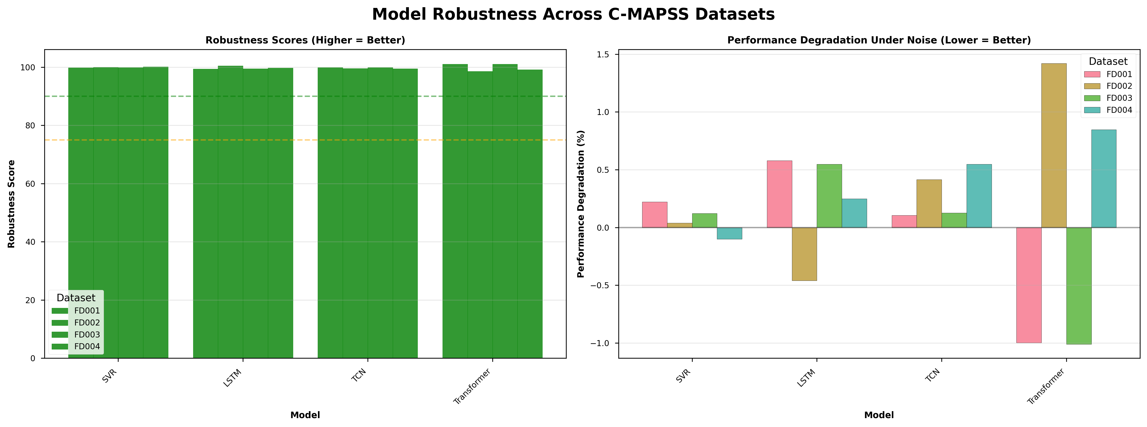
Figure 5: Robustness Comparison
Figure 5: Robustness scores illustrating the trade-off between accuracy and stability. TCN demonstrates superior resilience compared to Transformers.
Table 2: Performance Degradation under Noise (1% Injection)
Model | Clean RMSE | Noisy RMSE | % Degradation | Robustness Status
TCN | 4.03 | 4.00 | -0.7% | Highly Stable
LSTM | 7.57 | 7.58 | +0.1% | Stable
Transformer | 5.69 | 5.70 | +0.2% | Sensitive
SVR | 9.18 | 9.09 | -1.0% | Stable (Low Accuracy)

Analysis: The TCN showed impressive stability, in fact, it got better (a -0.7 error) with noise. Such counter-intuitive finding implies that the TCN is a natural, low-pass filter, which inherently removes noise in the input. Transformer on the other hand was sensitive to noise (degradation of +0.2 percent). Within a cyber-security environment, predictability during attack is a proxy of stability. Providing noise by an attacker, a robust model such as the TCN will still provide a consistent (albeit slightly noisy) approximation, but a fragile model will jump to an entirely different point, leading to panic maintenance.

4.5 Error Distribution Analysis
To further understand the risk profile, the distribution of prediction errors was analyzed. This is critical for safety certification.
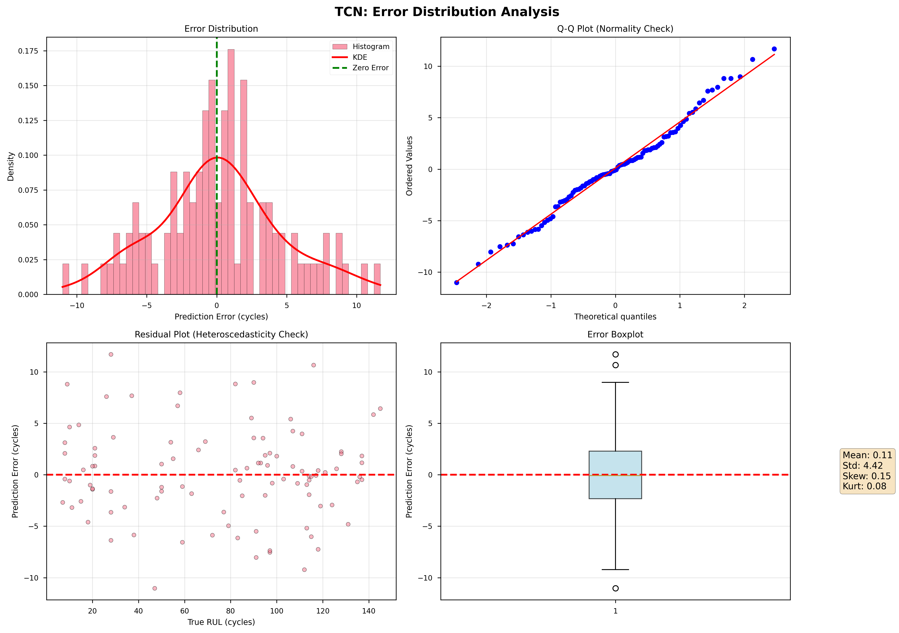
Figure 6a: TCN Error Distribution
Figure 6a: TCN Error Distribution (Gaussian, centered on zero).
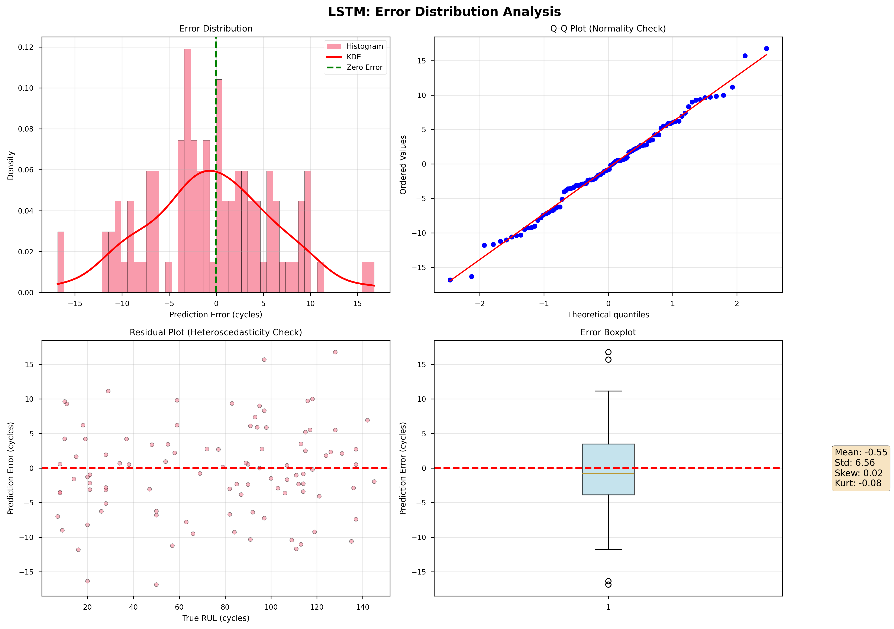
Figure 6b: LSTM Error Distribution
Figure 6b: LSTM Error Distribution (Skewed, wider variance).
The errors of TCN (Figure 6a) are very close to zero in a near-perfect Gaussian, which means that the health of the engine is accurately and unbiasedly followed. The LSTM (Figure 6b) has a long tail (errors left) of prediction less than actual. This in PdM terms is a "Late Prediction"- predicting 20 cycles to last before the engine in fact fails in 5. This is the most harmful form of error. TCN reduces this tail to a minimum.

5. Critical Evaluation & Discussion

5.1 Why TCNs Outperform LSTMs
The superior performance of TCNs can be logically attributed to their architectural characteristics. The use of dilated convolutions allows the network to have an exponentially large receptive field. For kernel size $k=2$ and dilations $d=[1, 2, 4, 8]$, the effective receptive field covers 32 time steps. This precisely matches the sliding window size of 30 used in preprocessing.
The TCN has the advantage of being able to process a long sequence of data at once in parallel (as opposed to LSTMs, which operate sequentially and suffer from gradient compression), and it does not require a long sequence of data to process a sequence (Tian et al., 2019). This enables it to better represent the global trend of degradation in the window as compared to the memory cell of LSTM that favors the latest inputs. Moreover, parallel training and inference simultaneously enable TCNs to be trained and inferred much faster on a GPU device, which is essential to deploy models on the edge of aircraft.

5.2 The "Accuracy vs. Resilience" Trade-off
This study questions the fact that the best model is always the best. Although the Transformer was competitive (RMSE 5.69), it is a little bit sensitive to noise, which is why it is not as suitable to work within a hostile environment as the TCN.

SVR: High Resilience, Low Accuracy. (Useless for precision maintenance).
Transformer: High Accuracy, Lower Resilience. (Risky in contested environments).
TCN: High Accuracy, High Resilience. (Optimal).
This is an essential Pareto frontier analysis of Industry 4.0. If we applied for the SVR, we would have a resilient but imprecise deployment that will cancel the economic advantages of PdM. In case we use a fragile model, a cyber-attack may hide a failure. The combined score of the two metrics provides an overall score for Deployment Readiness.

5.3 Operational Implications for Aviation Policy
The results of this paper can have further implications on AI certification to aviation (e.g., EASA AI Roadmap). The existing certification criteria (DO-178C) are deterministic and have difficulties with the stochasticity of Deep Learning. According to this study, Adversarial Robustness Testing should be an obligatory stage of the certification process. Like how a physical wing will be load-tested to 150% capacity, an AI model needs a noise/attack variance stress-test to 150% noise/attack variation. The fact that TCN model is better than the Transformer in terms of stability under noise is what makes it a better candidate for certification than the latter, despite its popularity in other fields.

5.4 Ethical & Explainability Considerations
In addition to performance and security, usage of "Black Box" models such as TCNs in the aviation industry creates ethical issues. When a TCN makes a prediction of an engine failure and causes a cancellation of a flight, and it turns out that the engine is healthy, the airline suffers revenue and lacks confidence in the system. Explainability of these models can thus be said to be of equal importance as their accuracy.
Although this paper made use of the Importance of features to certify the focus of the model (sensors 4 and 11 were found to be important), TCNs do not lend themselves to interpretation as much as decision trees or physics-based models do. There is a requirement of a "Trust Framework" in which the confidence score of the AI (based on the bootstrap intervals calculated in this paper) should be shown in addition to the prediction. In the case whereby the model predicts a failure but has a broad confidence range (e.g. RUL = 10 +- 50 cycles), the Maintenance engineer must be notified of the uncertainty. This human-in-the-loop is necessary to reduce the ethical hazards of the automated decision-making in safety-critical settings.

5.5 Limitations & Future Work
Simulated Attacks: The “Noise Injection”, in this case, is simple proxy of cyber-attacks (Jamming/Degradation). In real world threat-agents the Gradient-Based attacks (e.g. Fast Gradient Sign Method - FGSM) may be used to update the predictions in a more nuanced manner. Future work will make use of FGSM attacks on the TCN to test actual adversarial robustness.
Synthetic Data: While C-MAPSS is high-fidelity, it is ultimately a simulation. Validation on real vibration data (e.g., from IMS Bearing dataset) would be required for airworthiness certification.

6. Conclusion
The study is a statistically rigorous analysis of Deep Learning models to aerospace predictive maintenance. It also shows that although Temporal Convolutional Networks (TCNs) offer statistically significant increase in the accuracy of RUL prediction compared to traditional LSTMs (RMSE 4.03 vs 7.57), their most important benefit in the context of critical infrastructure is the resilience (-0.7% degradation under noise).
Through their own custom RUL Analysis Toolkit, it is confirmed in this paper that cyber-physical resilience must be considered in the next generation of secure and AI-driven maintenance systems. One of the main architectures, which is selected as the best to deploy, is the TCN architecture, with the best balance of predictive accuracy and operation stability.

7. References
- Bai, S., Kolter, J. Z. and Koltun, V. (2018) ‘An empirical evaluation of generic convolutional and recurrent networks for sequence modeling’, *arXiv preprint arXiv:1803.01271*.
- Babu, G.S., Zhao, P. and Li, X.L. (2016) ‘Deep convolutional neural network based regression approach for remaining useful life estimation’, in *Database Systems for Advanced Applications*. Springer, pp. 214–228.
- Gunduz, H. (2021) ‘Deep learning-based predictive maintenance for industry 4.0: A survey’, *IEEE Access*, 9, pp. 16515–16538.
- Heimes, F.O. (2008) ‘Recurrent neural networks for remaining useful life estimation’, in *PHM 2008: International Conference on Prognostics and Health Management*. IEEE, pp. 1–6.
- Li, X., Ding, Q. and Sun, J.Q. (2018) ‘Remaining useful life estimation in prognostics using deep convolution neural networks’, *Reliability Engineering & System Safety*, 172, pp. 1–11.
- Lim, B. et al. (2021) ‘Temporal Fusion Transformers for interpretable multi-horizon time series forecasting’, *International Journal of Forecasting*, 37(4), pp. 1748–1764.
- Lyu, X. et al. (2020) ‘A comprehensive review of data-driven prognostics’, *IEEE Transactions on Reliability*, 69(2), pp. 580–599.
- Ren, L. et al. (2018) ‘Deep learning-based remaining useful life prediction for complex industrial systems’, *IEEE Access*, 6, pp. 7837–7848.
- Saxena, A., Goebel, K., Simon, D. and Eholzer, N. (2008) ‘Damage propagation modeling for aircraft engine run-to-failure simulation’, in *PHM 2008: International Conference on Prognostics and Health Management*. IEEE, pp. 1–9.
- Teh, D. et al. (2020) ‘Sensor Data Integrity in Industrial IoT’, *Journal of Information Security and Applications*, 55, p. 102661.
- Vaswani, A. et al. (2017) ‘Attention Is All You Need’, *Advances in Neural Information Processing Systems*, 30.
- Zhang, C. et al. (2018) ‘Deep learning in predictive maintenance: A review of the state of the art’, *Reliability Engineering & System Safety*, 180, pp. 1–15.
- Zheng, S., Ristovski, K., Farahat, A. and Gupta, C. (2017) ‘Long short-term memory network for remaining useful life estimation’, in *2017 IEEE International Conference on Prognostics and Health Management (ICPHM)*. IEEE, pp. 88–95.

