<AkiProPlus Information System>

Software Development Plan (Small Project)

Version <1.0>

Team Members: Manasseh Castello ID#: 812004570

Jevon Philip ID#: 812004472

Johann Blaides ID#: 812006000

Lloyd Philbert ID#: 812003893

Revision History

|  |  |  |  |
| --- | --- | --- | --- |
| **Date** | **Version** | **Description** | **Author** |
| 03/10/2014 | 1.0 | First milestone release of Software Development Plan | Lloyd Philbert, Jevon Philip, Manasseh Castello, Johann Blaides |
|  |  |  |  |
|  |  |  |  |
|  |  |  |  |

Table of Contents

1. Introduction 3

1.1 Purpose **Error! Bookmark not defined.**

1.2 Scope **Error! Bookmark not defined.**

1.3 Definitions, Acronyms, and Abbreviations **Error! Bookmark not defined.**

1.4 References **Error! Bookmark not defined.**

1.5 Overview **Error! Bookmark not defined.**

2. Project Overview Error! Bookmark not defined.

2.1 Project Purpose, Scope, and Objectives **Error! Bookmark not defined.**

2.2 Assumptions and Constraints **Error! Bookmark not defined.**

2.3 Project Deliverables **Error! Bookmark not defined.**

2.4 Evolution of the Software Development Plan **Error! Bookmark not defined.**

3. Project Organization Error! Bookmark not defined.

3.1 Organizational Structure **Error! Bookmark not defined.**

3.2 External Interfaces **Error! Bookmark not defined.**

3.3 Roles and Responsibilities **Error! Bookmark not defined.**

4. Management Process Error! Bookmark not defined.

4.1 Project Estimates **Error! Bookmark not defined.**

4.2 Project Plan **Error! Bookmark not defined.**

4.2.1 Phase Plan **Error! Bookmark not defined.**

4.2.2 Iteration Objectives **Error! Bookmark not defined.**

4.2.3 Releases **Error! Bookmark not defined.**

4.2.4 Project Schedule **Error! Bookmark not defined.**

4.2.5 Project Resourcing **Error! Bookmark not defined.**

4.3 Project Monitoring and Control 3

5. Annexes 3

Software Development Plan (Small Project)

# 

# Introduction

The software development plan is mainly focused on collecting the necessary information to initiate, develop, and modify the AkiProPlus project, which was developed to overhaul the existing AkiPro management system from AkiBakery. This overhaul, which tackles issues related to handling invoices, data storage, inventory management, and customer feedback will be governed by the software development plan. Furthermore, this document is divided into several phases which are governed by the needs and deliverables from AkiBakery. To increase the comprehensiveness of the software development plan a section dedicated to definitions, acronyms, and abbreviations will be included. A references section will also be provided to ensure a list of documents referenced throughout the software development plan. To conclude, an overview of the rest of the points of interest in the software development plan is featured.

## Purpose

[Specify the purpose of this **Software Development Plan**. The text below is provided as an example**.** ]

This Software Development Plan aims to collect the necessary information to initiate, develop, and modify the AkiProPlus project. This will be executed by: having the development plan function as the top-level plan used by managers to direct the development cycle and by describing the approach to the development of the new management system. It will be used to direct the project's development from the project's inception (requirements planning) to the launch of the AkiProPlus Project.

Members using this plan will be:

* + The project manager
  + Project team members
  + Company Stakeholders

## Scope

[A brief description of the scope of this **Software Development Plan**; what Project(s) it is associated with and anything else that is affected or influenced by this document. The text below is provided as an example.]

*Justification*

The scope of the Software Development Plan is divided into several phases. These phases are governed by the needs and deliverables obtained from AkiBakery. The needs of the business require an in-depth automated system capable of strengthening core business processes that enable production and distribution.

*Objectives*

Primarily the intended system seeks to rectify issues pertaining to invoicing, data storage, inventory management, and customer feedback. Invoices should be automated and dynamic. To be specific, the system will allow remote use to facilitate purchase order changes in real time. The whole premise of the intended system is efficiency. The goal is optimize the core processes in order to better facilitate executive decision making.

The Objectives can be classified as followed:

Specific

Measureable

Attainable

Realistic

Time Bound

*Description*

The end product of the system will satisfy all functional requirements of AkiBakery.These requirements include automated billing and procurement, CRM features, data storage, data recovery and some measure of interoperability.

This *Software Development Plan* describes the overall plan to be used by the <project name> project, including deployment of the product. The details of the individual iterations will be described in the Iteration Plans.  
The plans as outlined in this document are based upon the product requirements as defined in the *Vision Document*.

## Definitions, Acronyms, and Abbreviations

[This subsection provides the definitions of all terms, acronyms, and abbreviations required to properly interpret the **Software Development Plan**. This information may be provided by reference to the project’s Glossary

* + **AkiPro**: The original management software system used by AkiBakery which will eventually be replaced by the new management system *AkiProPlus*.
  + **AkiBakery**: The name of the bakery using the AkiPro management system.
  + **Activity Diagrams**: Diagrams that tend to show the general flow of logic that has to interact with various activities of the system.
  + **RDBMS**: Relational Database Management System.
  + **Actors**: Usually external entities that are able to interact with the system
  + **Use-Cases:** Written use-cases generally shows how a system’s behavior reacts under various conditions based on the requests from clients.
  + **Entity-Relationship Diagram (ERD):** A detailed view or representation of an ER-Model.
  + **Data-Flow-Diagram (DFD):** A diagram depicting the movement of data between subsequent processes, data stores and entities which are generally external.
  + **Level-0 diagram:** A diagram that represents all of the major systems processes at a much higher level.
  + **Context Diagram:** Shows the systems boundaries, external entities and the major flows between the system and entities of an organization.
  + **Gantt chart:** A Gantt chart is generally a pictorial representation of a project that shows the different tasks that are to be completed within a specific time period.
  + **Work-Break-Down Structure:** This can be defined as incrementally chopping the project into smaller modules so that it can be used more efficiently.
  + **Trigger:** Triggers are basically events that initiates the beginning of a use case.
  + **Rational Unified Process (RUP):** A development methodology which consists of four phases: inception, elaboration, construction and transition.

See the Project Glossary.

## References

[This subsection provides a complete list of all documents referenced elsewhere in the **Software Development Plan**. Identify each document by title, report number if applicable, date, and publishing organization. Specify the sources from which the references can be obtained. This information may be provided by reference to an appendix or to another document.

For the **Software Development Plan**, the list of referenced artifacts includes:

* RUP for Small Projects Website
* Iteration Plans
* Development Case
* Vision
* Glossary
* Any other supporting plans or documentation.

## Overview

[This subsection describes what the rest of the **Software Development Plan** contains and explains how the document is organized. The text below is provided as an example.]

This Software Development Plan contains the following information:

* + **Project Overview** — provides a description of the project's purpose, scope, and objectives.  It also defines the deliverables that the project is expected to deliver.
  + **Project Organization** — describes the organizational structure of the project team.
  + **Management Process** — explains the estimated cost and schedule, defines the major phases and milestones for the project, and describes how the project will be monitored.
  + **Applicable Plans and Guidelines** — provides an overview of the software development process, including methods, tools and techniques to be followed.

# Project Overview

## Project Purpose, Scope, and Objectives

## Project Purpose, Scope, and Objectives

The AkiProPlus project aims to primarily overhaul existing functions (business processes) of the current AkiPro management system and introduce new functions to improve the effectiveness of the improved management system over the previous one. The project ultimately must be able to fully replace the previous AkiPro management system for a new and improved one.

Below in this section is a bullet point list of the functional and non-functional requirements each entity of the new system must be able to fulfill in order for the project to be a success. Some of these functional requirements contain deliverables that are integral to its corresponding functional requirement. These entities include: customers, clerks, the AkiProPlus management system, van drivers, merchandisers, and suppliers.

***Functional Requirements***

**Customers:**

* Customers must be able to gain access to their resources through authentication via a username and password.
* Customers must be able to request for a change of their password if they happen to forget it.
* Customers must be able to request a standing order or order.
* Customers must be able to check their invoices and balances.
* Customers and must be able to cancel orders or standing orders via the system's interface.
* The customer must be able to make phone orders, orders via the use of AkiProPlus web interface and also order via cash payments.
* Customers must be able to request modifications to their standing orders or orders.

**Clerks:**

* Clerks must be able to approve or disapprove a customer's request to make a modification to a standing order.
* Clerks must be able to generate an order based on a customer request for an order.
* Clerks must be able to receive purchase orders from suppliers to either accept or decline a purchase order.
* Clerks must be able to financially clear purchase orders for the suppliers to ship their products to the bakery.
* Purchase orders from the suppliers must be stored in the central database of the AkiProPlus management system in order to keep check of the ingredients the business currently have in stock .

**The AkiProPlus management system:**

* The AkiProPlus management system must be able to provide a customer a new password if the customer happened to forget it.
* The AkiProPlus management system must make provisions for the clerks so they can adjust orders in case there are changes to be made, example return of items and discrepancies in orders.
* **The AkiProPlus management system must provide the bank and suppliers with documents including reports about ...**
* The AkiProPlus management system must provide options for the customer to check the status of their orders made and view their respective balances.
* The AkiProPlus management system must provide the customer with feedback containing information about if the order made was successful and provide options in which transactions can be made via a credit or debit card.
* The AkiProPlus management system must be able to differentiate between the different types of customers who are categorized as daily, weekly and monthly paid customers.
* Once a standing order is approved by a clerk, the AkiProPlus management system must generate a list of the various orders that must be carried out for that particular day.
* The system must be able to update inventory data regarding inventory replenishment based on received goods from suppliers via received purchase orders.
* The AkiProPlus management system must be able to store relevant data of recipes and inventory.
* The AkiProPlus management system must be able to create financial graphs on a timely basis (in real-time).
* The AkiProPlus management system must be able to create weekly reports outlining the status of the inventory.

**Van Drivers:**

* Van Drivers must be able to upload a localized copy of the database management system on their company tablets.
* Van Drivers must be able to synchronize the localized copy of the database management system on their company tablets to the main database management system.
* Van drivers must be able to print invoices.
* Van Drivers must be able to request a copy of a list with the respective orders that must be carried out for a particular route from the system which will be stored their tablets.

**Merchandisers:**

* Merchandisers must be able to upload a localized copy of the database management system on their company tablets.
* Merchandisers must be able to synchronize the localized copy of the database management system on their company tablets to the main database management system.
* Merchandisers must be able to make changes on standing orders using their company tablets.

Merchandisers must be able to indicate to the AkiProPlus management system if certain products are not selling as well as forecasted.

**Management (Department):**

* The Management department must be able to analyze the real-time created financial graphs created by the AkiProPlus management system to assist in decision-making business processes.
* The Management department must be able to access weekly reports outlining the status of the inventory to make the required purchase orders to suppliers for inventory replenishment.

**Suppliers:**

* The Supplier must come with a purchase order to AkiBakery to be accepted and payed by a clerk
* The Supplier must be able to replenish the inventory once the associated purchase order has been accepted and financially cleared.

***Non-Functional Requirements***

The system must be able to fulfill the following non-functional requirements:

* **Shutdown/Crash Recovery Mechanism**: The system must be able to recover from an unexpected shutdown or system crash.
* **Redundant power feeds during power failure**: The system must be able to continue operating during a power outage using redundant power feeds for a minimum of 2 days.
* **User Friendliness**: The system must have a user friendly UI.
* **Maintainability**: The system must be maintainable by database administrators and other qualifiable staff.
* **Adequate security measures**: The system must have adequate means of security (only authorized users have access to certain functions).
* **Cross-platform interoperability**: The system must allow for seamless use between all platforms and devices.

## Assumptions and Constraints

[A list of assumptions that this plan is based and any constraints, for example. budget, staff, equipment, schedule, that apply to the project.]

**Contraints**:

* The project must be completed within a 12 week time period.
* The system must allow staff and customers to be able to have access to the system via any device eg. Tablets, Pc's, Mobile devies etc.
* The tablets which will be given to van drivers should be at a low - cost in order to maintain a profitable state.
* The staff will have to be trained to use the system and the new equipment.
* The conversion process during business operations will be problematic.

**Assumptions:**

* There is a budget allocated towards the training of staff to use the new system.
* The equipment needed such as tablets and mobile devices will be compatible with the system software.
* Customer and supplier account information will be easily transferred to the system files.
* There are backup procedures in place to keep all system data safe.
* New employees would be able to deal with current customers or suppliers easily with accessible information on their accounts.
* Security is in place to protect customer and supplier account information from unauthorized access.

## Project Deliverables

[A list of the artifacts to be created during the project, including target delivery dates. The text below is provided as an example.]

|  |  |  |  |  |
| --- | --- | --- | --- | --- |
| Deliverable Number | Deliverable Title | | Deliverable Date | |
| 1 | | Software Development Project Plan | | 11/2/2014 | |
| 2 | | Requirements Specification | | 15/01/2014---11/2/2014 | |
|  | | Analysis [DFD’s, ERD’s,User interface] | |  | |
| 3 | | Architecture Specification | | 15/2/2014--- 21/2/2014 | |
|  | | Component/Object Specification | | 15/2/2014--- 21/2/2014 | |
| 4 | | Test Plan | | N/A | |
| 5 | | Final Product w/ Demo | | N/A | |

Deliverables for each project phase are identified in the Development Case. Deliverables are delivered towards the end of the iteration, as specified in section *4.2.4 Project Schedule*.

## Evolution of the Software Development Plan

[A table of proposed versions of the **Software Development Plan**, and the criteria for the unscheduled revision and reissue of this plan. The text below is provided as an example.]

The *Software Development Plan* will be revised prior to the start of each Iteration phase.

# Project Organization

## Organizational Structure

[Describe the organizational structure of the project team, including management and other review authorities.]

A layout of the team’s organizational is depicted below. This diagram will show where each member is positioned along with their primary responsibilities. Responsibilities can be changed periodically by the team leader depending on constraints that must be met. For an in depth detailed description of the member’s roles and responsibilities refer to section 3.3.

## External Interfaces

[Describe how the project interfaces with external groups. For each external group, identify the internal and external contact names. This should include responsibilities related to deployment and acceptance of the product.]

**Manager:**

AkiProPlus: The group has had several discussions with the manager of AkiProPlus (Dr. Wayne Goodridge).Through these meetings the functional requirements for the intended system were easily identified. A list of responsibilities were specified as it pertains to the deployment and acceptance of the end product.  
  
The Responsibilities for deployment and acceptance of the product are as follows:

* The systems intended functions must be fully operational upon implementation and deployment.
* Training manuals must be provided to the company’s staff to easy system migration.
* The final cost of the end product must stay within range of the company’s planned budget.
* It is important that the investors are updated regularly on the state of the project’s progression. These updates should include challenge hindrances in development.
* The end product must follow general HCI principles so that the employees feel comfortable using the system.
* The end product must be maintained in a way so that it provides regular version updates which should account for compatibility issues across operating systems.
* There needs to be a comparison of the company’s old system and the new intended system physically. This is done to see if the new system will adhere to the physically infrastructure of the business, if not adaptations will be made to the end product.
* Relevant help desk and online support should be put in place to account for ease of transition into the new system at least for the first few months.

**Merchandisers:**

* Will be able to monitor stock movements provided that all products have been distributed.
* Will be allowed to make changes to standing orders once a product is not selling as it should.
* Are allowed to monitor reports, data trends and also figure analysis using their tablet devices. Using this technology merchandisers will have the ability to detect or spot areas where the demand on certain products lie.
* Using the provided technology Merchandisers can calculate which selling product has the most profit and even monitor customers purchasing habits which will then be inputted into the system so AkiProPlus can make changes which will improve the overall reliability of the business.

**Van drivers:**

* Are allowed to utilize the route information from the tablet to deliver goods to the relevant customers.
* Will be allowed to do on demand sales, this type responsibility belongs to the van driver exclusively.

## Roles and Responsibilities

[Identify the project organizational units that will be responsible for each of the disciplines,

workflow details, and supporting processes. The text below is provided as an example.]

|  |  |
| --- | --- |
| **Person** | **Rational Unified Process Role** |
| *Manasseh Castello, Project Manager* | Responsible as a:  System Analyst  Test Analyst  Conflict manager (for settling conflicts)  Requirements Specifier  Design Reviewer  Test Manager  The project manager works closely with the project leader as both these roles are very similar in leadership, communication, and problem solving disciplines.  The project manager has a closer level of communication with the other organizational units for e.g. conflict resolution. The project manager |
| *Lloyd Philbert, Project Leader* | Responsible as a:  System Analyst  Test Analyst  Customer Relations Manager  Requirements Reviewer  Change Control Manager Requirements Specifier Design Reviewer  Test Manager  The project leader works closely with the project manager as both these roles are very similar in leadership, communication, and problem solving disciplines. The main difference is that the project leader has the authority to review requirements while the project manager does not. |
| *Johann Blaides, Software Engineer* | Responsible as a: Designer Implementer (Coder)  User Interface Designer Software Architect  Software Administrator Code Reviewer Integrator Test Designer  To a lesser extent also does the following: Tester Technical Writer  As the individual responsible for implementing the coding and eventual testing of the main software running the new AkiProPlus management system this individual will have to work closely with the database engineer. This is to make sure the software compenents work seamlessly with the database components of the new management system to avoid inconsistencies in interoperability between the software and database |
| *Jevon Phillips, Database Engineer* | Responsible as a:  Designer Implementer (Coder) Code Reviewer Integrator  Database Administrator  Test Designer  To a lesser extent also does the following roles:  Tester Technical Writer  As the individual responsible for implementing the coding and eventual testing of the database component of the new AkiProPlus management system this individual will have to work closely with the database engineer. |

Anyone on the project can perform Any Role activities.

# 

# Management Process

## Project Estimates

[Provide the estimated cost and schedule for the project, as well as the basis for those estimates, and the points and circumstances in the project when re-estimation will occur.]

## Project Plan

[This section contains the schedule and resources for the project.]

### Phase Plan

**Work Breakdown Structure (WBS)**

|  |  |  |  |  |
| --- | --- | --- | --- | --- |
| Task Name | Duration | Start | Finish | Predecessors |
| Software Development Project | **61 days** | **Mon 9/8/14** | **Mon 12/1/14** |  |
| Planning Phase | **11 days** | **Mon 9/8/14** | **Mon 9/22/14** |  |
| Completion of value chain analysis | 6 days | Mon 9/8/14 | Sat 9/13/14 |  |
| Completion of weighted multi-criteria analysis | 4 days | Wed 9/10/14 | Sat 9/13/14 | 2 |
| Completion of Break-even Analysis | 2 days | Sat 9/13/14 | Mon 9/15/14 | 3 |
| Completion of Baseline Project Plan (BBP) | 5 days | Tue 9/16/14 | Sat 9/20/14 | 4 |
| Completion of Project Scope Statement(PSS) | 5 days | Tue 9/16/14 | Sat 9/20/14 | 5 |
| Completion of Walkthrough of BPP | 3 days | Mon 10/20/14 | Wed 10/22/14 | 6 |
| Analysis Phase | **11 days** | **Mon 9/22/14** | **Mon 10/6/14** |  |
| Requirements Planning | 6 days | Mon 9/22/14 | Sat 9/27/14 |  |
| Requirements Analysis | 3 days | Sat 9/27/14 | Tue 9/30/14 | 9 |
| Completion of Software Development Plan | 11 days | Mon 9/22/14 | Sun 10/5/14 | 10 |
| Completion of Requirements Document | 3 days | Sat 9/27/14 | Tue 9/30/14 | 11 |
| Completion of Specifications Document | 4 days | Mon 9/29/14 | Thu 10/2/14 | 12 |
| Completion of Architecture Specifications Document | 4 days | Wed 10/1/14 | Mon 10/6/14 | 13 |
| Completion of Component/Object Specifications Document | 4 days | Wed 10/1/14 | Mon 10/6/14 | 14 |
| Design Phase | **16 days** | **Mon 10/6/14** | **Mon 10/27/14** |  |
| Completion of Database modeling | 6 days | Mon 10/6/14 | Mon 10/13/14 |  |
| Completion of Forms and Reports | 6 days | Mon 10/13/14 | Sat 10/18/14 | 17 |
| Completion of Dialogues and Interfaces | 7 days | Sun 10/19/14 | Sat 10/25/14 | 18 |
| Completion of Distributed and Internet Systems | 6 days | Mon 10/20/14 | Mon 10/27/14 | 19 |
| Software Implementation Phase | **26 days** | **Mon 10/27/14** | **Mon 12/1/14** |  |
| Pre-alpha software version milestone | 11 days | Mon 10/27/14 | Mon 11/10/14 |  |
| Completion of Master Test Plan | 6 days | Mon 11/3/14 | Mon 11/10/14 | 22 |
| Alpha software version milestone | 6 days | Tue 11/11/14 | Tue 11/18/14 | 23 |
| Beta software version milestone | 7 days | Wed 11/19/14 | Thu 11/27/14 | 24 |
| Completion of Demo | 4 days | Wed 11/19/14 | Sat 11/22/14 | 25 |
| Completion of Installation | 3 days | Sun 11/23/14 | Tue 11/25/14 | 26 |
| Completion of Documentation | 7 days | Wed 11/19/14 | Thu 11/27/14 | 27 |
| Completion of Staff Training | 7 days | Wed 11/19/14 | Thu 11/27/14 | 28 |
| Completion of Support System | 6 days | Thu 11/20/14 | Thu 11/27/14 | 29 |
| Production (Launch) software version milestone | 3 days | Thu 11/27/14 | Mon 12/1/14 | 30 |
| Completion of project Close-Down | **3 days** | **Thu 11/27/14** | **Mon 12/1/14** |  |
| Completion of Evaluation Report | 3 days | Thu 11/27/14 | Mon 12/1/14 |  |

**Timeline or Gantt chart showing the allocation of time to the project phases or iterations**

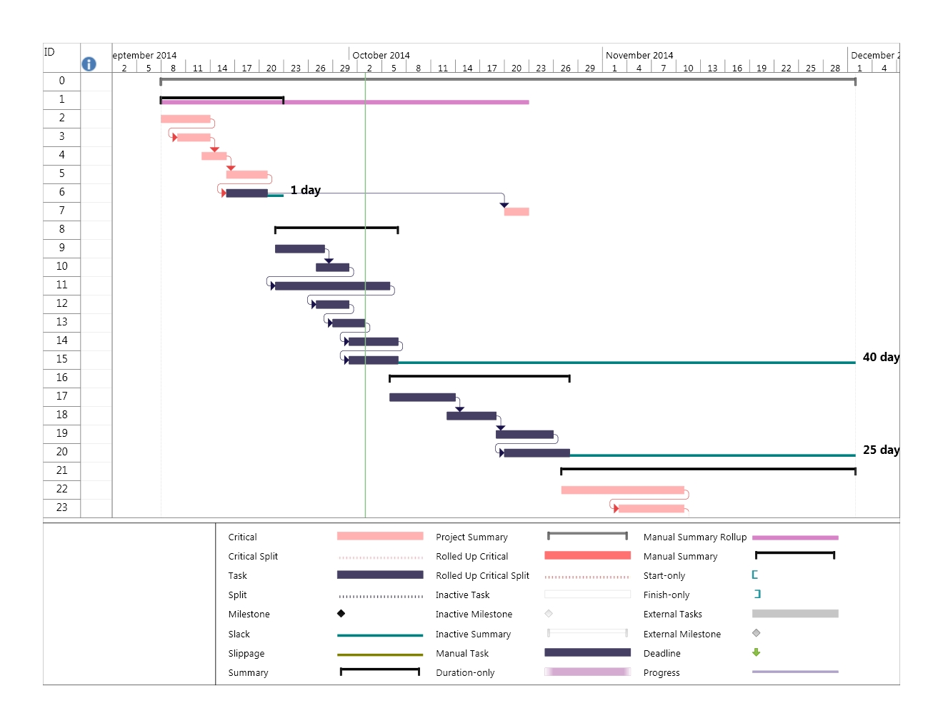

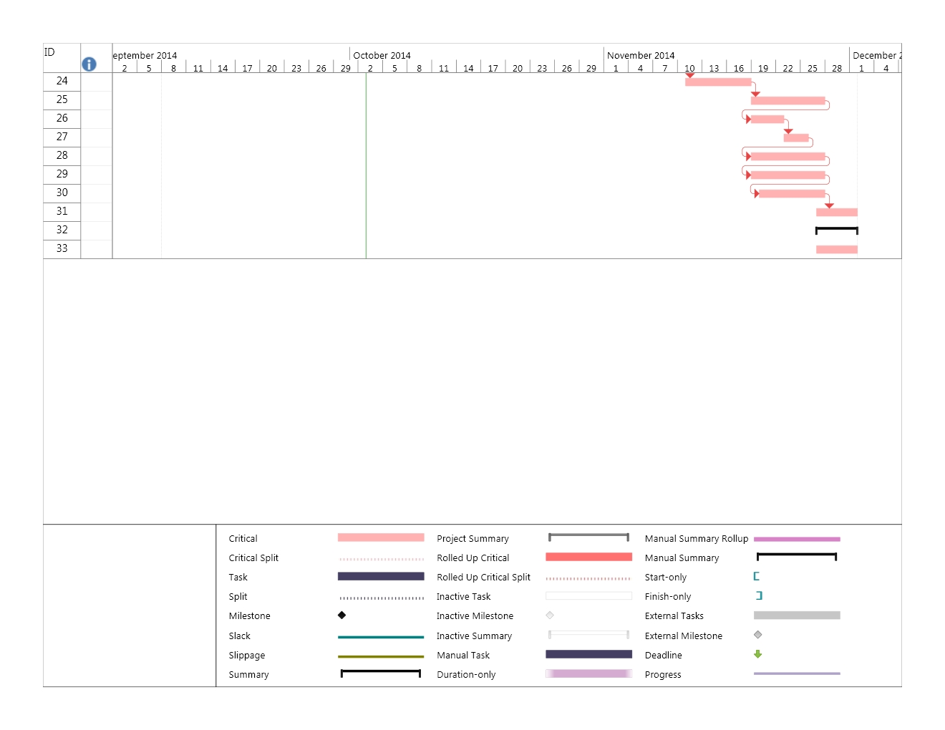

**Identify major milestones with their achievement criteria**

|  |  |
| --- | --- |
| Major Milestones | Achievement criteria |
| Completion of Software Development Plan | Completion of key components that make up the document. The Introduction, Project Overview, Project Organization and Management processes. |
| Completion of Walkthrough of BPP | Completion of Baseline project plan |
| Completion of Component/Object Specifications Documents | All pervious task that exist within in the Analysis phase must be completed in their entirety. |
| Completion of distributed and Internet Systems. | All previous task that exist within the design phase must be completed in their entirety. |
| Project Launch | All previous task that exist within the implementation phase must be completed in their entirety |
| Completion of Evaluation report | Completion of all previous milestones |

Define any important release points and demos.]

[List the objectives to be accomplished for each of the iterations.]

The iterative objectives are as follows:

Requirements Analysis, Software Project Plan, Alpha and Beta versions

Requirements Analysis gives way to functional and non -functional requirements. The objectives that exist within Requirements Analysis are used to identify key business processes and functions.

The Software Project Plan helps to identify detailed objectives that revolve around planning design and implementation which are used to accomplish the end product product/system.

Alpha software version-The main objective of this version is to provide a measure of functionality in an effort to simulate what the end product may look like.

Beta Software Version-The main objective of this version is to provide a stable end product with most of the intended functionalities being fully operational.

### Releases

|  |  |  |
| --- | --- | --- |
| Version number | Function | Description |
| ver. 0.1 | Pre-alpha version of AkiProPlus | This software release represents the first milestone release of the software's development phase.  It functions more as a starting point of what the system should be able to do before alpha testing begins. This is where all the necessary requirements come to together to initiate the software design and software development of the system. |
| ver. 0.5 | Alpha version of AkiProPlus  (for alpha testing) | This software release represents the second milestone release of the software's development phase. This version can still be considered a rough draft of the complete system with minimal stable functionalities. At the end of this phase the software contains all the features needed to perform all its functional and non-functional requirements.  This version contains alpha testing, which uses simulated data to test primarily the workings of each application (function) within the management system. |
| ver. 0.8 | Demo (beta) version of AkiProPlus  (for beta / usability testing) | This software release represents the first relatively stable and third milestone release of the software's development phase. It can be assumed that all the system's basic and advanced functionalities have been implemented to the point where the system is ready for rigorous testing. Due to the potentially buggy and lagged environment of the software these test will prove integral to fixing these problem before the launch version of the software. These test will feature the customer's future software users.  These test, unlike the alpha testing, includes using real data in a real user environment rather than using simulated data. |
| ver. 1.0 | Production (Launch) version of AkiProPlus | This software release represents the last milestone release of the software's development phase where the software is now in the system implementation phase of the SDLC. This version will be used by the customer. Even though this is the launch version of the software there may still lie room for unfixed bugs which may stifle the software's performance. Hence this is not guaranteed to be the last version of the software. |

### Project Schedule

|  |  |
| --- | --- |
| Milestone | Target Date |
| 1). Planning Phase | **08/9/2014 --- 22/9/2014 (2 weeks)** |
| 1.1) Completion of value chain analysis | 08/9/2014 --- 13/9/2014 |
| 1.2). Completion of weighted multicriteria analysis | 10/9/2014 --- 13/9/2014 |
| 1.3). Completion of Break-even Analysis | 13/9/2014 --- 15/9/2014 |
| 1.4). Completion of Baseline Project Plan (BPP) | 16/9/2014 --- 20/9/2014 |
| 1.5). Completion of Project Scope Statement (PSS) | 16/9/2014 --- 20/9/2014 |
| 1.6). Completion of Walkthrough of BPP | 20/9/2014 --- 22/9/2014 |
|  |  |
| 2). Analysis Phase | **22/9/2014 --- 06/10/2014 (2 weeks)** |
| 2.1). Requirements Planning | 22/9/2014 --- 27/9/2014 |
| 2.2). Requirements Analysis | 27/9/2014 ---30/9/2014 |
| 2.3). Completion of Software Development Plan | 22/9/2014 --- 05/10/2014 |
| 2.4). Completion of Requirements Document | 27/9/2014 --- 30/9/2014 |
| 2.5). Completion of Specifications Document | 29/9/2014 --- 02/10/2014 |
| 2.6). Completion of Architecture Specifications Document | 01/10/2014 ---06/10/2014 |
| 2.7). Completion of Component/Object Specifications Document | 01/10/2014 --- 06/10/2014 |
|  |  |
| 3). Design Phase | **06/10/2014 --- 27/10/2014 (3 weeks)** |
| 3.1). Completion of Database modeling | 06/10/2014 --- 13/10/2014 |
| 3.2). Completion of Forms and Reports | 13/10/2014 --- 18/10/2014 |
| 3.3). Completion of Dialogues and Interfaces | 19/10/2014 --- 25/10/2014 |
| 3.4). Completion of Distributed and Internet Systems | 20/10/2014 --- 27/10/2014 |
|  |  |
| 4). Software Implementation Phase | **27/10/2014 --- 01/12/2014 (5 weeks)** |
| 4.1). Pre-alpha software version milestone | 27/10/2014 --- 10/11/2014 |
| 4.2). Completion of Master Test Plan | 03/11/2014 --- 10/11/2014 |
| 4.3). Alpha software version milestone | 11/11/2014 --- 18/11/2014 |
| 4.4). Beta software version milestone | 19/11/2014 --- 27/11/2014 |
| 4.4.1). Completion of Demo | 19/11/2014 --- 22/11/2014 |
| 4.4.2). Completion of Installation | 23/11/2014 --- 25/11/2014 |
| 4.4.3). Completion of Documentation | 19/11/2014 --- 27/11/2014 |
| 4.4.4). Completion of Staff Training | 19/11/2014 --- 27/11/2014 |
| 4.4.5). Completion of Support System | 20/11/2014 --- 27/11/2014 |
| 4.5). Production (Launch) software version milestone | 27/11/2014 --- 01/12/2014 |
| 4.6). Completion of Project Closedown | 27/11/2014 --- 01/12/2014 |
| 4.6.1). Completion of Evaluation Report | 27/11/2014 --- 01/12/2014 |

### Project Resourcing

|  |  |  |  |
| --- | --- | --- | --- |
| Type of Staff | Number of Staff | Special Skills / Experience required | Scheduled for Project Phase |
| Software Developer | 2 | **Skills**: Programming skills in the following programming languages: C++, C# Java, .NET.  **Experience:** Must have at least 3 years experience working on inventory-based management systems. Would be a plus if the programmer has experience in working with RDMS's. | **Software Implementation phase** |
| Database Developer | 2 | **Skills**: Programming skills in the following programming languages: SQL, MySQL.  Must be able to multi-task.  **Experience**: Must have experience in Database Administration, System Administration, web-based technologies, etc. | **Software Implementation phase** |
| Project Manager | 1 | **Skills**: Leadership skills, communication skills, problem solving skills, conflict management, team management, and risk & change management.  **Experience**: Must have at least 5 years of managing experience in a software development environment. | **Throughout the entire software development life cycle.** |
| Web Application Developer | 1 | **Skills**: Programming skills in the following programming languages: Java, HTML, CSS3, JavaScript, JQuery, PHP, MySQL, ASP.NET, etc.  **Experience:** Must have at least 3 years experience in developing database-driven websites, web-apps, etc. | **Software Implementation phase** |
| Systems Analyst | 2 | **Skills**: Analytical skills, problem-solving skills, Programming skills in the following programming languages and programs: SQL, Oracle, Visual Basic, C++, Java, UML. Optional but a plus: SAP ERP systems, web-based technologies.  **Experience:** Must have at least 5 years experience in the profession. | **Analysis, Design and Implementation phase** |
| Information System Planner | 1 | **Skills**: Business analytical skills, communication skills, time management skills, operational knowledge, ICT and procurement skills.  **Experience:** Must have at least 3 years of experience in business analysis, implementing business changes and processes and an extensive understanding of project costing and estimation, information legislation. | **Planning phase** |
| Database Administrator | 1 | **Skills**: Analytical skills, problem-solving skills, organizational skills, Programming skills in the following programming languages: SQL, UNIX,  **Experience:** Must have at least 5 years experience with working in a RDBMS environment and must be familiar with systems administration, information legislation, and working in a team. | **Analysis, Design, and Implementation phase** |

## 4.3 Project Monitoring and Control

**Requirements Management**

The requirements for this system are captured in the section labeled functional requirements and non- functional requirements. Any changes to the requirements are recorded (project status report) and changed manually.

**Schedule and Budget Control**

**The budget of the end system is proposed by the stakeholders. All expenses are logged and stored in a budget report. This report is presented at periodic meetings regarding the progression of the project .Any additional expenses are brought before the stakeholders and discussed. The schedule for the project is divided into milestones, each milestone has a expected delivery date, and within each milestones is a series of task. The schedule denotes who is working on what and when each task is to be performed.**

**Quality Control**

**The quality of the end product is closely monitored through the use of version control. To achieve this seamlessly, GitHub is used to synchronize the product as to passes through different phases in the development cycle. Each phase of the product is worked on by many different people, through GitHub the changes to the product are recorded, this allows for accountability. If there is a problem it can easily be identified, who made the change and what change was made. Another measure of quality control that is implemented is a document known as a time sheet report. The time sheet report will be used to record the amount time that human resources are spending on the project. This report will be compared to the budget report to make sure the allocated time set by the budget is met, it assures a measure of accountability.**

**Reporting and Measurement**

**The amount of money spent will be closely monitored which will be used to generate a budget report. This report will be generated at every major meeting or phase of development.**

**The project status report will show the amount of work completed to date, and risk or changes that were encountered. It will also show any cost or schedule variance. This report will be generated at every major meeting.**

**Time sheet report will be used to record the amount time that human resources are spending on the project. This report will be compare the budget report to make sure the allocated time set by the budget is met, is assures a measure of accountability.**

**Risk Management**

|  |  |  |
| --- | --- | --- |
| Risk Ranking(High, Medium, Low) | Risk Description and impact | Mitigation Strategy/ and /or Contingency Plan |
| 1) Market Risk | * The probability that the system under development does not make a greater return on investment (ROI) than the previous one. * Rise in inflation rates may affect the overall budget of the project thus reducing required resources. * Depending on the state of the economy there may be a rise or drop in demand for the system. * Depending on how well the system performs in its early stages, stockholder may be reluctant to invest any further before the system actually start to produce great results. * Unavailability of raw materials. * Increase in competitiveness in terms of other companies having a more reliable system in place than ours. | * Having extra funds in place can be used as a backup in case the company falls short of money. * Creating connections and also gathering sponsors will help in ensuring the project survival. * By having a disaster recovery plan in place we can reduce the effect that it has on the company. * Making sure that the system performs at its peak can prevent competition in terms of how fast business processes are being carried out. |
| 2) Financial Risk | * Risk concerning the project exceeding the budget's capital from which it was originally intended. * Problems concerning acquiring the right amount of funding in order to purchase proper tools so that team members can complete their tasks appropriately. * There is a risk that the money spent towards the project may be wasted because the system produced did not meet the required standard expected. * The system may actually cost more to maintain than the profit it actually generates. | * By preparing and submitting weekly/monthly reports and documents, we are able to have an idea about the company's current state and thus put measures in place to reduce and advert the occurrence of the problems stated from actually happening. * By having a close client relationship we are able to capture the best requirements and by extension we are able to produce the ideal system in which the client expects. * By preparing a feasibility study we can determine if the proposed system is worth the time, effort and money to invest. |
| 3) Technology Risk | * There is a chance that the tablets purchased were not of good quality which can therefore cause the company a lot of money to fix or replace them. * Making sure that the technology being purchased is compatible with the software which is to be installed. * Being overly dependent on technology in order to complete daily business processes may leave you in an unfavorable position in a case when it actually fails. * With technology comes security and privacy issues. | * By first gathering advice from an IT solutions expert we are able to purchase the right technology to suit the company's need. * By preparing and putting the right fail-safe measures in place, we are able to recover quickly in an event the failure do occur.   Some measures to consider are;   * Generator backup plan * Having more than one internet service provider (ISP) in case the network goes down. |
| 4) People Risk | * Loss of team members can be detrimental especially during critical phases of the project thus requiring more money in order to hire and train new members. * Disgruntled members can steal confidential information about the system and disclose it to other people which can create vulnerabilities to exploit in the system. * Projects that are rushed by team members are doomed for failure. * Poor team communication/ no single point of collaboration | * By letting members sign off on a team contract, in the event that something were to happen we'll actually know who is responsible. * By having a privacy policy in place we can determine what information can and cannot be disclosed to the public. * Peer programming should be encouraged in order to minimize problems in a case where if one team member leaves, the whole team should not suffer as a consequence. * By having regular team meetings, each team member will be on the same page therefore eliminating poor communication. |
| 5) Structure /Process Risk | * Uncertainty that business processes are completed as planned. * Errors that are produced by the system which impacts greatly on daily processes. * Information entered incorrectly into the system (for example standing orders of customers or projected figures for profit increase). * Loss of critical information caused by faulty hardware. | * Implementing proper fail-safe measures can reduce or provide quick recovery from system errors. * Creating multiple backups during non-peak time hours can ensure safety of data. * Using a robust Database Management System (DBMS) can improve system responsiveness and decrease downtime. * Hiring qualified IT technicians to deal with technical issues related to the system can aid in providing smooth recovery. |

**Configuration Management**

**Once a problem is identified it is brought forward to the stakeholders of AkiProPlus or by the stakeholders of AkiProPlus. Depending on the severity of the problem an immediate meeting between respective members and the project team will be called into effect. It is through discussion between technical experts and the stakeholders most problems will be resolved. Some measures may include revisions to the functional requirements or the allocated budget.**

**In regards to retentions polices and backups for the system, a GFS retention method will be implemented. Our technical experts see this as the best option to safely back up all database information as it allows for hierarchical restore points over a long period of time.**

**A disaster recovery plan is used to cover the critical parts of the implemented system.**

**The main threats to the system are as follows:**

|  |  |  |  |
| --- | --- | --- | --- |
| **Critical System** | **Threat** | **Response**  **Strategy** | **Recovery**  **Strategy** |
| **Accounts payable system** | **Server Failure** | **Use of backup server and UPS and at all stations** | **Fix and Replace Servers** |
| **Storage Database** | **Unable to sync the drivers database to the company’s database**  **due to loss of internet** | **Upload data to an offline database** | **Get in contact with local ISP provider.** |

Most of the data will be stored online. The use of the cloud is very important for the synchronization process .The only time data is stored offline is if the cloud service is down. All data is to be saved and stored on hard disk that using the standardized NTFS format.

***Problem Resolution***

The problem resolution plan will be categorized accordingly;

1. Procedure in which the project team will follow for reporting and correcting problems.
   * Problems will be documented using a structured approach and would then then be sent to be reviewed by the team leader. Once the team leader has reviewed the document it will then be assessed and a meeting will be scheduled with the whole team to develop a proposed solution.
2. Approach taken to resolve conflicts locally within the group;
   * Conflicts within the group will be handled by the team leader. Usually the team leader will call for a meeting whereby each member would voice their views and complaints. Once all issues have been voiced, a voting process would then begin thereby selecting the most critical problems that must be dealt with urgently. Once that process is completed a set of proposed solutions would then be developed and the most suitable one would be used.
3. Approach taken to resolve conflicts with the customer;

In a case where the customer and the project team happens to have a disagreement with one another, based on the severity of the problem different approaches will be taken in order to remedy the problem. Some of these steps are follows;

* + A meeting would be scheduled with the client to rectify the current problems. This will be conducted by providing the client with real data (Cost benefit Analysis, feasibility study, etc.) to support our argument and guide the client in choosing the best solution that will benefit him and the company at large.
  + Depending if the problem is not serious, a simple suggestion of what we think is the most appropriate solution should suffice.
  + Contractual disagreements would be generally resolved via negotiations between both parties including the stakeholders. A final decision would then be made to resolve differences and come to terms with the preferred requirements.
  + With regards to schedules that have gone beyond the given time allotted. Contingency measure would be put in place in order to mitigate the event of that happening. Some of these measures that would be put in place is accounting for extra time when creating the Gantt chart so that if a task goes beyond the expected finish date we'll always have until the late finished date meaning the latest date that a specific task should be completed.

# Annexes

[Additional material of use to the reader of the **Software Development Plan**. Reference or include any project technical standards and plans which apply to this project. This typically includes the Development Case, plans for infrastructure, and product acceptance. It also typically includes Programming Guidelines, Design Guidelines, and other process guidelines. The text that follows is provided as an example.]

The project will follow the RUP for Small Projects process, as tailored by the project Development Case.

Other applicable process plans are listed in the references section, including Programming Guidelines.