Image Classification and Object Detection
Assessment Task 2

Leiko Armand Lique Ravelo
Student Number: 26045171
42028 – Deep Learning and Convolutional Neural Network
University of Technology Sydney

Table of Contents
Introduction 3
Level 2 Heading1 3
Level 3 Heading 3
Dataset 3
Level 2 Heading1 3
Level 3 Heading 3

Introduction
Heading levels 1-3 get their own paragraph, as shown. Headings 4 and 5 are run-in headings used at the beginning of the paragraph. Include a period at the end of a run-in heading. Double-space all text, including headings. Use descriptive headings to help readers identify sections of your paper.

Dataset

Image Classification
For the task of image classification, the models were trained on a dataset of varying dog breeds. The dataset contains 1,707 images, split across 10 dog classes namely: Appenzeller, Lakeland Terrier, Leonberg, Samoyed, Weimaraner, Yorkshire Terrier, Affenpinscher, Briard, Otterhound, and Schipperke. Figure 1 shows an example image for each dog class. Figure 1 shows an example image for each dog class in the dataset.
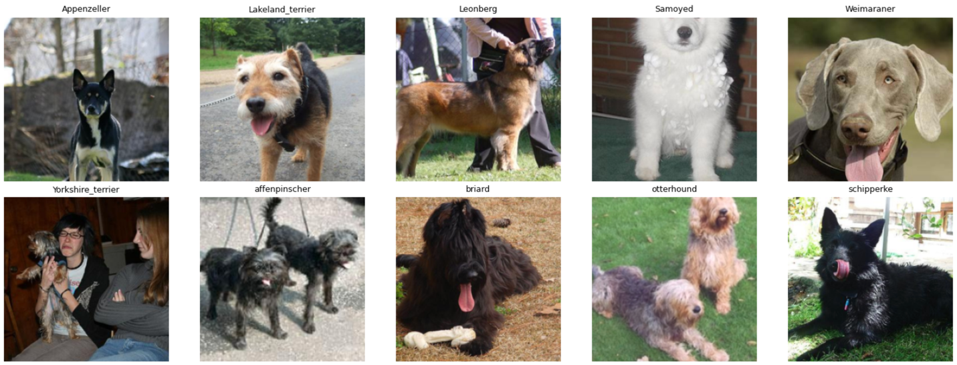
Figure 1: Dogs dataset with one example image per dog class
The data is split evenly, average to about 150-160 images per class, with some classes having above average examples such
Appenzeller
Images
Images

Object Detection
To add a table of contents (TOC), apply the appropriate heading style to just the heading text at the start of a paragraph and it will show up in your TOC. To do this, select the text for your heading. Then, on the Home tab, in the Styles gallery, click the style you need.

Image Classification Models
Heading levels 1-3 get their own paragraph, as shown. Headings 4 and 5 are run-in headings used at the beginning of the paragraph. Include a period at the end of a run-in heading. Double-space all text, including headings. Use descriptive headings to help readers identify sections of your paper.

Baseline Architecture – ResNet-18
To add a table of contents (TOC), apply the appropriate heading style to just the heading text at the start of a paragraph and it will show up in your TOC. To do this, select the text for your heading. Then, on the Home tab, in the Styles gallery, click the style you need.

Customised Architecture – ResNet-18 with (reduced basic blocks)
To add a table of contents (TOC), apply the appropriate heading style to just the heading text at the start of a paragraph and it will show up in your TOC. To do this, select the text for your heading. Then, on the Home tab, in the Styles gallery, click the style you need.

Introduction
Last Name, A. B. (Year). Article Title. Journal Title, Pages #-#. URL. URL.
Last Name, C. D. (Year). Book TitleBook Title URL.
Last Name, D. E., Last Name, F. G. (Year). Report TitleReport Title URL.
Last Name, H. I. (Year, Month Day). Article Title/Headline. Periodical.Periodical.
Organization Name. (Year, Month Day). Webpage Title. URL.

Footnotes
¹For APA reports, add footnotes manually on their own page following references. Do not use the Insert Footnotes method on the References tab as they will not be formatted correctly. For APA formatting requirements, it’s easier to type your own footnote references and notes. To format a footnote reference, select the number and then, on the Home tab, in the Styles gallery, click Footnote Reference. The body of a footnote, such as this example, uses the Normal text style. If you delete this sample footnote, don’t forget to delete its in-text reference at the end of the sample Heading 2 paragraph on the first page of body content in this template.

Tables
Table 1
Table Title
Column Head | Column Head | Column Head | Column Head | Column Head
Row Head | 123 | 123 | 123 | 123
Row Head | 456 | 456 | 456 | 456
Row Head | 789 | 789 | 789 | 789
Row Head | 123 | 123 | 123 | 123
Row Head | 456 | 456 | 456 | 456
Row Head | 789 | 789 | 789 | 789

Note: Place all tables for your paper in a tables section, following references and footnotes. Start a new page for each table, include a table number and table title for each, as shown. All explanatory text appears in a table note that follows the table, like this one. Use the Table/Figure style, available on the Home tab, in the Styles gallery, to get the spacing between table and note. Tables in APA format can use single or 1.5 line spacing. Include a heading for every row and column, even if the content seems obvious. A default table style has been set up for this template that fits APA guidelines. To insert a table, on the Insert tab, click Table.

Figures Title
Figure 1.
Include all figures in their own section, following references, footnotes, and tables. Include a numbered caption for each figure. Use the Table/Figure style for easy spacing between figure and caption.

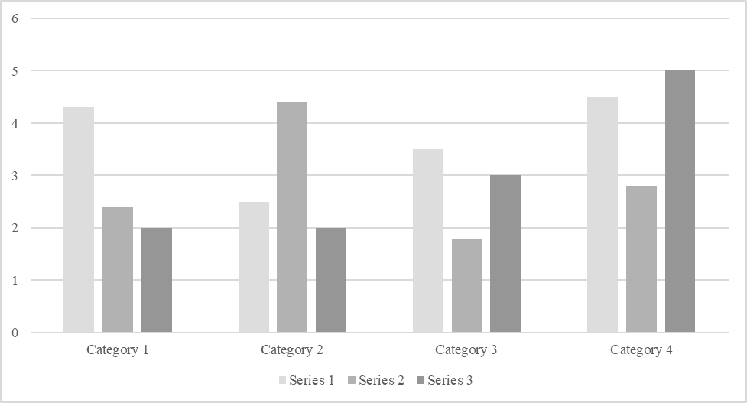

For additional information on APA Style formatting, please consult the APA Style Manual, 7th Edition.

