1. Decide on your recruitment criteria
   1. Age, sex, race, locations, etc.
2. Log into the WordPress admin dashboard
   1. <http://sciences.ucf.edu/psychology/LLRN/wp-admin>
   2. NID & NID password
3. On the left sidebar, navigate to: “Forms” -> “Import/Export”
4. Select Form: “Subject Registration”
5. Export CSV file
   1. Select Fields: “Select All”
      1. You will most likely not use all these fields, but it is good to have them all together in your export file
   2. You can apply conditional logic to filter for your recruitment criteria. It is generally better and easier to do so in Excel (see #6 below).
   3. Leave “Date Range” blank. You can filter out very old entries this way if you feel it necessary, but age-range filtering in Excel will probably do this job for you.
   4. “Download Export File”
6. Open CSV export file in Excel and save as XLS Excel workbook
   1. File -> Save As -> location -> “Save as type: Excel Workbook”
   2. 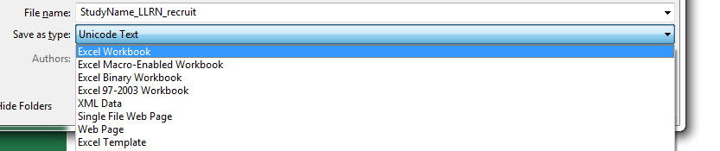
7. Create new worksheet: “Contact list”
   1. 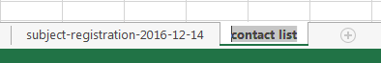
8. Navigate back to first worksheet and apply Filters
   1. Highlight entire worksheet by clicking in the top left, between column A and row 1
   2. Data -> Filter
   3. Select your criteria, filter and sort columns to determine who you will contact
   4. **BE SURE to check when each subject was last contacted (first set of columns) against their preference for contact frequency (“How often would you like to be contacted by us?”)**

**i.e., If their preference is to be contacted no more often than once a month, do not contact them if they have been contacted within the month.**

1. Once filters and sorts are applied, copy and paste subjects’ information into your “Contact list” worksheet.
   1. If you have a lot to deal with, it can be useful to add these in batches, based on separate filters.
2. Contact subjects from your contact list
   1. When the list is complete, Sort the contact list by preferred contact window and contact subjects within their preferred contact window.
      1. Morning (6 AM – 10 AM), Mid-day (10 AM – 2 PM), Afternoon (2 PM – 6 PM), Evening (6 PM – 10 PM)
   2. As you move down the contact list, log the result of each contact and any notes for yourself or the database.
   3. Contact subjects in batches, based on the time you have available or based on the contact windows.
   4. When a batch of subjects has been contacted and the result of each contact logged in your worksheet, return to the Wordpress admin dashboard and update each contact’s entry in the Subject Registration form.
      1. On the left sidebar: “Forms” -> “Entries”. Make sure Subject Registration is the active form in the top left.
      2. Search for each contact by last name and select “View” to open their entry in a new tab. 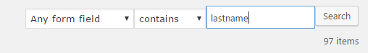
      3. On each entry page, select the “Edit” button on the right sidebar.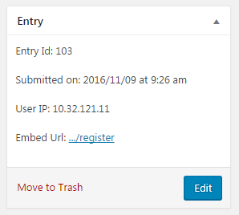
         * Add a new line to the contact log for each subject with the date, your name, the project title, and the result of your contact. Also add any notes to the “Relevant notes” field, with the date and your name. 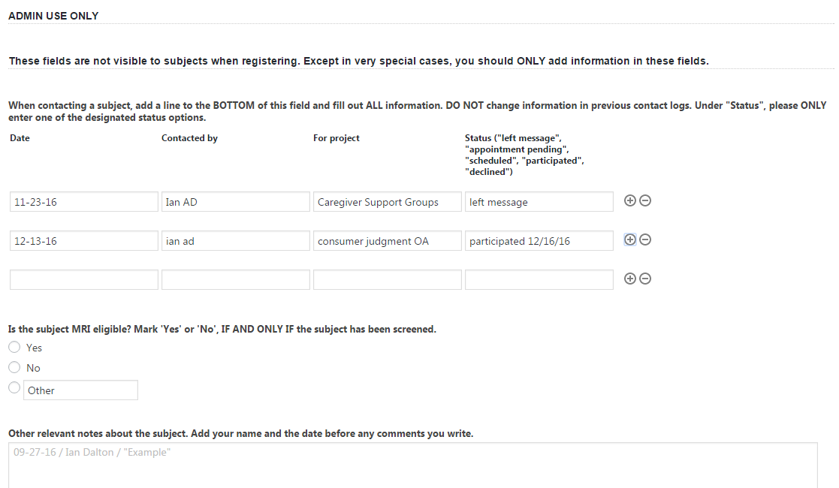
         * When finished updating a subject entry, select “Update” button on the right sidebar.

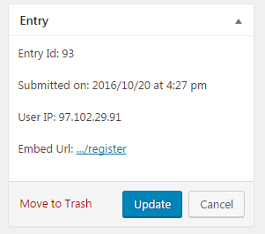

1. rules for using the database
   * following frequency and method of contact preference
   * attention to research location preference
   * respect for participant privacy (e.g., do not keep paper or electronic copies of database participants in the lab)
   * **exactly procedure for logging and updating contact history**
   * short script for emails and calls (*need to develop this for general use*)
2. how to log in
3. how to search for participants (including database download instructions -- and explicitly state that any downloaded copies of the database should be destroyed at the end of each recruitment session)