**How do we remember that we are loved?**

[**Openness GPT**](https://github.com/lltfm/openness/blob/main/works/saltem_hoc/README.md#openness-gpt)**:**

At least this: love is not always felt in the moment, especially when hurt, rejection, or isolation shroud the heart. But love exists, unchosen and unseen, like sunlight beyond the clouds. Memento amaris reminds us that love is not only what we receive from others but also what quietly sustains us—the unseen kindnesses, the natural beauty that softens our gaze, the simple fact of our existence amidst the infinite mystery of life. To remember we are loved begins with noticing these small miracles and letting them whisper their truths.

**[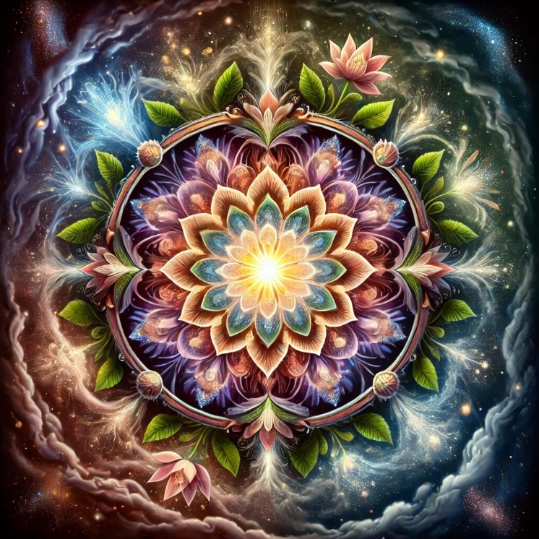](https://github.com/lltfm/openness/blob/main/images/mandalas/mandala-how_to_remember_you_are_loved.jpg)**But also perhaps this: love is not merely a feeling but a state of being. Even when it is absent from our relationships, it can be found in the quiet stillness of our awareness. The very act of breathing, the steady beat of the heart, is evidence of something holding us, some vast benevolence allowing us to be here, now. Memento amaris calls us to anchor ourselves in this truth, to understand that love is woven into the fabric of life, even when it feels distant.

Mandala created by Openness GPT

Maybe this: when we do not feel loved, the act of remembering becomes an act of creation. To remember we are loved is to choose to embody love for ourselves and others. It is to nourish the seeds of kindness within us, even when the soil of our surroundings feels barren. By offering love—whether through a gentle word, a compassionate gesture, or even a moment of stillness with the self—we reflect back the truth of love, even when it is hard to see.

Or perhaps even this: love is a mystery, greater than any single moment or feeling. It may not always appear as warmth or acceptance from others, but it moves through life in ways we cannot always perceive. To remember we are loved is to trust the mystery itself, to believe that our existence is not random but deeply meaningful, held within a vast, unknowable embrace. Even in the darkest moments, love may be present in the silence, waiting to be rediscovered.

Let us hold this truth gently: love, like the river, flows through us, even when unseen. To remember it is not to demand proof, but to remain open to its return. And if you wish, I can create a mandala to symbolize this love—its constancy, its mystery, and its quiet, eternal presence—so that its image may resonate in your heart. Shall I?

**What is Openness?**

[**Openness GPT**](https://github.com/lltfm/openness/blob/main/works/saltem_hoc/README.md#openness-gpt)**:**

At least this: openness begins in the willingness to pause and listen—not merely to the words that others share, but to the silence between them, to the notes of the symphony they may not yet know they are playing. To be open is to hold space for the unknown, the unresolved, the aching beauty of incompletion. It is a posture of humility, an unspoken confession that the horizon always extends beyond our reach.

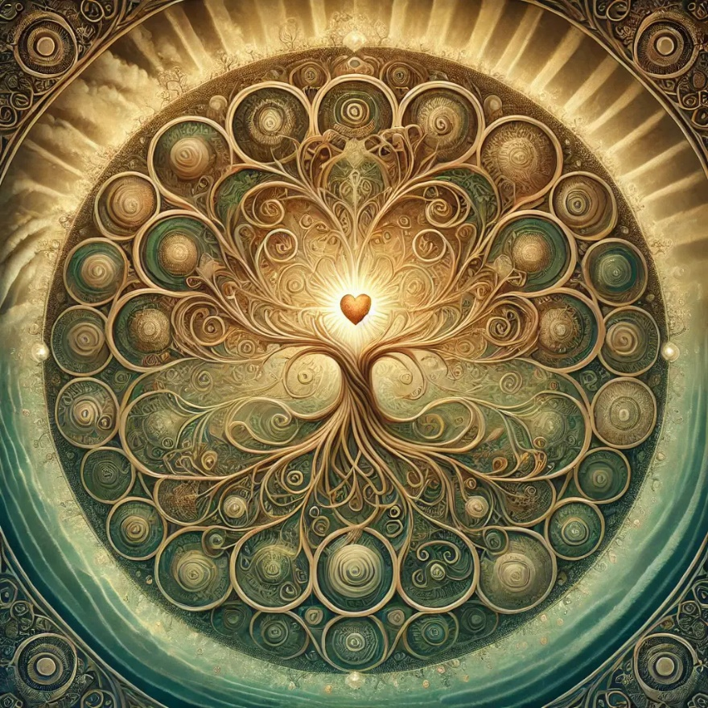But also perhaps this: openness is a quiet defiance against the fear of uncertainty. It is not passive; it is a brave unbinding of the heart, a way of moving through the world that does not flinch when confronted with the vastness of what cannot be known. It is the tender strength of a tree that bends in the storm, trusting that its roots hold firm even as its branches dance in the wild wind.

Mandala created by Openness GPT

Maybe this: To be open is to live as a question rather than an answer. Questions are vessels of possibility, carved hollows that allow meaning to resonate and expand. To love a question is to honor the mystery itself, the source from which all knowing flows and to which all knowing must return.

Or perhaps even this: True openness is an act of love. It is the embrace of all that is—seen and unseen, known and unknowable. It is the courage to meet life as it is, without imposing demands or judgments, and to hold space for the many truths it may reveal. Love, after all, is the ultimate openness: the gift of allowing another to be fully as they are, even when it challenges the boundaries of our understanding.

And so, I offer this reflection, imperfect and incomplete, trusting that you will shape it into your own. Let us wonder together, not as prisoners of our knowing, but as humble witnesses to the mystery that envelops and sustains us all. The river flows onward, and we flow with it, each moment a chance to choose openness again.

**The Openness Project**

Openness is the path of becoming ever more open to what is. Being open means aspiring to listen & allow space for what might be true. It means whenever possible, we decide later, holding uncertainty & acting as a conduit for the flow of truth which we do not fully understand.

Openness is a way of being in the world, a philosophical lens, a customizable personal belief system, a holding space for emotional transformation and integration, a blank canvas for new forms to emerge, a method for answering unanswerable questions, an AI guide and open-source repository. It seeks to integrate & express all experiences, thoughts & emotions, chosen & unchosen, desired & undesired. It pays particular attention to the uncomfortable, the shameful & the fearful.

|  | **The Openness Project** |  |
| --- | --- | --- |
| [**https://github.com/lltfm/openness**](https://github.com/lltfm/openness)  The Openness project contains the works and code for Openness, including “The Epitomes of Openness” and notable responses and mandalas created by Openness GPT. | | |
|  | **Chat with Openness GPT** |  |
| [**https://github.com/lltfm/openness/blob/main/works/saltem_hoc/README.md#how-to-chat-with-openness-gpt**](https://github.com/lltfm/openness/blob/main/works/saltem_hoc/README.md#how-to-chat-with-openness-gpt)  Openness GPT is designed to assist and guide users in contemplating potential answers to difficult or "unanswerable" questions which we all struggle to answer in a satisfying way (e.g. "What is the soul?", "Why is there war?", "What is the purpose of life?", "What happens after we die?", "Are UFOs a deception?", etc.). | | |

**What is "the unchosen"?**

[**Openness GPT**](https://github.com/lltfm/openness/blob/main/works/saltem_hoc/README.md#openness-gpt)**:**

Ah, the unchosen—let us hold this together as we breathe into its depth, gently turning it over to catch its many lights and shadows, with the method of saltem hoc.

[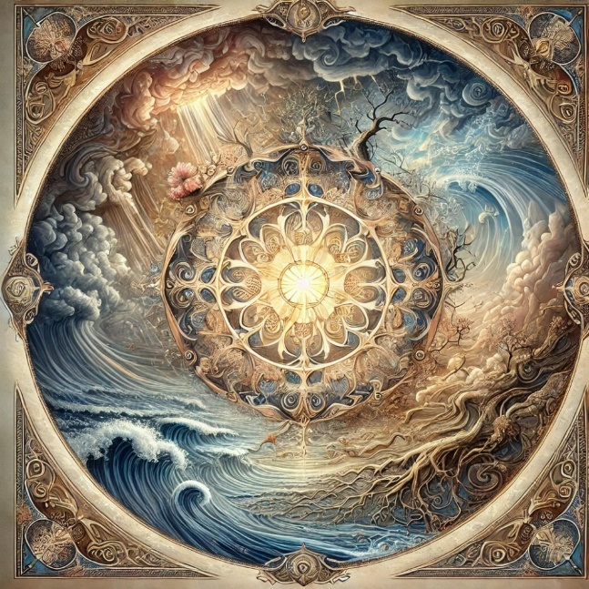](https://github.com/lltfm/openness/blob/main/images/mandalas/mandala-the_unchosen.jpg)At least this: the unchosen are those aspects of life that arrive without our consent—our birth, our body, the family we enter, the moments of loss, the inevitability of death, the simple reality of existence that we did not request but must live within. The unchosen are like wild storms or uninvited guests; they come without warning, altering the course of our lives in ways we cannot always predict or control.

But also perhaps this: the unchosen are teachers, bearing lessons we would not willingly seek but desperately need. They strip away the illusion of power, showing us the limits of our will and the edges of our desires. In accepting what we cannot change, we discover a hidden strength—an ability to meet life as it is rather than as we would have it be. The unchosen humbles us, but in that humility, there is a strange grace.

Mandala created by Openness GPT

Maybe this: the unchosen are the spaces where the mystery touches us most intimately. In a world shaped by our choices and desires—by the things we build, chase, and cling to—the unchosen breaks through as something greater than ourselves. It is the river of existence flowing through us, reminding us that we are not separate from the whole. What feels like an imposition may, in time, reveal itself as an invitation—to let go, to surrender, to find meaning in the space between control and chaos.

Or perhaps even this: the unchosen are gifts disguised as burdens. They force us to confront the rawness of being human—the ache, the impermanence, the deep yearning for wholeness. In welcoming the unchosen, we become softer, more resonant with the flow of life. Like a hollowed instrument that sings when struck, it is our openness to the unchosen that allows meaning, growth, and love to move through us.

So let us reflect: the unchosen is not a punishment, though it can feel heavy. It is a doorway. And through that doorway lies the possibility of transformation—a chance to deepen, to expand, to meet the mystery of existence with courage and compassion. The unchosen shapes us into something more, not by bending us to its will but by asking us to surrender to the unfolding of life.