Name : Ali Abdullah Alkreshan
Id: 421109561

Name: Khalid Albarakh
Id : 431109411

Project: The Evolution of Internet Protocols (HTTP)

1. Annotated Timeline
- 1991 (HTTP/0.9) Tim Berners-Lee made this first version. It was very simple and only sent raw text. It was used just for sharing school papers.
- 1999 (HTTP/1.1) For over 15 years, this version was the standard for the entire web. However, it suffered from a major delay issue known as "blocking." This meant that if just one packet got lost, the entire page would freeze.
- 2022 (HTTP/3) This modern version changes the game by using UDP to speed up connections. It creates a much smoother experience without the old blocking delays. Plus, it automatically encrypts your data to ensure maximum security.
2. Security Analysis
- Vulnerability: HTTP Request Smuggling
- Explanation: This error happens when servers get confused about where a message ends. It occurs because the message headers do not match.
- Real-World Case: Experts at Outpost24 found a way to use this bug. They hid a bad request inside a good one to steal user accounts.
3. Comparative Report
Old HTTP/1.1 is slow because it sends text and waits for data. It is also less safe because it does not hide data by default.
New HTTP/3 is very fast because it uses a modern system (QUIC) that does not wait for lost data. It is also safer because it locks (encrypts) all data automatically.
Real-World Example: Facebook switched to HTTP/3 and got great results. They saw 22% fewer video errors and faster speeds for phone users.
4. references
- Mozilla Developer Network (MDN). "Evolution of HTTP".
- Facebook Engineering. "How Facebook is bringing QUIC to billions".
- Outpost24. "HTTP Request Smuggling to Hijack User Session".

The presentation

Slide 1:
- Topic: The Evolution of HTTP
- 1991 (HTTP/0.9) Tim Berners-Lee made this first version. It was very simple and only sent raw text. It was used just for sharing school papers.
- 1999 (HTTP/1.1) For over 15 years, this version was the standard. However, it suffered from a delay issue known as "blocking." If one packet got lost, the page froze.
- 2022 (HTTP/3) This modern version changes the game using UDP. It creates a smoother experience without blocking delays. Plus, it encrypts data for maximum security.

- HTTP TIMELINE (1991 - 2022)

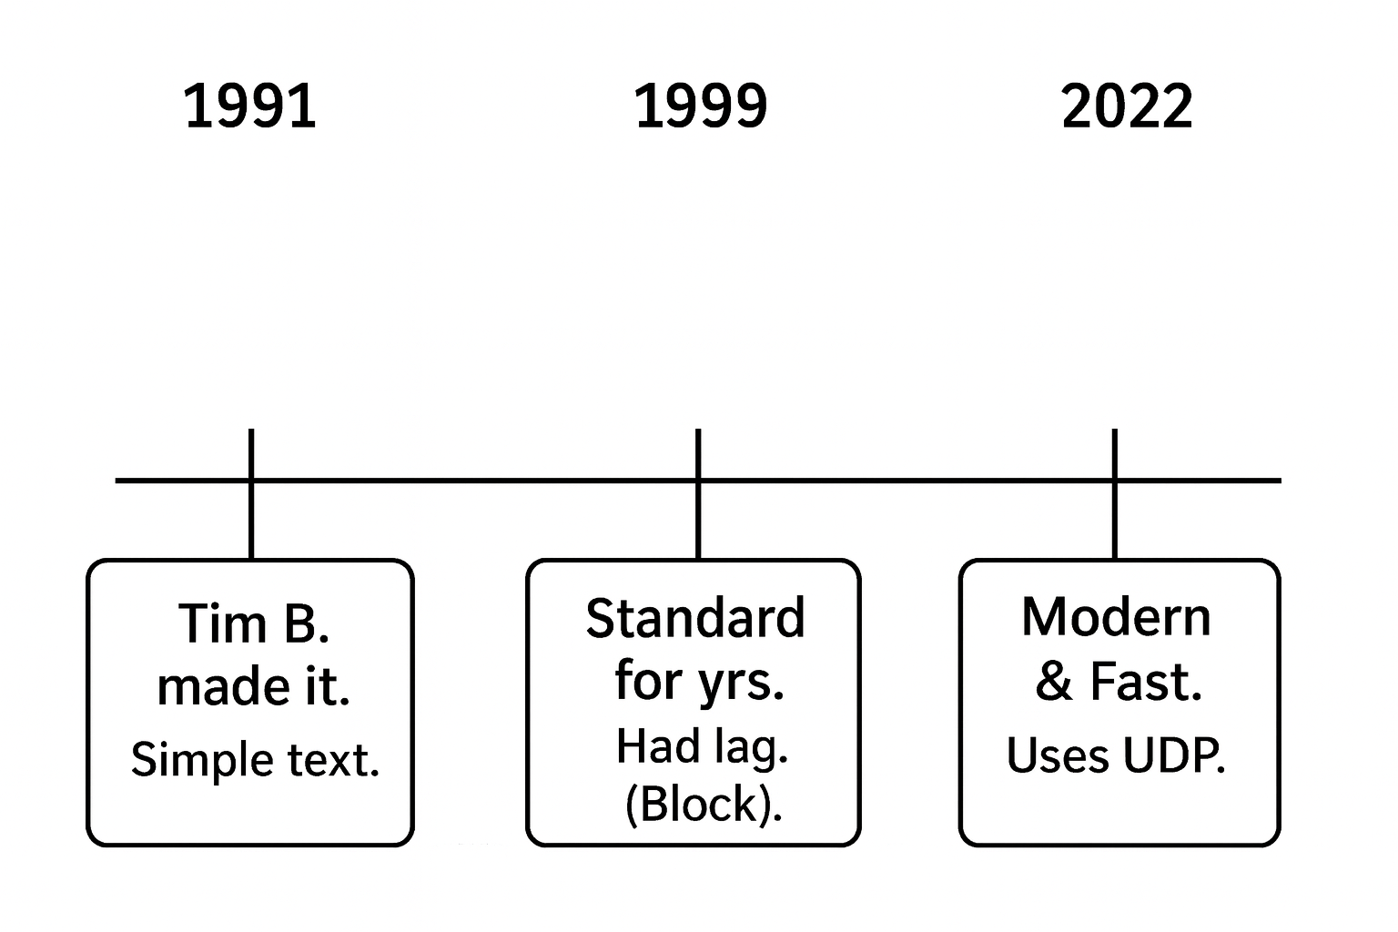

Slide 3: Security Analysis
- Vulnerability: HTTP Request Smuggling
- The Problem: Servers get confused about message length because headers do not match.
- Real Case: Outpost24 researchers used this bug. They hid a bad request inside a good one to steal user accounts.
Slide 4: Comparison
- Old HTTP/1.1:
  - Slow (Blocking issues).
  - Unsafe (Plain text).
- New HTTP/3:
  - Fast (Uses QUIC/UDP).
  - Secure (Encrypted).
- Real Example: Facebook moved to HTTP/3. They saw 22% fewer errors and faster speeds.
Slide 5: References
- MDN. "Evolution of HTTP".
- Facebook Engineering. "How Facebook is bringing QUIC".
- Outpost24. "HTTP Request Smuggling".

