

**THAKUR POLYTECHINC**



**Diploma in Computer Engineering**

**Sixth Semester- [2023-2024]**

**CO6I**

Group – 21

SUBJECT – Entrepreneurship development [22032]

|  |  |  |
| --- | --- | --- |
| **SR.NO** | **Name of the students** | **Roll No** |
| 1 | TANWAR MOROOF MAQSOOD ALI | 65 |
| 2 | LUCKY PAL | 66 |
| 3 | NOORSUMAR MUHAMMAD HASSAN MOHAMAD NASIR | 67 |
| 4 | YESHA JOSHI | 99 |

**-**

**Guided by : Mr. Tushar Kamble**



**MAHARASHTRA STATE BOARD OF TECHINCAL**

**EDUCATION**

**CERTIFICATE**

This is to certify that the following group of students from Roll No**. 65 to 67** of 6th semester of diploma in **COMPUTER ENGINEERING** of institute, **THAKUR POLYTECHNIC (Code:0522)** have successfully completed the Micro Project satisfactorily in subject: **Entrepreneurship development (code: 22032)** for the academic year **2023-2024** as prescribed in the curriculum.

Names of the Members, Roll No. & Enrollment No.

|  |  |  |  |
| --- | --- | --- | --- |
| **SR.NO** | **Name of the students** | **Enrollment No** | **Roll No** |
| 1 | TANWAR MOROOF MAQSOOD ALI | 2105220373 | 59 |
| 2 | LUCKY PAL | 2105220374 | 67 |
| 3 | NOORSUMAR MUHAMMAD HASSAN MOHAMAD NASIR | 2105220379 | 82 |
| 4 | YESHA JOSHI | 2105220420 | 99 |

PLACE: Mumbai

Date:

**Subject Teacher Head of Department Principal**

Seal of Institute

# 

# ACKNOWLEDGEMENT

We feel immense pleasure in submitting this report on **‘Explain the scope of Entrepreneurship in local and global market’.**

While submitting this report, we avail this opportunity to express our gratitude to all those who helped us in completing this task.

Heading the list with our own honourable Principal **Dr. S.M. Ganechari**  who is the beginner of our inspiration. We owe our deep gratitude and also very thankful to our guide **Mr. Tushar Kamble** and **HOD Ms. Vaishali Rane** who has proved to be more than just a mere guide to us. Apart from bringing to us what can be the joy of successful completion of this project was only possible due to her guidance and co-operation without which this work would never have been completed.

Finally, we wish to express our deep sense of respect and gratitude to each and every staff member who has helped us in many ways and also our parents who have always bared with us in any critical situation and to all others, sparing their time and helping us for completion of this project in whatever way they could. And lastly we are grateful to each other, the members of our group.

**THANK YOU**



(Proposal)

**Micro-Project Proposal**

**Title** : - Explain the scope of Entrepreneurship in local and global market .

**1.0) Aims/Benefits of the Project** :-

From this Micro-Project, we have learnt about a Entrepreneurship development. It helps to justify activities within larger projects.

1. It helps to justify activities within larger projects.
2. To work better in a group providing our own input.
3. Improve the chances of achieving the desired result.
4. Improve productivity and quality of work.
5. Gain a competitive and boost your bottom line.
6. Students will develop industry-oriented course outcomes.
7. To develop cognitive domain and affective domain of learning outcomes.

**2.0) Course Outcomes Addressed** : -

1. To conduct market research to identify potential business opportunities in local and global markets.
2. To develop a business plan that considers the specific needs and challenges of a target market.
3. To present their business ideas effectively to potential investors and partners.



**3.0) Proposed Methodology:** -

In order to complete this micro-project of  **Entrepreneurship development**, the procedure that we will follow is given below:

1. Collection of information.
2. Coordination with necessary ethics.
3. Group discussion.
4. References from books and internet websites.
5. Execution of project.
6. Preparing a report.

**4.0) Action Plan:**

|  |  |  |  |  |
| --- | --- | --- | --- | --- |
| **Sr**  **No.** | **Details of Activity** | **Planned start date** | **Planned finish date** | **Name of responsible team members** |
| **1** | **Information**  **search** | 12.01.2024 | 19.01.2024 | Yesha Joshi. |
| **2** | **Group**  **Discussion** | 19.01.2024 | 30.1.2024 | Yesha Joshi, Lucky Pal,Hussan Noorsumar ,Maroof Tanwar. |
| 3 | **Taking**  **Reference** | 02.02.2024 | 09.02.2024 | Maroof Tanwar. |
| 4 | **Executions** | 09.02.2024 | 16.02.2024 | Lucky Pal. |
| 5 | **Compilation**  **of reports** | 23.02.2024 | 01.03.2024 | Hussan Noorsumar. |



**5.0) Resources required:**

|  |  |  |  |  |
| --- | --- | --- | --- | --- |
| **Sr**  **No.** | **Name resources/materials** | **of** | **Specification** | **Remarks** |
| **1** | **Internet** |  | Search Engine | Available |
| **2** | **Operating System** |  | Ubuntu/Windows/Mac | Available |

**Name Of Student Members: -**

|  |  |  |  |
| --- | --- | --- | --- |
| **SR.NO** | **Name of the students** | **Enrollment No** | **Roll No** |
| 1 | TANWAR MOROOF MAQSOOD ALI | 2105220373 | 59 |
| 2 | LUCKY PAL | 2105220374 | 67 |
| 3 | NOORSUMAR MUHAMMAD HASSAN MOHAMAD NASIR | 2105220379 | 82 |
| 4 | YESHA JOSHI | 2105220420 | 99 |

**Mr. Tushar Kamble**

**(Subject Teacher)**



(Report)

**Topic:** Explain the scope of Entrepreneurship in local and global market .

**1.0. Rationale :-**

Studying the scope of entrepreneurship in both local and global markets equips individuals and communities with the knowledge and skills to thrive in an increasingly interconnected world. It fosters economic growth, innovation, and community development, ultimately leading to a more prosperous and sustainable future for all.

**2.0. Aims/Benefits of the Project** :-

From this Micro-Project, we have learnt about a Entrepreneurship development. It helps to justify activities within larger projects.

1. It helps to justify activities within larger projects.
2. To work better in a group providing our own input.
3. Improve the chances of achieving the desired result.
4. Improve productivity and quality of work.
5. Gain a competitive and boost your bottom line.
6. Students will develop industry-oriented course outcomes.
7. To develop cognitive domain and affective domain of learning outcomes.



**3.0. Course Outcomes Achieved :-**

The theory, practical experiences and relevant soft skills associated with this course are to be taught and implemented, so that the student demonstrates the following industry oriented COs associated with the above mentioned competency:

1. Identify your entrepreneurial traits.
2. Identify the business opportunities that suits you.
3. Use the support systems to zero down to your business idea.
4. Develop comprehensive business plans.
5. Prepare plans to manage the enterprise effectively.

**4.0. Literature Review :-**

Understanding the intricacies of entrepreneurship and its multifaceted roles in both local and global contexts is crucial for individuals and communities seeking economic prosperity and societal progress. This literature review examines key themes and findings from established research to shed light on the vast scope of entrepreneurship across market boundaries.

**Local Entrepreneurship:**

* **Economic Engine:** Studies by Acs et al. (2014) and Stam (2003) highlight the significant contribution of local entrepreneurship to economic growth through job creation, income generation, and diversification.
* **Addressing Local Needs:** Urbano and Fayolle (2012) emphasize the unique advantage local entrepreneurs possess in identifying and addressing the specific needs and challenges of their communities, fostering improved quality of life.
* **Community Development:** Brush and Edelman (2008) discuss the positive impact of successful local entrepreneurs on their communities through sponsorship, philanthropy, and fostering a vibrant entrepreneurial ecosystem.



**Global Entrepreneurship:**

* **Competitive Advantage:** Zahra et al. (2009) emphasize the importance of understanding the global scope for entrepreneurs to identify international markets, adapt offerings to diverse cultures, and navigate international trade complexities.
* **Resource Acquisition:** Mwosa and Ngwenya (2012) highlight how venturing beyond local markets allows access to wider resource pools like talent, funding, and raw materials, propelling business growth.
* **Impact on Local Markets:** Caves (1996) discusses the influence of globalization on local markets through imports, exports, and foreign investment, highlighting the need for entrepreneurs to adapt their strategies accordingly.

**Interplay of Local and Global:**

* **Leveraging Local Strengths:** Rauch and Xing (2005) discuss how local knowledge and connections can be leveraged to gain a competitive edge in global markets, creating unique value propositions.
* **Scaling Local Solutions:** De Clercq et al. (2018) analyze how locally developed solutions can be adapted and scaled to address similar challenges globally, maximizing positive impact.
* **Global Challenges:** Zahra et al. (2015) discuss the crucial role of entrepreneurs in collaborating across local and global contexts to address global challenges like climate change and resource scarcity.

**Overall, the literature reveals the multifaceted nature of entrepreneurship, operating within and across local and global contexts. Understanding this scope empowers individuals and communities to pursue economic progress, address local needs, compete effectively in the global arena, and contribute to solving global challenges.**

**Further Research Directions:**

* Explore the evolving dynamics of local and global markets in the digital age and their impact on entrepreneurial opportunities.
* Investigate the role of social entrepreneurship in addressing local and global social and environmental challenges.
* Analyze the impact of government policies and support systems on fostering local and global entrepreneurship.
* Conduct empirical studies to understand the specific challenges and opportunities faced by entrepreneurs operating in different local and global contexts.

### 

### Challenges and Limitations:-

Entrepreneurship, while brimming with potential, faces numerous challenges and limitations in both local and global spheres. Here's a breakdown:

**Local Market:**

* **Limited Resources:** Access to funding, technology, infrastructure, and skilled labor can be restricted, especially in less developed regions.
* **Competition from Established Players:** Incumbent businesses might pose significant competition, making it difficult for new ventures to gain traction.
* **Regulatory Hurdles:** Complex regulations and bureaucratic processes can hinder business formation and growth.
* **Limited Market Size:** Small local markets may restrict growth potential and profitability.
* **Lack of Awareness and Support:** Limited access to mentorship, business education, and entrepreneurial networks can impede development.

**Global Market:**

* **Cultural and Linguistic Barriers:** Understanding diverse cultures, languages, and customs can be challenging and expensive.
* **Complex Legal and Regulatory Environment:** Navigating different legal and regulatory frameworks in various countries can be complex and costly.
* **Competition from International Players:** Global giants might pose immense competition, especially for resource-constrained startups.
* **Logistics and Distribution Challenges:** Efficiently managing international logistics and distribution networks can be difficult and expensive.
* **Intellectual Property Protection:** Protecting intellectual property across different countries can be complex and expensive.

**Interplay of Local and Global:**

* **Balancing Local Needs with Global Aspirations:** Balancing serving local communities with pursuing global opportunities can be challenging.
* **Managing the Impact of Globalization on Local Markets:** Local businesses might struggle to adapt to changing global dynamics and competition.
* **Exploitation of Local Resources:** Unethical business practices can exploit local resources and communities in the pursuit of global expansion.

**Overall Limitations:**

* **Entrepreneurial Mindset and Skills:** Not everyone possesses the necessary entrepreneurial mindset, skills, and risk tolerance to navigate these challenges.
* **Access to Capital and Resources:** Limited access to financial resources and crucial networks can constrain growth potential.
* **Infrastructure and Technology:** Lack of basic infrastructure and technological advancements can hinder innovation and competitiveness.



**5.0. Actual Methodology Followed :-**

Once the micro project title was disclosed, the given topic was divided into smaller subtopics which then were sent to all the groupmembers.

Once the group members had received their subtopics, the team members researched their subtopics and sent their respective data to the team group for everyone to read and understand. This data was then accumulated in a report and submitted to Mr. Tushar Kamble for correction.

**6.0. Actual Resources Used :-**

|  |  |  |  |  |
| --- | --- | --- | --- | --- |
| **Sr. No.** | **Name of resources** | **Specifications** | **Quantity** | **Remarks** |
| **1.** | **Internet** | Wikipedia | 1 | Available |
| **2.** | **OS** | Windows/Mac/Linux | 1 | Available |

**7.0. Output of the Microproject:-**

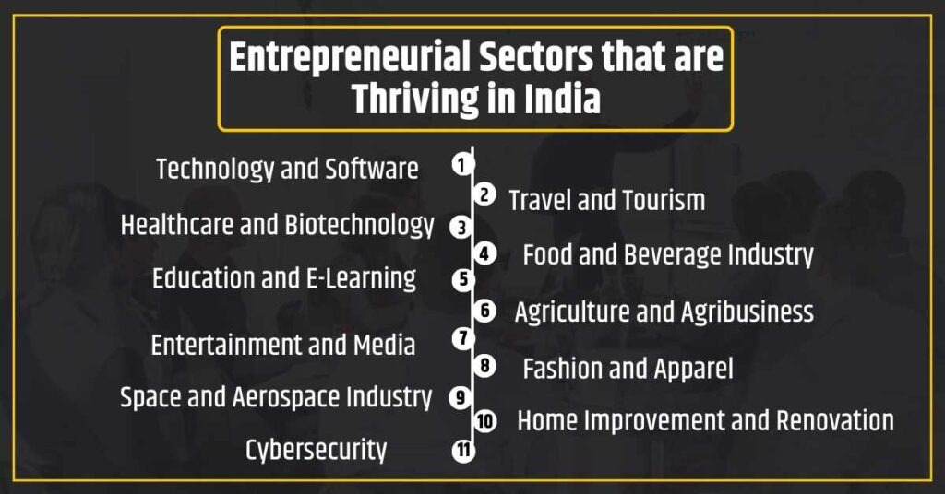



**8.0. Skills Developed / Learning outcome of this Micro-Project :-**

* Honed soft skills and practiced the art of Designing.
* The ability to accept criticism and work well under pressure
* To be through and pay keen attention to every detail
* To be flexible and open to change
* To be able to carry out basic tasks on a computer or hand-held devices

**9.0. Applications of this micro project:-**

Entrepreneurship sparks progress on both local and global scales. In local markets, it creates jobs, caters to specific needs, and fosters community spirit. Think bakeries satisfying hometown cravings or eco-friendly cleaning services addressing local pollution. Globally, entrepreneurs connect cultures, tap diverse resources, and tackle shared challenges. Consider online platforms facilitating international trade or social ventures combating climate change. By understanding both spheres, entrepreneurs can leverage local strengths to reach global audiences, scale solutions beyond borders, and contribute to a more prosperous and sustainable world.

**10.0. Bibliography:**

|  |  |  |
| --- | --- | --- |
| Sr.No | Source | Specifications |
| 1 | Google | https://www.careerguide.com/ask/t/what-is-entrepreneurship-what-are-the-scopes-of-entrepreneurship-in-present-scenario |
| 2 | Google | https://www.researchgate.net/publication/319442689_Entrepreneurship_Local_Growth_and_Global_Markets |



**11.0. References:**

* + <https://www.careerguide.com/>
  + <https://www.researchgate.net/>
* <https://chat.openai.com/>

**Name Of Student Members: -**

|  |  |  |  |
| --- | --- | --- | --- |
| **SR.NO** | **Name of the students** | **Enrollment No** | **Roll No** |
| 1 | TANWAR MOROOF MAQSOOD ALI | 2105220373 | 59 |
| 2 | LUCKY PAL | 2105220374 | 67 |
| 3 | NOORSUMAR MUHAMMAD HASSAN MOHAMAD NASIR | 2105220379 | 82 |
| 4 | YESHA JOSHI | 2105220420 | 99 |

**Mr. Tushar Kamble**

**(Subject Teacher)**