
<!DOCTYPE html>
<html lang="en">
<head>
<meta charset="UTF-8">
<title>Java 시험</title>
</head>
<body>
<h2>Java 시험</h2>
<ul>
<li><a href="/exam">시험 응시</a></li>
<li><a href="/results">시험결과 조회</a></li>
</ul>
</body>
</html>
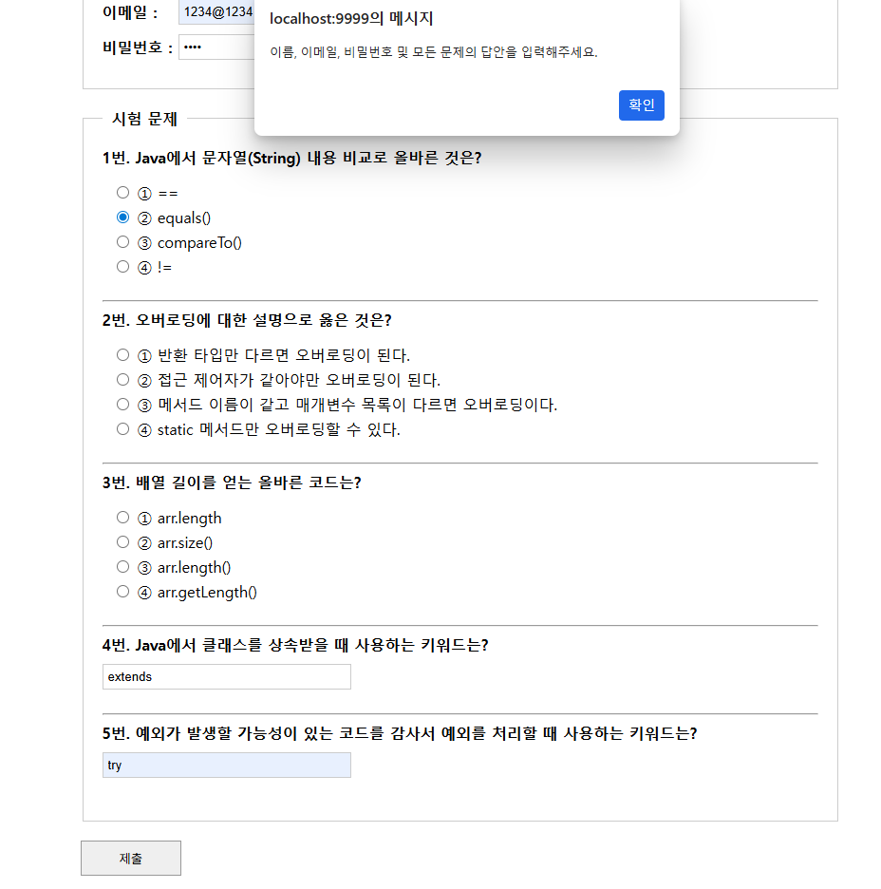
<script th:inline="javascript">
// 중복 응시 에러 메시지 처리
let error = [[${error}]];
if(error) window.alert(error);
// 필수 항목 JavaScript 검증 [cite: 58, 59]
document.getElementById('examForm').onsubmit = function() {
let name = document.getElementsByName('name')[0].value.trim();
let email = document.getElementsByName('email')[0].value.trim();
let pw = document.getElementsByName('password')[0].value.trim();
let a1 = document.querySelector('input[name="answer1"]:checked');
let a2 = document.querySelector('input[name="answer2"]:checked');
let a3 = document.querySelector('input[name="answer3"]:checked');
let a4 = document.getElementsByName('answer4')[0].value.trim();
let a5 = document.getElementsByName('answer5')[0].value.trim();
if(!name || !email || !pw || !a1 || !a2 || !a3 || !a4 || !a5) {
alert("이름, 이메일, 비밀번호 및 모든 문제의 답안을 입력해주세요.");
return false;
}
return true;
};
</script>
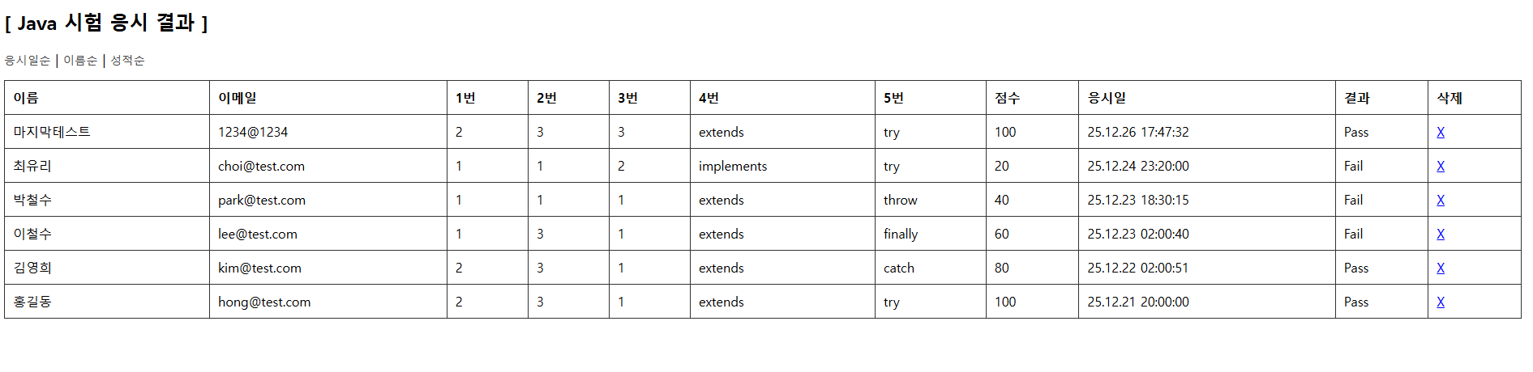
<!DOCTYPE html>
<html lang="ko" xmlns:th="http://www.thymeleaf.org">
<head>
<meta charset="UTF-8">
<title>시험 결과 조회</title>
<style>
body { font-family: 'Malgun Gothic', sans-serif; margin: 20px; }
.sort-menu { margin-bottom: 15px; }
.sort-menu a { text-decoration: none; color: #444; font-size: 0.9em; }
.sort-menu a:hover { text-decoration: underline; }
table { width: 100%; border-collapse: collapse; border: 1px solid #333; }
th, td { border: 1px solid #333; padding: 10px; text-align: left; }
th { background-color: #fff; }
.btn-delete { color: blue; text-decoration: underline; }
</style>
</head>
<body>
<h2>[ Java 시험 응시 결과 ]</h2>
<div class="sort-menu">
<a th:href="@{/results(sort='date')}">응시일순</a> |
<a th:href="@{/results(sort='name')}">이름순</a> |
<a th:href="@{/results(sort='score')}">성적순</a>
</div>
<table>
<thead>
<tr>
<th>이름</th>
<th>이메일</th>
<th>1번</th>
<th>2번</th>
<th>3번</th>
<th>4번</th>
<th>5번</th>
<th>점수</th>
<th>응시일</th>
<th>결과</th>
<th>삭제</th>
</tr>
</thead>
<tbody>
<tr th:each="res : ${responses}">
<td th:text="${res.name}"></td>
<td th:text="${res.email}"></td>
<td th:text="${res.answer1}"></td>
<td th:text="${res.answer2}"></td>
<td th:text="${res.answer3}"></td>
<td th:text="${res.answer4}"></td>
<td th:text="${res.answer5}"></td>
<td th:text="${res.score}"></td>
<td th:text="${#dates.format(res.submittedAt, 'yy.MM.dd HH:mm:ss')}"></td>
<td th:text="${res.score >= 80 ? 'Pass' : 'Fail'}"></td>
<td>
<a th:href="@{/results/delete(id=${res.id})}" class="btn-delete">X</a>
</td>
</tr>
</tbody>
</table>
</body>
</html>
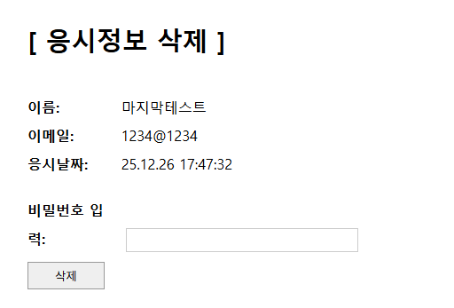
<!DOCTYPE html>
<html lang="ko" xmlns:th="http://www.thymeleaf.org">
<head>
<meta charset="UTF-8">
<title>응시정보 삭제</title>
<style>
body { font-family: 'Malgun Gothic', sans-serif; margin: 50px; line-height: 2; }
h2 { font-size: 1.8em; margin-bottom: 30px; }
.info-box { margin-bottom: 20px; }
.label { font-weight: bold; width: 100px; display: inline-block; }
.pw-input { padding: 5px; width: 250px; border: 1px solid #ccc; margin-left: 5px; }
.del-btn { padding: 5px 30px; background-color: #efefef; border: 1px solid #999; cursor: pointer; margin-top: 10px; }
.error { color: red; font-weight: bold; }
</style>
</head>
<body>
<h2>[ 응시정보 삭제 ]</h2>
<div class="info-box" th:if="${response != null}">
<div><span class="label">이름:</span> <span th:text="${response.name}">홍길동</span></div>
<div><span class="label">이메일:</span> <span th:text="${response.email}">hong@test.com</span></div>
<div><span class="label">응시날짜:</span> <span th:text="${#dates.format(response.submittedAt, 'yy.MM.dd HH:mm:ss')}">25.12.21 11:00:00</span></div>
</div>
<form th:action="@{/results/delete}" method="post">
<input type="hidden" name="id" th:value="${response.id}">
<div>
<span class="label">비밀번호 입력:</span>
<input type="password" name="password" class="pw-input" required>
</div>
<button type="submit" class="del-btn">삭제</button>
</form>
<div th:if="${error}" class="error" th:text="${error}"></div>
</body>
</html>

