How to run the program:

To play using Scanner/user input, run PlayGame.java

To play using GUI, run PlayGameGui.java

Currently we are having issues with the functionality of our GUI, however the game is fully functional through the PlayGame driver. When playing the game using the PlayGame driver, the program prompts the user with text through the interactions panel and allows the user to respond using text input. The numbered square brackets represent the rooms that are connected to the current room the player is int. A plus sign indicates that the door is unlocked and a negative sign indicates that the door is locked. To unlock a locked door, the user is prompted with a set of ten keys, from which they have three chances to choose the correct one to unlock the door (later versions of the game can include more interesting text interactions with the doors and keys).

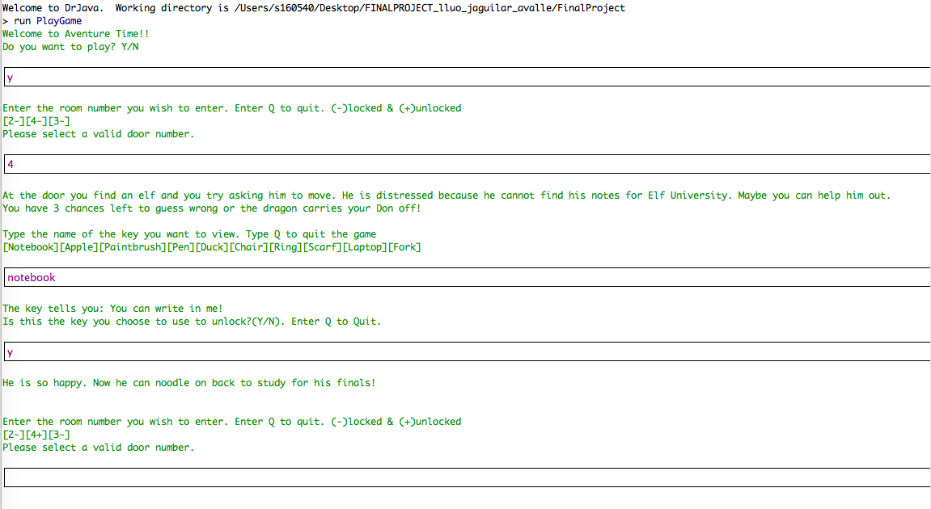

Once the user successfully makes their way through the map and enters the 10th room, they are prompted to play a game of hangman to save the don in distress who is being held captive by a dragon.

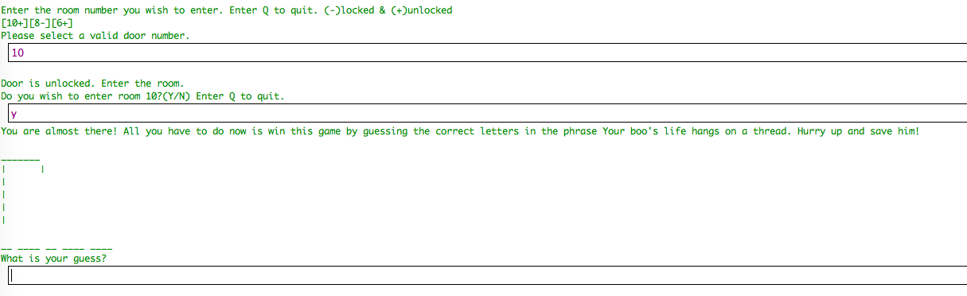

If the user correctly guesses the phrase before they run out of chances, a congratulatory message appears on the screen and the user is asked whether or not they wish to replay the game.

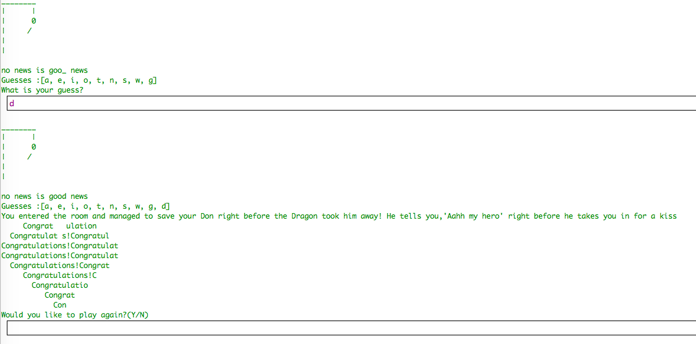

If the user does not guess the phrase correctly before running out of chances (6 wrong guesses are allowed), the don in distress is hidden in a new location by the dragon and the user is asked if they wish to replay the game.

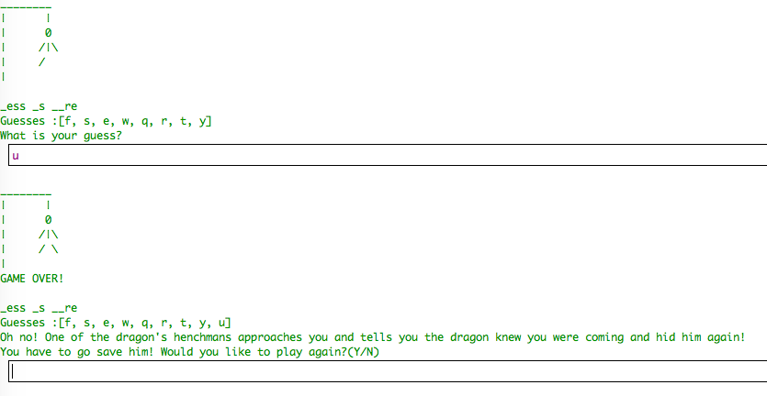

With the GUI, we had some difficulties getting beyond the start page of our game. The GUI was intended to allow the user to see an image that represented the interior of the room they are currently in. They should be able to click on the doors in the room and the keys in the room (buttons).

