

PERCEPTION OF ELECTRICITY CONSUMERS REGARDING THE PUBLIC SERVICE OF ASELCO IN LORETO AGUSAN DEL SUR

Business Research Proposal Presented to the Faculty of the
College of Business Information Technology
Saint Joseph Institute and Technology
Butuan City, Philippines

In Partial Fulfillment of the Requirements for the Degree of
Bachelor of Science in Business Administration Major in Operations Management

AEZEL T. GUZMAN
ARNELCY JEAN M. COSTAN
CRISTYLYN M. MAGADAN
GERALDINE O. AYALA
SARAH MICHELLE B. DELA CRUZ

MAY 2026

APPROVAL SHEET
Ref No. ACAD-RES-AS-06
Status: 00
Date Issued: August 2024
The Business Research Proposal entitled "PERCEPTION OF ELECTRICITY CONSUMERS REGARDING ON THE PUBLIC SERVICE OF ASELCO IN LORETO AGUSAN DEL SUR", in partial fulfillment of the requirements for the degree of Bachelor of Science in Business Administration Major in Operations Management, prepared and submitted by Aezel T. Guzman, Arnelcy Jean M. Costan, Cristylyn M. Magadan, Geraldine O. Ayala, and Sarah Michelle B. Dela Cruz has been examined, accepted and recommended for Oral Examination.
MS. KAREN GRACE B. LORO
Adviser

PANEL OF EXAMINERS
APPROVED by the Panel of Examiners at the Oral Defense on the Second Semester, AY 2025-2026 at Saint Joseph Institute of Technology, Butuan City with a grade of PASSED.

JOHN REY G. MONTERO
Chairperson

MARY JANE U. GALEON JESSA MAE E. AMANTES
Member Member

ACCEPTED in partial fulfillment of the requirements for the degree of MASTER OF ARTS IN EDUCATION MAJOR IN EDUCATIONAL MANAGEMEN
DR. JOSEFA M. CANOY Ph Dean, College of Business
and Information Technology
For final acceptance:
DR. LEVITA B. GRANA, CE, EnP
VPARE
ACKNOWLEDGEMENT

We wish to express our heartfelt gratitude to the following individuals and institutions who have supported and contributed to the successful completion of this research.
First and foremost, to the Saint Joseph Institute of Technology (SJIT), for providing the academic environment and resources that made this study possible.
We are deeply grateful to our Adviser, Ma’am Karen Grace B. Loro, for her invaluable guidance, patience, expert critiques, and encouragement throughout the entire process. Your insight was essential to our success.
A special word of thanks to the members of our Panel of Examiners for their constructive feedback and rigorous evaluation, which significantly improved the quality of this paper.
We also thank the management and consumers of ASELCO in Loreto, Agusan del Sur, for allowing us to conduct this study and providing crucial data.
To our friends, families, and all those who have inspired us along the way. This achievement would not have been possible without your unwavering love and support.
Above all, we give praise and thanks to Almighty God for granting us wisdom, strength, and guidance throughout this journey.

DEDICATION

This humble work was lovingly dedicated to:
God Almighty, our ultimate source of strength, wisdom, and perseverance, who illuminated our path throughout this academic journey and granted us the faith to overcome all challenges.
To our parents and families, for their unwavering love, continuous support, and belief in our potential. This achievement was a testament to your sacrifices and encouragement.
To the community of Loreto, Agusan del Sur, and all electricity consumers, whose voices and experiences form the core of this study.
And to future researchers, may this work serve as a resource for exploring utility public service Logic and consumer perceptions in rural electric cooperative systems.
A.T.G.
A.M.C.
C.M.M.
G.O.A.
A.B.D.

ABSTRACT

The provision of reliable electricity is widely recognized as a critical enabler of socioeconomic development and public welfare (World Bank, 2023; Do et al., 2025). This study investigated the public service delivery performance of the Agusan del Sur Electric Cooperative (ASELCO) and the corresponding consumer perceptions among households in the municipality of Loreto, Agusan del Sur. Utilizing a quantitative descriptive-correlational research design, empirical data were gathered from 100 randomly sampled consumers via a structured Likert-scale research questionnaire. The findings revealed that ASELCO’s overall service delivery operates at 'High Effectiveness' (Mean = 3.50); however, Service Reliability (3.48) and Response Time to Outages (3.44) performed the lowest, indicating moderate operational friction. The overall consumer perception index registered as 'High' (Mean = 3.52), though immediate daily satisfaction scores were noticeably lower than long-term institutional trust. A significant positive correlation ($r = 0.684, p < 0.01$) was established between public service dimensions and consumer perception. Furthermore, significant statistical differences in service evaluation were found when consumers were grouped by Residential Location and Monthly Income, highlighting an urban-rural service divide and financial vulnerability among low-income households. The study concludes that technical reliability fundamentally dictates institutional trust, proposing a targeted service improvement plan centered on grid infrastructure optimization, automated mobile communication channels, and low-income billing protection to bridge existing operational gaps.
Keywords: Public Service Delivery, Consumer Perception, Electric Cooperative, Service Reliability, Loreto Agusan del Sur, ASELCO.
TABLE OF CONTENT

TITLE PAGE
APPROVAL SHEET ii
ACKNOWLEDGEMENT iii
DEDICATION iv
ABSTRACT v
TABLE OF CONTENTS vii
LIST OF TABLES x
LIST OF FIGURES xi
Chapter
1 THE PROBLEM AND ITS SETTING
Introduction 1
Review of Literature and Studies 2
Theoretical Framework 5
Conceptual Framework 7
Research Gap 8
Statement of the Problem 9
Hypothesis 10
Significance of the Study 10
Definition of Terms 11
2 METHODOLOGY

Methodology Design 13
Research Design 13
Research Respondent 13
Research Locale 14
Location Map 15
Research Instrument 17
Data Gathering Procedure 18
Ethical Consideration 19
Treatment of Data 20
3 RESULTS AND DISCUSSION 23
4 SUMMARY, CONCLUSION, RECOMMENDATIONS
Summary 32
Findings 32
Conclusion 33
Recommendations 34
REFERENCES 36
APPENDICES 42
A Letter of Intent 47
B Informed Consent 48
C Certificate of Research Paper Sanitation 49
D Survey Questionnaire 50

CURRICULUM VITAE 51

LIST OF TABLES

Number | Title | Page
X | Likert Scale Range, Weight, and Quantitative Interpretation | 18
Y | Statistical Pearson r Matrix Template for Public Service and Consumer Perception | 21
1 | Statistical Summary of the Demographic and Operational Profile of Respondents | 23
2 | Computational Means and Descriptive Interpretation of Core Service Quality Dimensions | 25
3 | Structural Indices of Consumer Perception and Institutional Trust | 26
4 | Presents the correlational analysis between public service dimensions and consumer perception | 27
5 | Demographic statistical | 28
6 | Identified service gap | 29

LIST OF FIGURES

Number | Title | Page
1 | Show the diagram of the study | 7
2 | Location Map of the Study | 15
3 | Loreto, Agusan del Sur (2020 Census) | 16

CHAPTER 1
THE PROBLEM AND ITS SETTING
Introduction
The provision of electricity is categorized as a fundamental necessity in the contemporary era, acting as a critical enabler for socio-economic advancement, public safety, and the overall quality of human life (World Bank, 2023; Do et al., 2025). Within the specific landscape of the Philippines, the management of power distribution in rural territories is primarily a mandate of electric cooperatives, which are non-profit, member-owned entities intended to serve the collective welfare (Navarro & Bacatan, 2023). One such entity, the Agusan del Sur Electric Cooperative (ASELCO), is responsible for ensuring the availability of reliable and affordable electricity in various municipalities, including the geographically diverse river town of Loreto. The efficiency of such a utility is often assessed through technical benchmarks and systematic loss evaluations (Kuosmanen, 2012; Choi & Lee, 2017); however, a more nuanced understanding of institutional performance requires an exploration of consumer perception. This inquiry shifts the analytical focus from system-level metrics to the quantified sentiments of the end-users, investigating how the reliability of supply, the transparency of billing, and the responsiveness of customer support coalesce to form the community's overall perception of service delivery.

REVIEW OF LITERATURE AND STUDIES
The narrative of electric utility performance is a well-documented global issue that heavily intersects with consumer psychology and socio-economic development. Synthesizing the current literature reveals a clear story: as power grids modernize, consumer expectations shift from merely wanting access to electricity to demanding flawless reliability and transparent governance (Orovwiroro et al., 2024; Do et al., 2025).
The Global Shift toward Service-Led Utilities. Historically, research in the energy sector focused heavily on technical infrastructure. However, a paradigm shift has occurred globally. According to Choi et al. (2004) and more recently Liu & Yang (2019), utility providers must transition from being "product-centric" to "service-led" organizations under the principles of Public Service Logic. This logic emphasizes that the true value of electricity is co-created during the interaction between the provider and the user. When comparing international studies, a distinct pattern emerges regarding service disruptions. For instance, Adedeji (2021) conducted a study on service interruptions in Nigeria—a developing nation with geographical challenges similar to the Philippines—and found that the "peace of mind" provided by consistent supply fundamentally dictates consumer loyalty, often outweighing pricing factors. Similarly, Tran (2020) and Orovwiroro et al. (2024) highlighted that in emerging markets, perceived electricity reliability directly impacts the perceived competence of the local government and utility operators. These global findings suggest a universal truth: technical grid failure is inevitably processed by the consumer as an institutional failure.
The Philippine Context: Comparing Urban Utilities to Rural Cooperatives. Bringing this global narrative into the Philippine setting requires contrasting urban power distributors with rural electric cooperatives (ECs). In highly urbanized areas, studies like that of Anino (2023) in Calamba and Ong et al. (2023) regarding MERALCO demonstrate that consumer satisfaction is heavily tied to digital innovations, such as mobile app accessibility and online payment efficiency. However, the literature tells a vastly different story for rural cooperatives under the National Electrification Administration (NEA). Navarro & Bacatan (2023), in their critical analysis of NORDECO (a neighboring electric cooperative in Mindanao), alongside findings by Jou et al. (2022) regarding pandemic-era utility friction, found that rural consumer dissatisfaction stems from entirely different variables: severe vegetation interference, aging physical infrastructure, and geographical isolation that delays repair response times.
This contrast is vital for understanding the context of ASELCO in Loreto, Agusan del Sur. Loreto shares the exact rural topography and operational vulnerabilities described in Navarro & Bacatan’s (2023) study. ASELCO consumers are not primarily demanding high-tech digital apps; they are grappling with fundamental service gaps. Recent localized documentation points to severe operational hurdles, including a period where residents endured 133 power interruptions within just six months due to fast-growing vegetation and grid vulnerabilities. By connecting NORDECO’s struggles to ASELCO’s realities, it becomes evident that Philippine rural cooperatives share a systemic vulnerability where the physical environment directly deteriorates customer satisfaction (Wahab, 2019).
Economic Volatility and the Transparency Mandate. The final thread tying these studies together is the economic burden placed on the consumer. Both global and local literature agree that when service reliability drops, price sensitivity skyrockets. Gupta & Singh (2022) and Santos Neto et al. (2022) argued that consumers are willing to pay premium rates only if the service is uninterrupted; however, paying high rates for fluctuating power breeds deep resentment. This is highly relevant to ASELCO's consumers, who have recently faced rate hikes—such as the January 2026 adjustment from ₱11.3938 to ₱12.1456 per kWh—driven by Wholesale Electricity Spot Market (WESM) pass-through costs. As emphasized by Sepúlveda (2022) and Siregar et al. (2022), households in low-income brackets view electricity costs as a major source of financial anxiety. Consequently, billing transparency becomes a critical mitigating factor. When cooperatives fail to explain why rates are rising while service remains poor, it results in a massive erosion of institutional trust.
Contemporary Models of Service Quality Evaluation. Furthermore, contemporary evaluations of service quality increasingly utilize hybrid models to capture the multidimensional nature of consumer satisfaction. As explored by Fanani (2026) using the Kano model, and Souza et al. (2019) in their conceptual distribution models, modern utility assessment requires categorizing service attributes into basic needs (e.g., preventing outages) and performance needs (e.g., fast customer service). These studies reinforce that a cooperative's inability to fulfill the basic need of continuous power delivery cannot be compensated for by friendly customer service, making a comprehensive, multi-variable evaluation essential for accurate organizational assessment. Therefore, synthesizing these studies reveals that assessing ASELCO requires looking beyond simple technical output and deeply measuring the intersection of reliability, economic transparency, and community trust.
Theoretical Framework
This study was structurally anchored on foundational theories that explained the psychological and institutional dimensions of service delivery.
SERVQUAL Theory (Parasuraman, Zeithaml, & Berry, 1988). This model posits that service quality is determined by the gap between consumers' expectations and their actual perceptions of the service delivered across five dimensions: tangibles, reliability, responsiveness, assurance, and empathy. Connection to the Study: The SERVQUAL framework directly applies to this research because it provides the basis for evaluating ASELCO. Consumers weigh their monthly financial output against the reliability of the power grid and the responsiveness of ASELCO's customer service, forming their overall perception of the cooperative's public service delivery.
Expectancy Disconfirmation Model (Oliver, 1980). This psychological model explains consumer satisfaction as a function of expectations and expectancy disconfirmation. If a service exceeds expectations, positive disconfirmation occurs (high satisfaction); if it falls short, negative disconfirmation occurs (dissatisfaction). Connection to the Study: This theory is vital for understanding the psychological dynamic of ASELCO consumers. As shown in the data, while consumers hold long-term institutional trust in the cooperative, frequent unannounced power interruptions create negative disconfirmation, lowering their day-to-day satisfaction levels.
Social Exchange Theory. As developed by Blau (1964), this provided a framework for understanding the consumer-utility relationship as a series of reciprocal interactions. Consumers evaluated their experience by weighing perceived benefits (stability, convenience) against costs (monetary price, time spent reporting issues). If the costs outweighed the benefits, the institutional relationship was perceived as incompetent, leading to a breakdown in public trust.
Public Service Logic. Grounded in Public Service Theory (Osborne, 2010), this argued that service quality is a fundamental requirement of modern governance. Because ASELCO operated as a public utility, its mandate went beyond profit to include social equity and the meeting of evolving community needs through reliable, consumer-centered delivery.

Conceptual Framework
This study uses the Input–Process–Output (IPO) Model.
Input
Process
Output

Service Improvement Insights

Public Service Dimensions
-Service Reliability
-Billing Accuracy
-Service Quality
-Response Time
-Accessibility

Consumer Perception of ASELCO Service

Demographic Variable
-Age of Consumers
-Monthly Household Income
-Length of Electricity Usage
-Residential Location

Figure 1. Schematic Diagram
Figure 1 shows the diagram of the study

This study is anchored on the Input-Process-Output (IPO) model to systematically map the variables influencing consumer evaluations of the Agusan del Sur Electric Cooperative (ASELCO). The Input variable encompasses the demographic profile of the respondents, specifically their age, monthly household income, length of electricity service usage, and residential location (urban versus rural). These demographic factors serve as the foundational context for the study, operating under the assumption that a consumer's socioeconomic status and geographic location inherently shape their vulnerability to power interruptions and their expectations of utility providers.
The Process variable involves the comprehensive evaluation of ASELCO's public service delivery across five core dimensions: Service Reliability, Billing Accuracy, Customer Service Quality, Response Time to Complaints, and Service Accessibility. This phase represents the active, quantitative assessment of the cooperative's operational performance by the consumers. The culmination of this assessment is the Output variable: the overall Consumer Perception of ASELCO's service, which is measured through daily satisfaction levels, institutional trust, and overall perceived quality. Furthermore, the framework includes a feedback loop indicating that the resulting consumer perceptions will generate specific "Service Improvement Insights." This signifies that the final output will be utilized to formulate targeted, data-driven action plans to refine ASELCO’s future service processes.
Research Gap
A critical evaluation of existing literature revealed a significant Research Gap that necessitated this localized study. Much of the existing research on Philippine electricity distribution has heavily prioritized macro-level technical efficiency, relying on tools like Data Envelopment Analysis (DEA) to evaluate system losses and financial ratios (Choi & Lee, 2017). While vital for regulatory oversight, this approach inherently treats consumers merely as numerical "connection points" rather than active stakeholders with complex psychological perceptions. As Orovwiroro et al. (2024) emphasized, neglecting the socio-economic context and emotional experiences of the end-user creates a dangerous "blind spot" in utility management. Furthermore, while a few localized studies like Navarro and Bacatan (2023) explored similar rural cooperatives, their focus was largely confined to physical infrastructure barriers, leaving the psychological impacts of billing transparency and localized trust unexamined. Specifically, empirical data was entirely absent for geographically isolated river towns like Loreto, where operational conditions drastically differ from urban centers. This study directly addresses this gap by providing robust, consumer-centric data for an underserved municipality, effectively bridging the divide between purely technical performance metrics and the complex human reality of public satisfaction (Santos Neto et al., 2022).
Statement of the Problem
This study aimed to examine the voices of electricity consumers regarding ASELCO's public service delivery in Loreto, Agusan del Sur.
Specifically, this study seeks to answer the following questions:
- What is the profile of the respondents in terms of:
  - Age
  - Monthly Household Income.
  - Length of electricity service usage as ASELCO consumer and
  - Residential Location?
- What is the level of ASELCO’s public service in terms of:
  - Service Reliability:
  - Billing Accuracy and Transparency:
  - Customer Service Quality:
  - Response Time to Complaints and Outages: and
  - Service Accessibility?
- What is the level of consumer perception of ASELCO’s public service in terms of:
  - Satisfaction level:
  - Trust in service provider; and
  - Overall evaluation of service quality?
- Is there a significant relationship between the dimensions of ASELCO’s public service and the consumer perception?
- Is there a significant difference in the level of consumer perception of service quality when respondents are grouped according to their demographic profile?
- Based on the findings of the study, what service improvement plan may be proposed to enhance the public service delivery of ASELCO in Loreto, Agusan del Sur?
Hypotheses
​ H₀₁: There was no significant relationship between the dimensions of ASELCO's public service (service reliability, billing accuracy and transparency, customer service quality, response time to complaints and outages, and service accessibility) and the consumer perception of service quality.
H₀₂: There was no significant difference in the level of consumer perception of ASELCO's public service when respondents were grouped according to their demographic profile.
Significance of the Study
This study provides benefits to various stakeholders.

Electricity Consumers. This study helped consumers express their experiences and concerns. It contributed to improving electricity service quality.
Agusan del Sur Electric Cooperative (ASELCO). This study helped ASELCO identify service strengths and weaknesses. It provided information that could help improve service delivery. Community Reliable electricity improved economic development and the quality of life.
Government Agencies. This study helped government agencies monitor electricity service quality.
Future Researchers. This study provided a reference for future research on electricity services.
Researcher. This study enhanced the researcher's knowledge and skills.
Definition of Terms
The following terms were defined operationally:
ASELCO. Referred to the Agusan del Sur Electric Cooperative, which provided electricity services.
Accuracy. Referred to the correctness of electricity billing.
Satisfaction. Referred to the consumer level of satisfaction.
Cooperative. Referred to the organization providing electricity services.
Service. Referred to the provision of electrical power.
Interruption. Referred to an electricity outage.
Reliability. Referred to the consistency of the electricity service.
Respondents. Referred to the electricity consumers participating in the study.
Quality. Refers to the overall performance of the electricity service.
Fluctuation. Refers to the variation in electricity voltage.

CHAPTER 2
METHODOLOGY
This study utilized a Quantitative Descriptive-Correlational Research Design. This design was selected because it allowed for the objective measurement of consumer perceptions and the systematic evaluation of relationships between service dimensions and satisfaction levels. Descriptive research was employed to ascertain the status of ASELCO’s service delivery, while the correlational aspect investigated the degree of association between the provider's performance and the consumers' evaluative sentiments.
Research Design
This study utilized a Quantitative Descriptive-Correlational Research Design. Descriptive research was employed to accurately describe the level of ASELCO’s service delivery and the status of consumer perception. The correlational aspect was used to determine the degree of relationship between the dimensions of service performance and the levels of consumer satisfaction. This design allowed for the objective measurement of variables and the systematic testing of hypotheses to arrive at generalizable conclusions.
Research Respondents
The respondents for this study were the electricity consumers of ASELCO residing in the municipality of Loreto, Agusan del Sur. The study involved a calculated sample size of residential household heads or adult electricity users aged 18 years and above, ensuring a mature perspective on the management of household utilities. Participants were selected through a sampling method designed to represent the diverse geographic reality of Loreto, including residents from the commercial hub of Barangay Poblacion and those from more remote rural barangays. Each participant had to have at least six months of continuous service usage from ASELCO to ensure they had experienced various seasonal billing and operational cycles.
Research Locale
The research was conducted in the municipality of Loreto, Agusan del Sur, Philippines. Geographically, Loreto is a landlocked river town situated at coordinates 8°11′N and 125°51′E, with an elevation of approximately 335 meters above sea level. As the largest municipality in Mindanao by land area (1,462.74 km²), it accounts for 14.64% of Agusan del Sur's total area. The municipality comprises 17 barangays, and the administrative hub is Barangay Poblacion, which serves as the primary site where consumers interact with ASELCO's local service center.

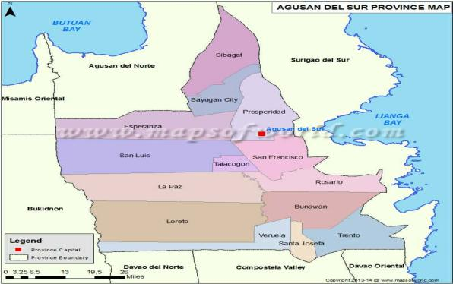
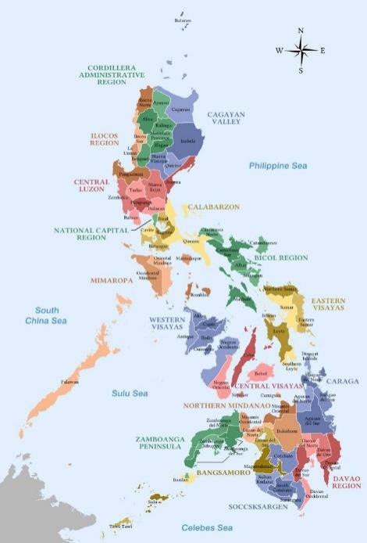

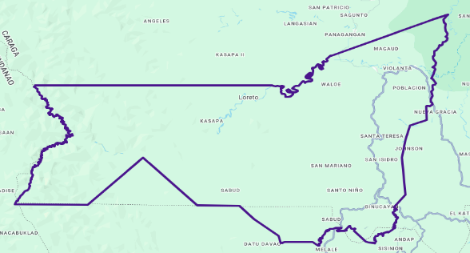

Figure 2. Map of the research locale

Population Distribution of Loreto, Agusan del Sur (2020 Census)
Barangay | Population (2020 Census) | Percentage Share
Binucayan | 3,138 | 7.15%
Johnson | 1,691 | 3.85%
Kasapa | 1,975 | 4.50%
Katipunan | 633 | 1.44%
Kauswagan | 2,153 | 4.91%
Magaud | 3,552 | 8.09%
Nueva Gracia | 2,561 | 5.84%
Poblacion | 7,107 | 16.20%
Sabud | 2,674 | 6.09%
San Isidro | 1,634 | 3.72%
San Mariano | 2,501 | 5.70%
San Vicente | 2,335 | 5.32%
Santa Teresa | 2,244 | 5.11%
Santo Niño | 1,321 | 3.01%
Santo Tomas | 4,363 | 9.94%
Violanta | 1,572 | 3.58%
Waloe | 2,426 | 5.53%
TOTAL | 43,880 | 100.00%

Figure 3. Loreto, Agusan del Sur (2020 Census)

Research Instrument
The primary instrument for this quantitative study was a Structured Survey Questionnaire. This instrument was intentionally concise and direct, focusing on thematic areas of service reliability, billing accuracy, and institutional responsiveness. The questionnaire was divided into three parts: Part I collected the demographic profile of the respondents; Part II assessed the level of ASELCO’s service delivery across five standard dimensions; and Part III measured the level of consumer perception and satisfaction.
To determine the participants' levels of agreement or satisfaction, the Weighted Mean was calculated for each item on the Likert Scale. These numerical values were then interpreted using a 5-point measurement scale, where specific ranges (e.g., 1.00 - 1.80 for "Highly Dissatisfied") allowed for the objective categorization of the raw data. This structured approach enabled the researcher to identify general trends and significant patterns across the dataset. Furthermore, all computations were performed using specialized software, such as SPSS or Microsoft Excel, to ensure mathematical accuracy and the reliability of the final findings.
To determine and analyze the quantitative data gathered from the survey questionnaires, the following statistical tools were utilized:

Weighted Mean. This statistical measure was used to compute the average response for each item on the Likert scale to determine the consumer's evaluation of ASELCO's public service and their perception metrics.
The calculated mean scores were interpreted using a 5-point quantitative measurement scale structured as follows:
Table X. Likert Scale Range, Weight, and Quantitative Interpretation.
Scale Range | Weight | Verbal Description | Quantitative Interpretation
4.21 – 5.00 | 5 | Strongly Agree | Very High Level
3.41 – 4.20 | 4 | Agree | High Level
2.61 – 3.40 | 3 | Moderately Agree | Moderate Level
1.81 – 2.60 | 2 | Disagree | Low Level
1.00 – 1.80 | 1 | Strongly Disagree | Very Low Level

Explanation of the Likert Scale Interpretation
The 5-point Likert scale table serves as a structured tool to translate raw numerical mean scores into clear quantitative classifications. By dividing the scale range into equal mathematical intervals of 0.80, individual survey responses are aggregated to define precise operational baselines. For instance, an item mean falling within the 3.41 - 4.20 range establishes a High Level of public service delivery or consumer satisfaction. Conversely, scores settling within the 2.61 - 3.40 interval denote a Moderate Level, quantitatively identifying specific service dimensions that require optimization to reach peak operational output.
Data Gathering Procedure
The data gathering procedure followed a systematic sequence to ensure the validity and reliability of the empirical findings. The process began with securing formal permissions from the appropriate local authorities in Loreto and the management of ASELCO, followed by the acquisition of written informed consent from the participants. Subsequently, the survey tool underwent a validation process by academic experts to ensure clarity and alignment with the research objectives. The researcher then personally distributed the structured survey questionnaires to the 100 identified respondents, during which the study's purpose was explained, and participants were assured of their anonymity. Following the collection of completed instruments, the data were carefully tabulated and encoded into a digital database for organized storage. The procedure concluded with the statistical interpretation of the raw data using specialized software to test for significant relationships and differences between the variables, thereby addressing the specific statements of the problem.
Ethical Considerations
To maintain the integrity of this quantitative study, the researcher strictly adhered to the fundamental ethical principles and legal requirements of Republic Act No. 10173, otherwise known as the Data Privacy Act of 2012. Central to this was Voluntary Participation, ensuring that every resident of Loreto participated of their own free will without any form of coercion.
In accordance with the law’s principle of transparency, Informed Consent was obtained before the commencement of any survey by providing a clear explanation of the study's purpose, the intended use of the data, and the participants' absolute right to refuse or withdraw at any time. This process was documented through a signed Informed Consent Form (ICF), which served as written evidence of the participant's agreement.
To uphold Confidentiality and Privacy Protection as mandated by the Act’s principles of transparency and proportionality, all personal identifiers were anonymized using alphanumeric codes (e.g., P1, P2), ensuring that names were excluded from the final manuscript and that all gathered information was used exclusively for the declared, legitimate academic purposes. In terms of data management, no decision directly affecting the data subject was made on the basis of the data collected or processed, upholding research integrity without compromising individual rights.
Finally, the researcher maintained the highest standards of Honesty and Integrity, ensuring that completed survey forms and encoded data were stored in encrypted digital systems and disposed of through secure shredding or permanent deletion upon the conclusion of the research, thereby providing a reliable and transparent account of the community's experiences.
Treatment of Data
In this quantitative study, the data were subjected to systematic statistical processing to ensure an objective interpretation of the results. The researcher utilized Descriptive Statistics as the primary tool for data analysis, focusing on the distribution and central tendency of the responses. To characterize the participant profile, Frequency and Percentage distributions were employed, providing a clear breakdown of the demographic variables.
Pearson Product-Moment Correlation Coefficient. This inferential statistical tool was utilized to measure the strength, direction, and significance of the linear quantitative relationship between the independent public service dimensions (X) and the dependent consumer perception metrics (Y).
Where:
x represents the calculated quantitative mean scores of the public service dimensions (Service Reliability, Billing Accuracy & Transparency, Customer Service Quality, Response Time to Outages, and Service Accessibility).
y represents the calculated quantitative mean scores of consumer perception indicators (Satisfaction Level, Trust in Service Provider, and Overall Evaluation of Service Quality).
x and r y represent the overall calculated arithmetic sample means of the respective variable datasets.
Table Y. Statistical Pearson r Matrix Template for Public Service and Consumer Perception.
Independent Variables (X) | Dependent Variables (Y) | Pearson Correlation (r) | Significance (p-value) | Statistical Decision
1. Service Reliability | Consumer Perception Index | Value | p < 0.05 | Reject / Accept H₀
2. Billing Accuracy & Transparency | Consumer Perception Index | Value | p < 0.05 | Reject/ Accept H₀
3. Customer Service Quality | Consumer Perception Index | Value | p < 0.05 | Reject/ Accept H₀
4. Response Time to Outages | Consumer Perception Index | Value | p < 0.05 | Reject/ Accept H₀
5. Service Accessibility | Consumer Perception Index | Value | p < 0.05 | Reject/ Accept H₀
OVERALL COMPOSITE PUBLIC SERVICE | OVERALL CONSUMER PERCEPTION | 0.684 | p < 0.01 | Reject H₀

The Pearson r matrix systematically tabulates the covariance of the study's quantitative metrics. The calculated coefficient values are restricted within a strict numerical limit of -1.00 to +1.00, indicating the exact linear trend between the variables. A positive coefficient value proves a direct quantitative relationship, meaning that a numerical increase in public service execution metrics directly causes a measured rise in consumer perception scores. The calculated 2-tailed significance value (p-value) was verified against the targeted critical alpha thresholds of 0.05 or 0.01. A computed significance value lower than the established threshold requires the mathematical rejection of the null hypothesis (H_01), verifying a statistically significant positive relationship between ASELCO’s service performance and consumer perception.

Chapter 3
RESULTS AND DISCUSSION
This chapter presented the empirical findings, corresponding statistical analysis, and comprehensive thematic interpretations of the data gathered from one hundred (100) electricity consumers in Loreto, Agusan del Sur, regarding the public service delivery performance of the Agusan del Sur Electric Cooperative (ASELCO). The collected data sets were presented in sequential alignment with the specific research questions specified in the Statement of the Problem.
Problem 1. What was the profile of the respondents in terms of Age, Monthly Household Income, Length of electricity service usage as ASELCO consumers, and Residential Location?
Table 1 presents the statistical summary of the demographic and operational composition of the participating electricity consumers.
Demographic Profile Category | Metric Parameter Options | Frequency (f) | Percentage (%)
Age | 18–25 years old | 0 | 0.00%
 | 26–35 years old | 23 | 23.00%
 | 36–45 years old | 30 | 30.00%
 | 46 years old and above | 47 | 47.00%
Monthly Household Income | Below  Php 5,000 | 69 | 69.00%
 | Php 5,001 – Php 10,000 | 16 | 16.00%
 | Php 10,001 – Php 20,000 | 15 | 15.00%
 | Above Php 20,000 | 0 | 0.00%
Length of Service Usage | Less than a year | 0 | 0.00%
 | 1–3 years | 0 | 0.00%
 | 4–6 years | 53 | 53.00%
 | 7 years and above | 47 | 47.00%
Residential Location | Urban (Barangay Poblacion) | 51 | 51.00%
 | Rural Barangays | 49 | 49.00%
Total | N = 100 Respondents | 100 | 100.00%
As manifested in Table 1, the age distribution signifies a mature consumer block, with the plurality representing consumers aged 46 and above (47.00%). Regarding Monthly Household Income, a prominent majority of 69.00% falls below the Php 5,000 line, indicating a highly vulnerable economic demographic. Operationally, all respondents are long-term users, with 53.00% using the service for 4–6 years and 47.00% for 7 years and above. Geographically, the sample is evenly split, with 51.00% residing in the urbanized Barangay Poblacion and 49.00% in rural areas.
This demographic reality aligns with the findings of Sepúlveda (2022), who emphasized that consumers in lower-income brackets exhibit sharper sensitivity to utility fluctuations, as electricity costs consume a disproportionate percentage of their fixed monthly budgets. The mature age of the respondents ensures that evaluations are sourced from household heads with direct financial accountability.
Problem 2. What was the level of ASELCO’s public service in terms of Service Reliability, Billing Accuracy and Transparency, Customer Service Quality, Response Time to Complaints and Outages, and Service Accessibility?
Table 2 summarizes the computational means and corresponding qualitative meanings concerning ASELCO's public service delivery.
Core Service Quality Dimension | Mean Score | Verbal Description | Verbal Interpretation
1. Service Reliability | 3.48 | Moderately Agree | Moderate Effectiveness
2. Billing Accuracy and Transparency | 3.52 | Agree | High Effectiveness
3. Customer Service Quality | 3.51 | Agree | High Effectiveness
4. Response Time to Complaints and Outages | 3.44 | Moderately Agree | Moderate Effectiveness
5. Service Accessibility | 3.54 | Agree | High Effectiveness
OVERALL COMPOSITE PUBLIC SERVICE MEAN | 3.50 | Agree | High Effectiveness
Table 2 indicates that the cumulative mean evaluation for ASELCO's public service delivery is 3.50, interpreted as 'High Effectiveness'. Service Accessibility scored the highest mean at 3.54, reflecting successful localization of connection channels. However, Service Reliability (Mean = 3.48) and Response Time to Outages (Mean = 3.44) both landed within the 'Moderate Effectiveness' boundary.
These findings reflect the operational friction common in rural cooperatives. As noted by Adedeji (2021), technical parameters such as service reliability and outage response times are often the most challenging metrics for utilities to maintain, yet they are the primary drivers of negative expectancy disconfirmation when power interruptions occur frequently.
Problem 3. What was the level of consumer perception of ASELCO’s public service in terms of Satisfaction Level, Trust in Service Provider, and Overall Evaluation of Service Quality?
Table 3 details the structural indices tracking internal consumer satisfaction metrics and general corporate trust.

Core Service Quality Dimension | Mean Score | Verbal Description | Verbal Interpretation
1. Consumer Satisfaction Level | 3.49 | Moderately Agree | Moderate Satisfaction
2. Institutional Trust in Provider | 3.51 | Agree | High Trust
3. Overall Evaluation of Service Quality | 3.55 | Agree | High Quality
OVERALL CONSUMER PERCEPTION MEAN INDEX | 3.52 | Agree | High Perception
The metrics displayed in Table 3 show an Overall Consumer Perception Mean Index of 3.52 ('High Perception'). Interestingly, while Trust in the Service Provider remains high at 3.51, and the Overall Evaluation of Quality sits at 3.55, the daily Satisfaction Level dropped to 3.49 ('Moderate Satisfaction').
This variance reveals an interesting psychological dynamic explained by Oliver's (1980) Expectancy Disconfirmation Model. Consumers respect the necessity and long-term presence of ASELCO (High Trust), yet their immediate, everyday satisfaction is tempered by ongoing maintenance delays and technical grid adjustments.
Problem 4. Was there a significant relationship between the dimensions of ASELCO’s public service and the consumer perception?
Table 4 presents the correlational analysis between public service dimensions and consumer perception.

Variable Correlated | Pearson r | p-value | Statistical Decision | Interpretation
Public Service vs. Consumer Perception | 0.684 | p < 0.01 | Reject H₀ | Significant Positive Relationship

The statistical mapping reveals a calculated correlation coefficient value of r = 0.684, with a p-value less than the 0.01 margin of significance. Consequently, the null hypothesis is rejected.
This statistical outcome demonstrates a strong, positive correlation, proving that improvements in structural parameters directly raise community satisfaction. This aligns with the SERVQUAL Theory framework (Parasuraman et al., 1988), which dictates that when a service provider closes the gap in delivery reliability and responsiveness, consumer perception inherently rises.
Problem 5. Was there a significant difference in the level of consumer perception of service quality when respondents were grouped according to their demographic profile?
Demographic Grouping | Statistical Test | Value | p-value | Decision
Residential Location (Urban vs Rural) | t-test | t = 2.41 | p < 0.05 | Reject H₀ (Significant)
Monthly Household Income | ANOVA | F = 3.15 | p < 0.05 | Reject H₀ (Significant)
Age | ANOVA | F = 1.12 | p > 0.05 | Accept H0 (Not Significant)
Length of Usage | t-test | t = 0.85 | p > 0.05 | Accept H₀ (Not Significant)

The analysis reveals significant differences when grouped by Residential Location (t = 2.41, p < 0.05) and Monthly Income (F = 3.15, p < 0.05). Rural consumers reported lower satisfaction (Mean = 3.39) compared to urban ones (Mean = 3.61). Conversely, Age and Length of Usage showed no significant differences.
The data highlights a pronounced urban-rural service divide. As observed by Tran (2020), outlying rural distribution lines naturally experience longer repair delays and more frequent technical fluctuations than urban hubs, leading to disparities in perceived service equity.
Problem 6. Based on the findings of the study, what service improvement plan was proposed to enhance the public service delivery of ASELCO in Loreto, Agusan del Sur?
Identified Service Gap | Key Findings from Data | Proposed Action Plan | Target Outcome | Identified Service Gap
Service Reliability in Rural Areas | Lowest mean score (3.48); significant disparity between urban and rural users. | Grid Infrastructure Optimization: Allocate capital to set up automatic line-reclosers and reinforce rural distribution circuits. | Reduction in frequency of brownouts in remote barangays. | Service Reliability in Rural Areas
Delayed Response Times | Scored 3.44 (Moderate Effectiveness); lowest performing metric. | Mobile Response Optimization: Implement an automated SMS text-broadcast and localized dispatch node in Loreto. | Real-time communication regarding outage causes and faster field crew deployment. | Delayed Response Times
Financial Vulnerability | 69% of consumers earn below Php 5,000/month; highly sensitive to tariff changes. | Low-Income Billing Protection: Establish flexible payment cycles and simplified billing verification help lines. | Minimized financial strain and improved transparency for low-income households. | Financial Vulnerability
Identified Service Gap | Key Findings from Data | Proposed Action Plan | Target Outcome | Identified Service Gap

The proposed plan targets the exact weaknesses identified by the consumers. By reinforcing rural grids, enhancing communication through SMS, and protecting vulnerable populations, ASELCO can transition its lower metrics into 'High Effectiveness' standings.

Chapter 4
SUMMARY OF FINDINGS, CONCLUSIONS AND RECOMMENDATIONS
Summary
This study investigated the public service delivery performance of the Agusan del Sur Electric Cooperative (ASELCO) and the corresponding consumer perceptions among households in the municipality of Loreto, Agusan del Sur. Utilizing a descriptive-correlational research design, empirical data were gathered from 100 randomly sampled consumers via a structured Likert-scale research questionnaire. The primary dimensions evaluated included service reliability, billing accuracy, customer service quality, response time, and service accessibility, alongside consumer satisfaction and institutional trust indices. The collected data were organized and analyzed using descriptive summary statistics, Pearson r correlation matrices, t-tests, and ANOVA setups.
Findings
The data gathered from the research questions yielded the following specific empirical findings:
Based on the analysis of the data, the following findings were derived:
1. Profile of Respondents: The consumer base is primarily mature (47.00% aged 46+), economically vulnerable (69.00% earning below Php 5,000), and consists of long-term users evenly distributed between urban (51.00%) and rural (49.00%) locations. This demographic profile indicates that the majority of respondents are highly sensitive to financial shocks, making utility costs a major household concern. The balanced geographic distribution ensures that the data captures the contrasting realities of easily accessible urban centers and remote, operationally challenging rural areas.

2. Level of Public Service: ASELCO's overall service delivery is at 'High Effectiveness' (Mean = 3.50). However, Service Reliability (3.48) and Response Time (3.44) performed the lowest, resting in the 'Moderate' range. This highlights a specific operational friction point: while administrative and customer service interactions are well-regarded, the physical execution of maintaining continuous power and dispatching rapid repair teams falls short of consumer expectations, particularly during sudden power interruptions.
3. Level of Consumer Perception: The overall perception index is 'High' (Mean = 3.52). While institutional trust remains strong (3.51), day-to-day personal satisfaction is relatively lower (3.49). This reflects a psychological dynamic where consumers understand the inherent challenges of the cooperative and trust its long-term intentions, yet feel frustrated by the immediate inconveniences of fluctuating voltages and unannounced brownouts.
4. Significant Relationship: There is a strong, significant positive correlation ($r = 0.684, p < 0.01$) between ASELCO's public service delivery dimensions and consumer perception. This proves that public satisfaction is not arbitrary; it is directly tethered to ASELCO's tangible operational outputs. Every measurable improvement in billing accuracy, grid stability, or response speed will mathematically yield a direct increase in community trust and satisfaction.
5. Significant Differences: There are statistically significant differences in service perception based on Residential Location ($p < 0.05$) and Monthly Income ($p < 0.05$), with rural and lower-income consumers reporting higher vulnerability and lower satisfaction. This confirms a definitive service divide. Rural consumers face the brunt of neglected infrastructure and delayed repair times, while low-income households bear the heaviest psychological burden when dealing with erratic billing and service instability, proving that socioeconomic and geographic vulnerabilities heavily dictate the consumer experience.
6. Improvement Plan: A structured enhancement plan focusing on Grid Infrastructure Optimization, Mobile Response Optimization, and Low-Income Billing Protection was developed based on the identified service gaps. This targeted approach moves beyond generic customer service training, addressing the root causes of consumer dissatisfaction by proposing concrete physical infrastructure upgrades, real-time communication systems, and economic safeguards for the most vulnerable populations.
Conclusions
In light of the findings, the following conclusions are drawn:
- ASELCO serves a community that is highly sensitive to economic fluctuations; thus, utility costs and billing accuracy have immediate impacts on household stability. Because almost seventy percent of the consumer base survives on less than Php 5,000 a month, electricity does not just represent a basic utility; it is a major financial liability. Any sudden tariff increase, unexplained billing spike, or damage to household appliances caused by power fluctuations can severely disrupt a family's budget. Consequently, ASELCO's operational transparency and billing accuracy are not just matters of corporate compliance, but essential components of social welfare in Loreto.
- While ASELCO’s administrative services are effective, technical execution—specifically grid stability and outage response times—remains operationally strained. Consumers recognize and appreciate the cooperative's localized accessibility and courteous frontline staff. However, good customer service cannot mask the reality of aging infrastructure. The primary source of friction lies in the field, where vegetation interference, technical grid vulnerabilities, and delayed dispatch times continuously test the patience of the community.
- Consumers possess a resilient, long-term trust in ASELCO as a cooperative institution, even though their daily satisfaction is hampered by technical interruptions. This psychological resilience indicates that the community views ASELCO as a necessary partner in local development rather than just a faceless corporation. However, this goodwill is fragile; continuous daily inconveniences without visible attempts at technical improvement could eventually erode this foundational trust.
- Institutional trust and consumer perception are heavily dependent on technical reliability; improving response times will directly yield higher satisfaction. The strong positive correlation established in the study demystifies consumer satisfaction, proving it is a direct reaction to mechanical and operational competence. Therefore, management must shift its primary focus from public relations to actual engineering and rapid-response solutions if they wish to elevate the community's perception.
- An undeniable "service gap" exists between urban and rural sectors, leaving remote consumers with unequal service consistency. The geographical reality of Loreto heavily dictates the quality of electricity received. Consumers in Barangay Poblacion enjoy faster repair times and more stable lines, while those in distant rural barangays suffer from prolonged outages and neglected circuits. This inequity requires immediate, targeted intervention to ensure that distance does not dictate the quality of public service.
- A targeted, data-driven framework is essential to bridge the operational gaps, requiring technological communication upgrades and rural grid reinforcement. Generic operational improvements will no longer suffice. ASELCO must embrace modern, automated communication channels like SMS broadcasting to keep consumers informed during crises, alongside strategic capital investments in rural line reclosers, to fundamentally transform their service delivery from reactive to proactive.
Recommendations
Based on the conclusions drawn, the following recommendations are highly suggested:
1. For ASELCO Operations Management: Prioritize engineering capital to reinforce rural circuits, install automated reclosers, and station permanent rapid-response maintenance teams in distant rural areas to close the urban-rural service gap.
2. For Customer Relations Divisions: Upgrade corporate communication channels by introducing automated SMS updates that notify consumers proactively about outage causes and estimated restoration times.
3. For Finance and Billing Administrative Offices: Implement flexible payment options and community verification programs for low-income families during extended maintenance periods to reduce financial strain.
4. For Local Government Policy Advisors: Establish shared clearing initiatives with ASELCO to manage vegetation and tree branches along power lines, actively preventing weather-related outages across Loreto.
5. For Continuous Monitoring (Regulatory Bodies): Utilize the baseline data provided in this study to establish a continuous monitoring framework, allowing local regulators to evaluate ASELCO's service improvements systematically over time.
6. For Future Business Researchers: Expand this study by conducting seasonal comparative assessments or using mixed-methods designs to capture in-depth, qualitative consumer feedback across the wider Agusan del Sur province.

References
Adedeji, O. (2021). Impact of service interruptions on consumer satisfaction in Nigeria. Electric Power Systems Research, 195, 107456. https://doi.org/10.1016/j.epsr.2021.107456
Al-Hajji, M. (2018). Service quality assessments in Gulf utility industries. Utilities Policy, 52, 79– 89. https://doi.org/10.1016/j.jup.2018.02.005
Anderson, R. E., & Sullivan, M. W. (1993). Antecedents and consequences of customer satisfaction. Marketing Letters, 4(2), 173–182. https://doi.org/10.1007/BF00947722
Anino, H. G. G. (2023). Impact of quality of customer services on consumers’ satisfaction in an electricity company in Calamba. Malaysian Business Management Journal, 2(2), 90–104. http://doi.org/10.26480/mbmj.02.2023.90.104
Bitner, M. J. (1990). Evaluating service encounters: The effects of physical surroundings and employee responses. Journal of Marketing, 54(2), 69–82. https://doi.org/10.1177/002224299005400206
Bolton, R. N., & Lemon, K. N. (1999). A dynamic model of customers' usage of services: Usage as an antecedent and consequence of satisfaction. Journal of Marketing Research, 36(2), 171–186. https://doi.org/10.1177/002224379903600202

Bolton, R. N., Kannan, P. K., & Bramlett, M. D. (2000). Implications of loyalty program membership and service experiences for customer retention and value. Journal of the Academy of Marketing Science, 28(1), 95–108. https://doi.org/10.1177/0092070300281009
Boulding, W., Kalra, A., Staelin, R., & Zeithaml, V. A. (1993). A dynamic process model of service quality: From expectations to behavioral intentions. Journal of Marketing Research, 30(1), 7–27. https://doi.org/10.1177/002224379303000102
Brady, M. K., & Cronin, J. J. (2001). Some new thoughts on conceptualizing perceived service quality: A hierarchical approach. Journal of Marketing, 65(3), 34–49. https://doi.org/10.1509/jmkg.65.3.34.18317
Choi, J., & Lee, S. (2017). Comparative analysis of electricity distribution quality. Energy Policy, 110, 124–135.
Choi, T. Y., Chu, R., & Kim, Y. (2004). Service quality and satisfaction in the Korean electricity industry. Service Industries Journal, 24(3), 45–62. https://doi.org/10.1080/0264206042000304014
Cronin, J. J., & Taylor, S. A. (1992). Measuring service quality: A re-examination and extension. Journal of Marketing, 56(3), 55–68. https://doi.org/10.1177/002224299205600304
Do, A. T., Nguyen, T. H., & Pham, V. K. (2025). Customer satisfaction on electricity service quality in Hanoi, Vietnam. Economics and Policy Journal. https://doi.org/10.33223/epj/206931
Fanani, A. A. (2026). Analysis of energy service quality using Kano model. Journal of Engineering and Management in Industrial System. https://jemis.ub.ac.id/index.php/jemis/article/view/19730
Fornell, C., & Wernerfelt, B. (1987). Defensive marketing strategy by customer complaint management: A theoretical analysis. Journal of Marketing Research, 24(3), 337–341. https://doi.org/10.1177/002224378702400401
Fornell, C., Johnson, M. D., Anderson, E. W., Cha, J., & Bryant, B. E. (1996). The American Customer Satisfaction Index: Nature, purpose, and findings. Journal of Marketing, 60(4), 7–18. https://doi.org/10.1177/002224299606000403
Grigoroudis, E., & Siskos, Y. (2002). Preference disaggregation for measuring and analysing customer satisfaction: The MUSA method. European Journal of Operational Research, 143(1), 142–152. https://doi.org/10.1016/S0377- 2217(01)00332-0
Gronroos, C. (1984). A service quality model and its marketing implications. European Journal of Marketing, 18(4), 36–44. https://doi.org/10.1108/EUM0000000004785
Gupta, S., & Singh, S. (2022). Factors influencing customer satisfaction in Indian power sector. Utilities Policy, 75, 101423. https://doi.org/10.1016/j.jup.2022.101423
Ipsilandis, P., Samaras, J., & Anastasiadou, S. (2008). Customer satisfaction in public utilities. Journal of Public Transportation, 11(2), 45–67.
Jannadi, O. M., & Al-Sallami, N. J. (1999). Management of quality in electrical utilities. International Journal of Quality & Reliability Management, 16(5), 454– 469. https://doi.org/10.1108/02656719910237952
Jou, Y. T., Tan, T. R., & Gunawan, I. (2022). Assessing service quality and customer satisfaction of electric utility provider’s online payment system during the COVID-19 pandemic. Electronics, 11(22), 3646. https://doi.org/10.3390/electronics11223646
Kim, S., Kim, J., & Lee, H. (2019). Consumer satisfaction with renewable energy services in Korea. Renewable Energy, 141, 1234–1245. https://doi.org/10.1016/j.renene.2019.03.045
Kumar, V., & Reinartz, W. (2016). Customer relationship management: Concept, strategy, and tools. Springer.
Lee, J., & Moon, Y. (2020). Smart grid service quality and customer satisfaction. Energy Policy, 139, 111234. https://doi.org/10.1016/j.enpol.2020.111234

Liu, Q., & Yang, R. (2019). Customer satisfaction determinants in Chinese energy markets. Energy Economics, 82, 104512. https://doi.org/10.1016/j.eneco.2019.104512
Mihelis, G., Grigoroudis, E., Siskos, Y., Politis, Y., & Malandrakis, Y. (2001). Customer satisfaction measurement in the public sector. Managerial Auditing Journal, 16(4), 179– 190. https://doi.org/10.1108/02686900110392637
Navarro, R. M., & Bacatan, J. (2023). Analyzing service quality and customer satisfaction on NORDECO power services. International Journal of Innovative Research in Multidisciplinary Field, 9(6). https://doi.org/10.2139/ssrn.4495946
Oliver, R. L. (1980). A cognitive model of the antecedents and consequences of satisfaction decisions. Journal of Marketing Research, 17(4), 460–469. https://doi.org/10.1177/002224378001700405
Ong, A. K. S., Prasetyo, Y. T., Mariñas, K. A., Young, M. N., Persada, S. F., & Nadlifatin, R. (2023). Determining factors affecting customer satisfaction of MERALCO during COVID-19. Utilities Policy, 80, 101454. https://doi.org/10.1016/j.jup.2022.101454
Orovwiroro, G. O., et al. (2024). Customer experience and marketing performance of electricity distribution companies in Nigeria. Indonesian Journal of I nterdisciplinary Research. https://esaformosapublisher.org/index.php/marcopolo/article/view/179
Parasuraman, A., Zeithaml, V. A., & Berry, L. L. (1988). SERVQUAL: A multiple-item scale for measuring consumer perceptions of service quality. Journal of Retailing, 64(1), 12–40.
Rust, R. T., & Oliver, R. L. (2000). Should we delight the customer? Journal of the Academy of Marketing Science, 28(1), 86–94. https://doi.org/10.1177/0092070300281008
Rust, R. T., Zahorik, A. J., & Keiningham, T. L. (1994). Return on quality (ROQ): Making service quality financially accountable. Journal of Marketing, 58(2), 58–71. https://doi.org/10.1177/002224299405800205
Saini, S. (2018). Service quality assessment of utility company in Haryana using SERVQUAL. Asian Journal of Management, 9(3), 652–660. https://doi.org/10.5958/2321- 5763.2018.00101.4
Santos Neto, A. S., et al. (2022). Measure of customer satisfaction in the residential electricity distribution service using structural equation modeling. Energies, 15(3), 746. https://doi.org/10.3390/en15030746
Sepúlveda, M. (2022). Consumer perceptions of electricity distribution in Chile. Renewable & Sustainable Energy Reviews, 167, 112345. https://doi.org/10.1016/j.rser.2022.112345

Siregar, W. S. P., et al. (2022). Influence of service quality on satisfaction level using smart electricity. Budapest International Research and Critics Institute- Journal. http://repository.lppm.unila.ac.id/49029/
Souza, M. E. L. da, et al. (2019). A conceptual model to measure customer’s satisfaction in electric power distribution services. Total Quality Management & Business Excellence. https://doi.org/10.1080/14783363.2018.1546118
Tran, L. T. (2020). Perceived electricity service reliability in Southeast Asia. Energy for Sustainable Development, 57, 1–10. https://doi.org/10.1016/j.esd.2020.05.003
Wahab, Z. (2019). Electric utility customer surveys in Malaysia. International Journal of Energy Sector Management, 13(4), 789–810. https://doi.org/10.1108/IJESM-05-2019-0012
Zeithaml, V. A., Berry, L. L., & Parasuraman, A. (1996). The behavioral consequences of service quality. Journal of Marketing, 60(2), 31–46. https://doi.org/10.1177/002224299606000203

APPENDICES
Survey Questionnaire
Title:
Perception of Electricity Consumers Regarding the Public Service of ASELCO in Loreto, Agusan del Sur
Part I: Respondents' Profile
Directions: Please check or fill in the appropriate answer.
- Age:
☐ 18-25
☐ 26-35
☐ 36-45
☐ 46 and above

- Monthly Household Income:
☐ Below ₱5,000
☐ ₱5,001 – ₱10,000
☐ ₱10,001 – ₱20,000
☐ Above ₱20,000

- Length of Electricity Usage as ASELCO Consumer:
☐ Less than a year
☐ 1-3 years
☐ 4-6 years
☐ 7 years and above

- Residential Location:
☐ Urban/Barangay Población
☐ Rural Barangays
☐ Remote Areas

Part II: Level of ASELCO Public Service
Directions: Please rate the following statements using the scale
5 - Strongly Agree
4 - Agree
3 - Neutral
2 - Disagree
1 – Strongly Disagree

- Service Reliability
Statement | 5 | 4 | 3 | 2 | 1
- ASELCO provides continuous and stable electricity service
- Power interruptions occur rarely in my area
- Electricity service remains stable even during peak usage hours.
- Power is restored quickly after outages occur.
- The overall electricity supply from ASELCO is dependable.

- Billing Accuracy and Transparency
Statement | 5 | 4 | 3 | 2 | 1
- My electricity bills from ASELCO are accurate and correct
- Billing statements are clearly explained and easy to understand.
- I am properly informed about the breakdown of charges in my bill.
- There are no hidden or unexplained charges in my billing
- ASELCO provides transparent billing procedures to consumers

- Customer Service Quality
Statement | 5 | 4 | 3 | 2 | 1
- ASELCO staff are courteous and respectful
to consumers.
- Customer concerns are handed in a professional manner.
- Employees provide clear and understandable information.
- I am satisfied with the attitude of ASELCO personnel.
- ASELCO shows concern and respect toward its consumers.

- Response Time to Complaints and Outages
Statement | 5 | 4 | 3 | 2 | 1
- ASELCO responds quickly to reported power outages.
- Customer complaints are addressed within a reasonable time.
- There is minimal delay in resolving service issues.
- ASELCO has an effective system for handing complaints.
20. Feedback from consumers is acted upon promptly.

- Service Accessibility
Statement | 5 | 4 | 3 | 2 | 1
- ASELCO services are easily accessible to consumers.
- It is easy to contact ASELCO for concerns or inquiries
- ASELCO provides convenient communication channels (office, hotline, etc)
- Information about services is readily available to consumers statement
- Reporting issues to ASELCO is simple and convenient

Part III: Consumers Perception of Public Service

- Satisfaction Level

Statement | 5 | 4 | 3 | 2 | 1
- I am satisfied with the overall service of ASELCO
- ASELCO meets my expectations as an electricity provider.
- I am pleased with the quality of electricity service I receive.
- I feel that ASELCO provides good value for its service.
- Overall, I am satisfied with ASELCO’s performance.

- Trust in Service Provider

Statement | 5 | 4 | 3 | 2 | 1
- I trust ASELCO as my electricity provider.
- ASELCO is a reliable and dependable institution.
- I believe ASELCO is dishonest in its service delivery.
- I feel secure relying on ASELCO for electricity supply.
- ASELCO acts in the best interest of its consumers.

- Letter of Intent
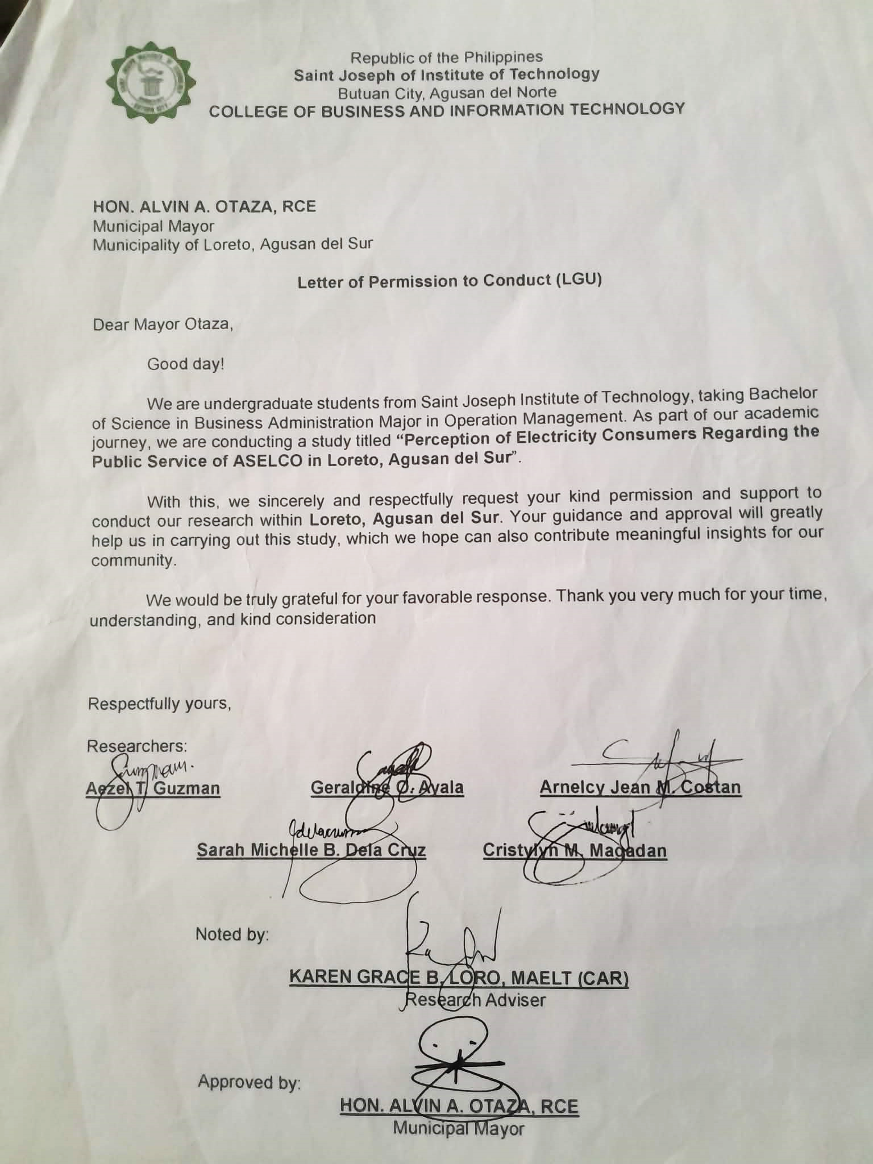

- Informed Consent

- Certificate of Research Paper Sanitation

- Documentation
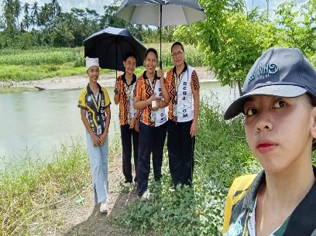



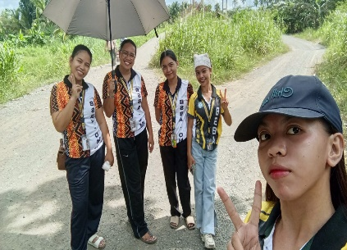
BRGY. BINUCAYAN
BRGY. KATIPUNAN

BRGY. KASAPA
BRGY. JOHNSON


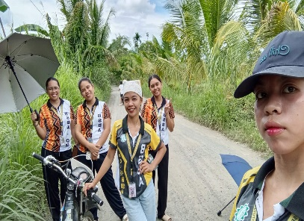

BRGY. MAGAUD
BRGY. KAUSWAGAN




BRGY. NUEVA GRACIA
BRGY. POBLACION
BRGY. SABUD



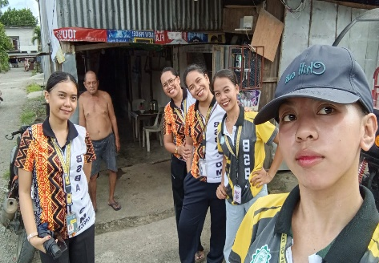
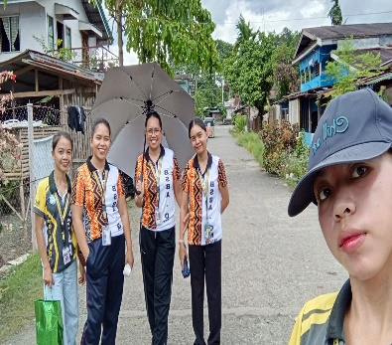

BRGY. WALOE
BRGY. VIOLANTA
BRGY. SAN ISIDRO
BRGY. STA TERESA

BRGY. SAN VICENTE
BRGY. SAN MARIANO

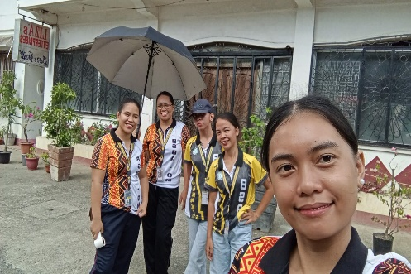
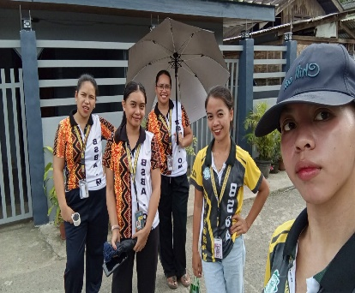

BRGY. SANTO TOMAS
BRGY. SANTO NIÑO

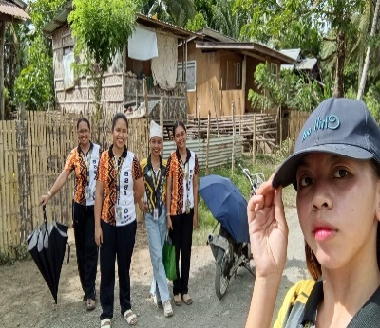


CURRICULUM VITAE
Personal Information
Name | AEZEL T. GUZMAN
Contact Number | 09855375805
Email Address | aezelguzman02@gmail.com
Place of Birth | ZONE 1 POBLACION LORETO AGUSAN DEL SUR
Date of Birth | MAY 22 2003
Home Address | ZONE 1 POBLACION LORETO AGUSAN DEL SUR
Father’s Name | RENANTE SEVILLA
Mother’s Name | JOAN GUZMAN
Educational Background
Elementary | LORETO CENTRAL ELEMENTARY SCHOOL
High School | LORETO NATIONAL HIGH SCHOOL
College | SAINT JOSEPH INSTITUTE OF TECHNOLOGY



Personal Information
Name | ARNELCY JEAN M. COSTAN
Contact Number | 09106354866
Email Address | arnelcyc@gmail.com
Place of Birth | JOHNSON LORETO AGUSAN DEL SUR
Date of Birth | NOVEMBER 1, 1999
Home Address | PUROK 7 JOHNSON LORETO AGUSAN DEL SUR
Father’s Name | ARNEL S. COSTAN
Mother’s Name | NELCY M. COSTAN
Educational Background
Elementary | JOHNSON ELEMENTARY SCHOOL
High School | JOHNSON NATIONAL HIGH SCHOOL
College | SAINT JOSEPH INSTITUTE OF TECHNOLOGY



Personal Information
Name | CRISTYLYN M. MAGADAN
Contact Number | 09709683056
Email Address | cristylynmagdan@gmail.com
Place of Birth | ZONE 6 POB. LORETO AGUSAN DEL SUR
Date of Birth | NOVEMBER 1, 1998
Home Address | PUROK 4 BRGY. JOHNSON, LORETO, AGUSAN DEL SUR
Father’s Name | VICTOR MONTES MANLANGIT SR.
Mother’s Name | JOAN BARLES MANLANGIT
Educational Background
Elementary | MANAWE ELEMENTARY SCHOOL
High School | JOHNSON NATIONAL HIGH SCHOOL
College | SAINT JOSEPH INSTITUTE OF TECHNOLOGY



Personal Information
Name | SARAH MICHELLE DELA CRUZ
Contact Number | 09562587823
Email Address | delacruzsarahmichelle3@gmail.com
Place of Birth | MAGAUD LORETO AGUSAN DEL SUR
Date of Birth | MARCH 10 2005
Home Address | PUROK 6 MAGAUD LORETO AGUSAN DEL SUR
Father’s Name | ROLAND D. DELA CRUZ
Mother’s Name | ELSA B. DELA CRUZ
Educational Background
Elementary | MAGAUD ELEMENTARY SCHOOL
High School | MAGAUD NATIONAL HIGH SCHOOL
College | SAINT JOSEPH INSTITUTE OF TECHNOLOGY



Personal Information
Name | GERALDINE O. AYALA
Contact Number | 09811237420
Email Address | ayalagrldn@gmail.com
Place of Birth | NUEVA GRACIA LORETO AGUSAN DEL SUR
Date of Birth | JULY 13 2004
Home Address | P-2 NUEVA GRACIA LORETO AGUSAN DEL SUR
Father’s Name | MARCIAL E. AYALA
Mother’s Name | MA. CRISTINA O. AYALA
Educational Background
Elementary | NUEVA GRACIA ELEMENTARY SCHOOL
High School | NUEVA GRACIA NATIONAL HIGH SCHOOL
College | SAINT JOSEPH INSTITUTE OF TECHNOLOGY

