

AGUSAN DEL SUR STATE COLLEGE OF AGRICULTURE AND TECHNOLOGY

ERRANDEXPRESS: A MICROTASK PLATFORM FOR STUDENTS AND FACULTY

MECHILE EVANGELIO ASTRONOMO
LUISITO JR FRANCISCO SEDILLO

BACHELOR OF SCIENCE IN INFORMATION TECHNOLOGY

MARCH 2025

AGUSAN DEL SUR STATE COLLEGE OF AGRICULTURE AND TECHNOLOGY
BACHELOR OF SCIENCE IN INFORMATION TECHNOLOGY

MECHILE EVANGELIO ASTRONOMO
LUISITO JR FRANCISCO SEDILLO
ErrandExpress: A Microtask Platform for Students and Faculty

Thesis Adviser:
Leonalyn B. Peñero
College of Computing and Information Sciences

MARCH 2025

Chapter I

INTRODUCTION

Background of the Study

Technology has rapidly evolved over the past decades, revolutionizing communication, education, and task management in both academic and professional settings (Smith, 2020). The emergence of digital platforms has enabled individuals and organizations to streamline daily operations, improving convenience and efficiency through automated systems and real-time communication (Jones & Lee, 2021).
In academic institutions, however, managing small but essential errands remains a challenge. Faculty and students often rely on face-to-face interactions or informal arrangements to handle microtasks like photocopying, document delivery, or organizing materials. This traditional approach can result in inefficiencies, miscommunication, and unnecessary delays, particularly for faculty members with demanding schedules (Garcia, 2019).
Currently, there is no structured system in place that connects students who are often available and seeking income opportunities with faculty who need assistance completing minor yet time-sensitive tasks. This lack of organization represents a missed opportunity for improved task delegation and student engagement (Dela Cruz et al., 2022).
ErrandExpress aims to address this gap by providing a web-based platform that facilitates seamless microtask delegation through a built-in messaging feature. This system allows users to communicate directly, negotiate task details, and clarify expectations in real time. By eliminating the dependence on in-person coordination, ErrandExpress enhances both the convenience and efficiency of errand management within academic communities. Through this platform, ErrandExpress bridges the gap between task requesters and performers, promoting transparency, accountability, and collaboration. Its implementation is expected to streamline task workflows, improve productivity, and support students in gaining practical experience while earning income.

Statement of the Problem
Faculty members at Agusan del Sur State College of Agriculture and Technology (ASSCAT) often struggle to manage small yet essential tasks, such as photocopying materials, delivering documents, organizing resources, purchasing food, and Checking students' outputs, due to their demanding schedules. At the same time, students are actively seeking opportunities to earn extra income but lack access to flexible and convenient work arrangements. Despite the potential for a mutually beneficial solution, no structured platform currently exists to connect faculty members needing assistance with students willing to complete microtasks. This gap leads to inefficiencies, missed opportunities, and a lack of a systematic approach to task delegation within the institution.

Objectives of the Study
The general objective of this study is to develop ErrandExpress, a web-based platform designed to help faculty members delegate small tasks to students in a convenient and organized manner.
Specifically, the study aims to:
- Design and develop a system that enables teachers to post errands and allows students to accept and complete the assigned tasks.
- Implement a task-matching system that allows teachers to post tasks and students to accept and complete them.
- Provide a rating and feedback mechanism to maintain quality and accountability among users, ensuring that both students and faculty have a reliable system to assess performance.
- Evaluate the system based on the ISO 25010 standard in terms of:
  - Functionality
  - Reliability
  - Usability
  - Efficiency
  - Security

Significance of the Study

This study holds considerable significance for various stakeholders within the academic environment, particularly faculty members, students, and the institution as a whole. By introducing ErrandExpress, a web-based microtask platform, the study aims to contribute to the body of knowledge on task delegation, digital innovation in education, and student engagement through practical work integration. The potential benefits are categorized as follows:

Faculty Members. The implementation of ErrandExpress addresses the increasing demands on faculty members by offering a structured and accessible system for delegating non-academic tasks. This platform is expected to improve time management by allowing faculty to offload minor errands, thereby enabling them to focus more effectively on teaching, research, and administrative responsibilities. Moreover, the system offers a cost-efficient alternative to outsourcing minor support services, making it a sustainable solution within academic settings.

Students. ErrandExpress provides a viable avenue for students to gain practical experience while earning supplementary income. Through participation in various microtasks, students can enhance their interpersonal and organizational skills, including communication, time management, and task negotiation. Furthermore, the platform promotes a flexible work model that supports students in balancing academic and extracurricular commitments. As such, the system fosters both financial support and personal development among students.

Academic Institution. From an institutional perspective, the introduction of a structured microtask platform can significantly enhance operational efficiency. By streamlining the process of task delegation, the platform reduces delays and miscommunication, thereby optimizing internal workflows. Additionally, the system promotes student involvement in institutional functions, encouraging a culture of cooperation and shared responsibility.
These improvements contribute to the overall effectiveness and responsiveness of the institution’s service delivery.
Academic Community and Educational Sector. Beyond the immediate users, this study supports broader educational goals by encouraging the integration of technology in administrative and support functions. ErrandExpress exemplifies how digital solutions can foster a more collaborative and efficient academic environment. The system serves as a model for innovation in educational management, potentially influencing the design and deployment of similar platforms in other academic institutions.
Future Research. The development and assessment of ErrandExpress may serve as a foundation for future studies on the use of microtasking in academic contexts. Insights from this research can inform enhancements in system features, user experience, and platform scalability. Additionally, the study opens avenues for exploring monetization strategies, sustainability models, and the long-term impact of digital task delegation systems on academic performance and institutional efficiency.

Scope and Delimitation of the Study

Scope of the Study:
- The study focuses on the design, development, and evaluation of ErrandExpress, a web-based microtask platform.
- The platform is intended for use within Agusan del Sur State College of Agriculture and Technology (ASSCAT).
The primary users of the system are:
- Faculty members from the College of Computing and Information Sciences (CCIS) – task requesters.
- All enrolled students from any department of ASSCAT – task performers.
- Faculty users will be limited to CCIS faculty members only during the implementation and evaluation of the system.
The system enables the following user functionalities:
For CCIS Faculty Users:
- Create an account and log in to the system
- Post new errands with task details (title, description, deadline, and payment)
- Edit or cancel posted tasks if not yet accepted
- View student applicants and select a task performer
- Communicate with students via built-in messaging
- Track task progress and confirm task completion
- Rate and leave feedback for students after task completion
For ASSCAT Student Users:
- Create an account and log in to the system
- Browse available tasks posted by CCIS faculty
- Apply for or accept available errands
- Communicate with faculty through the built-in chat feature
- Mark tasks as completed and await confirmation
- Receive ratings and feedback based on performance
- View task history and earned income summary
- The study includes a usability evaluation based on user feedback and system performance assessed using the ISO 25010 quality model.
- The system will be developed using web technologies accessible through computers and mobile devices with internet connectivity.
Delimitation of the Study:
- The study is limited to microtasks within the academic context and does not include complex or long-term job requests.
- Only faculty members from the College of Computing and Information Sciences (CCIS) can register and post tasks on the platform.
- All enrolled students from any college or department of ASSCAT are eligible to browse, accept, and complete available tasks.
- Tasks posted and completed are assumed to be non-academic or support-related and must comply with institutional policies.
- Financial transactions, if any, will be handled through manual payment and not integrated with digital payment gateways in the current version.
- The platform will not include features such as geolocation tracking, third-party hiring, or full-time job matching.
- Data privacy and security measures are implemented, but the system assumes responsible and ethical use by all users.

Time and Place of the Study
The study will be conducted during the second semester of the academic year 2025-2026 at Agusan del Sur State College of Agriculture and Technology (ASSCAT), located in San Teodoro, Bunawan, Agusan del Sur.
Conceptual Framework
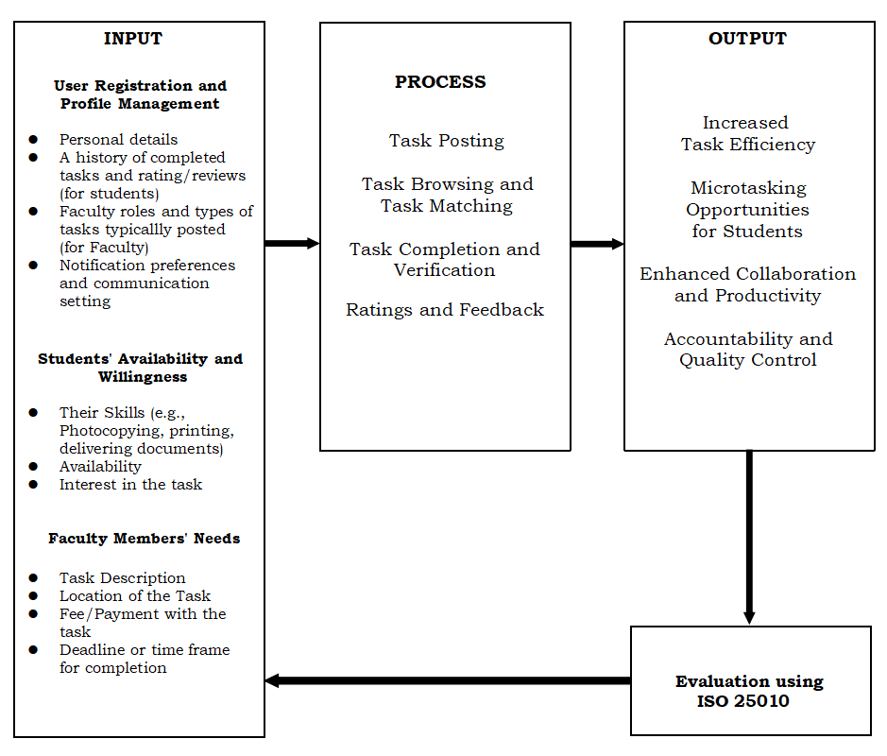
Figure 1. Conceptual Framework of the Study

The Input-Process-Output (IPO) model of ErrandExpress: A Microtask Platform for Students and Faculty illustrates how the system functions to streamline task delegation within an academic environment.
The input phase includes the faculty members’ needs, such as task descriptions, locations, deadlines, and payment details; the students’ availability and willingness to participate based on their skills and interest; and user registration and profile management, where both parties provide personal information and task-related preferences.
The process involves key platform functions such as task posting by faculty, task browsing and selection by students, task completion and verification, and the exchange of ratings and feedback to ensure quality and accountability. These processes are supported by communication tools and a user-friendly interface.
The output of this system includes increased task efficiency for faculty, accessible microtasking opportunities for students, improved collaboration between users, and enhanced accountability through the feedback system.
Using ISO 25010 for Evaluation standard to ensure it meets software quality attributes such as Functionality, reliability, usability, efficiency and security, contributing to a well-functioning and sustainable solution.

Operational Definition of Terms
ErrandExpress – A web-based system developed to link faculty members with students for the execution of small tasks such as photocopying materials, delivering documents, or Checking students' outputs. It provides key features including task creation, basic task-matching functionality, real-time messaging, and task confirmation to streamline the delegation process.
Task Matching – A simplified process within ErrandExpress that connects posted tasks from faculty members with suitable students. This is achieved by using filters such as task category, time availability, and location rather than relying on complex algorithms, promoting ease of use and relevance.
Student Profile – An account created by students on the platform, containing their personal details, listed skills, task preferences, and availability. These profiles are used to match students with appropriate tasks.
Faculty Member Profile – An account set up by faculty members which includes personal information and allows them to post tasks, interact with students, and manage task-related activities.
Task Posting – The feature that allows faculty members to publish new tasks on the platform. Each task includes essential details like the type of service required, location, description, and preferred timing.
Task Filters – Built-in tools that enable students to find tasks based on specific criteria such as task type, location, and available times, ensuring that task suggestions are personalized and manageable.
Task Type – The classification of an errand listed by faculty members (e.g., photocopying, document delivery). This categorization helps students identify tasks that align with their interests or abilities.
Availability – Refers to the specific timeframes that students indicate they are available to work on tasks. This is critical in matching tasks with the right individuals.
Location – The specified place on or near campus where a task must be executed. Location filtering ensures that students are matched with tasks that are convenient for them geographically.
Negotiation – The communication process between faculty and students via the platform’s messaging system to finalize key task details such as timing, expectations, and potential rewards before a task is accepted.
Rating and Feedback Mechanism – A feature that enables users to evaluate and provide comments on each other’s performance after a task is completed. This encourages accountability, reliability, and service quality.
Messaging System – A real-time chat tool built into the platform that allows both parties to discuss and clarify the specifics of tasks, resolve concerns, and confirm agreement on task execution.
Task Confirmation – The step in which the faculty member reviews and verifies whether the task was completed as specified. Approval at this stage validates the fulfillment of the errand.
Task Completion – The successful fulfillment of an assigned task by a student, followed by verification from the faculty member that the task met the stated requirements.
Admin – The platform’s administrator responsible for maintaining system operations, monitoring activity, managing user accounts, resolving disputes, and ensuring the smooth functionality of ErrandExpress.
Platform – Refers to ErrandExpress itself, the digital environment that supports the interaction between faculty and students, enabling errand posting, task matching, messaging, completion tracking, and feedback exchange.

Chapter II

REVIEW OF RELATED LITERATURE, SYSTEMS AND STUDIES

Microtasking and On-Demand Services
Microtasking platforms have gained significant popularity in recent years as they allow users to delegate small tasks to available individuals. Studies suggest that microtasking systems enhance efficiency, streamline operations, and provide economic opportunities for workers. According to Howe (2020), crowdsourcing and microtasking models have been widely adopted in various industries, improving service delivery and reducing operational costs.
Similar to general microtasking platforms, ErrandExpress enables faculty members to delegate small academic-related tasks (e.g., printing, document retrieval) to students, ensuring efficiency in workload distribution. Both systems aim to optimize resource allocation and reduce inefficiencies. Unlike traditional microtasking platforms that cater to a broad range of industries, ErrandExpress is designed specifically for academic institutions, focusing on student-faculty interactions. It operates within an educational framework, ensuring that tasks remain relevant to the university setting, unlike commercial platforms that offer diverse, non-academic tasks.

Mobile Application Development for Task Management
Mobile applications have revolutionized how individuals manage tasks, offering ease of access and automation. According to Kim et al. (2021), mobile task management applications are essential in modern environments, as they provide features such as task tracking, notifications, and secure transactions. These applications rely on intuitive interfaces and effective filtering mechanisms to match users with relevant tasks, enhancing user experience and efficiency. The Software Development Life Cycle (SDLC) plays a vital role in ensuring the effectiveness of mobile applications. Research indicates that implementing Agile methodologies improves adaptability and responsiveness to user needs, leading to higher satisfaction rates (Martinez & Lee, 2018).
Like existing task management applications, ErrandExpress leverages mobile technology to streamline the delegation and completion of tasks. It includes task-tracking features, notifications, and an efficient user interface for seamless interactions between students and faculty. Unlike most general task management apps, ErrandExpress does not function as a personal productivity tool but as an academic task-matching platform. It does not focus on individual to-do lists or corporate workflows but rather on facilitating transactions between students and faculty for specific tasks within an institution.

TaskRabbit
TaskRabbit is a well-known microtasking platform that connects users with individuals willing to perform small tasks such as delivery, cleaning, and handyman services. The system employs a bidding and rating mechanism, ensuring task quality and accountability. The success of TaskRabbit demonstrates the viability of digital microtasking platforms in various contexts.
Both platforms match users with task providers and ensure efficient task fulfillment. They also implement accountability mechanisms, such as tracking task completion. While TaskRabbit is an open, market-driven platform where users bid on tasks and negotiate payments, ErrandExpress follows a fixed-rate model based on predefined academic-related errands, ensuring fairness and eliminating competitive bidding.

Uber Works
Uber Works functions as a staffing solution, connecting businesses with temporary workers for short-term employment. This system utilizes location-based matching and scheduling algorithms to optimize the hiring process. The structured task delegation model of Uber Works serves as an inspiration for academic-oriented microtasking platforms. Both platforms use an algorithmic matching system to connect users with task providers efficiently. Unlike Uber Works, which focuses on temporary employment and gig work, ErrandExpress does not function as an employment service but as a student-faculty assistance platform, with tasks limited to non-academic errands such as document printing, material retrieval, or minor administrative support.

University-Based Task Management Systems
Several educational institutions have experimented with digital task management systems to enhance administrative efficiency. A study conducted by Gonzalez et al. (2022) highlights the effectiveness of such systems in reducing workload disparities and improving collaboration between students and faculty members. Both systems aim to improve academic productivity by leveraging technology for task management within an educational setting. Unlike general university task management systems that focus on academic tasks (assignments, deadlines, grading), ErrandExpress is specifically designed for non-academic errands, ensuring faculty and students can collaborate efficiently outside formal coursework.

Efficiency of Digital Task Management in Academic Institutions
According to Carter and White (2021) explores the impact of task management platforms in universities, showing a 35% increase in task completion rates among students who used digital systems. The study underscores the importance of usability, reliability, and security in task management applications. Both ErrandExpress and existing academic task management platforms aim to streamline task delegation and improve completion rates. Unlike traditional task management platforms that focus on coursework and deadlines, ErrandExpress prioritizes faculty assistance tasks, ensuring professors can delegate minor, non-academic errands to students for a small fee.

Gamification in Task-Based Platforms
According to Patel and Singh (2019) suggests that incorporating gamification elements into microtasking applications increases engagement and productivity. Features such as rewards, leaderboards, and progress tracking have been shown to motivate users to participate actively in task completion. Both systems benefit from user engagement strategies to keep participants active and committed to task completion. Unlike platforms that heavily integrate game mechanics, ErrandExpress is more transactional and efficiency-driven, focusing on quick, practical task fulfillment rather than a competitive, gamified experience.

Errand delivery adoption by business users: Integrated perceived SERVQUAL model within TOE- TAM model

Errand delivery is a new delivery model, supported by the forces of consumer progress (Cardenas et al., 2017). The pervasive influence of the online economy and the ubiquity of the internet have resulted in the gradual maturation and strengthening of the errand delivery service industry. Currently, daily errand platforms in the market have learned to address the delivery dilemmas encountered by a large population (IiMedia Report, 2022).
Errand delivery, as discussed by Cardenas et al. (2017), is driven by consumer needs and the growth of the online economy, evolving to address the increasing demand for task completion across various sectors. Platforms in this model focus on overcoming common delivery issues with an emphasis on efficiency and scalability. In contrast, ErrandExpress is specifically designed for the academic environment, connecting faculty with students who are available to complete microtasks for compensation. While both models involve paying for task completion, ErrandExpress targets a specific audience such as students and faculty in educational settings, whereas broader errand delivery platforms aim at a wider, more diverse consumer base. Furthermore, ErrandExpress specializes in academic microtasks that align with students' schedules, while other errand platforms offer a broader range of services, from personal shopping to general errands.

A Cross-platform Errand Service Application for Campus with a Dual-user Identity Model

The daily errand-running platforms available in the market can deliver most individuals issues. Two of the most well-liked errand service apps two in China are FlashEx and UU Paotui. As a one-on-one rush delivery platform within the same city instant delivery sector, FlashEx is a pioneer in the same city instant delivery sector, establishing the service standard and timeliness of one-to-one rush delivery. UU Paotui emphasizes same-city pickup and delivery functions, offering consumers purchasing, shipping, queuing, and hourly labor services.
FlashEx and UU Paotui are well-known errand-running platforms in China, both focusing on same-city delivery. FlashEx specializes in one-to-one rush deliveries, while UU Paotui offers a wider range of services, such as shopping, shipping, queuing, and hourly labor. Both platforms emphasize fast, efficient service in urban environments. In contrast, ErrandExpress is specifically designed for the academic world, connecting faculty with students to complete microtasks in exchange for payment. While FlashEx and UU Paotui serve a broad customer base with quick delivery and varied services, ErrandExpress focuses on a specific market academic users and offers tasks that align with students’ schedules, setting it apart from the more general services of the other two platforms.

EL-service-YU: An Android Mobile Application for Errand
Services

El-Service-Yu; an android app for hailing, errand services, delivery and others. El-Service-Yu is an app that enables the user to employ their own personal errand runner, hail or book for a ride, employ and book for a delivery service and request other services like laundry, gardening and massage. The thought comes to assist in making time a bit less hustle for individuals who have a hectic daily routine. Through the application, customers can save time and enjoy what they love to do. The application can assist the customers in securing their shopping and business time through the services of El-Service-Yu service providers to arrange errands for them and also reducing their waiting time in hailing a ride through the services of El-Service-Yu drivers. Additionally, service providers can earn additional income via service charges and free bonuses from customers of El-Service-Yu.
El-Service-Yu and ErrandExpress both aim to simplify individuals' daily routines by providing errand-running and task completion services, but they cater to different audiences and offer different service models. El-Service-Yu is an all-encompassing app that allows users to hire personal errand runners for a variety of tasks like delivery, laundry, gardening, and ride-hailing, targeting busy individuals looking to save time across multiple service categories. Additionally, it provides opportunities for service providers to earn extra income. In contrast, ErrandExpress focuses specifically on the academic sector, connecting faculty members with students to complete microtasks in exchange for compensation, emphasizing a platform designed around academic schedules and student needs. While both apps aim to reduce time spent on everyday tasks, El-Service-Yu serves a broad market with diverse services, whereas ErrandExpress has a more niche approach targeting the university community.

- rrands: An android-based application for shop and ship of concierge services integrating geolocation technology

Geolocation is the determination of the geographical position of the user through a range of data collection methods including GPS Technology and Google Maps Data (Estes, 2016). Geolocation technology is using the obtained user's information from a person's mobile device or computer to define or identify the user's real physical location (Giang, 2020) (NirmalHaldikar, 2014). Geolocation incorporation to various multimedia offers the foundation for conventional performance-enhancing and recovery calamity solutions (Benedict, 2021) (MacVittie, 2013).
Geolocation technology, as described by Estes (2016) and others, determines a user's physical location using methods like GPS and Google Maps, offering various benefits for applications such as performance improvement and emergency management (Benedict, 2021). It plays a key role in enhancing multimedia and task-based platforms by enabling location-specific services. In contrast, ErrandExpress is a web-based platform designed to connect faculty members with students for completing academic microtasks in exchange for compensation, with no particular focus on geolocation. While both are digital platforms for task completion, geolocation is essential in services like delivery and ride-hailing, but it is not a primary feature of ErrandExpress, which is more concerned with academic task management rather than physical location. Therefore, while geolocation is vital for many task-driven platforms, ErrandExpress remains dedicated to academic collaboration rather than location-based services.

Consumers’ usage of errand delivery services: The effects of service quality and consumer perception

A few current studies on errand delivery have mainly centered on developing the system (Ancheta et al., 2021; Tian et al., 2022) or designing and optimizing routes for delivery (Yu et al., 2022), prioritizing convenience and usability for delivery staff. For example, Yen and Kamsin (2021) present a V runner system, an application offering delivery services, queue assistants, errands runners, and personal shoppers. It serves individual or corporate needs by providing errand solutions dependent on customers' requirements.
A lot of individuals need support with tasks as a result of transportation and time limitations (Wang et al., 2024). In addition, densely populated urban regions demand errand delivery services because waiting times are long and lines at locations like banks, hospitals, restaurants, and airports, particularly during rush hours (Alsaeed and Alhazmi, 2019). Tian et al. (2022) designed an overall errand service platform specific to cater to the various requirements of university students in a campus environment.
Current studies on errand delivery, such as those by Ancheta et al. (2021) and Tian et al. (2022), often focus on system development and optimizing routes for delivery to improve convenience and usability, primarily benefiting delivery staff. Yen and Kamsin (2021) present the VRunner system, which offers a broad range of services like delivery, queue assistance, errand running, and personal shopping, catering to both individual and corporate needs. These systems emphasize task completion efficiency and service optimization. In contrast, ErrandExpress targets a more specific market—connecting faculty members with students for completing microtasks in exchange for compensation. Unlike the broad focus of other errand delivery platforms, ErrandExpress is tailored to an academic context, offering a platform for students to earn money through microtasks while helping faculty with academic-related needs, without the need for extensive route optimization or diverse service offerings like those in systems such as VRunner. Thus, while both focus on simplifying task completion, ErrandExpress has a more niche focus on academic settings, whereas other platforms have a broader service scope.
Errand Runners of Digital Platform Capitalism: The Errand Economy as a Contribution to the Discussion on the Gig Economy

The gig economy and the platform economy concepts are brought forward by the liberal party as flexible, free, independent, high-paying, entrepreneurial forms of jobs that make people the bosses of their own enterprises. Platform capitalism, though, aggravates inequalities, precarity, instability, and informality and lowers labour incomes. All lines of work under platform capitalism suffer from the above-mentioned disadvantages and is reduced to cheap errands. The second reason to employ the idea of the 'errand economy' is that the platform economy is termed digital technologies and the gig economy as piecework. The 'errand economy', however, refers to the debasement of labour (Braverman, 1998), regardless of qualification, and emphasizes the relationality of production. It also emphasizes how labour becomes debased labour for surplus-value extraction in situations of platform capitalism. The concept of the "errand economy" within platform capitalism highlights the exploitation and precariousness of labor in the gig economy, where digital platforms reduce tasks to cheap, often unstable piecework, devaluing labor for surplus-value extraction (Braverman, 1998). This reflects how platform capitalism, while promoting flexibility and independence, exacerbates inequalities and instability. In contrast, ErrandExpress focuses on creating a platform specifically for academic environments, where students complete microtasks for faculty in exchange for compensation. Unlike the broader, exploitative framework of the "errand economy," which critiques the precarity of gig work, ErrandExpress provides a more structured and potentially less precarious model within a university context. However, both models involve platforms that connect individuals to tasks, with ErrandExpress targeting a more specialized, compensated form of labor compared to the generalized and often undervalued work described in platform capitalism.

Operations Scheduling and Service Quality among Errand
Service Providers in Kenya

Courier service is a type of specialized errand, whereby errand provider sees to it that an efficient and effective service is provided up to door-to-door. Courier takes messages, packages, and mail. Their service is either scheduled or programmed; there is also an on demand courier service (Stevenson and William, 2005). Courier services exist on all levels, from within individual towns or cities, to regional, national and international services. These include large courier firms such as; Associated Air Services, DHL, ESTAFETA, FedEx, EMS International, TNT, UPS, and Aramex. These provide international services, normally through a hub and spoke system.
Courier services, as described by Stevenson and William (2005), involve the delivery of messages, packages, and mail, with operations that can be scheduled or on-demand, and typically extend from local to international levels through large companies like FedEx, DHL, and UPS. These services prioritize efficiency, timeliness, and the reliable delivery of goods, often operating on a hub-and-spoke model for larger international networks. In contrast, ErrandExpress focuses on a more localized, web-based platform that connects faculty with students to complete microtasks for compensation, specifically within the academic setting. While both models aim to address the need for task completion, courier services emphasize logistics and delivery across different regions, whereas ErrandExpress is focused on academic-related tasks and micro-assignments, catering to a niche audience of students and faculty rather than offering broad, commercial delivery services. Thus, while courier services are more about physical goods and extensive geographical reach, ErrandExpress centers on academic support and compensation for smaller, task-based work.

Errand Running App for Android With Geolocation Support
The principle behind ErrandMe is simply to upload an errand and hold on for the other person to accept the uploaded errand. Contact information of the person who accepted or uploaded the errand will be shared with each of them upon the acceptance of the errand. The contact information will be used in scheduling when the errand has to be done. Geolocation and location awareness enable one to locate close errands, submit new ones in terms of where the device is presently located and calculate the distance to accepted errands. ErrandMe is designed to offer a means of making money and assisting individuals with their daily activities. Individuals who would gain the most from the errand creation feature are the disabled and the elderly. Individuals who would gain the most from taking errands may be young unemployed individuals and college students (Tenn, 2017).
Both ErrandMe and ErrandExpress offer task completion services, but they cater to different audiences and serve distinct purposes. ErrandMe is an Android app that integrates geolocation, allowing users to upload errands, accept nearby tasks, and coordinate through shared contact details, prioritizing local convenience. It is particularly useful for the elderly, disabled, or anyone needing assistance, as well as young unemployed individuals and students looking to earn extra money. On the other hand, ErrandExpress is a web-based platform tailored to academic environments, where faculty members connect with students to complete microtasks related to their studies in exchange for compensation. While both platforms aim to facilitate task completion, ErrandMe has a wider focus on local, everyday tasks and geolocation, whereas ErrandExpress is more specialized, catering to academic microtasks within universities.

Chapter III

METHODOLOGY

Software Process Model
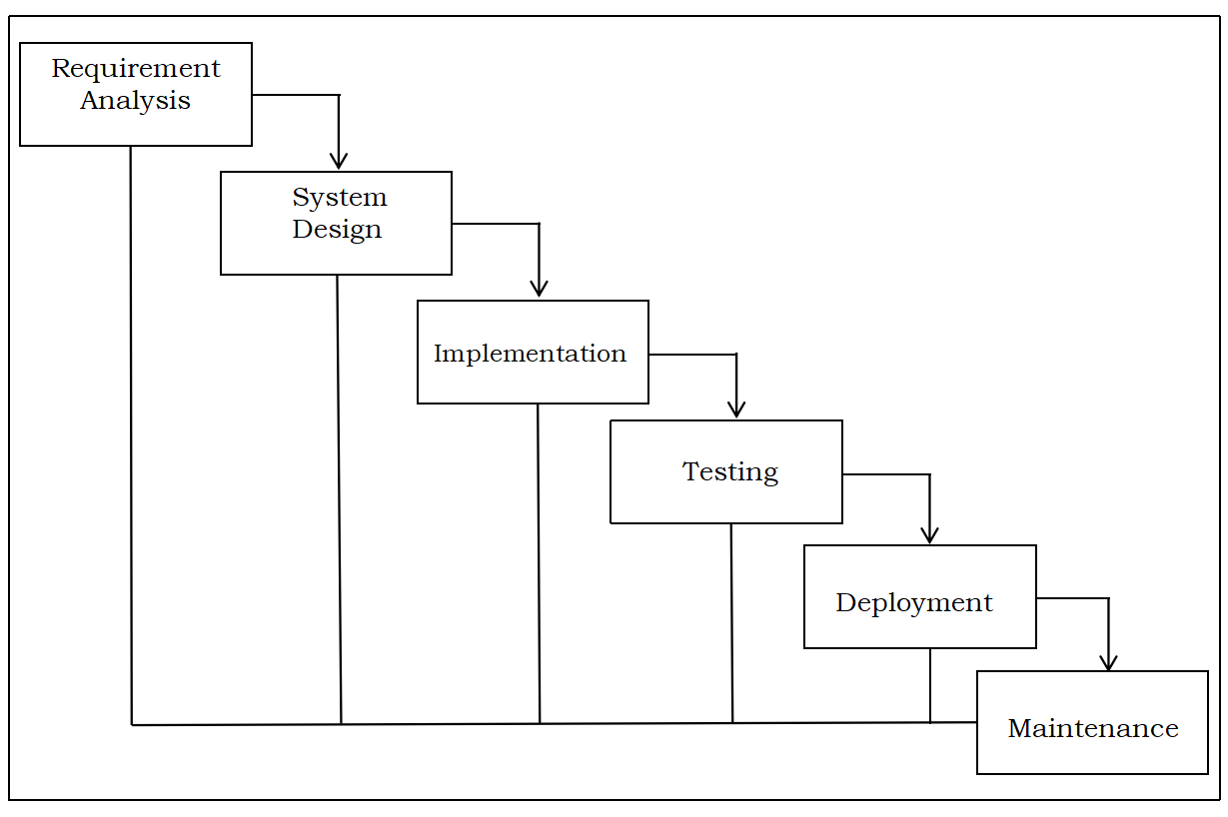
The development of ErrandExpress employed the Iterative Waterfall Model as the chosen software process model. This model was selected due to its structured yet adaptable nature, which aligns with the scope and complexity of the platform. The Iterative Waterfall Model divides the development cycle into well-defined phases: requirements analysis, system design, implementation, testing, deployment, and maintenance. After each phase, feedback is collected and necessary adjustments are made before proceeding to the next stage. This iterative approach allows for the gradual improvement of the system, especially during the testing and feedback phases.
Figure 2. The Iterative Waterfall Model
As illustrated in Figure 2, the Iterative Waterfall Model is well-suited for this system due to the need for continuous validation and refinement based on feedback from both student and faculty users. Considering the available resources and the timeline of the academic semester, this model ensures systematic progress while allowing for necessary adjustments informed by real-world usability testing.

Requirements Phase

Requirements Specification
The requirements for ErrandExpress were gathered through surveys, interviews, and informal consultations with faculty and students at Agusan del Sur State College of Agriculture and Technology (ASSCAT). These engagements helped identify key pain points in task delegation and highlighted the expectations for a digital platform to support microtask management.

User Requirements Faculty members and students serve as the primary users of the ErrandExpress platform — task requesters and task performers, respectively. Their individual expectations and required functionalities are outlined in the tables that follow:

Table 1. User Requirements for Faculty
Requirement | Description
Secure Registration  and Login | Faculty members must be able to securely register and access their accounts on the platform
Post Tasks | Faculty can post new tasks with details such as task type, deadline, location, and compensation
View Applicants | Faculty should be able to view and select from a list of student applicants for a task
Messaging Feature | A built-in chat system for communicating with students about task details
Track Task Progress | Faculty must be able to monitor task status from posting to completion
Provide Feedback | Faculty should have the ability to rate and give feedback to students after a task is completed

Table 2. User Requirements for Students
Requirement | Description
Secure Registration  and Login | Students must be able to create an account and securely access the platform
Browse and  Filter Tasks | Students can view available tasks and filter them by type, location, or available time slot
Accept or Apply  for Tasks | Students must be able to apply for or accept posted tasks
Messaging  Feature | Students must be able to communicate with faculty to clarify task details
Mark Task as  Completed | Students should be able to mark tasks as finished once done
View Feedback  and History | Students can see feedback received and view their performance history

Functional Requirements
The following section outlines the essential system features that facilitate seamless task-related interaction between faculty and students. Each function contributes to a complete task lifecycle beginning from task creation and ending with confirmation and user feedback.
Table 3: Functional Requirements
Requirement | Description
User Registration  and Login | Allows both faculty and students to create secure accounts and log in to the platform
Task Posting Module | Enables faculty to post tasks by entering task type, location, deadline, and compensation
Task Listing  and Filtering Sytem | Lets students browse and filter tasks by type, location, or time slot
Task Application  and Assignment  Feature | Allows students to apply for tasks and faculty to assign selected applicants
Real-Time Messaging System | Provides built-in chat for students and faculty to discuss task details and negotiate terms
Task Status Tracking  and Update Mechanism | Enables tracking of task progress from assignment to completion
Task Confirmation and Verification Process | Lets faculty confirm and verify that the task was completed satisfactorily
Feedback and  Rating Feature | Allows users to rate and leave feedback after task completion
Admin Panel | Provides administrative tools to manage users, tasks, and monitor system activity

Non-Functional Requirements
The following overview outlines the quality attributes expected from the ErrandExpress platform, including usability, performance, and security factors that influence the user experience, system reliability, and ease of maintenance.
Table 4. Non-Functional Requirements
Requirement | Description
Usability | The platform must be user-friendly and easy to navigate for both faculty and students
Performance | The system should be responsive and able to handle multiple users concurrently without lag or interruption
Security | Ensures user data is protected and communications are secure through authentication and encryption
Accessibility | The platform must be accessible via web browsers and optimized for mobile devices
Maintainability | The system should be built with standard coding practices and technologies for ease of maintenance
Reliability | The platform must perform its functions consistently under normal conditions without unexpected failures

Software and Hardware Requirements
Software Requirements
Software tools and platforms used for the development and deployment of the ErrandExpress system.
Table 5. Software Requirements
Software/Tools
Visual Studio Code | Source code editor used for front-end and back-end development
Postman | Used for API testing and debugging
Git and GitHub | Tools for version control and code collaboration
Libraries
React.js | JavaScript library used for building dynamic, responsive web interfaces
Firebase | Library providing tools for user authentication and messaging
Frameworks
Node.js | JavaScript runtime environment used for backend developmentrequests
Express.js | Web application framework used to manage server-side routing and APIs
Operating Systems
Windows 10 or higher | Used for development workstations
Windows/Android/iOS | Target platforms for web access by end-users.  Browser-compatible OS for user access.

Hardware Requirements
Hardware specifications required for development and user access to the ErrandExpress system.

Table 6. Hardware Requirements
Hardware Specification Description
Development Computer | Intel Core i5 processor, 8 GB RAM, 256 GB SSD, stable internet connection
User Device – Desktop/Laptop | At least 4 GB RAM, modern browser, internet-enabled
User Device – Mobile/Tablet | Android 8.0+ or iOS 13+, capable of running a modern web browser
Network Connectivity | Stable and reliable internet connection for platform access

Survey and Data Collection

Sampling Procedure
Participants for the survey were selected from the faculty and student population of Agusan del Sur State College of Agriculture and Technology (ASSCAT). A stratified sampling technique was employed to ensure representation from both faculty members and students, the two primary user groups of the ErrandExpress platform. Within each group, random sampling was used to select individuals who have varying levels of familiarity with task delegation processes.

Survey Instrument
To gather meaningful insights, the study used structured questionnaires as the primary survey instrument. These questionnaires included both closed-ended and open-ended questions designed to assess current practices, identify common task delegation challenges, and collect expectations for a digital microtasking system. Separate versions of the survey were created for students and faculty to ensure relevance and clarity.

Data Analysis
Collected data will be tabulated and analyzed using descriptive statistics. Frequency distributions, percentages, and graphical representations were used to summarize the data. Responses were evaluated to identify patterns and trends in user expectations and behavior, which guided the refinement of the system’s features. Where applicable, qualitative responses were categorized thematically to provide deeper insight into user concerns and preferences.

Feasibility Analysis

Economic Feasibility
The development of the ErrandExpress platform is economically feasible due to the use of open-source tools and technologies. Since the platform is a capstone project, no commercial software licensing fees are required. Development will be done using tools like Visual Studio Code, Firebase, and MongoDB, all of which offer free tiers. The primary costs are limited to internet usage, minimal printing or presentation materials, and electricity consumption. The potential benefits include time-saving for faculty, earning opportunities for students, and improved productivity within the campus community.
Technical Feasibility
The technology stack chosen for ErrandExpress, including Node.js, Express.js, React.js, and Firebase is highly capable of supporting the platform’s intended functionality. These tools are modern, scalable, and widely used in web development. Since the system will run on web browsers and does not require high-performance hardware, it is technically feasible for both development and deployment within the school environment. The developers are familiar with the tools and capable of learning necessary components through documentation and community support.
Operational Feasibility The ErrandExpress platform is operationally feasible within the environment of Agusan del Sur State College of Agriculture and Technology (ASSCAT). The institution already uses digital platforms for education and communication, which makes user adaptation more likely. The system integrates into the existing workflow by allowing faculty to post real-world tasks and students to fulfill them. Since the interface is designed to be user-friendly, both students and faculty can use the platform with minimal training. The benefits in terms of task management efficiency and student engagement contribute to the system's long-term viability.

Project Cost
The following table provides a breakdown of the estimated costs associated with the development, testing, deployment, and maintenance of the ErrandExpress platform. These include both direct and indirect costs incurred throughout the capstone project lifecycle.
Table 7. Estimated Project Cost Breakdown
Cost Item | Description | Estimated Cost (PHP)
Internet Usage | Monthly data subscription and usage during development | 1,000
Printing  and Documentation | Hard copies of reports, and presentation materials | 500
Electricity | Power consumption during development sessions | 500
Equipment | Laptops, mobile phones, and peripherals (no purchase needed) | 0
Software Tools and Libraries | Open-source tools (VS Code, Git, Firebase, MongoDB) | 0
Transportation (Meetings/Defense) | Local transport during project coordination and capstone presentation | 1,000
Contingency | Miscellaneous or unforeseen minor expenses | 500
Total Estimated Cost |  | 3,500

Risk Management
Risk Type | Description | Mitigation Strategy
Technical | Lack of experience with chosen technologies could delay development | Conduct self-paced learning through documentation, tutorials, and developer communities to build competence with the chosen technologies
Financial | Limited funding for internet, printing, or presentation materials | Utilize open-source software and maintain a small buffer fund to cover essential minor expenses
Operational | Users may face difficulty in adopting the new platform | Design a user-friendly interface supported by clear onboarding instructions and user assistance materials
Schedule | Academic responsibilities may impact development time | Establish a structured development schedule with defined tasks and assigned team roles to ensure accountability
Data Security | Risk of unauthorized access to user accounts and task data | Apply robust Firebase authentication methods along with encrypted data transactions and secure storage protocols
The development of the ErrandExpress platform involves several potential risks across technical, financial, and operational aspects. To ensure the project remains on track, the following risks and their corresponding mitigation strategies have been identified:
Table 8. Risk Assessment and Mitigation Strategies
Implementation Plan
Team Collaboration and Planning
The development team collaborated through consistent weekly meetings and used tools such as Gantt charts to visualize timelines and deadlines. Task boards were employed to assign responsibilities and monitor task progress. Each member was assigned roles based on strengths in research, design, development, or documentation. Regular consultations with the project adviser ensured alignment with academic guidelines and project goals.
Designing, Programming, Compilation, and Linking
The design process began with creating wireframes and interface prototypes using Figma. System architecture and database structures were outlined before implementation. Programming involved writing modular code in React.js for the front end and Node.js with Express for the backend. Source files were compiled using build tools and linked into a single deployable application. Frequent code reviews helped catch errors early and ensured consistency in code structure.
Structuring and Quality Control
To maintain quality throughout development, the team established naming conventions and modular design principles. Code versions were managed manually by maintaining local backups, and updates were regularly reviewed as a team to ensure consistency and quality. Testing included unit tests, integration testing, and user acceptance testing (UAT) to validate features and usability. Identified issues were documented and resolved before progressing to the next development cycle.
System Documentation Documentation
Included a user manual for faculty and students, outlining how to post, accept, and track tasks. A technical guide was also developed, detailing system architecture, installation instructions, and administrative functions. These documents ensure maintainability and provide reference for future enhancements or support needs.
System Installation and Configuration
The system was hosted on a cloud-based server, allowing platform access through standard web browsers. Installation involved uploading source files to a live environment using platforms such as Vercel or Firebase Hosting. Configuration included setting up environment variables, initializing the database, and testing system performance under live conditions.
System Start-up and Administration
The system was officially launched within the ASSCAT environment after final validation. User credentials were distributed to test users (students and faculty) to begin real-world usage. Ongoing administration involves monitoring activity, resolving reported issues, and periodically backing up the database. Feedback from users during this stage continues to inform refinements and long-term maintenance strategies.
Design Phase
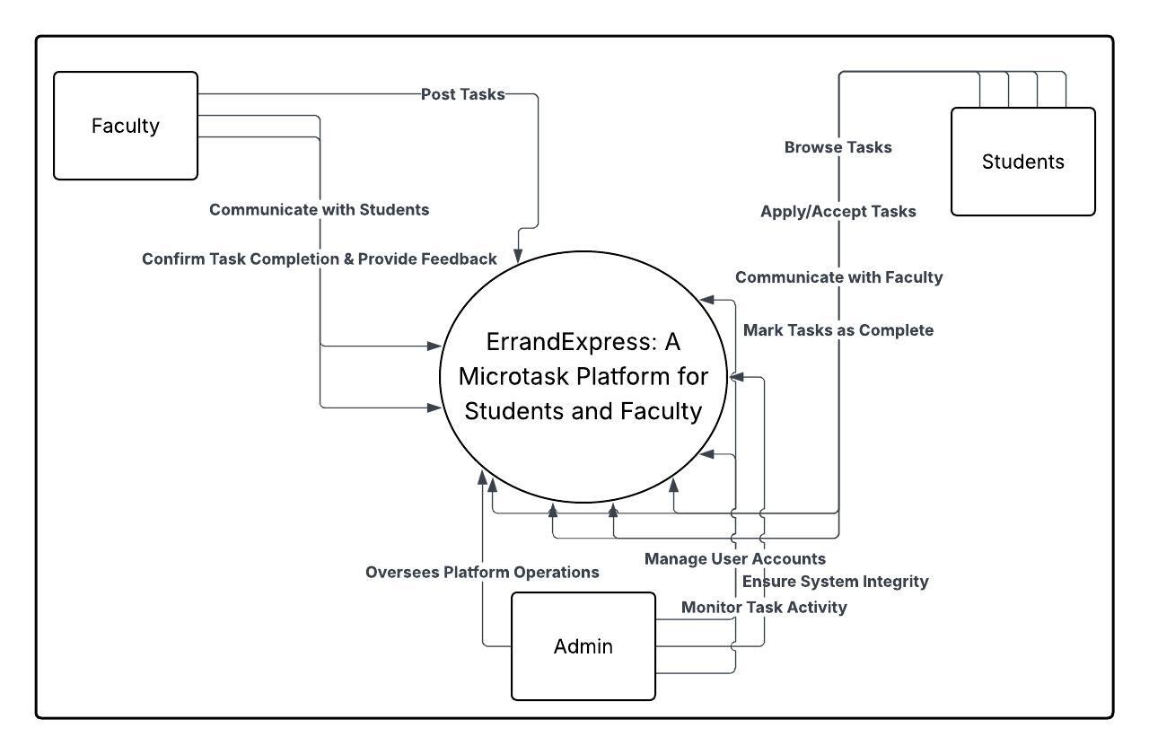
ErrandExpress: A Microtask Platform for Students and Faculty features key design elements such as the context diagram, data flow diagram, use case diagrams, entity-relationship diagrams, data dictionaries, and sequence diagrams. The context diagram shows system interactions with external entities, while the data flow diagram maps how information moves between processes. The use case diagram highlights user interactions, the entity-relationship diagrams define data relationships, the data dictionaries ensure consistency, and the sequence diagrams visualize the flow of operations over time. Figure 3. Context Diagram of the System
In the ErrandExpress platform, the Faculty serves as the source of microtasks and plays a critical role in task management. Faculty members interact with the system primarily to post tasks that students can view and apply for. They are also responsible for maintaining communication with students throughout the task process, providing necessary details or clarifications. Once a student marks a task as complete, it is the faculty’s role to review and confirm the task's completion and provide appropriate feedback or ratings. Their participation ensures that tasks are properly defined, monitored, and evaluated.
The Students act as the primary task executors within the system. They use the platform to browse available tasks, often filtering them based on their preferences or schedules. After identifying a suitable task, students can apply or accept the task depending on its availability. Communication with faculty is a vital part of their interaction, as it allows for clarification of expectations or instructions. Upon completion of a task, students are responsible for marking it as done within the system, signaling to the faculty that it is ready for review. This process allows students to engage in productive work while developing responsibility and communication skills.
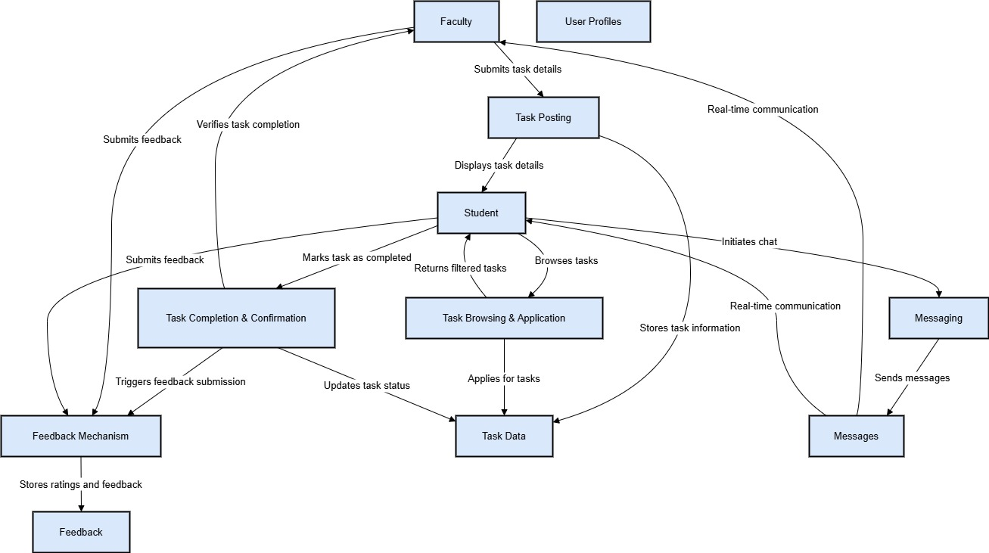
The Admin is responsible for overseeing the overall operation of the ErrandExpress platform. This includes managing user accounts by adding, updating, or removing access for both students and faculty as needed. The Admin actively monitors ongoing task activities to ensure that processes are functioning correctly and that users are engaging with the system appropriately. In addition, the Admin ensures the integrity of the platform by addressing issues, resolving conflicts, and maintaining system reliability. This role is essential to keeping the platform organized, secure, and operating according to its intended purpose.
Figure 4. Data Flow Diagram of the System
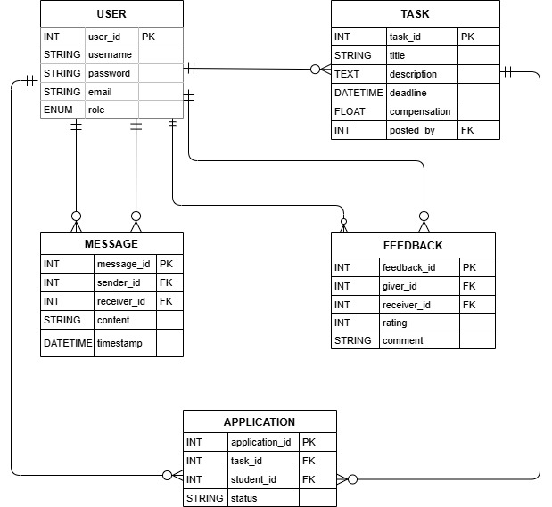
The Data Flow Diagram (DFD) illustrates the internal flow of data within the ErrandExpress platform, focusing on how information is processed and transferred between users and the system’s core functionalities. At Level 0, the diagram outlines the major processes that include task posting, task browsing and application, messaging, task completion and confirmation, and feedback. Faculty members begin the cycle by posting tasks with details such as title, deadline, location, and compensation. Students then browse these available tasks and apply for the ones that match their preferences or skills. A messaging system enables faculty and students to communicate directly, fostering clarification and coordination during task execution. Once a student completes a task, they mark it as done within the platform, which prompts the faculty to verify completion and provide a review. After confirmation, both faculty and students can exchange feedback and ratings to maintain transparency and ensure accountability. This diagram effectively maps the movement of data and interactions, supporting seamless task lifecycle management across the system.
Figure 5. Entity Relationship Diagram of the System
The Entity Relationship Diagram (ERD) defines the structural framework of the ErrandExpress platform by outlining the main entities in the system and the relationships between them. This data model includes essential entities such as User, Task, Application, Message, and Feedback, each designed to support specific platform functionalities. The User entity represents all registered individuals, both faculty and students, distinguished by a role attribute that categorizes them accordingly. The Task entity captures details about each posted errand, including the title, description, deadline, compensation, and the faculty member who created it. Applications are recorded in a dedicated entity, tracking which students have applied for specific tasks along with the status of their application. The Message entity supports the communication system, documenting messages exchanged between users about particular tasks. Lastly, the Feedback entity stores performance evaluations submitted by users upon task completion, promoting accountability and quality assurance. These defined relationships between entities support the platform’s core operations by maintaining clear linkages between users, tasks, and associated activities such as applications, communication, and feedback.

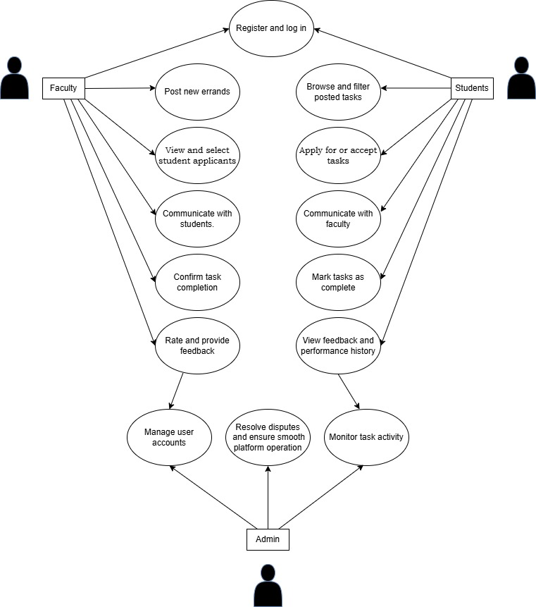

Figure 6. Use Case Diagram of ErrandExpress
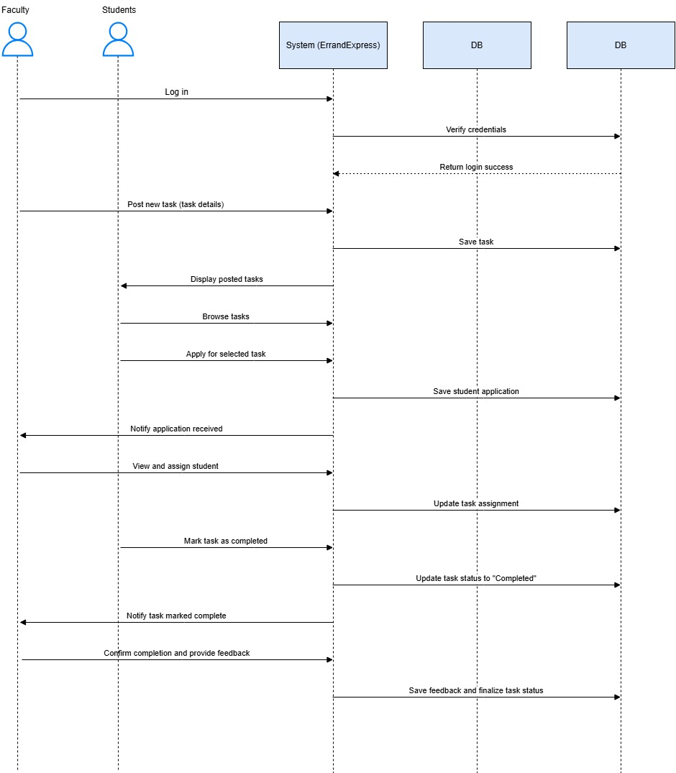
The Use Case Diagram provides a visual representation of the primary interactions between users and the ErrandExpress system, capturing the core functionalities accessible to each role - Faculty, Students, and Admin. It illustrates how faculty members utilize the platform to register, log in, post errands, manage student applicants, communicate with selected students, confirm task completion, and provide feedback. Students, in turn, can register and log in, browse and filter available tasks, apply for or accept tasks, communicate with faculty, mark tasks as complete, and view their feedback or performance history. The Admin plays a supervisory role, with use cases centered around managing user accounts, monitoring task activity, and resolving disputes to ensure smooth platform operation. Each use case corresponds to a functional requirement, ensuring that the system accommodates the full range of actions needed by its users. This diagram effectively summarizes the different ways users engage with the platform and helps guide the development of user-centered features.
Figure 7. Sequence Diagram of the System

The Sequence Diagram depicts the chronological flow of interactions between the users and the system throughout a typical task lifecycle in the ErrandExpress platform. It begins when a faculty member logs in and posts a task, which is then stored in the system and displayed to all eligible student users. A student browsing available tasks may choose to apply for one, prompting the system to notify the corresponding faculty member. The faculty then reviews the application and assigns the task to the selected student. Upon completing the task, the student marks it as done within the platform, which prompts the system to request verification from the faculty. Once the task is verified, the faculty provides feedback, which the system records and uses to update the task’s status and user performance history. This diagram ensures transparency by detailing each system-user interaction and data update, supporting effective communication, accountability, and accurate task tracking.
Field Name | Data Type | Length | Description | Related Table
user_id | String | 36 | Unique identifier for each user (UUID) | User
name | String | 100 | Full name of the user | User
email | String | 100 | Email address (used for login and contact) | User
role | String | 10 | Indicates 'faculty', 'student', or 'admin' | User
password | String | 255 | Encrypted password | User
task_id | String | 36 | Unique identifier for each task | Task
title | String | 100 | Title or name of the task | Task
description | Text | - | Detailed description of the task | Task
deadline | DateTime | - | Task submission deadline | Task
compensation | Decimal | 10,2 | Monetary reward or equivalent | Task
status | String | 20 | Status: pending, assigned, completed | Task, Application
application_id | String | 36 | Unique identifier for task applications | Application
student_id | String | 36 | Foreign key referencing the applicant (user_id) | Application
message_id | String | 36 | Unique ID for messages | Message
sender_id | String | 36 | Foreign key: sender (user_id) | Message
receiver_id | String | 36 | Foreign key: receiver (user_id) | Message
content | Text | - | Message content | Message
timestamp | DateTime | - | Date and time sent | Message
feedback_id | String | 36 | Unique ID for feedback entries | Feedback
from_user | String | 36 | User giving the feedback | Feedback
to_user | String | 36 | User receiving the feedback | Feedback
rating | Integer | 1 | Score (1-5) | Feedback
comment | Text | - | Additional remarks | Feedback

Figure 8. Data Dictionary of the ErrandExpress System
The Data Dictionary of the ErrandExpress platform provides a comprehensive reference for the database schema by defining each field's name, data type, length, description, and the table it belongs to. It outlines the structure and characteristics of critical data elements used across the system’s main modules. For instance, the user_id field is a unique identifier for each user and appears in multiple tables, linking user-related data with other components such as tasks, applications, messages, and feedback. Fields like name, email, role, and password define essential attributes for user management. The task_id field serves as a unique key for tasks and is associated with properties such as title, description, deadline, compensation, and status. Applications are tracked using application_id and are connected to both student and task identifiers. Messaging and feedback functionalities are supported by structured fields like message_id, sender_id, receiver_id, content, timestamp, feedback_id, rating, and comment. By organizing these fields within clearly defined tables—User, Task, Application, Message, and Feedback—the data dictionary ensures consistency, accuracy, and integrity across all system operations.

Development Phase
The development of the ErrandExpress platform followed a modular and collaborative approach using the following tools and technologies:

Tools & Technologies Used
- Frontend: React.js for component-based UI development
- Backend: Node.js with Express.js for handling server-side logic and API routing
- Database: Firebase Firestore for NoSQL storage and authentication
- Version Control: Git & GitHub for code versioning and collaboration
- Prototyping: Figma for interface design and layout planning
- Deployment: Vercel for frontend hosting; Firebase for backend services

Best Practices
- Clean, modular code using ES6+ standards
- Responsive UI optimized for both desktop and mobile
- Secure authentication using Firebase Auth
- Regular code reviews and refactoring for maintainability
- Commenting and documentation to enhance readability
- Task boards (e.g., Trello) for organizing development workflow

Testing Phase
To ensure the functionality and reliability of ErrandExpress, multiple types of testing were performed:

Types of Testing
- Unit Testing: Ensured individual functions and components perform as intended.
- Integration Testing: Verified that modules (e.g., messaging + authentication) work together.
- System Testing: Assessed the platform’s overall operation in simulated real-world conditions.
- User Acceptance Testing (UAT): Conducted with select students and faculty to validate usability and functionality.

Testing Tools & Strategy
- Jest (for frontend unit tests)
- Postman (for API testing and debugging)
- Manual Testing (for user interface interaction and experience checks)

Issue Resolution
- All bugs and inconsistencies were logged using a shared bug tracker.
- Each issue was assigned to a team member with priority levels.
- Fixes were tested, documented, and reviewed before re-deployment.

Deployment Phase

Deployment of the ErrandExpress platform to the production environment was conducted in a controlled, multi-step process: Deployment Steps
- Code Compilation & Build: Final frontend code was built via Vercel’s CI/CD pipeline.
- Database Configuration: Firestore rules and structures were set for live use.
- Environment Variables: Keys and API settings were configured for production.
- User Training: Orientation sessions for faculty and students, along with user manuals.
- Data Migration: No pre-existing data to migrate; started with fresh user registration.
- Final Validation: Conducted smoke testing in the live environment to confirm feature readiness.
- Monitoring: Admin panel used to monitor activities, log data, and gather post-launch feedback.
LITERATURE CITED

Zhao, J., Liu, Q., Son, H., & Liu, Y. (2025). Errand delivery adoption by business users: Integrated perceived SERVQUAL model within TOE- TAM model. Retrieved on January 22, 2025 from https://doi.org/10.1016/j.rtbm.2025.101313

Tian, C., Fang, X., Yang, X., & Wang, Y. (2022). A Cross-platform Errand Service Application for Campus with a Dual-user Identity Model. Retrieved on October 31, 2022 from https://ieeexplore.ieee.org/document/9930264

Dela Cruz, M., Santos, L., & Reyes, P. (2022). Bridging gaps in academic task management: Opportunities for student engagement.

Ancheta, A.D., Catbagan, J.S., De Guzman, I., Hortizuela, M.R., & Pulido, J. (2021). EL-service-YU: An Android Mobile Application for Errand Services. Retrieved on December 11, 2021 from https://ieeexplore.ieee.org/document/9681457

Garcia, R. (2019). Challenges in academic microtask management: A case study. Journal of Educational Administration, 57(3), 245– 259.

Tuano, M., Martinez, D., Cayabyab, A., Sapin, S., & Lanuang, M. (2021). E-rrands: An android-based application for shop and ship of concierge services integrating geolocation technology. Retrieved on December 2021 from https://www.researchgate.net/publication/361912868_Errand s_An_androidbased_application_for_shop_and_ship_of_concierge_ services_integrating_geolocation_technology

Jones, A., & Lee, S. (2021). The digital shift: Streamlining operations through real-time communication. Technology and Society Journal, 18(2), 112–130.

Zhao, J., Liu, Q., Lee, M.K., Qi, G., & Liu, Y. (2024). Consumers’ usage of errand delivery services: The effects of service quality and consumer perception. Retrieved on July 29, 2024 from https://www.sciencedirect.com/science/article/abs/pii/S0969 698924003448
Demir, I. (2024). Errand Runners of Digital Platform Capitalism: The Errand Economy as a Contribution to the Discussion on the Gig Economy. Retrieved on February 27, 2024 from https://doi.org/10.31269/triplec.v22i1.1438

Weldone, S. (2013). Operations Scheduling and Service Quality Among Errand Service Providers in Kenya. Retrieved on October, 2013 fromhttps://erepository.uonbi.ac.ke/bitstream/handle/11295/ 63044/Sigei_Operations%20scheduling%20and%20service%20q uality%20among%20errand%20service%20providers%20in%20 Kenya.pdf?sequence=3&isAllowed=y

Smith, J. (2020). Technology and its impact on modern communication and education. Global Communications Review, 12(1), 35–50.

Tenn, J. (2017). Errand Running App for Android With Geolocation Support. Retrieved on April 15, 2017 from https://core.ac.uk/download/pdf/237084314.pdf

