VISIONS FILM FESTIVAL AND CONFERENCE | 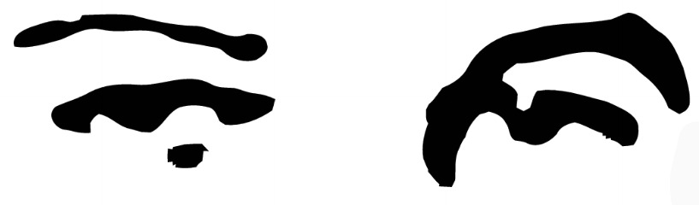
2012 ENTRY FORM
PAPER SUBMISSIONS

Please fill out the information below. Attach this completed form with your abstract and a brief author bio, then email to visions@uncw.edu.

AUTHOR INFORMATION

Author |  | Date
University |  | Department
Paper topic

Technical requirements:

(i.e. projectors, A/V equipment, PowerPoint, etc.)

ABSTRACT AND AUTHOR BIO

In 250 to 400 words, outline the main points of the argument presented in your paper, detailing the field of academic discourse to which you will be contributing. In addition, please include a brief author bio.

Email abstracts to visions@uncw.edu.
(In subject line: “Abstract Submission: Applicant’s Name”)

Deadline for abstracts: January 6, 2012
Deadline for papers (if selected): February 8, 2012

**NOTE: Works-in-progress will not be accepted. All papers must meet MLA guidelines.**

CONTACT INFORMATION

Address
City |  | State/Region
Country |  | ZIP Code
Phone |  | Email

FOR OFFICIAL USE ONLY
- Entry Form  - Abstract  - Author Bio | Paper Submission Complete?  - Yes ☐ No
Proceed? ☐ Yes ☐ No

