DES加密算法标准

2.1 分组长度：8-bit

2.2 密钥长度：10-bit

2.3 算法描述：

2.3.1 加密算法：[C=IP^{-1}(f_{k_{2}}(SW(f_{k_{1}}(IP(P)))))](" \l ")

2.3.2 解密算法：[P=IP^{-1}(f_{k_{1}}(SW(f_{k_{2}}(IP(C)))))](" \l ")

2.3.3 密钥扩展：[k_{i}=P_{8}(Shift^{i}(P_{10}(K))), (i=1,2)](" \l ")

2.4 转换装置设定：

2.3.1 密钥扩展置

* [P_{10}=(3,5,2,7,4,10,1,9,8,6)](" \l ")

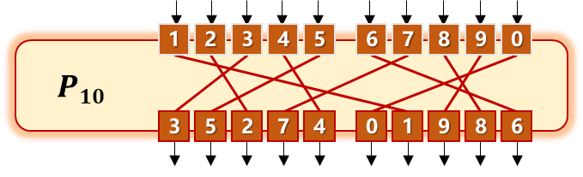

* [P_{8}=(6,3,7,4,8,5,10,9)](" \l ")

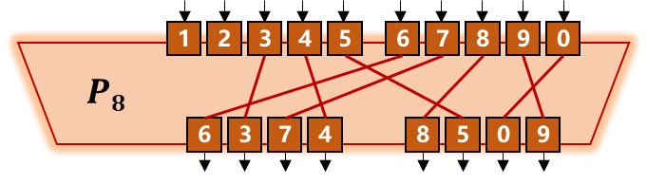

* [Left_Shift^1=(2,3,4,5,1)](" \l ")
* [Left_Shift^2=(3,4,5,1,2)](" \l ")

2.3.2 初始置换盒

* [IP=(2,6,3,1,4,8,5,7)](" \l ")

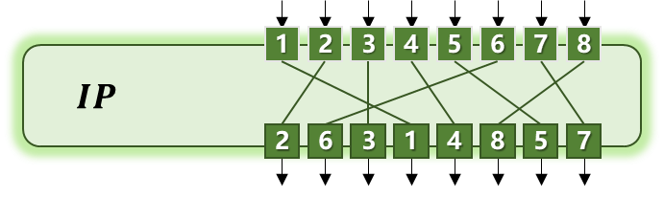

2.3.3 最终置换盒

* [IP^{-1}=(4,1,3,5,7,2,8,6)](" \l ")

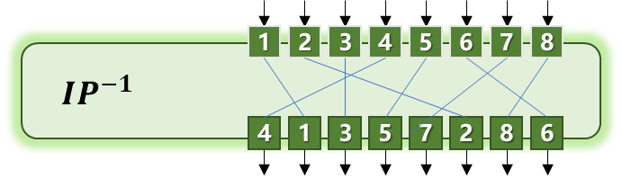

2.3.4 轮函数[F](" \l ")

* [EPBox=(4,1,2,3,2,3,4,1)](" \l ")

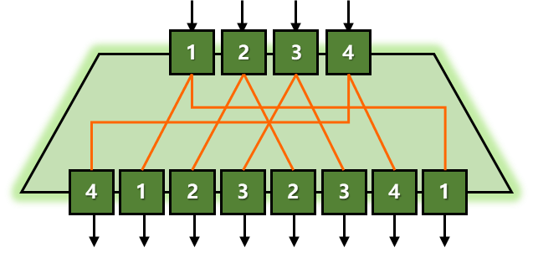

* [SBox_{1}=[(1,0,3,2);(3,2,1,0);(0,2,1,3);(3,1,0,2)]](" \l ")

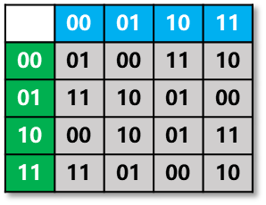

* [SBox_{2}=[(0,1,2,3);(2,3,1,0);(3,0,1,2);(2,1,0,3)]](" \l ")

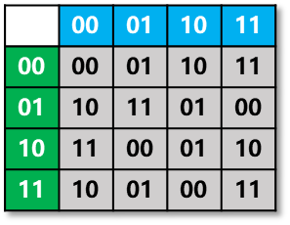

* [SPBox=(2,4,3,1)](" \l ")

