Задание 1

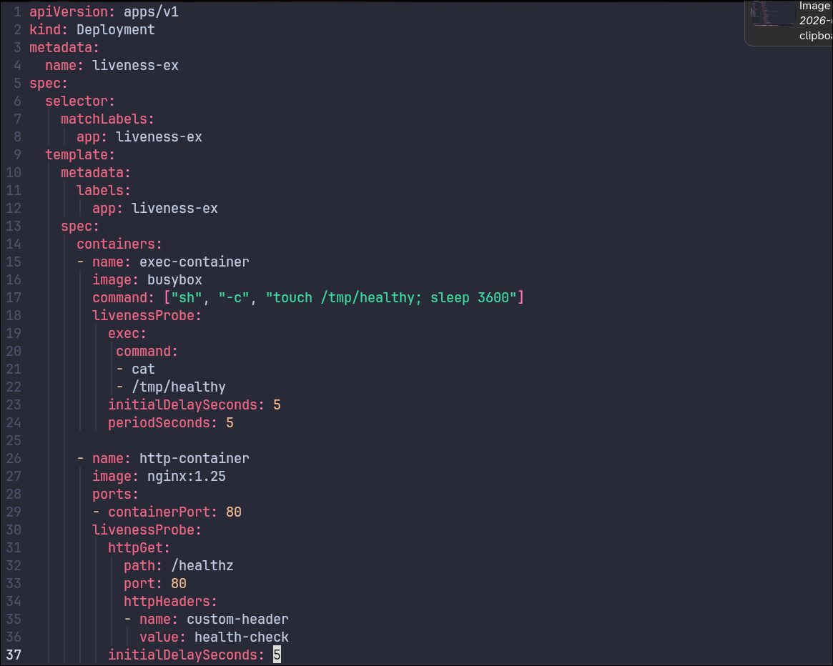
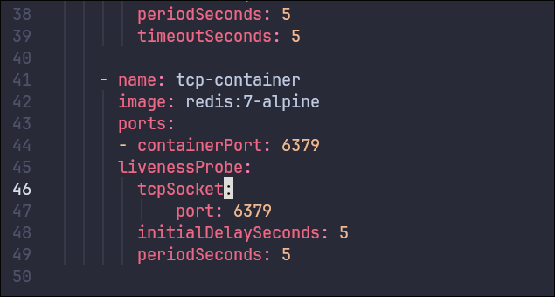
deploy.yaml
kubectl get pods -l app=liveness-ex

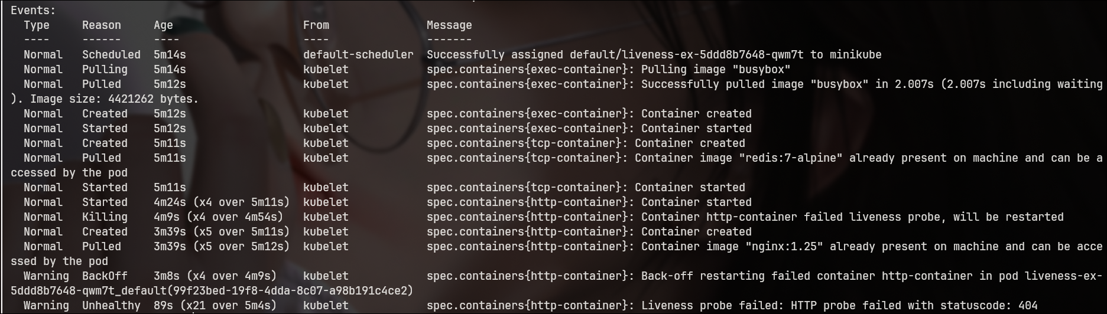
kubectl describe pods -l app=liveness-ex

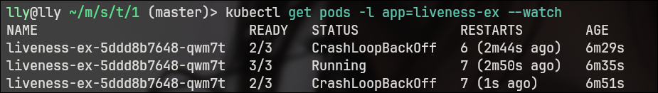
kubectl get pods -l app=liveness-ex –watch

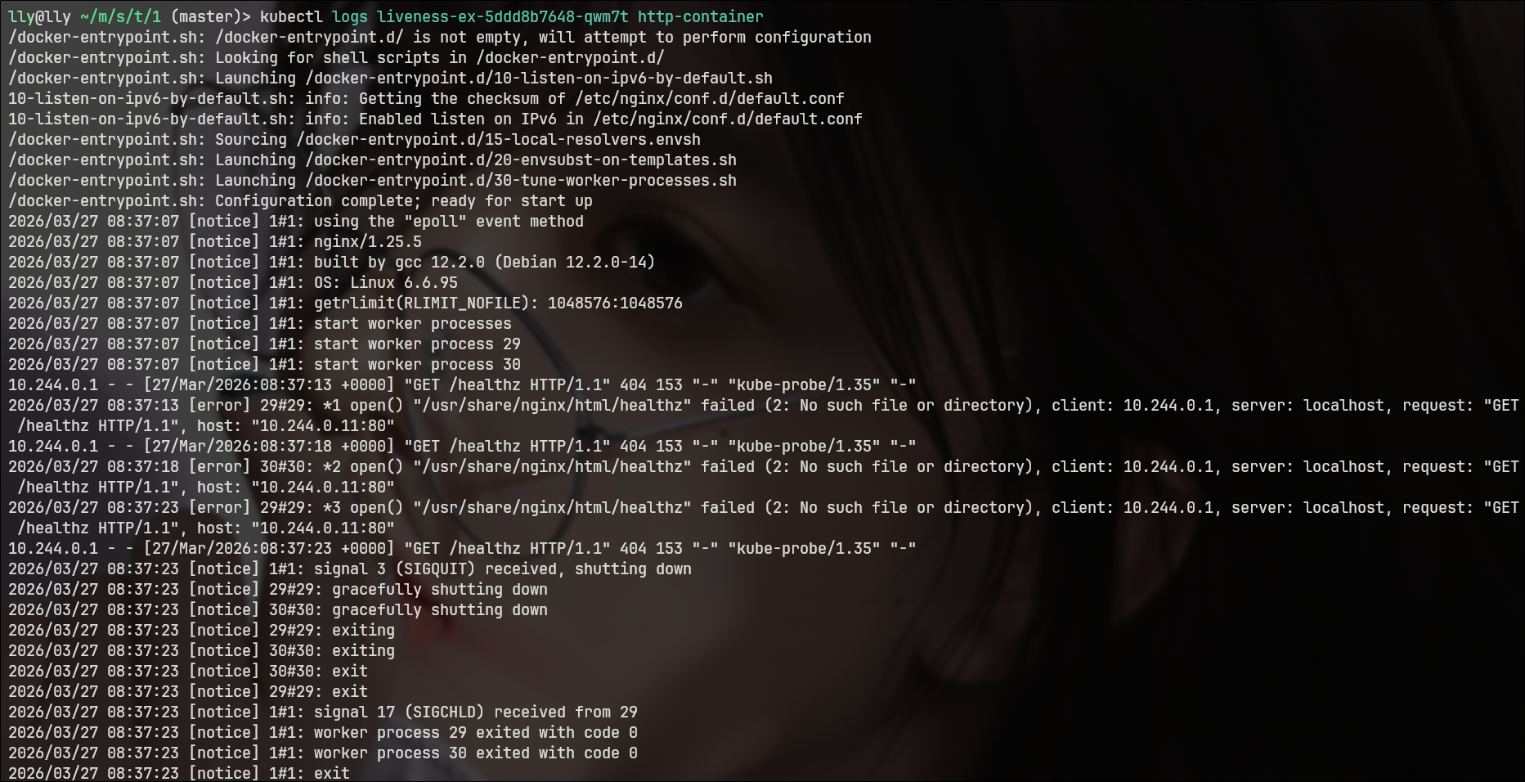
kubectl logs <pod_name> http-container

