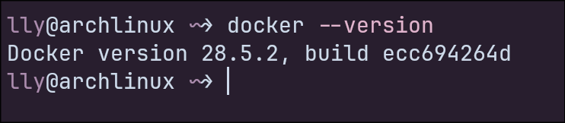
Docker --version

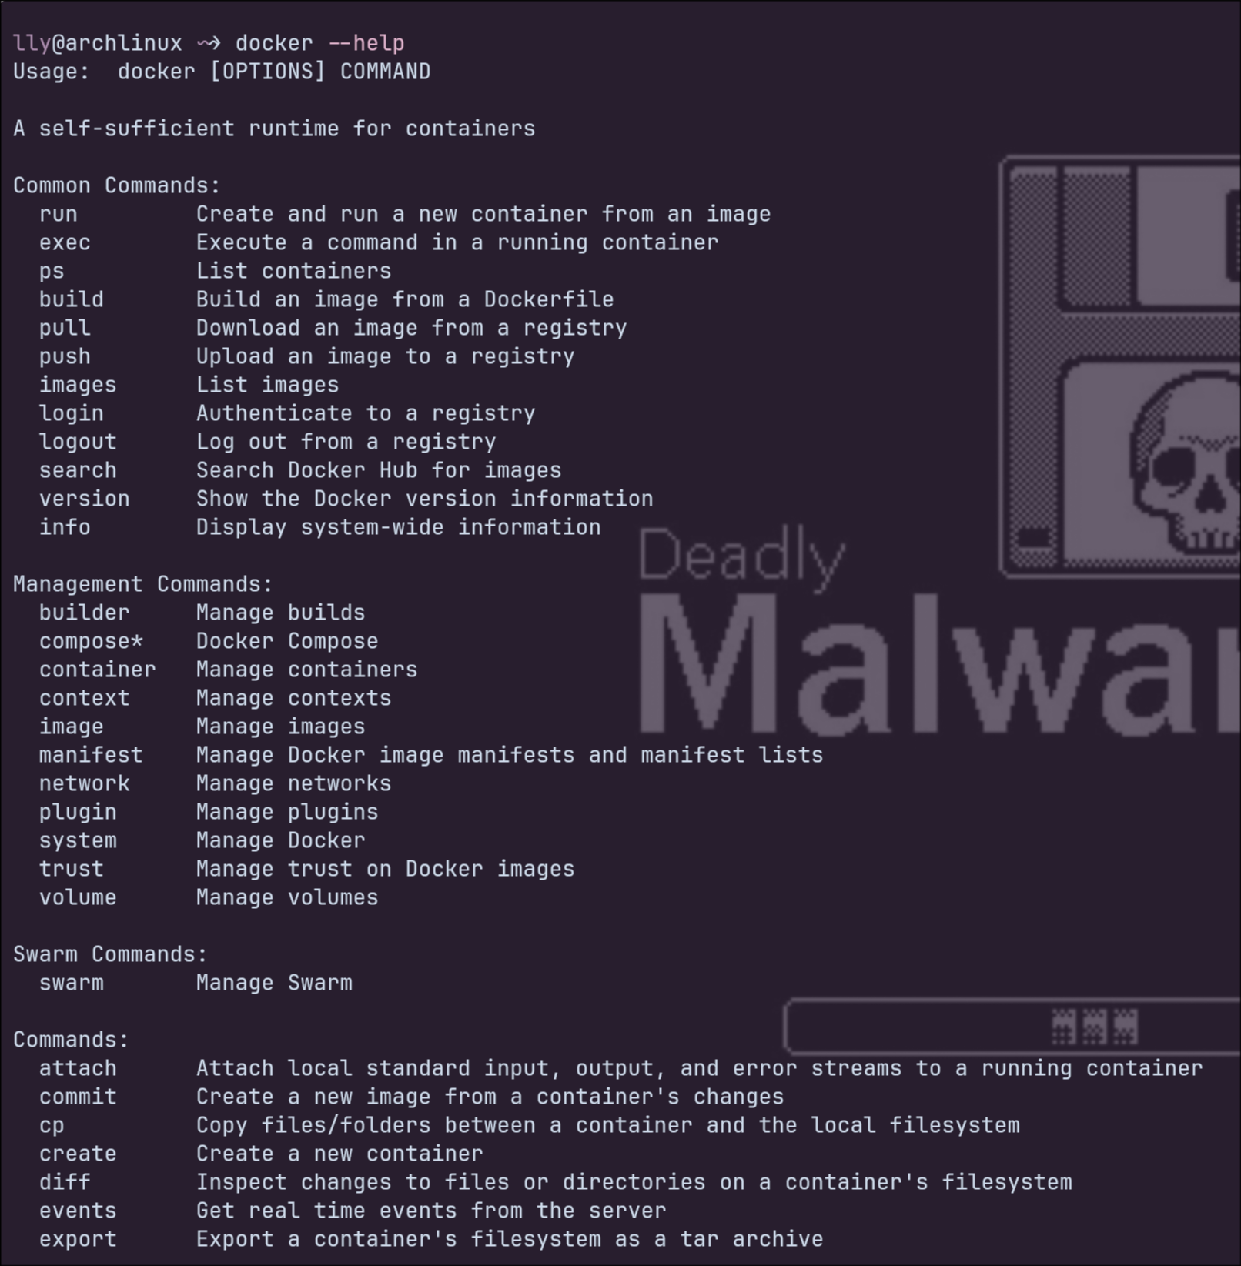
docker --help

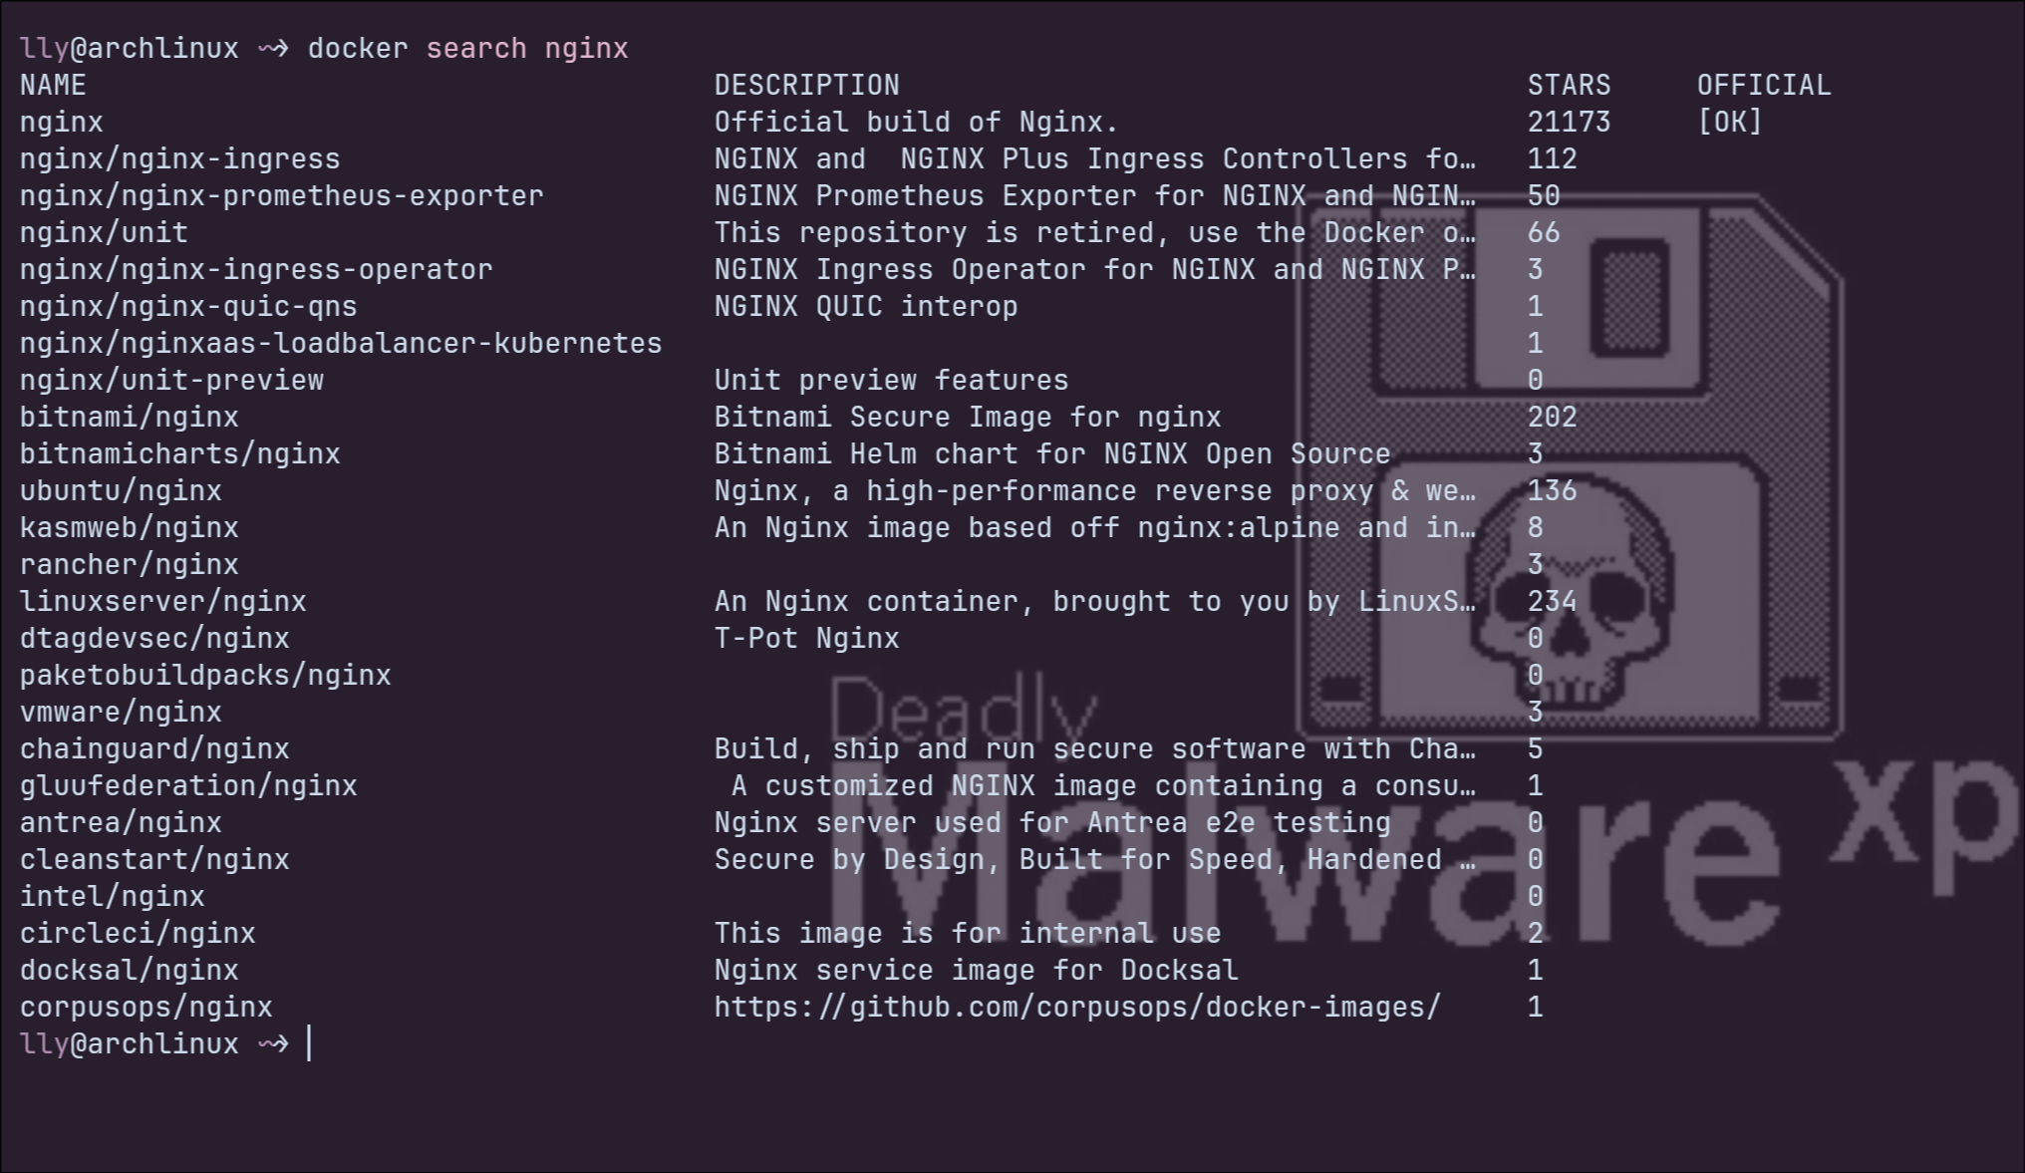
docker search nginx

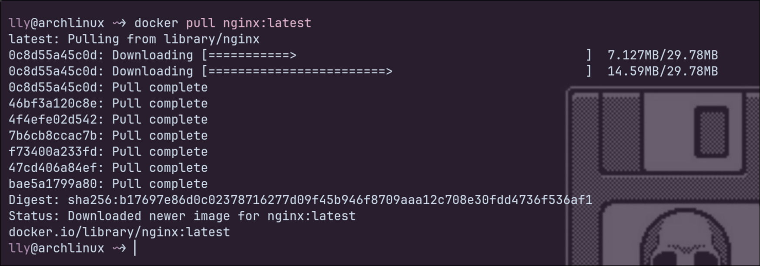
docker pull nginx:latest

docker run -d —name my_ngingx -p 80:80 nginx:latest

docker ps -a

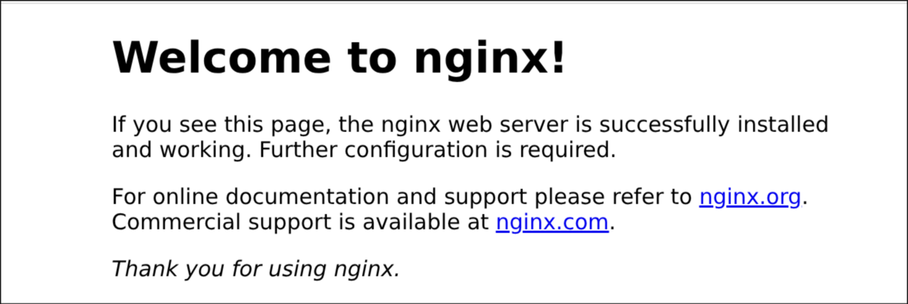
nginx output

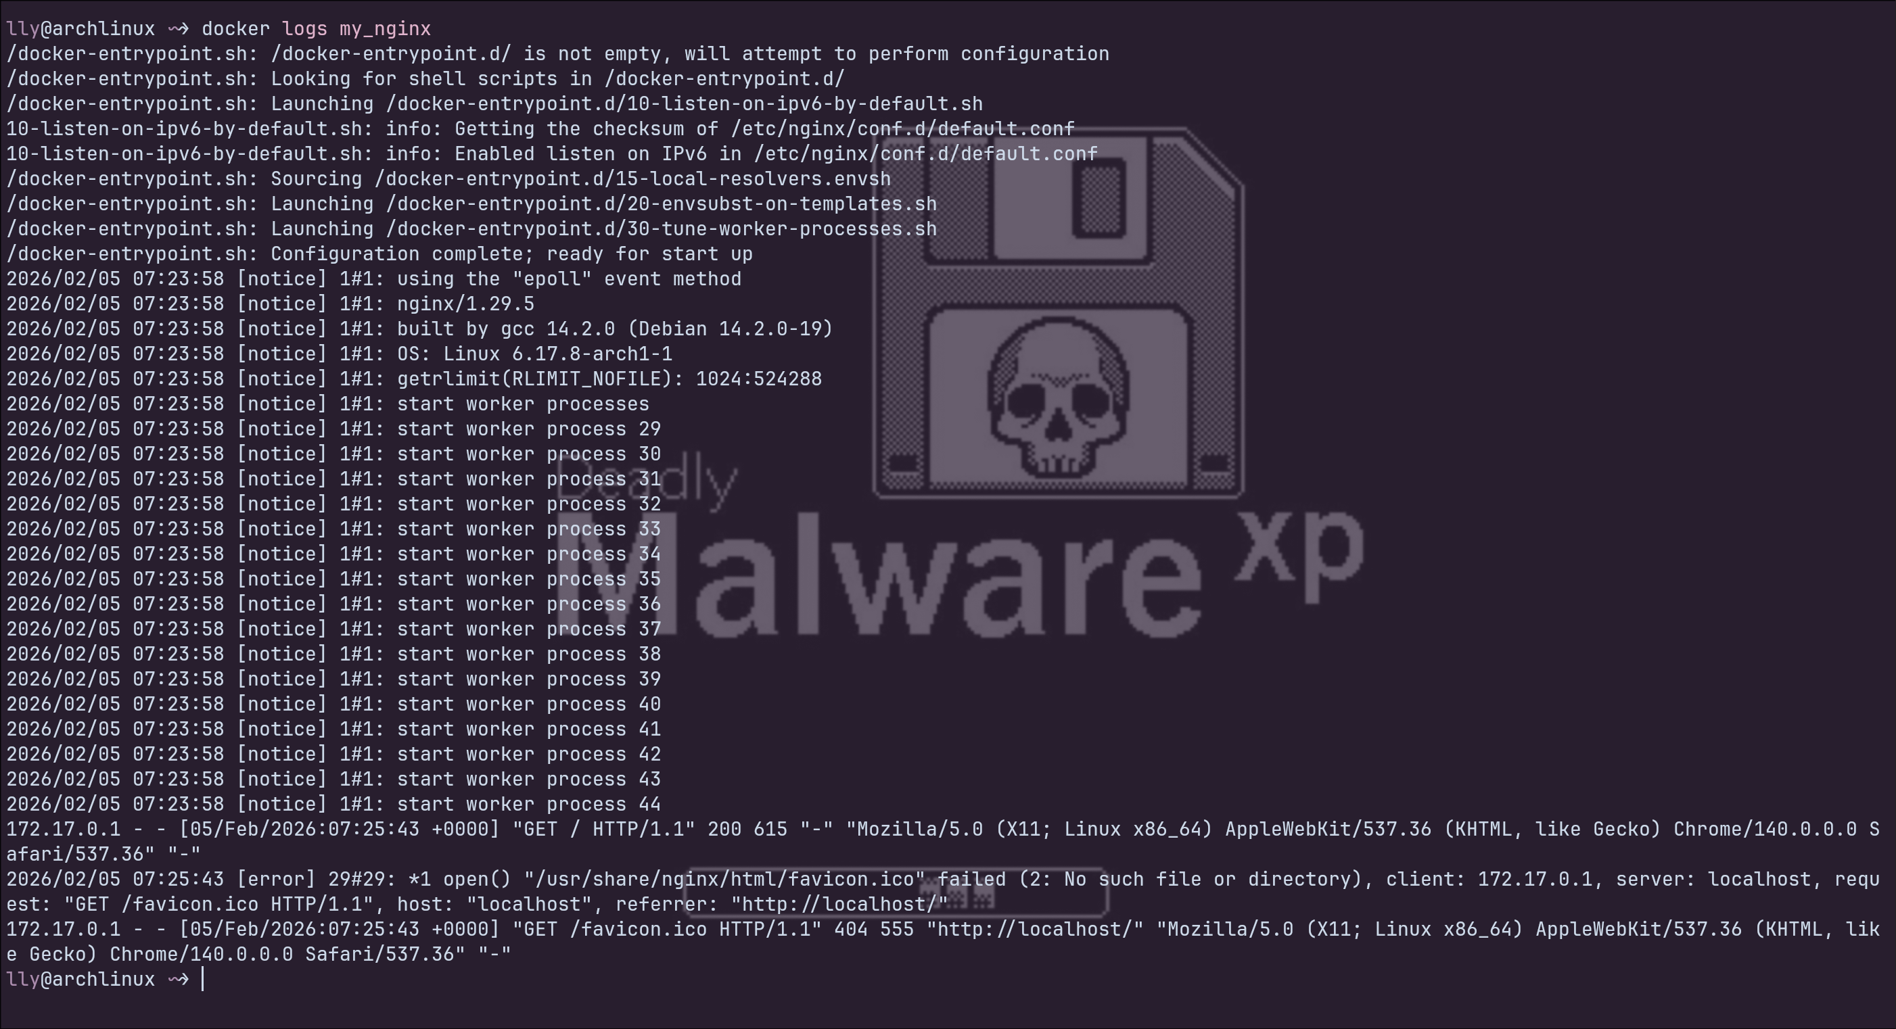
docker logs my_nginx

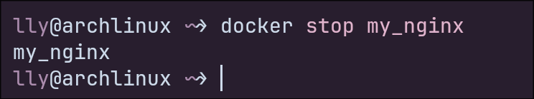
docker stop my_nginx

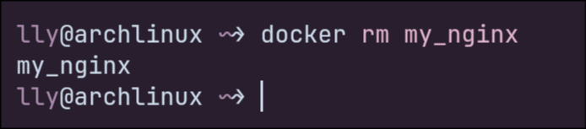
docker rm my_nginx
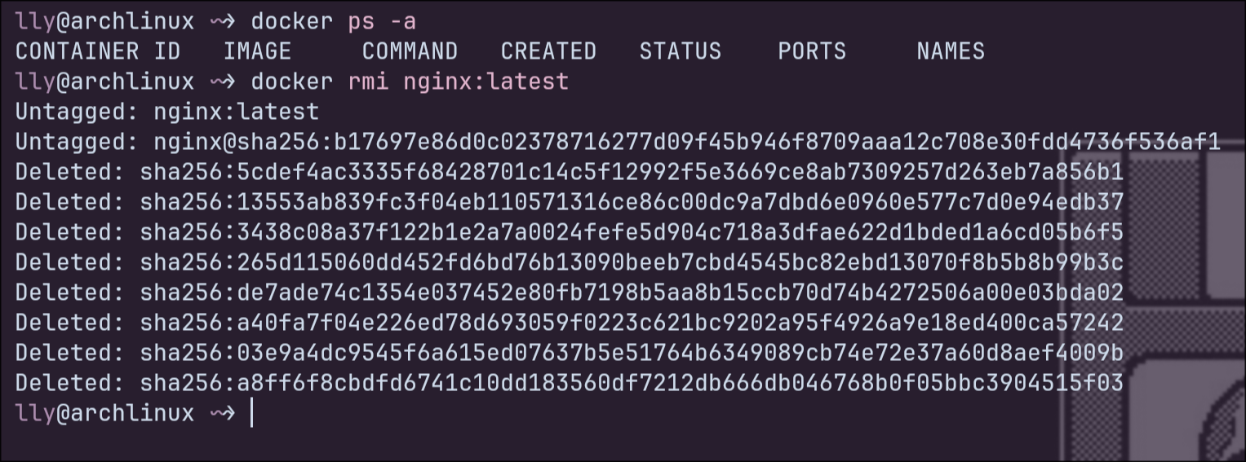
docker ps -a
docker rmi nginx:latest

