Задание 1

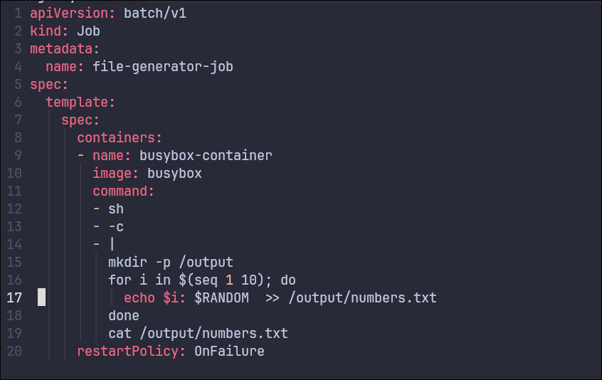
job.yaml


kubectl logs job/file-generator-job && kubectl get jobs -w

