

Comparative Data Mining
on Adult and Mushroom
Classification and Association Analysis
CDS 535 DATA MINING
Report date 28 October 2026
Team name [TEAM NAME] Instructor [INSTRUCTOR]
Member | Full name | Student ID
1 | HUANG WENLONG | [Student ID]
2 | LUO YIPENG | [Student ID]
3 | WEN YONGCHENG | [Student ID]
4 | LIU YONGZHI | [Student ID]
5 | FU SHIFANG | [Student ID]
6 | CHEN YISHU | [Student ID]

Abstract
We compare complete data mining pipelines on the UCI Adult and Mushroom datasets, downloaded directly from the UCI Machine Learning Repository. The study combines data auditing, missing value handling, encoding and scaling, four classifiers, and Apriori association analysis. Each dataset is assessed using training-set stratified ten-fold cross-validation and a separate stratified 20% holdout test. A fixed baseline uses identical classifier configurations across datasets while retaining preprocessing appropriate to their attribute types.
Adult contains 48,842 records with mixed attributes and a 23.93% high-income positive class. Mushroom contains 8,124 records with categorical attributes and a 48.20% poisonous class. In the baseline, Adult SVM achieves the highest accuracy, 86.01%, whereas random forest achieves the highest F1, 0.6774. Mushroom decision tree, random forest and RBF SVM classify all 1,625 holdout records correctly; logistic regression misses one poisonous record. Adult preprocessing comparisons show small, model-dependent changes rather than a universally superior strategy. Association rules reveal interpretable patterns, with different thresholds limiting direct rule-count comparisons. Results are descriptive, subject to data representation, duplicate-record risks and the absence of repeated external validation.
Keywords: UCI Adult; Mushroom; preprocessing; classification; Apriori; cross-dataset evaluation.

Contents
1 Group Project Requirement 1
2 Introduction 1
2.1 Background and Motivation for Research 1
2.2 Research Implication 1
2.3 Key Points of Innovation 1
2.4 Data Sources and Description 1
3 Data Distribution and Preprocessing 2
3.1 Data Visualisation and Analysis 2
3.2 Data Preprocessing 3
4 Basic Concepts of Algorithms 4
5 Model Training 5
5.1 Model Initialization and Configuration 5
5.2 Validation Boundaries and Metrics 5
5.3 Running the Documented Experiments 5
6 Results and Evaluation 6
6.1 Adult Classification Results 6
6.2 Mushroom Classification Results 7
6.3 Direct Cross Dataset Comparison 8
6.4 Apriori Association Analysis 9
6.5 Limitations and Threats to Validity 10
7 Conclusion and Future Work 10
7.1 Future Work 11
7.2 Team Contributions 11
References 12
Data Provenance and Local Evidence 13

1 Group Project Requirement
The workflow is raw files to schema and label cleaning, then stratified holdout, then fold-specific preprocessing and classifier training, then saved predictions, metrics and plots. The same stages are rerun for both datasets with the documented preprocessing differences in Table 2. Baseline parameters are fixed rather than tuned against the holdout. Adult S2 is used consistently for all four models, not selected separately per test metric.

2 Introduction

2.1 Background and Motivation for Research
Income classification and mushroom classification share a binary prediction structure but differ in the information available and the consequences of mistakes. We investigate which model and preprocessing choices remain useful across these tasks, and how attribute types, class imbalance and missingness explain changes in performance. Adult provides a larger mixed-attribute task; Mushroom provides a smaller categorical task with relatively balanced classes. This pairing contrasts four dimensions, exceeding the required minimum of two.

2.2 Research Implication
Our research questions are whether classifier rankings persist across datasets, whether preserving missing information improves Adult classification, and what association rules add to the interpretation of classifier outcomes. The objective is an empirical comparison of documented pipelines, rather than a claim that one algorithm is best for every task.

2.3 Key Points of Innovation
Two three-person subgroups developed the dataset pipelines. The work covers obtaining UCI files, checking schemas and missingness, building preprocessing alternatives, training and tuning classifiers, mining association rules, saving predictions, calculating metrics, and producing interpreted figures. A separate comparison entry verifies Adult's saved S2 classifier parameters and metrics, trains the matched Mushroom baseline, saves all 40 CV scores and produces the eight-row comparison. It does not overwrite either original project.

2.4 Data Sources and Description
Both datasets were downloaded directly from https://archive.ics.uci.edu/. Adult is UCI ID 2, DOI 10.24432/C5XW20, credited to Barry Becker and Ronny Kohavi (1996); the records were extracted by Becker from the 1994 Census database [1]. Mushroom is UCI ID 73, DOI 10.24432/C5959T; the local names file identifies Jeff Schlimmer as the 1987 donor and the 1981 Audubon field guide as the underlying source [2]. The records describe hypothetical mushroom samples corresponding to 23 species, not a prospective field deployment.
Both current UCI pages state Creative Commons Attribution 4.0 International licensing. Reuse must credit the source, link the license and identify changes. Our changes include label cleaning, CSV conversion, preprocessing and experimental data splitting. On 28 October 2026, the local raw data files were verified byte-for-byte against the corresponding files in the official UCI ZIP downloads. The original download date was not recorded; the verification date is not presented as the acquisition date.
Table 1. Dataset schema and class definitions; feature counts exclude the target.
Property | Adult | Mushroom
Records | 48,842 | 8,124
Raw features | 14 | 22; 21 after constant removal
Types | 6 numeric; 8 categorical | All categorical
Class 0 | <=50K: 37,155 (76.07%) | Edible: 4,208 (51.80%)
Class 1 | >50K: 11,687 (23.93%) | Poisonous: 3,916 (48.20%)
Rows with missing data | 3,620 (7.41%) | 2,480 (30.53%)
Missing representation | ? converted to NaN | ? retained as a category
Adult uses adult.data and adult.test with 14 feature fields followed by income; whitespace and the period suffix in test labels are removed. Mushroom uses agaricus-lepiota.data with class first and 22 coded categorical fields. CSV headers and explicit label mappings define the modeling schema. Adult combines the official files and makes a new seeded split, so our scores should not be treated as results on the original UCI split.

3 Data Distribution and Preprocessing

3.1 Data Visualisation and Analysis
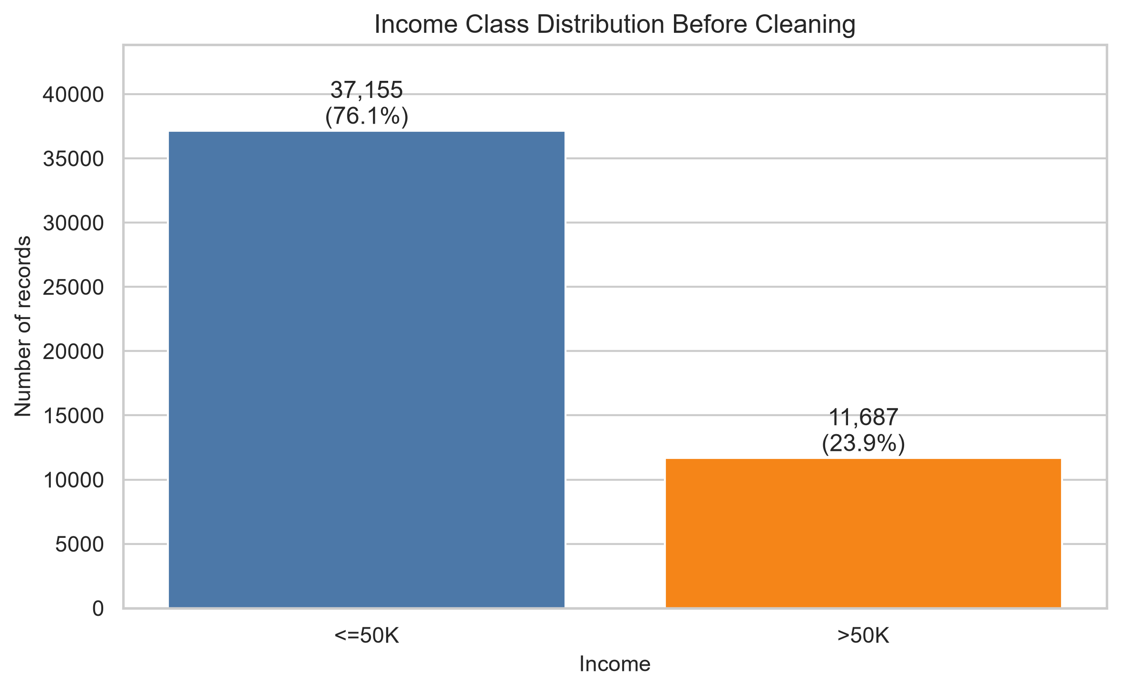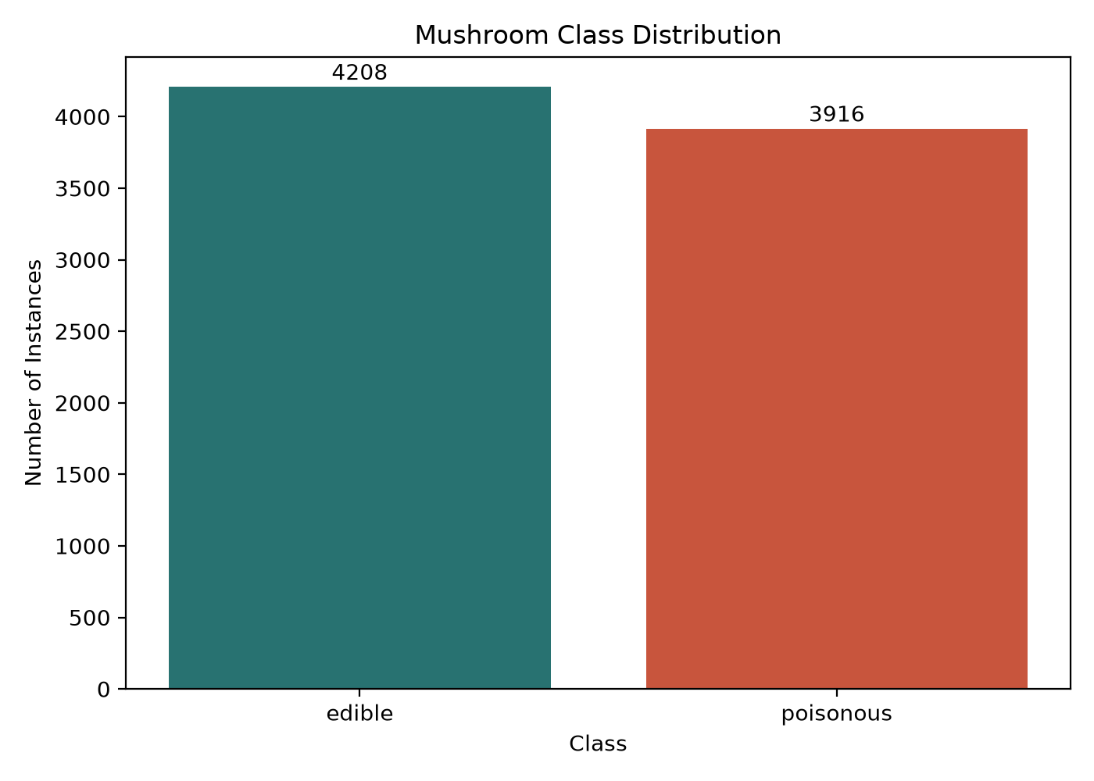
Figure 1. Original class distributions for Adult (left) and Mushroom (right).
Figure 1 shows that Adult is substantially less balanced. Predicting only the majority class would give about 76.07% accuracy under its full-data distribution, while identifying no high-income cases. Mushroom has a 51.80% majority-class reference. These are descriptive references; they explain why positive-class recall and F1 accompany accuracy throughout the report.
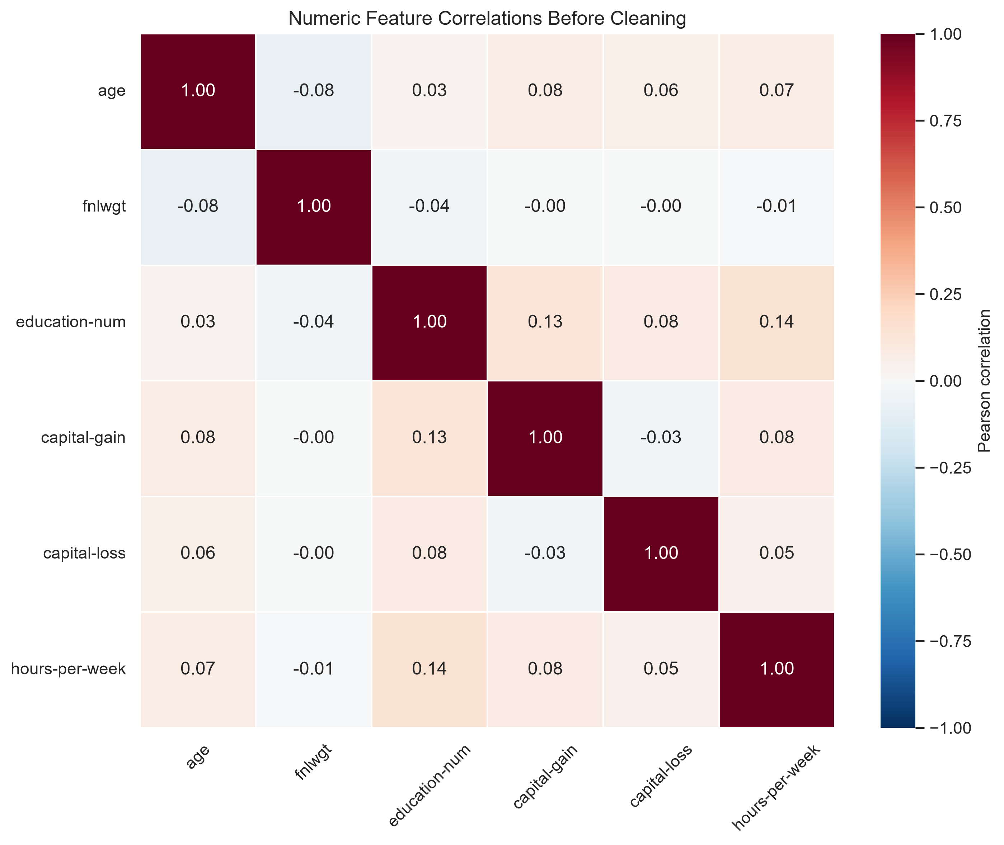
Figure 2. Original Adult numeric-feature Pearson correlation heatmap before cleaning.
Figure 2 shows weak pairwise linear correlations among the six numeric predictors; for example, education-num and hours-per-week correlate at about 0.14. Weak predictor correlations do not establish weak relationships with income, rule out nonlinear interactions or justify removing features. No correlation-based feature selection was performed. The categorical education and numeric education-num fields are also semantically related, which this numeric-only heatmap cannot fully assess.
Adult missing values occur in workclass, occupation and native-country; none of its six numeric attributes is missing in the current files. Mushroom missingness is confined to stalk-root, while veil-type is constant. Removing that constant reduces Mushroom to 21 predictors without discarding observed variation. Mushroom has no duplicate full records in the audit. Adult retains repeated records in its modeling branches, requiring an explicit validity limitation.

3.2 Data Preprocessing
We document at least three distinct transformations and their purposes. Missing value handling either removes incomplete rows or preserves them through imputation or an explicit missing category. StandardScaler centers and scales Adult numeric predictors for logistic regression and SVM. OneHotEncoder converts nominal predictors to indicators without imposing an artificial numeric order; handle_unknown="ignore" permits unseen categories at prediction time. Learned transformations are fitted within the classifier Pipeline in every cross-validation fold.
Table 2. Dataset-specific preprocessing and the resulting training and test sizes.
Branch | Missing treatment and additional processing | Train / test
Adult S1 | Delete incomplete rows after splitting; numeric scaling; categorical one-hot encoding. | 36,183 / 9,039
Adult S2 | Numeric median plus scaling; categorical mode plus one-hot encoding. | 39,073 / 9,769
Adult S3 | Numeric median with missing indicators plus scaling; categorical Missing plus one-hot encoding. | 39,073 / 9,769
Mushroom | Remove constant veil-type; retain ? as a category; one-hot encode 21 categorical predictors. | 6,499 / 1,625
Mushroom includes a most-frequent SimpleImputer, but its reader treats ? as a string, so it does not impute those entries. The original preprocessing also exports complete-case and stalk-root-removal variants, but their classifier performance has not been compared. Adult type restoration in the model module ensures numeric columns enter the intended numeric branch.
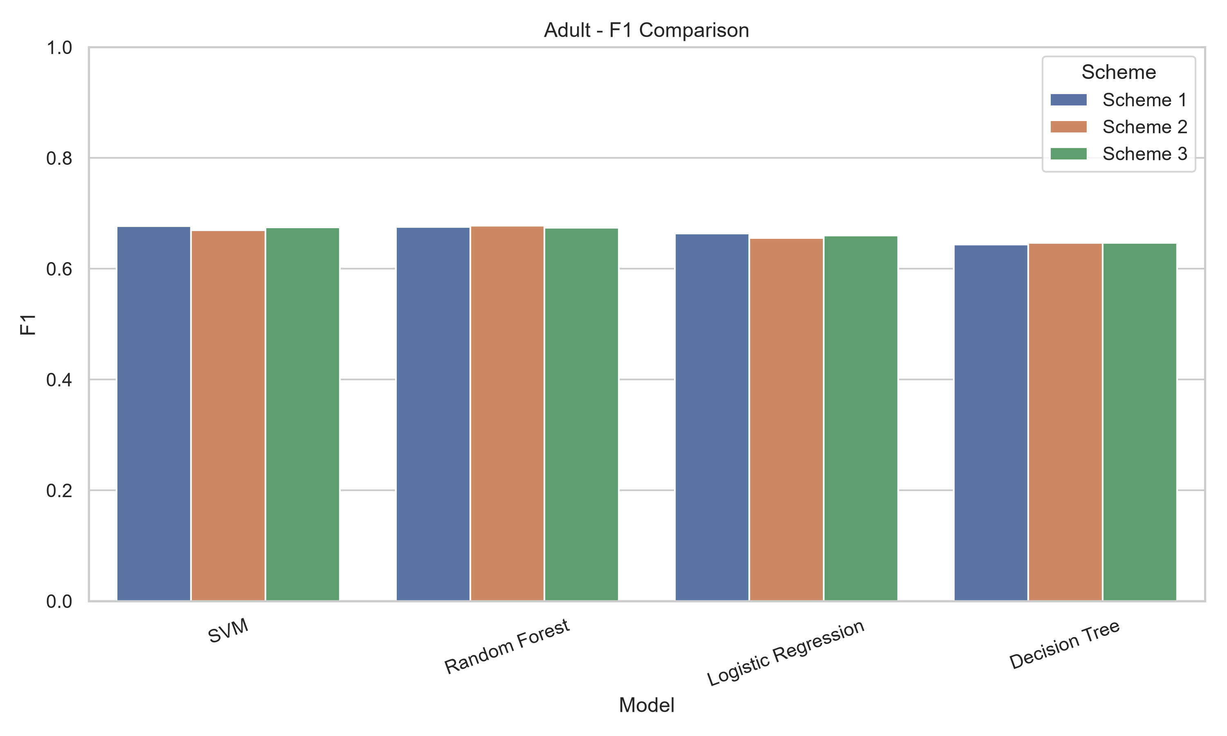
Figure 3. Original F1 comparison for the three Adult schemes and four classifiers.
S2 and S3 use identical test records, making their comparison the clearest preprocessing experiment. From S2 to S3, SVM accuracy increases from 86.01% to 86.22% and F1 from 0.6694 to 0.6747; LR F1 increases from 0.6557 to 0.6601. RF F1 instead falls from 0.6774 to 0.6742. Preserving categorical missingness therefore has model-dependent effects. Numeric missing indicators add no active features here because the numeric columns are complete. S1 changes the evaluated population by dropping missing test records, so its differences cannot be attributed solely to preprocessing.

4 Basic Concepts of Algorithms
We compare a single decision tree, random forest, logistic regression and a radial basis function SVM. A tree expresses attribute-dependent decisions; the forest aggregates 200 trees [4]. Logistic regression provides a regularized linear baseline, and RBF SVM permits nonlinear decision boundaries [5]. These are scikit-learn implementations [6]; the tree is not Weka J48 and the SVM is not claimed to be a byte-equivalent SMO implementation.
Let TP and FN count correctly and incorrectly classified positive records, and TN and FP their negative-class counterparts. Accuracy=(TP+TN)/N; precision=TP/(TP+FP); recall=TP/(TP+FN); F1=2PR/(P+R). ROC plots true-positive rate against false-positive rate as the score threshold varies; AUC summarizes ranking rather than a single decision threshold. Kappa measures agreement beyond chance. Precision, recall and F1 use high income as Adult positive and poisonous as Mushroom positive; they are not macro averages.
Apriori [3] supplies the unsupervised component by mining frequent itemsets and association rules. Every record becomes a set of attribute=value items, including the class for exploratory class-consequent rules. Adult age uses bins (0,25], (25,45], (45,65], (65,200]; hours-per-week uses (-1,35], (35,45], (45,60], (60,200]. Capital gain and loss become zero/positive items. Other fields are represented as categorical items and missing values as Missing. Mushroom already has nominal items and retains ?.
For a rule X to Y, support=P(X and Y), confidence=P(Y|X), and lift=confidence/P(Y). Adult additionally retains lift>=1. A rule relating education=Masters and education-num=14 has confidence=1 and lift=18.38, but mainly reflects redundant coding, not a new socioeconomic discovery.

5 Model Training

5.1 Model Initialization and Configuration
Table 3. Shared classifier parameters in the cross-dataset baseline.
Model | Settings
DT | DecisionTreeClassifier: max_depth=8; random_state=42; criterion=gini.
RF | RandomForestClassifier: n_estimators=200; max_features=sqrt; max_depth=None; random_state=42; n_jobs=-1.
LR | LogisticRegression: C=1.0; solver=lbfgs; max_iter=1000; random_state=42; current default L2 regularization.
SVM | SVC: kernel=rbf; C=1.0; gamma=scale; probability=True; random_state=42.

5.2 Validation Boundaries and Metrics
For each dataset, train_test_split uses test_size=0.2, stratify=y and random_state=42. Only the training partition enters StratifiedKFold(n_splits=10, shuffle=True, random_state=42). Each fold fits its own preprocessing and classifier. We average fold validation accuracy, then fit the full training partition and evaluate saved predictions and positive-class probabilities on the untouched holdout. This implements ten-fold CV plus a separate percentage-split protocol [8]. Apriori is a separate full-data exploratory analysis and does not select classifier features.
Mushroom original grid searches used five folds and included a calibrated linear SVM. Those tuning outputs remain a separate experiment. The new fixed-parameter baseline provides ten-fold CV for all four classifiers and RBF SVM. Matching configurations improves comparison, but gamma=scale and the encoded feature spaces remain data-dependent; the complete pipelines are not identical in every numerical detail.

5.3 Running the Documented Experiments
Use Python 3.14.6 with NumPy 2.4.6, pandas 3.0.3, scikit-learn 1.9.0, matplotlib 3.11.0 and joblib 1.5.3 for the verified baseline. Adult visualization additionally uses seaborn 0.13.2; spreadsheet export uses openpyxl 3.1.5. Historical Mushroom requirements list different versions; those pins were not installed for this comparison. SVC(probability=True) runs in the verified version but emits a deprecation warning; reproducing the saved model should use the recorded version.
With adult project as the working directory, run python evaluation.py --all to execute preprocessing.py, models.py and evaluation.py in order. Each file also runs independently after its prerequisites. With Data mining project/mushroom_preprocessing as the working directory, run python preprocess_mushroom.py, python evaluate_models.py, python model_tuning.py and python association_rules.py. The tuning step is the historical five-fold experiment, not the ten-fold baseline.
From cross_dataset_comparison, run python compare_baselines.py --cv-jobs 2 after both projects' prerequisite outputs exist. Paths resolve from file locations. Outputs include experiment_config.json, cross_dataset_metrics.csv, per-record split/fold assignments, predictions, models and plots. run_manifest.json must show status=complete. source_preservation.json records matching before/after SHA-256 values for 124 original-project files. The comparison imports Mushroom's original reader and preprocessor; it reuses rather than retrains Adult S2.

6 Results and Evaluation

6.1 Adult Classification Results
Table 4. Adult results by scheme. CV and accuracy are percentages; DT, RF and LR follow Table 3. P and R for the S2 baseline appear in Table 6.
Scheme | Model | CV % | Acc % | F1 | AUC
1 | DT | 85.17 | 85.20 | 0.6434 | 0.9005
1 | RF | 85.02 | 84.99 | 0.6751 | 0.9019
1 | LR | 84.89 | 84.81 | 0.6637 | 0.9036
1 | SVM | 85.25 | 85.70 | 0.6768 | 0.8973
2 | DT | 85.49 | 85.79 | 0.6468 | 0.9066
2 | RF | 85.16 | 85.63 | 0.6774 | 0.9054
2 | LR | 85.09 | 85.07 | 0.6557 | 0.9042
2 | SVM | 85.58 | 86.01 | 0.6694 | 0.8978
3 | DT | 85.51 | 85.78 | 0.6465 | 0.9054
3 | RF | 85.28 | 85.53 | 0.6742 | 0.9045
3 | LR | 85.24 | 85.19 | 0.6601 | 0.9059
3 | SVM | 85.60 | 86.22 | 0.6747 | 0.8984
Across all three schemes, S3 SVM has the highest observed test accuracy (86.22%), while S2 RF has the highest F1 (0.6774). Within the fixed S2 baseline, SVM leads in accuracy (86.01%) and RF leads in recall (63.05%). These rankings are descriptive; the holdout was not used for a new tuning step.
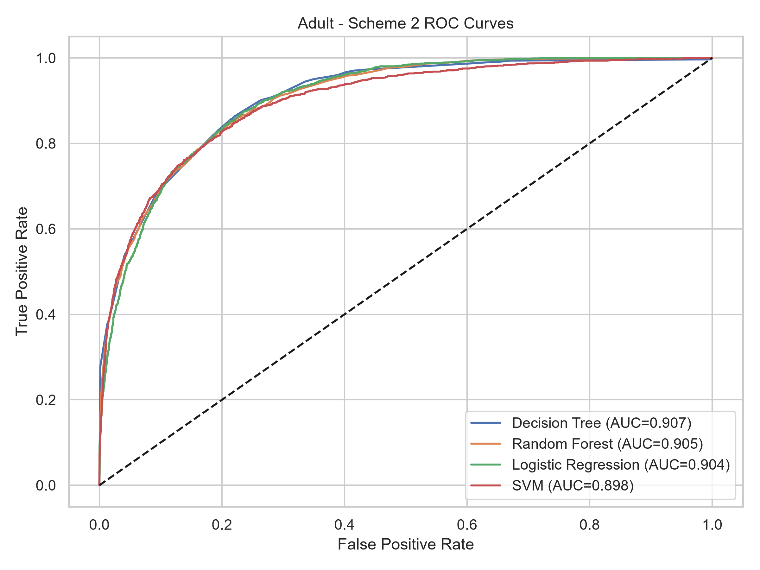
Figure 4. Original Adult S2 ROC curves with the diagonal chance reference.
Figure 4 shows AUC near 0.90 for every classifier. DT has the highest AUC (0.9066), but its recall is only 54.36% under its prediction rule. RF identifies 1,474 of 2,338 high-income test cases and misses 864, with 540 false positives and 6,891 true negatives. DT misses 1,067 and has 321 false positives. RF exchanges more false positives for fewer missed positives, explaining its higher F1 despite slightly lower accuracy.

6.2 Mushroom Classification Results
Table 5. New Mushroom fixed-parameter baseline. CV and accuracy are percentages; confusion counts are TN, FP, FN, TP in that order.
Model | CV % | Acc % | F1 | AUC | TN FP FN TP
DT | 99.97 | 100.00 | 1.0000 | 1.0000 | 842 0 0 783
RF | 100.00 | 100.00 | 1.0000 | 1.0000 | 842 0 0 783
LR | 99.94 | 99.94 | 0.9994 | 1.0000 | 842 0 1 782
SVM | 99.94 | 100.00 | 1.0000 | 1.0000 | 842 0 0 783
The test set contains 842 edible and 783 poisonous records. Three classifiers correctly classify every test record. LR misclassifies one poisonous record as edible, giving precision=100% and recall=99.87%. Its AUC is 1.0000 because its test scores perfectly rank the classes even though its prediction rule makes one classification error. AUC and threshold-dependent accuracy therefore answer different questions.
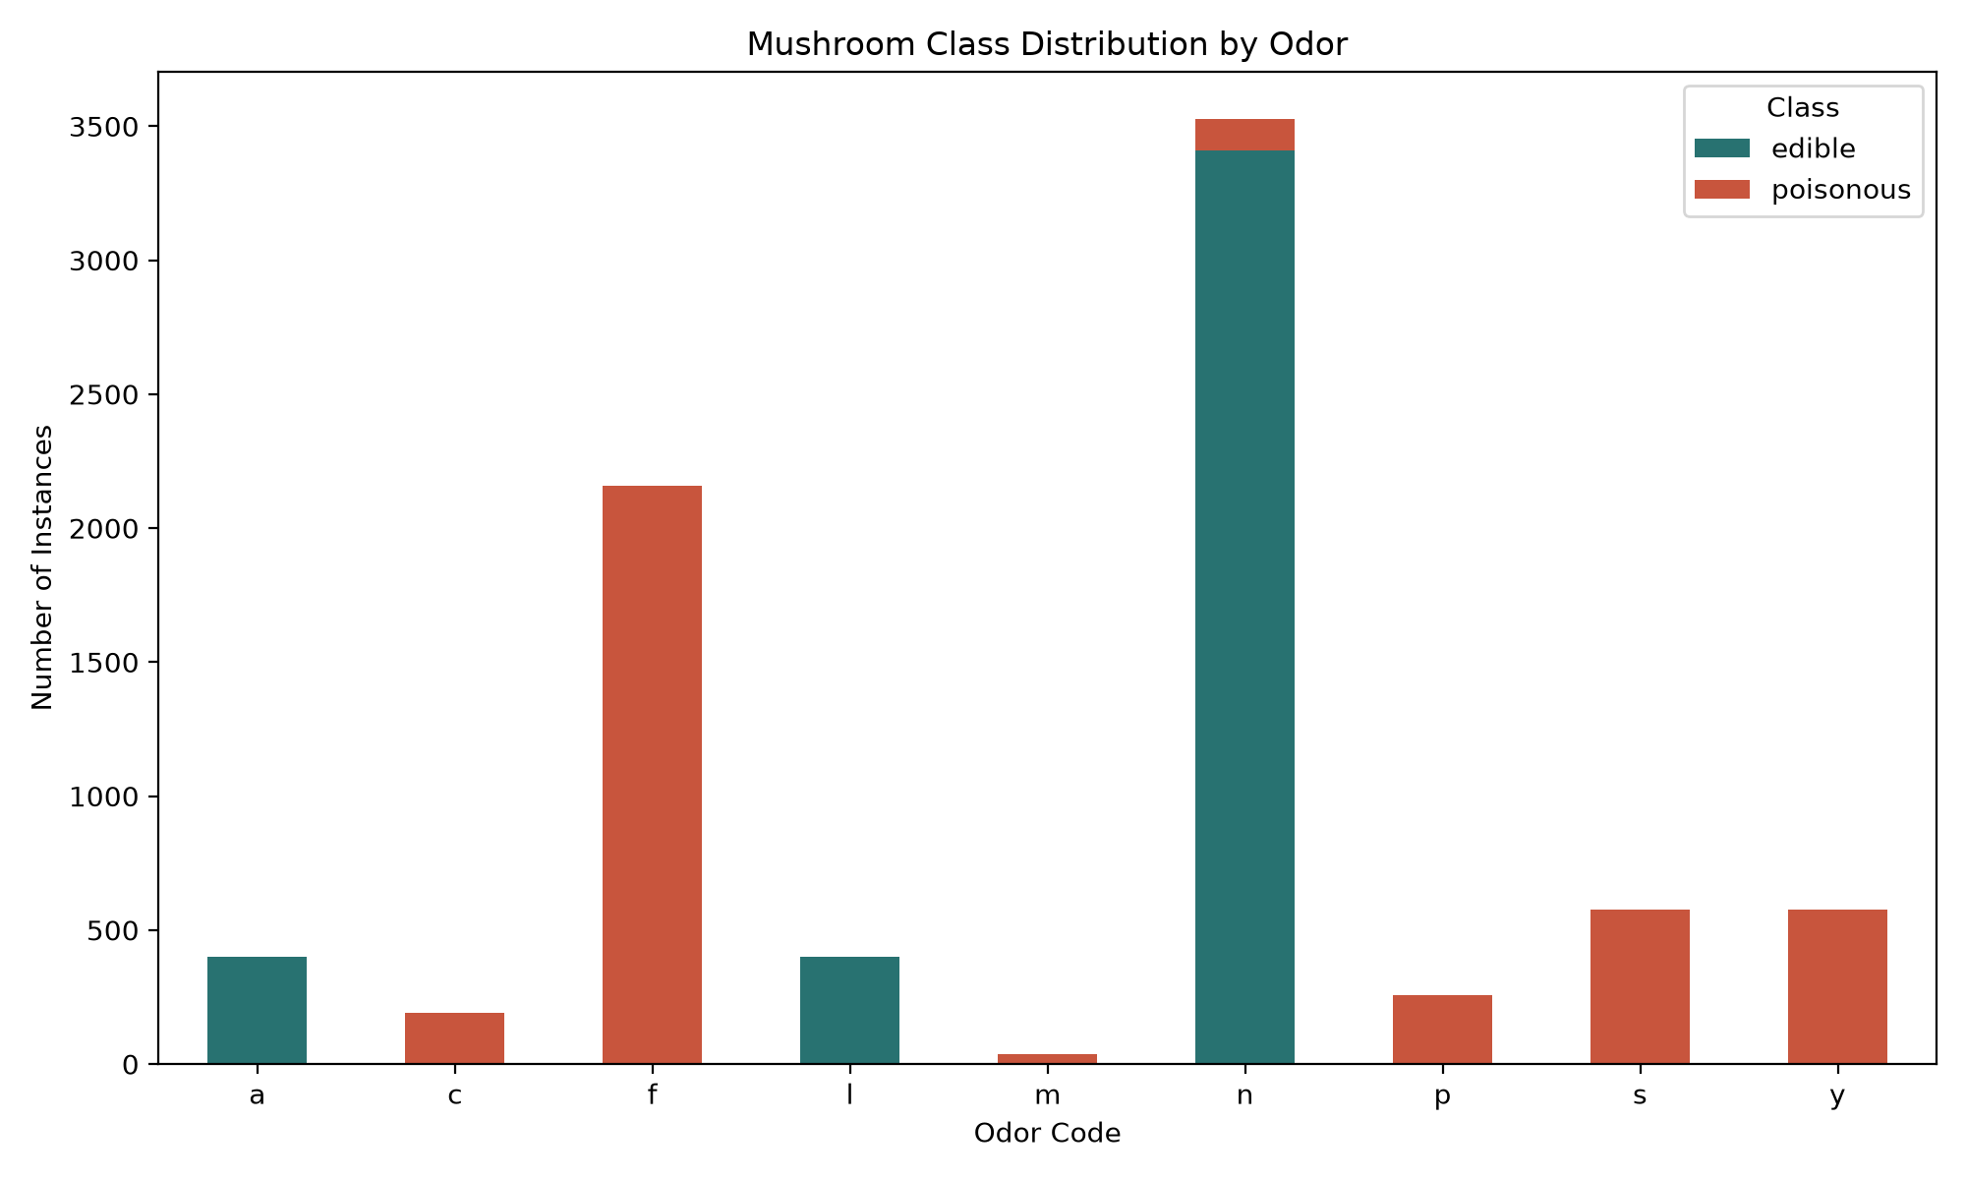
Figure 5. Original Mushroom class counts by odor category; full-data descriptive analysis.
Figure 5 helps explain high performance: eight of the nine observed odor categories contain only one class. All 2,160 records with odor=f are poisonous, whereas odor=n contains 3,408 edible and 120 poisonous records. Multiple attributes are still needed for ambiguous cases. This pattern is consistent with high separability in the encoded data and helps explain why even LR nearly reaches the performance ceiling. It does not establish perfect classification outside the current benchmark. The full-data plot was used for interpretation, not supervised feature selection.
Forty fold scores were saved, ten per classifier. RF scores 100% in every validation fold; DT has a minimum fold accuracy of 99.69%, while LR and SVM each have a minimum of 99.38%. Thus near-perfect mean CV does not mean every fold is error-free. Fold averages and holdout scores are consistent here, but are not a guarantee against dataset-specific bias or distribution shift. With poisonous as positive, false negatives deserve particular attention because they describe the hazardous error direction.

6.3 Direct Cross Dataset Comparison
Table 6. Common baseline. A=Adult S2; M=Mushroom. CV, Acc, P and R are percentages; remaining metrics are unitless. Positive classes differ by task.
Data | Model | CV | Acc | P | R | F1 | AUC | Kappa
A | DT | 85.49 | 85.79 | 79.84 | 54.36 | 0.6468 | 0.9066 | 0.5619
A | RF | 85.16 | 85.63 | 73.19 | 63.05 | 0.6774 | 0.9054 | 0.5856
A | LR | 85.09 | 85.07 | 73.14 | 59.41 | 0.6557 | 0.9042 | 0.5616
A | SVM | 85.58 | 86.01 | 77.02 | 59.20 | 0.6694 | 0.8978 | 0.5826
M | DT | 99.97 | 100.00 | 100.00 | 100.00 | 1.0000 | 1.0000 | 1.0000
M | RF | 100.00 | 100.00 | 100.00 | 100.00 | 1.0000 | 1.0000 | 1.0000
M | LR | 99.94 | 99.94 | 100.00 | 99.87 | 0.9994 | 1.0000 | 0.9988
M | SVM | 99.94 | 100.00 | 100.00 | 100.00 | 1.0000 | 1.0000 | 1.0000
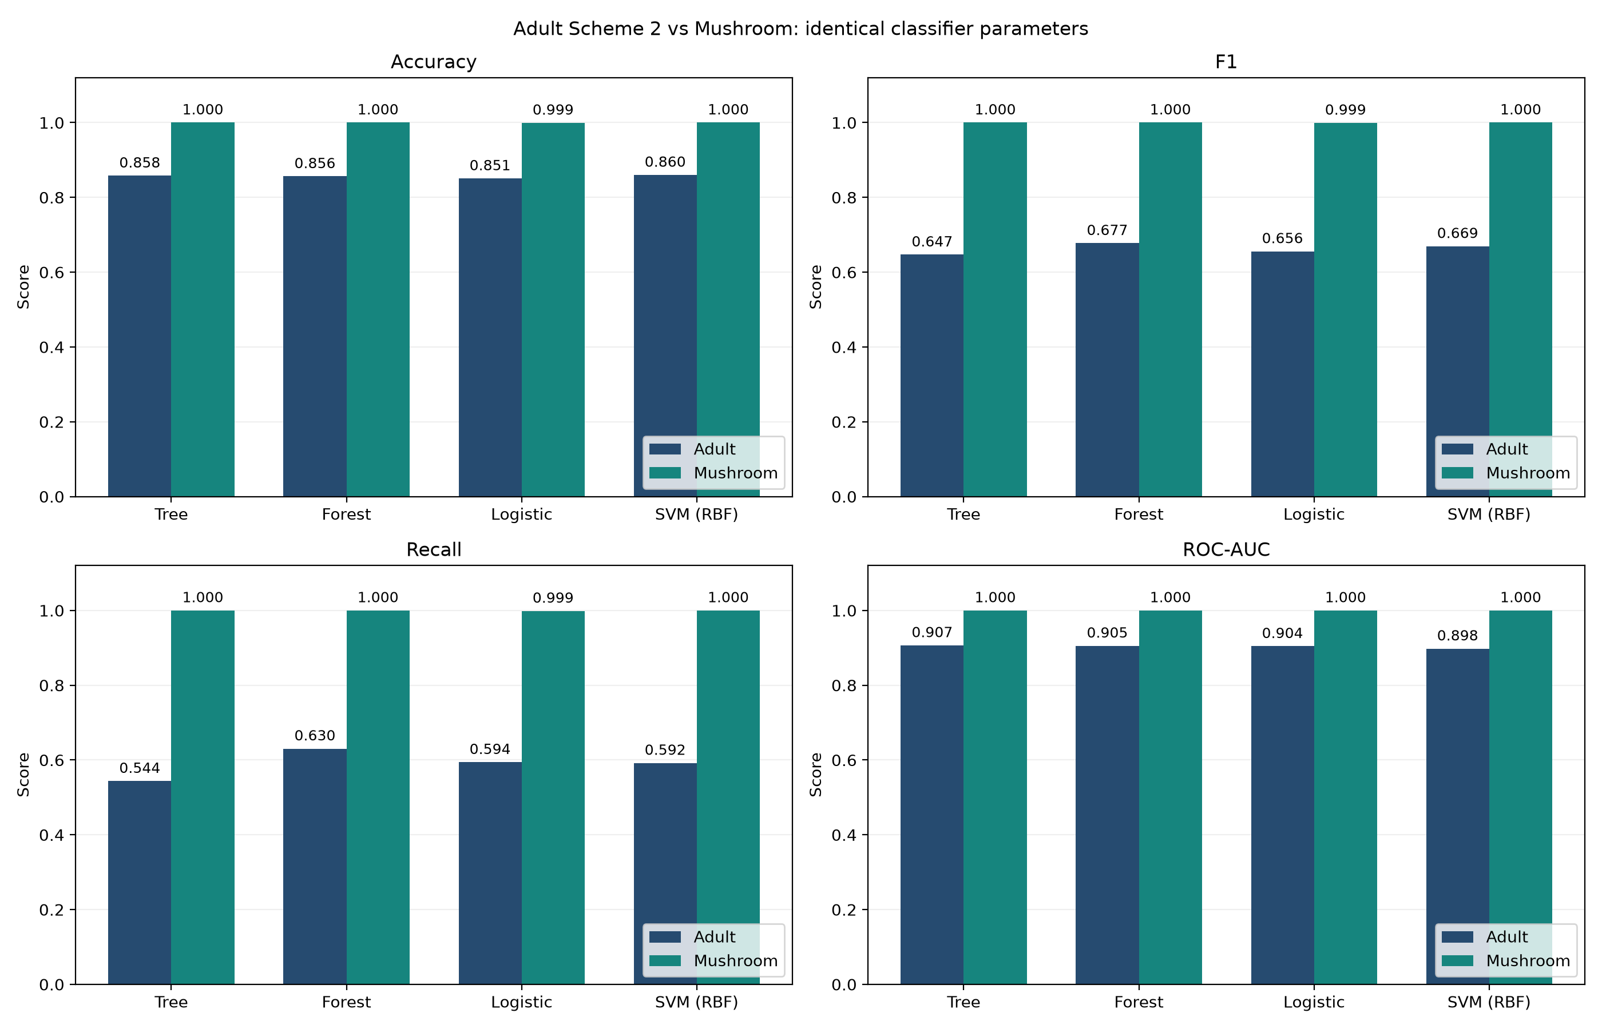
Figure 6. Baseline holdout comparisons under identical classifier configurations.
Figure 6 shows a larger change across tasks than across Adult classifiers. Mushroom has fewer records yet much higher scores, so sample size alone does not explain performance. Its categorical combinations are strongly separable, whereas Adult has mixed attributes, stronger imbalance and substantial positive-class errors. These observations support a dataset-dependent explanation, not an isolated causal effect of any one data property.
DT has Adult's lowest F1 but ties for the highest Mushroom F1; RF improves Adult positive recall over DT but yields no extra Mushroom holdout accuracy. SVM leads Adult accuracy and ties on Mushroom. This is a change in the usefulness of model complexity and in the relevance of metrics, rather than a strict reversal on every measure. Because preprocessing differs and Mushroom scores saturate, the evidence does not support a universal algorithm ranking.

6.4 Apriori Association Analysis
Table 7. Reported Apriori settings and outputs. Both implementations use a single-item consequent.
Setting or output | Adult | Mushroom
Minimum support | 0.05 | 0.30
Minimum confidence | 0.60 | 0.80
Maximum itemset length | 3 | 4
Frequent itemsets | 1,886 | 888
Rules | 1,864 | 1,868
Class-consequent rules | 208 | 106
An Adult class rule is marital-status=Married-civ-spouse AND occupation=Exec-managerial to income=>50K: support=5.02%, confidence=68.08%, lift=2.85. It identifies an income-associated subgroup; it does not show that marriage or occupation causes income. A Mushroom rule is bruises=f AND gill-attachment=f AND population=v to class=p: support=30.82%, confidence=95.43%, lift=1.98. It covers many observations but is not error-free or a standalone safety rule.
Table 8. Mushroom support sensitivity with confidence fixed at 0.80 and maximum length 4.
Support | Itemsets | Rules | Class rules
0.50 | 76 | 119 | 0
0.40 | 267 | 478 | 2
0.30 | 888 | 1868 | 106
0.20 | 3935 | 8669 | 547
Reducing support from 0.50 to 0.20 increases the number of rules from 119 to 8,669 and class-consequent rules from 0 to 547. Lower support admits less common patterns but adds interpretation burden. This is a support sensitivity experiment at fixed confidence, not a confidence sweep. Counts across datasets cannot measure relative complexity because thresholds, itemset lengths, marginal class frequencies and representations differ. Rules were mined on full data for exploration; their confidence is not an independent test accuracy.

6.5 Limitations and Threats to Validity
The comparison holds classifier configurations and evaluation stages constant but retains dataset-specific preprocessing. It cannot isolate the causal contributions of feature type, sample size, missingness and imbalance. In particular, identical SVM gamma=scale settings produce data-dependent numerical values. Historical Mushroom tuning results come from a different environment and experiment; they are excluded from the baseline comparison.
We use one seeded holdout split, with ten-fold CV confined to training. Small differences, including one Mushroom error and small Adult scheme changes, have not been tested over repeated splits or with significance tests. Adult S2 stores CV means rather than individual fold scores; no unavailable standard deviation or confidence interval is reported. Test scores are descriptive observations and should not be repeatedly consulted for tuning.
Adult retains repeated records in its modeling data, creating possible overlap between training and test feature patterns. A record index split and fold-specific preprocessing do not eliminate this risk. Adult S1 also changes test coverage by removing incomplete records. These issues may affect estimated performance and restrict comparisons; neither has been resolved by the present supplementary experiment.
Mushroom describes hypothetical samples based on a field guide. Its near-perfect benchmark results do not establish performance on new species, geographic populations, uncertain measurements or previously unseen categorical combinations. Adult uses historical Census data and demographic attributes; current deployment accuracy and subgroup fairness were not assessed. Association rules describe observed dependence, including missingness and redundant coding, rather than causal mechanisms.

7 Conclusion and Future Work
Model rankings do not transfer unchanged. Adult S2 favors SVM on accuracy and RF on positive-class F1, whereas Mushroom has a three-way holdout tie. A bounded-depth tree already performs perfectly on the Mushroom holdout, so a more complex model has little measurable headroom in that split. Adult's residual errors and unequal classes make precision-recall tradeoffs more visible. One-hot encoding is useful in both workflows, while numeric standardization is relevant to Adult's continuous inputs and has no corresponding branch in Mushroom.
The Adult S2/S3 experiment also shows that retaining categorical missingness helps LR and SVM slightly but does not improve every classifier. Missingness can carry information, yet the value of representing it depends on the learning method and observed data. Mushroom missingness is much higher, so complete-case deletion removes 2,480 records; however, the exported alternatives were not modeled and no superiority claim is made for keeping ? over true mode imputation or deleting stalk-root.

7.1 Future Work
The project completes documented preprocessing, four-classifier modeling, ten-fold CV, independent holdout evaluation and association analysis on both UCI datasets. High accuracy alone is insufficient for Adult because positive recall remains moderate; Mushroom performance requires cautious interpretation because of separability and limited external evidence. Follow-up work should assess duplicate-aware Adult splits, shared-test comparisons involving S1, Mushroom preprocessing alternatives, and repeated validation. Class weights or thresholds should be selected within training validation before a fresh final test. External validation is needed before either task supports practical decisions.

7.2 Team Contributions
Table 9. Individual responsibilities and approximate workload shares.
Member and ID | Role | Specific contribution | Share
HUANG WENLONG  [Student ID] | Adult evaluation | Adult ten-fold CV and independent holdout evaluation; metrics, confusion matrices and ROC analysis; joint protocol checks, cross-dataset comparison tables and interpretation with CHEN YISHU; joint report writing. | 16.67%
LUO YIPENG  [Student ID] | Adult preprocessing | Adult data provenance and schema; cleaning, missing-value handling, encoding and standardization; preprocessing comparisons, data distributions and quality figures; joint report writing. | 16.67%
WEN YONGCHENG  [Student ID] | Adult modeling | Adult training and parameter documentation for four classifiers; Apriori rule analysis; model input/output and reproduction steps; cross-dataset configuration checks with FU SHIFANG; joint report writing. | 16.67%
LIU YONGZHI  [Student ID] | Mushroom preprocessing | Mushroom data provenance and schema; cleaning, missing-marker handling and encoding; class distributions, attribute distributions and data-quality figures; joint report writing. | 16.67%
FU SHIFANG  [Student ID] | Mushroom modeling | Mushroom training and parameter documentation for four classifiers; Apriori and support sensitivity analysis; model input/output and reproduction steps; cross-dataset configuration checks with WEN YONGCHENG; joint report writing. | 16.66%
CHEN YISHU  [Student ID] | Mushroom evaluation | Mushroom ten-fold CV and independent holdout evaluation; metrics, classification errors and result figures; joint protocol checks and cross-dataset comparison with HUANG WENLONG; joint report writing. | 16.66%
All members contributed to report writing. Workload shares are provisionally estimated equally and adjusted for rounding to total 100%. Every member should be able to explain their own module, the validation boundaries and the reasons for the cross-dataset differences. The empirical results in this report were generated in Python; no Weka execution or statistical significance test is claimed. The equivalent reproducible Python workflow is documented above; Weka terminology refers to the course framework and reference [7].
All members share report writing and check the methods, parameters, values, figures and references in their sections; the group will designate the final compilation and submission owner. Presentation preparation assigns a speaking part to all six members, about 2–2.5 minutes each within 15 minutes, followed by 5 minutes of questions. Everyone must understand the full pipeline and prepare the required Weka workflow demonstration and cross-dataset comparison table. Before submission, the group will check team details, student IDs, references, filenames, PDF, slides and the page limit. These presentation and submission tasks are planned responsibilities, not claims of completion.

References
[1] Becker, B., & Kohavi, R. (1996). Adult [Dataset]. UCI Machine Learning Repository. https://doi.org/10.24432/C5XW20. Dataset page: https://archive.ics.uci.edu/dataset/2/adult. UCI ID 2. Source: 1994 Census database; extraction by Barry Becker. License: CC BY 4.0.
[2] Mushroom [Dataset]. UCI Machine Learning Repository. https://doi.org/10.24432/C5959T. Dataset page: https://archive.ics.uci.edu/dataset/73/mushroom. UCI ID 73. Original donor: Jeff Schlimmer, 1987, identified in agaricus-lepiota.names. Underlying source: The Audubon Society Field Guide to North American Mushrooms (1981), Alfred A. Knopf. License: CC BY 4.0. The current UCI generated citation uses the source year 1981; the donation is documented separately as 1987.
[3] Agrawal, R., & Srikant, R. (1994). Fast algorithms for mining association rules. Proceedings of the 20th International Conference on Very Large Data Bases, 487-499.
[4] Breiman, L. (2001). Random forests. Machine Learning, 45, 5-32. https://doi.org/10.1023/A:1010933404324.
[5] Cortes, C., & Vapnik, V. (1995). Support-vector networks. Machine Learning, 20, 273-297. https://doi.org/10.1007/BF00994018.
[6] Pedregosa, F., et al. (2011). Scikit-learn: Machine learning in Python. Journal of Machine Learning Research, 12, 2825-2830. Software: https://scikit-learn.org/.
[7] Frank, E., Hall, M. A., & Witten, I. H. (2016). The WEKA Workbench. Online appendix for Data Mining: Practical Machine Learning Tools and Techniques (4th ed.). Morgan Kaufmann. https://www.cs.waikato.ac.nz/ml/weka/.
[8] Kohavi, R. (1995). A study of cross-validation and bootstrap for accuracy estimation and model selection. Proceedings of the 14th International Joint Conference on Artificial Intelligence, 2, 1137-1143.
[9] Creative Commons. Attribution 4.0 International. https://creativecommons.org/licenses/by/4.0/. Credit the dataset providers and repository; identify preprocessing and formatting changes. UCI dataset metadata and license statements were checked on 28 October 2026.

Data Provenance and Local Evidence
Tables 4 and 6 use Adult outputs/evaluation/adult_comparison/adult_all_schemes_results.csv and cross_dataset_comparison/outputs/cross_dataset_metrics.csv. Mushroom fold scores and confusion counts use outputs/mushroom/cv_scores_10fold.csv and confusion_matrices.csv in the comparison directory. Apriori tables and examples come from Adult outputs/models/adult_apriori/ and Mushroom output/tables/apriori_*.csv. Figures 1-5 reuse original project images; Figure 6 uses the saved comparison image. The accompanying evidence index maps every table and figure to an exact local file.

