SRS
Team #
Team Members: Name 1, Name 2, Name 3, Name 4
TokenFest: Self-Hosted LLM API Gateway

Problem Statement
Teams now use LLM APIs from several providers (OpenAI, Anthropic, DeepSeek) and AI coding tools like Claude Code that make lots of API calls. The problem is that the whole team usually shares one API key, so nobody knows who spent what until the bill comes. There's no way to give each person a budget, so one bad script can burn through the month's money. And every provider has a different endpoint and pricing, so switching providers or handling an outage means changing code. What we need is one place that all requests go through, that knows who sent each request and how much it cost, and can stop people before they go over budget.

Objective / Goal
We're building a self-hosted gateway that sits between a team's apps and the LLM providers. Each member gets their own API key and only has to change the base URL in their app. The gateway forwards each request to the right provider and switches to a backup if one fails. It tracks the tokens and cost of every request, enforces a budget and rate limit for each user, and sends an alert before a budget runs out. Admins get a dashboard that shows where the money goes. The idea is based on the open-source project TokenParty, and we'll build our own version mainly in Java.

One Use Case (Primary)
User: Admin of a small dev team, plus the developers on the team
Use Cases:
- The admin adds the team's OpenAI and Anthropic keys and creates a key for each developer with a $100 monthly budget.
- A developer points their app or Claude Code at the gateway and uses their own key.
- The gateway checks the key, budget, and rate limit, then forwards the request to a provider for that model.
- If that provider fails, the gateway retries with a backup provider.
- The gateway saves the tokens and cost. When the developer reaches 80% of the budget, the team gets an email or Slack alert. At 100%, requests are blocked.
- At the end of the month, the admin checks cost by user and model on the dashboard and exports a CSV.

Scope of the Project
Per-user API keys for LLM access
OpenAI- and Anthropic-compatible proxy endpoints (with streaming)
Integration with LLM provider APIs (OpenAI, Anthropic, DeepSeek)
Routing by model with automatic provider fallback
Usage and cost tracking for every request
Monthly budget and rate limit per user
Budget alerts by email or webhook
Admin dashboard with usage charts and request log
User dashboard for personal usage
CSV export of monthly usage

Out of scope: converting between the OpenAI and Anthropic formats, other provider APIs (Gemini, Bedrock), running multiple gateway instances, payments, and a mobile app.

Tech Stack
Frontend:
Framework: React with TypeScript
UI Library: Tailwind CSS
Data Visualization: Recharts (for usage and cost charts)
Backend:
Language: Java 21
Framework: Spring Boot 4 (Spring WebFlux for the proxy and streaming)
API: RESTful API
Authentication: Spring Security with JWT (dashboard) and API keys (proxy)
Database:
Primary Database: PostgreSQL (users, keys, providers, request logs, usage)
Caching: Caffeine (in-memory cache for keys and spending)
External APIs:
LLM Providers: OpenAI API, Anthropic API, DeepSeek API
Development Tools:
Version Control: Git with GitHub
Build Tool: Maven
Project Management: GitHub Projects
CI/CD: GitHub Actions
Testing: JUnit 5, Mockito, WireMock (backend), Vitest (frontend)
Containerization: Docker
Hosting/Deployment:
Docker Compose on a local machine or a cloud VM (e.g., AWS EC2)

System Design Overview
Apps send requests to the Spring Boot gateway with their own key. The gateway checks the key and limits, picks a provider, forwards the request, and saves the usage to PostgreSQL. The React dashboard calls the gateway's REST API to show stats and manage settings.
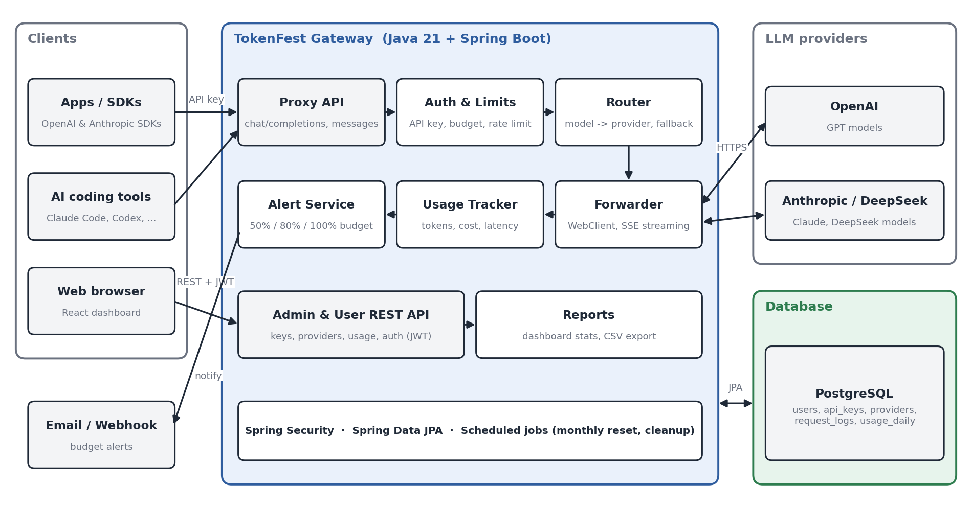

External Interface Requirements
User Interfaces
Login Page: admin login, or user login with their API key
Overview Page: total cost, requests, and tokens, with charts by day, user, and model
Requests Page: request log with filters and request details
Providers Page: add and edit providers, models, and prices
Users & Keys Page: create keys, set budgets and rate limits
Settings Page: alert thresholds and email/webhook settings
User Dashboard: personal spending, budget progress, and history

Hardware Interfaces
No specific hardware interfaces required
Any machine that can run Java 21 or Docker
Standard web browser for the dashboard

Software Interfaces
OpenAI API / Anthropic API / DeepSeek API: for forwarding chat requests
Authentication: API keys
Data Format: JSON
SMTP server and webhook (e.g., Slack): for budget alerts
Database Interface: PostgreSQL through Spring Data JPA

Functional Requirements
Admin login to the dashboard
Add and manage providers (API key, base URL, models, prices)
Create and manage user API keys with budget and rate limit
Forward OpenAI-format and Anthropic-format requests, including streaming
Fall back to another provider when one fails
Block requests that go over the rate limit or budget
Record tokens, cost, and latency for each request
Send alerts at 50%, 80%, and 100% of a user's budget
Show usage charts and the request log on the dashboard
Let users see only their own usage
Export monthly usage as CSV

Non-Functional Requirements
Performance: the gateway should add less than 50 ms per request and handle 50 requests at the same time
Reliability: if a provider goes down, requests should go to a backup provider automatically
Usability: developers only change the base URL and key; the dashboard should be simple, clean, and intuitive
Security: provider keys are stored encrypted and never shown to users; users can only see their own data

Estimated Timeline
1. Planning and Design (2 weeks) — All members
Week 1-2:
- Set up development environment and tools (GitHub, Maven, Docker, PostgreSQL)
- Finalize requirements and SRS documentation
- Create system architecture and design documents
- Design database schema
- Create wireframes and UI mockups
2. Development - Core Features (2 weeks) — [[Name 1]], [[Name 2]]
Week 3-4:
- Set up Spring Boot project and REST API structure
- Implement API key authentication
- Implement proxy endpoints with streaming
- Implement provider management and routing with fallback
- Implement usage and cost tracking
3. Development (3 weeks)
Week 5-6:
- Implement budget and rate limits — Name 2
- Implement admin login and admin API — Name 1
- Build dashboard pages (Overview, Requests, Providers, Users & Keys) — Name 3
Week 7:
- Implement budget alerts (email and webhook) — Name 4
- Build user dashboard and CSV export — Name 3, Name 2
4. Testing and Quality Assurance (2 weeks) — [[Name 4]] leads, all help
Week 8:
- Integration testing
- API testing
- Security testing
Week 9:
- User acceptance testing
- Performance and load testing
- Bug fixes and optimization
5. Deployment and Documentation (1 week) — All members
Week 10:
- Deploy with Docker
- Final documentation (user manual, API docs)
- Create demo video and presentation
- Project final submission

Testing and Success Criteria
Unit tests (JUnit 5, Mockito) for cost calculation, routing, and limits
Integration tests with WireMock as a fake LLM provider (streaming, fallback, blocked requests)
Success: OpenAI/Anthropic SDKs and Claude Code work through the gateway by only changing the base URL and key
Success: requests still work when the main provider is down
Success: requests over the budget or rate limit are blocked, and each alert is sent once
Success: dashboard costs match the provider's billing page within 5%

