Xi’an JIAOTONG-LIVERPOOL UNIVERSITY

**西 交 利 物 浦 大 学**

CourseWork Submission CoVer Sheet

|  |  |  |
| --- | --- | --- |
| Name | **Yuchen** | **Zhang** |
|  |  |  |
| Student Number | 1612648 |  |
|  |  |  |
| Programme | ICS |  |
|  |  |  |
| Module Title | Algorithmic Foundations and Problem Solving | |
|  |  |  |
| Module Code | CSE102 |  |
|  |  |  |
| Assignment Title | Assignment2 |  |
|  |  |  |
| Submission Deadline | 14.05.2018 |  |
|  |  |  |
| Module Leader | Dr. Wenjin Lu |  |
|  |  |  |

By uploading or submitting this coursework submission cover sheet, I certify the following:

* I have read and understood the definitions of PLAGIARISM, COLLUSION, and the FABRICATION Of DATA, as outlined in the Undergraduate Student Handbook of Xi’an Jiaotong-Liverpool University and as posted on the University Website.
* This work is my own, original work produced specifically for this assignment. It does not misrepresent the work of another person or institution as my own. Additionally, it is a submission that has not been previously published, or submitted to another module.
* This work is not the product of unauthorized collaboration between myself and others.
* This work is free of embellished or fabricated data.

I understand that PLAGIARISM, COLLUSION and the FABRICATION OF DATA are serious disciplinary offences. By uploading or submitting this cover sheet, I acknowledge that I am subject to disciplinary action if I am found to have committed such acts.

Signature ……*.*………………………………………………… Date ……*…*…*…*…………*………………………*……

|  |  |  |  |  |
| --- | --- | --- | --- | --- |
| For | Date Received | Days Late | Penalty |  |
| Academic |  |  |  |  |
|  |  |  |  |
| Office use: |  |  |  |  |
|  |  |  |  |  |

**Q1：**

1. **Shift table:**

|  |  |  |  |
| --- | --- | --- | --- |
| **A** | **G** | **C** | **T** |
| **5** | **1** | **4** | **2** |

1. **what is the number of comparisons?**

**AGCCGTGC**

**CGTGC**

**CGTGC**

**CGTGC**

**The number of comparisons is 3**

**Q2：**

|  |  |  |  |  |
| --- | --- | --- | --- | --- |
| **a** | **b** | **c** | **d** | **e** |
| **0** | **∞** | **∞** | **∞** | **∞** |
| **0** | **∞** | **∞** | **∞** | **4** |
| **0** | **∞** | **5** | **∞** | **4** |
| **0** | **∞** | **5** | **∞** | **-3** |
| **0** | **-1** | **5** | **∞** | **-3** |
| **0** | **-1** | **5** | **4** | **-3** |

**Q3：**

1. **Table:**

|  |  |  |  |  |  |  |  |
| --- | --- | --- | --- | --- | --- | --- | --- |
|  | **yj** | **A** | **C** | **A** | **T** | **G** | **T** |
| **xi** | **0** | **0** | **0** | **0** | **0** | **0** | **0** |
| **A** | **0** | **1** | **1** | **1** | **1** | **1** | **1** |
| **G** | **0** | **1** | **1** | **1** | **1** | **2** | **2** |
| **C** | **0** | **1** | **2** | **2** | **2** | **2** | **2** |
| **T** | **0** | **1** | **2** | **2** | **3** | **3** | **3** |
| **A** | **0** | **1** | **2** | **3** | **3** | **3** | **3** |

1. ACT

ACA

AGT

**Q4：**

**a.**

|  |  |  |  |  |  |  |  |
| --- | --- | --- | --- | --- | --- | --- | --- |
|  |  | **A** | **C** | **A** | **T** | **G** | **T** |
|  | **0** | **-1** | **-2** | **-3** | **-4** | **-5** | **-6** |
| **A** | **-1** | **↖1** | ←**0** | ↖  ←**-1** | ←**-2** | ←**-3** | ←**-4** |
| **G** | **-2** | ↑  **0** | ↑  ←**-1** | **↖**↑  ←**-2** | ↑  ←**-3** | **↖**  **-1** | ←**-2** |
| **C** | **-3** | ↑  **-1** | **↖**  **1** | ←**0** | ←**-1** | ↑  ←**-2** | **↖**↑  ←**-3** |
| **T** | **-4** | ↑  **-2** | ↑  **0** | ↑  ←**-1** | **↖**  **1** | ←**0** | **↖**  ←**-1** |
| **A** | **-5** | **↖**↑  **-3** | ↑  **-1** | ↖  **1** | ↑  ←**0** | ↖↑  ←**-1** | ↑  ←**-2** |

**b.**

A C A T G _ T _

_ _ A _ G C T A

and

A C A T G _ T _

A _ _ _ G C T A

and

A _ C A T G T _

A G C _ _ _ T A

and

A _ C A T G T _

A G C _ T _ _ A

A _ C A T G _ T

A G C _ T _ A _

and

A _ C A T G T

A G C _ T A _

and

A _ C A T _ G T

A G C _ T A _ _

and

A _ C _ A T G T

A G C T A _ _ _

**2. a.**

|  |  |  |  |  |  |  |  |
| --- | --- | --- | --- | --- | --- | --- | --- |
|  |  | **A** | **C** | **A** | **T** | **G** | **T** |
|  | **0** | **0** | **0** | **0** | **0** | **0** | **0** |
| **A** | **0** | **↖**  **1** | **0** | **↖**  **1** | **0** | **0** | **0** |
| **G** | **0** | **0** | **0** | **0** | **0** | **↖**  **1** | **0** |
| **C** | **0** | **0** | **↖**  **1** | **0** | **0** | **0** | **0** |
| **T** | **0** | **0** | **0** | **0** | **↖**  **1** | **0** | **↖**  **1** |
| **A** | **0** | **↖**  **1** | **0** | **↖**  **1** | **0** | **0** | **0** |

**b.**

**[1] A**

**A**

**[2] A**

**A**

**[3] G**

**G**

**[4] C**

**C**

**[5] T**

**T**

**[6] T**

**T**

**[7] A**

**A**

**[8] A**

**A**

**Q5：**

**R0= $\left(\begin{matrix}0 & 1 & 0 & 1 \\ 0 & 0 & 1 & 1 \\ 1 & 0 & 0 & 1 \\ 0 & 0 & 0 & 0\end{matrix}\right)$**

**R1= R0Ⅴ $\left(\begin{matrix}0 \\ 0 \\ 1 \\ 0\end{matrix}\right)$ $\left(\begin{matrix}0 & 1 & 0 & 1\end{matrix}\right)=$ $\left(\begin{matrix}0 & 1 & 0 & 1 \\ 0 & 0 & 1 & 1 \\ 1 & 1 & 0 & 1 \\ 0 & 0 & 0 & 0\end{matrix}\right)$**

**R2=R1Ⅴ $\left(\begin{matrix}1 \\ 0 \\ 1 \\ 0\end{matrix}\right)$ $\left(\begin{matrix}0 & 0 & 1 & 1\end{matrix}\right)=$ $\left(\begin{matrix}0 & 1 & 1 & 1 \\ 0 & 0 & 1 & 1 \\ 1 & 1 & 1 & 1 \\ 0 & 0 & 0 & 0\end{matrix}\right)$**

**R3= R2Ⅴ $\left(\begin{matrix}1 \\ 1 \\ 1 \\ 0\end{matrix}\right)$ $\left(\begin{matrix}1 & 1 & 1 & 1\end{matrix}\right)=$ $\left(\begin{matrix}1 & 1 & 1 & 1 \\ 1 & 1 & 1 & 1 \\ 1 & 1 & 1 & 1 \\ 0 & 0 & 0 & 0\end{matrix}\right)$**

**R4= R3Ⅴ $\left(\begin{matrix}1 \\ 1 \\ 1 \\ 0\end{matrix}\right)$ $\left(\begin{matrix}0 & 0 & 0 & 0\end{matrix}\right)=$ $\left(\begin{matrix}1 & 1 & 1 & 1 \\ 1 & 1 & 1 & 1 \\ 1 & 1 & 1 & 1 \\ 0 & 0 & 0 & 0\end{matrix}\right)$ = R3**

**Q6：**

**Node 0: lb={ [(1+2)+(2+3)+(1+1)+(1+3)+(2+2)]/2 }=9**

**Node 1: lb={ [(1+3)+(2+3)+(1+1)+(1+3)+(2+2)]/2 }=10**

**Node 2: lb={ [(1+5)+(2+3)+(1+1)+(1+5)+(2+2)]/2 }=12**

**Node 3: lb={ [(1+2)+(2+3)+(1+1)+(1+3)+(2+2)]/2 }=9**

**Node 4: ignored as d is not before e**

**Node 5: lb={ [(1+2)+(2+3)+(1+3)+(1+3)+(2+2)]/2 }=10**

**Node 6: lb={ [(1+2)+(2+3)+(1+1)+(1+3)+(2+2)]/2 }=9**

**Node 7: lb={ [(1+2)+(2+3)+(1+7)+(1+3)+(2+7)]/2 }=15**

**Node 8: leads to a optimal tour with lb=9**

**Node 9: leads to a tour with lb=15**

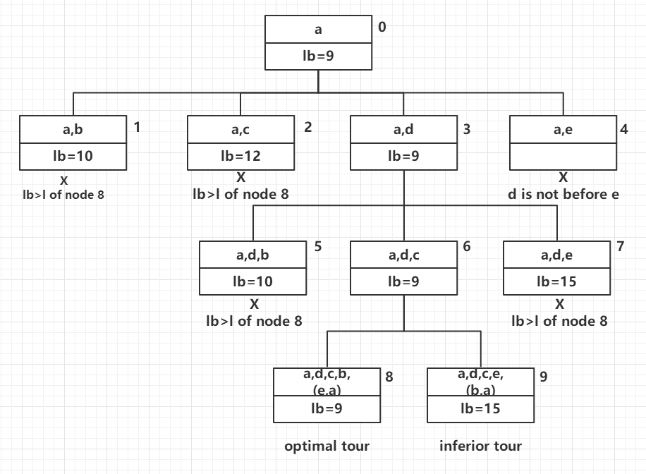

Solution: a d c b e a

**Q7:**

**Yes**