SFC 界面设计文档

1. SFC REST API 接口
   1. service nodes

通过service nodes 配置ovs所在节点信息。

* + 1. 添加service nodes

|  |  |
| --- | --- |
| 请求方式 | put |
| 服务路径 | /restconf/config/service-node:service-nodes |
| 路径参数/描述 | 无 |
| Header信息 | {'Content-type': 'application/yang.data+json',  'Accept': 'application/yang.data+json'} |
| Auth | USERNAME, PASSWORD（admin,admin） |
| 返回值类型 | application/json |
| 参数描述 | "service-nodes": {  "service-node": [  {  "name": "openflow:1",  "service-function": [  ],  "ip-mgmt-address": "10.164.16.13"  },  {  "name": "openflow:2",  "service-function": [  ],  "ip-mgmt-address": "10.164.16.14"  }  ]  } |

* + 1. 添加service node

|  |  |
| --- | --- |
| 请求方式 | put |
| 服务路径 | /config/service-node:service-nodes/service-node/{name} |
| 路径参数/描述 | Name of the service node |
| Header信息 | {'Content-type': 'application/yang.data+json',  'Accept': 'application/yang.data+json'} |
| Auth | USERNAME, PASSWORD（admin,admin） |
| 返回值类型 | application/json |
| 参数描述 | "service-node":  {  "name": "openflow:1",  "service-function": [  ],  "ip-mgmt-address": "10.164.16.13"  } |

* + 1. 获取service nodes

|  |  |
| --- | --- |
| 请求方式 | get |
| 服务路径 | /restconf/config/service-node:service-nodes |
| 路径参数/描述 | 无 |
| Header信息 | {'Content-type': 'application/yang.data+json',  'Accept': 'application/yang.data+json'} |
| Auth | USERNAME, PASSWORD（admin,admin） |
| 返回值类型 | application/json |

* + 1. 获取service node

|  |  |
| --- | --- |
| 请求方式 | get |
| 服务路径 | /config/service-node:service-nodes/service-node/{name} |
| 路径参数/描述 | Name of the service node |
| Header信息 | {'Content-type': 'application/yang.data+json',  'Accept': 'application/yang.data+json'} |
| Auth | USERNAME, PASSWORD（admin,admin） |
| 返回值类型 | application/json |

1.1.5 删除 service nodes

|  |  |
| --- | --- |
| 请求方式 | DELETE |
| 服务路径 | /restconf/config/service-node:service-nodes |
| 路径参数/描述 | 无 |
| Header信息 | {'Content-type': 'application/yang.data+json',  'Accept': 'application/yang.data+json'} |
| Auth | USERNAME, PASSWORD（admin,admin） |
| 返回值类型 | application/json |
| 参数描述 | 无 |

* + 1. 删除 service node

|  |  |
| --- | --- |
| 请求方式 | DELETE |
| 服务路径 | /config/service-node:service-nodes/service-node/{name} |
| 路径参数/描述 | Name of the service node |
| Header信息 | {'Content-type': 'application/yang.data+json',  'Accept': 'application/yang.data+json'} |
| Auth | USERNAME, PASSWORD（admin,admin） |
| 返回值类型 | application/json |
| 参数描述 | 无 |

1.2 service function

通过配置service function数据层面的信息使SF生效。

1.2.1 添加service functions

|  |  |
| --- | --- |
| 请求方式 | put |
| 服务路径 | /restconf/config/service-function:service-functions |
| 路径参数/描述 | 无 |
| Header信息 | {'Content-type': 'application/yang.data+json',  'Accept': 'application/yang.data+json'} |
| Auth | USERNAME, PASSWORD（admin,admin） |
| 返回值类型 | application/json |
| 参数描述 | (以下配置为最全配置，但并不意味着每一项都需要配置)  "service-functions": {  "service-function": [  {  “**tenant-id”** (Some tenant-id, *optional*): This SF was created for a specific tenant-id,  **“one-chain-only”** (true, *optional*): This SF can only be used in one service chain,  **“sf-data-plane-locator”(具体配置参照2.2.6,根据transport不同有所变化)**: A network data-plane locator  [  {  **“function-name”** : “sf1”,  **“service-function-forwarder”** :”sff1”,  **“service-function-ovs:ovs-port** “:  {  **“port-id**”:1  }  **“transport”** (mac,vxlan-gpe,vlan,mpls,lisp): “mac”  **“service-function-proxy:proxy-data-plane-locator**”:  {  **“function-name**”:”sf1”  **“service-function-proxy:transport”** :”mac,vxlan-gpe,vlan,mpls,lisp”  }  **“name”**:”sff1-dpl-0”  }  ]  **“type”** :”firewall,dpi,napt44,qos,ids,http-header-enrichment,tcp-proxy,Cisco-vASA,Cisco-vNmar”  **“rest-uri”** :”http://192.168.0.1:50000”  **“ip-mgmt-address”**: “192.168.0.1”  **“name”**:”sf1”  }  ]  }  } |

1.2.2 删除 service functions

|  |  |
| --- | --- |
| 请求方式 | DELETE |
| 服务路径 | /restconf/config/service-function:service-functions |
| 路径参数/描述 | 无 |
| Header信息 | {'Content-type': 'application/yang.data+json',  'Accept': 'application/yang.data+json'} |
| Auth | USERNAME, PASSWORD（admin,admin） |
| 返回值类型 | application/json |
| 参数描述 | 无 |

1.2.3 获取 service functions

|  |  |
| --- | --- |
| 请求方式 | GET |
| 服务路径 | /restconf/config/service-function:service-functions |
| 路径参数/描述 | 无 |
| Header信息 | {'Content-type': 'application/yang.data+json',  'Accept': 'application/yang.data+json'} |
| Auth | USERNAME, PASSWORD（admin,admin） |
| 返回值类型 | application/json |
| 参数描述 | 无 |

1.2.4 添加service function

|  |  |
| --- | --- |
| 请求方式 | put |
| 服务路径 | /restconf/config/service-function:service-functions/{name} |
| 路径参数/描述 | Name of service function |
| Header信息 | {'Content-type': 'application/yang.data+json',  'Accept': 'application/yang.data+json'} |
| Auth | USERNAME, PASSWORD（admin,admin） |
| 返回值类型 | application/json |
| 参数描述 | 参照2.2.1 |

1.2.5 获取 service function

|  |  |
| --- | --- |
| 请求方式 | Get |
| 服务路径 | /restconf/config/service-function:service-functions/{name} |
| 路径参数/描述 | Name of service function |
| Header信息 | {'Content-type': 'application/yang.data+json',  'Accept': 'application/yang.data+json'} |
| Auth | USERNAME, PASSWORD（admin,admin） |
| 返回值类型 | application/json |
| 参数描述 | 无 |

1.2.6 删除service function

|  |  |
| --- | --- |
| 请求方式 | delete |
| 服务路径 | /restconf/config/service-function:service-functions/{name} |
| 路径参数/描述 | Name of service function |
| Header信息 | {'Content-type': 'application/yang.data+json',  'Accept': 'application/yang.data+json'} |
| Auth | USERNAME, PASSWORD（admin,admin） |
| 返回值类型 | application/json |
| 参数描述 | 无 |

1.2.7 添加 data-plane-locator

|  |  |
| --- | --- |
| 请求方式 | put |
| 服务路径 | /config/service-function:service-functions/service-function/{name}/sf-data-plane-locator/{name} |
| 路径参数/描述 | Service function name sf-data-plane-locator name |
| Header信息 | {'Content-type': 'application/yang.data+json',  'Accept': 'application/yang.data+json'} |
| Auth | USERNAME, PASSWORD（admin,admin） |
| 返回值类型 | application/json |
| 参数描述 | (以下配置为最全配置，但并不意味着每一项都需要配置)  **“sf-data-plane-locator): A network data-plane locator**  **[**  **{**  **“function-name” : “sf1”,**  **“service-function-forwarder” :”sff1”,**  **“service-function-ovs:ovs-port “:**  **{**  **“port-id”:1**  **}**  **“transport” (mac,vxlan-gpe,vlan,mpls,lisp): “mac”**  **“service-function-proxy:proxy-data-plane-locator”:**  **{**  **“function-name”:”sf1”**  **“service-function-proxy:transport” :”mac,vxlan-gpe,vlan,mpls,lisp”**  **}**  **“name”:”sff1-dpl-0”**  **}**  **]**  注意：如果transport为service-locator:mac,则需添加以下：  {  "mac": "00:00:00:00:00:14",  “vlan-id”:304  }  如果transport为service-locator:vxlan-gpe，则需添加  {  Ip:”192.168.1.1”,  Port:”6633”  }  如果transport为service-locator:mpls，则需添加  {  “mpls-label”:”192.168.1.1”,  } |

1.2.8 获取data-plane-locators

|  |  |
| --- | --- |
| 请求方式 | Get |
| 服务路径 | /config/service-function:service-functions/service-function/{name}/sf-data-plane-locator/{name} |
| 路径参数/描述 | Service function name sf-data-plane-locator |
| Header信息 | {'Content-type': 'application/yang.data+json',  'Accept': 'application/yang.data+json'} |
| Auth | USERNAME, PASSWORD（admin,admin） |
| 返回值类型 | application/json |
| 参数描述 | 无 |

1.2.9 删除 data-plane-locators

|  |  |
| --- | --- |
| 请求方式 | Delete |
| 服务路径 | /config/service-function:service-functions/service-function/{name}/sf-data-plane-locator/{name} |
| 路径参数/描述 | Service function name sf-data-plane-locator |
| Header信息 | {'Content-type': 'application/yang.data+json',  'Accept': 'application/yang.data+json'} |
| Auth | USERNAME, PASSWORD（admin,admin） |
| 返回值类型 | application/json |
| 参数描述 | 无 |

1.2.10 添加proxy-data-plane-locator

|  |  |
| --- | --- |
| 请求方式 | Put |
| 服务路径 | /config/service-function:service-functions/service-function/{name}/sf-data-plane-locator/{name}/service-function-proxy:proxy-data-plane-locator |
| 路径参数/描述 | Service function name sf-data-plane-locator name :proxy-data-plane-locator name |
| Header信息 | {'Content-type': 'application/yang.data+json',  'Accept': 'application/yang.data+json'} |
| Auth | USERNAME, PASSWORD（admin,admin） |
| 返回值类型 | application/json |
| 参数描述 | service-function/service-functions/service-function/sf-data-plane-locator(config)proxy-data-plane-locator {  “service-function-proxy:function-name”:”SF1”,  “service-function-proxy:transport” : “mac, mpls ,vxlan-gpe,”  }  注意：如果transport为service-locator:mac,则需添加以下：  {  "mac": "00:00:00:00:00:14",  “vlan-id”:304  }  如果transport为service-locator:vxlan-gpe，则需添加  {  Ip:”192.168.1.1”,  Port:”6633”  }  如果transport为service-locator:mpls，则需添加  {  “mpls-label”:”192.168.1.1”,  } |

1.2.11 获取proxy-data-plane-locator

|  |  |
| --- | --- |
| 请求方式 | Get |
| 服务路径 | /config/service-function:service-functions/service-function/{name}/sf-data-plane-locator/{name}/service-function-proxy:proxy-data-plane-locator |
| 路径参数/描述 | Service function name sf-data-plane-locator name :proxy-data-plane-locator name |
| Header信息 | {'Content-type': 'application/yang.data+json',  'Accept': 'application/yang.data+json'} |
| Auth | USERNAME, PASSWORD（admin,admin） |
| 返回值类型 | application/json |
| 参数描述 | 无 |

1.2.12 删除proxy-data-plane-locator

|  |  |
| --- | --- |
| 请求方式 | Delete |
| 服务路径 | /config/service-function:service-functions/service-function/{name}/sf-data-plane-locator/{name}/service-function-proxy:proxy-data-plane-locator |
| 路径参数/描述 | Service function name sf-data-plane-locator name :proxy-data-plane-locator name |
| Header信息 | {'Content-type': 'application/yang.data+json',  'Accept': 'application/yang.data+json'} |
| Auth | USERNAME, PASSWORD（admin,admin） |
| 返回值类型 | application/json |
| 参数描述 | 无 |

1.2.13 增加ovs-port

|  |  |
| --- | --- |
| 请求方式 | Put |
| 服务路径 | /config/service-function:service-functions/service-function/{name}/sf-data-plane-locator/{name}/service-function-ovs:ovs-port |
| 路径参数/描述 | Service function name sf-data-plane-locator name ovs-port |
| Header信息 | {'Content-type': 'application/yang.data+json',  'Accept': 'application/yang.data+json'} |
| Auth | USERNAME, PASSWORD（admin,admin） |
| 返回值类型 | application/json |
| 参数描述 | **service-function/service-functions/service-function/sf-data-plane-locator(config)ovs-port {**  **“service-function-ovs:port-id”:** OVS port ID this SF is connected on  **}** |

1.2.14 获取ovs-port

|  |  |
| --- | --- |
| 请求方式 | Get |
| 服务路径 | /config/service-function:service-functions/service-function/{name}/sf-data-plane-locator/{name}/service-function-ovs:ovs-port |
| 路径参数/描述 | Service function name sf-data-plane-locator name ovs-port |
| Header信息 | {'Content-type': 'application/yang.data+json',  'Accept': 'application/yang.data+json'} |
| Auth | USERNAME, PASSWORD（admin,admin） |
| 返回值类型 | application/json |
| 参数描述 | **无** |

1.2.15 删除ovs-port

|  |  |
| --- | --- |
| 请求方式 | delete |
| 服务路径 | /config/service-function:service-functions/service-function/{name}/sf-data-plane-locator/{name}/service-function-ovs:ovs-port |
| 路径参数/描述 | Service function name sf-data-plane-locator name ovs-port |
| Header信息 | {'Content-type': 'application/yang.data+json',  'Accept': 'application/yang.data+json'} |
| Auth | USERNAME, PASSWORD（admin,admin） |
| 返回值类型 | application/json |
| 参数描述 | **无** |

* 1. service function forwarder
     1. 增/获取/删除service function forwarders

|  |  |
| --- | --- |
| 请求方式 | Put/get/delete |
| 服务路径 | /config/service-function:service-functions/service-function/{name}/sf-data-plane-locator/{name}/service-function-ovs:ovs-port |
| 路径参数/描述 | Service function name sf-data-plane-locator name ovs-port |
| Header信息 | {'Content-type': 'application/yang.data+json',  'Accept': 'application/yang.data+json'} |
| Auth | USERNAME, PASSWORD（admin,admin） |
| 返回值类型 | application/json |
| 参数描述(仅用于put时) | “Service-function-forwarders”: [  {  "service-function-forwarder": [  {  “name”:SFF2,  "connected-sff-dictionary": [  {  具体配置详解见  "name": "SFF1",  "sff-sff-data-plane-locator": {  "mac": "AA:00:00:00:AA:12",  "transport": "service-locator:mac"  },  }  ]    "service-function-dictionary": [  具体配置详解见  {  "name": "sf1",  "sff-sf-data-plane-locator": {  "sf-dpl-name": "sf1-plane-0",  "sff-dpl-name": "SFF2-dpl-sf11"  }  },  ],  "service-function-forwarder-ovs:ovs-bridge": {  具体配置见  "bridge-name": "SFF2",  "openflow-node-id": "openflow:2"  },  "service-function-forwarder-ovs:ovs-node": {  具体配置详解见  "node-id": "/opendaylight-inventory:nodes/opendaylight-inventory:node[opendaylight-inventory:id='openflow:2']"  },  "service-node": "openflow:1",  "sff-data-plane-locator": [  具体全面配置详解见  {  "data-plane-locator": {  "mac": "AA:00:00:00:AA:12",  "transport": "service-locator:mac",  "vlan-id": "12"  },  "name": "to-SFF2",  "service-function-forwarder-ofs:ofs-port": {  "port-id": 3  }  }      ]  }  ]  } |

* + 1. 增加/获取/删除service function forwarder

|  |  |
| --- | --- |
| 请求方式 | Put/get/delete |
| 服务路径 | /config/service-function-forwarder:service-function-forwarders/service-function-forwarder/{name} |
| 路径参数/描述 | Service function forwarder name |
| Header信息 | {'Content-type': 'application/yang.data+json',  'Accept': 'application/yang.data+json'} |
| Auth | USERNAME, PASSWORD（admin,admin） |
| 返回值类型 | application/json |
| 参数描述(仅用于put时) | {  "service-function-forwarder": [  {  “name”:SFF2,  "connected-sff-dictionary": [  {  具体配置详解见  "name": "SFF1",  "sff-sff-data-plane-locator": {  "mac": "AA:00:00:00:AA:12",  "transport": "service-locator:mac"  },  }  ]    "service-function-dictionary": [  具体配置详解见  {  "name": "sf1",  "sff-sf-data-plane-locator": {  "sf-dpl-name": "sf1-plane-0",  "sff-dpl-name": "SFF2-dpl-sf11"  }  },  ],  "service-function-forwarder-ovs:ovs-bridge": {  具体配置见  "bridge-name": "SFF2",  "openflow-node-id": "openflow:2"  },  "service-function-forwarder-ovs:ovs-node": {  具体配置详解见  "node-id": "/opendaylight-inventory:nodes/opendaylight-inventory:node[opendaylight-inventory:id='openflow:2']"  },  "service-node": "openflow:1",  "sff-data-plane-locator": [  具体全面配置详解见  {  "data-plane-locator": {  "mac": "AA:00:00:00:AA:12",  "transport": "service-locator:mac",  "vlan-id": "12"  },  "name": "to-SFF2",  "service-function-forwarder-ofs:ofs-port": {  "port-id": 3  }  "service-function-forwarder-termination:termination-point": {  "mac-address": "00:00:00:00:00:FE",  "port-id": 5  }      ]  }  ]  } |

* + 1. 增加/获取/删除sff-data-plane-locator

|  |  |
| --- | --- |
| 请求方式 | Put/get/delete |
| 服务路径 | /config/service-function-forwarder:service-function-forwarders/service-function-forwarder/{name}/sff-data-plane-locator/{name} |
|  |  |
| 路径参数/描述 | Service function forwarder name sff-data-plane-locator name |
| Header信息 | {'Content-type': 'application/yang.data+json',  'Accept': 'application/yang.data+json'} |
| Auth | USERNAME, PASSWORD（admin,admin） |
| 返回值类型 | application/json |
| 参数描述(仅用于put时) | 以下为最全配置，但实际sfc并不是所有参数都需要配置  "sff-data-plane-locator":  {  "data-plane-locator":  {详解见  "transport":"service-locator:( mac,vxlan,mpls)",  },  "name": "to-SFF2",  "service-function-forwarder-ofs:ofs-port": {  详解见  “mac-address”: "00:00:00:00:00:FE",  "port-id": 3  },  "service-function-forwarder-termination:termination-point": {  详解见  "mac-address": "00:00:00:00:00:FE",  "port-id": 5  }  "service-function-forwarder-ovs:ovs-bridge": {  详解见  "bridge-name": "br-sfc",  “uuid”:”32908djue-she”,  “**openflow-node-id”:”openflow:1”**  },  “service-function-forwarder-ovs:ovs-options”:  {  详解见  ‘’local-ip”:”flow”  "remote-ip": "flow",  "dst-port": "6633",  "key": "flow",  "exts": "gpe",  "nsp": "flow",  "nsi": "flow",  "nshc1": "flow",  "nshc2": "flow",  "nshc3": "flow",  "nshc4": "flow"  }  }  }    如果data-plane-locator 的transport为mac，需新增  "mac": "AA:00:00:00:AA:12",  "vlan-id": "12"  如果data-plane-locator 的transport为vxlan-gpe，需新增  "port": 6633,  "ip": "192.168.1.20”  如果data-plane-locator 的transport为mpls，需新增  “mpls-label”:100 |

* + 1. 增加/获取/删除 data-plane-locator

|  |  |
| --- | --- |
| 请求方式 | Put/get/delete |
| 服务路径 | /config/service-function-forwarder:service-function-forwarders/service-function-forwarder/{name}/sff-data-plane-locator/{name}/data-plane-locator |
| 路径参数/描述 | Service function forwarder name sff-data-plane-locator name |
| Header信息 | {'Content-type': 'application/yang.data+json',  'Accept': 'application/yang.data+json'} |
| Auth | USERNAME, PASSWORD（admin,admin） |
| 返回值类型 | application/json |
| 参数描述(仅用于put时) | 以下为最全配置，但实际sfc并不是所有参数都需要配置  "data-plane-locator":  {详解见  "transport":"service-locator:( mac,vxlan,mpls)",  },      如果data-plane-locator 的transport为mac，需新增  "mac": "AA:00:00:00:AA:12",  "vlan-id": "12"  如果data-plane-locator 的transport为vxlan-gpe，需新增  "port": 6633,  "ip": "192.168.1.20”  如果data-plane-locator 的transport为mpls，需新增  “mpls-label”:100 |

1.2.5增加/获取/删除 ofs-port

|  |  |
| --- | --- |
| 请求方式 | Put/get/delete |
| 服务路径 | /config/service-function-forwarder:service-function-forwarders/service-function-forwarder/{name}/sff-data-plane-locator/{name}/service-function-forwarder-ofs:ofs-port |
| 路径参数/描述 | Service function forwarder name sff-data-plane-locator name |
| Header信息 | {'Content-type': 'application/yang.data+json',  'Accept': 'application/yang.data+json'} |
| Auth | USERNAME, PASSWORD（admin,admin） |
| 返回值类型 | application/json |
| 参数描述(仅用于put时) | 以下为最全配置，但实际sfc并不是所有参数都需要配置  "service-function-forwarder-ofs:ofs-port": {  详解见  “mac-address”: "00:00:00:00:00:FE",  "port-id": 3  }, |

1.2.6增加/获取/删除 termination-point

|  |  |
| --- | --- |
| 请求方式 | Put/get/delete |
| 服务路径 | /config/service-function-forwarder:service-function-forwarders/service-function-forwarder/{name}/sff-data-plane-locator/{name}/service-function-forwarder-termination:termination-point |
| 路径参数/描述 | Service function forwarder name sff-data-plane-locator name |
| Header信息 | {'Content-type': 'application/yang.data+json',  'Accept': 'application/yang.data+json'} |
| Auth | USERNAME, PASSWORD（admin,admin） |
| 返回值类型 | application/json |
| 参数描述(仅用于put时) | 以下为最全配置，但实际sfc并不是所有参数都需要配置  "service-function-forwarder-termination:termination-point": {  详解见  "mac-address": "00:00:00:00:00:FE",  "port-id": 5  } |

1.2.7增加/获取/删除 ovs-bridge

|  |  |
| --- | --- |
| 请求方式 | Put/get/delete |
| 服务路径 | /config/service-function-forwarder:service-function-forwarders/service-function-forwarder/{name}/sff-data-plane-locator/{name}/service-function-forwarder-ovs:ovs-bridge |
| 路径参数/描述 | Service function forwarder name sff-data-plane-locator name |
| Header信息 | {'Content-type': 'application/yang.data+json',  'Accept': 'application/yang.data+json'} |
| Auth | USERNAME, PASSWORD（admin,admin） |
| 返回值类型 | application/json |
| 参数描述(仅用于put时) | 以下为最全配置，但实际sfc并不是所有参数都需要配置  "service-function-forwarder-ovs:ovs-bridge": {  详解见  "bridge-name": "br-sfc",  “uuid”:”32908djue-she”,  “**openflow-node-id”:”openflow:1”**  }, |

1.2.8增加/获取/删除 ovs-options

|  |  |
| --- | --- |
| 请求方式 | Put/get/delete |
| 服务路径 | /config/service-function-forwarder:service-function-forwarders/service-function-forwarder/{name}/sff-data-plane-locator/{name}/service-function-forwarder-ovs:ovs-options |
| 路径参数/描述 | Service function forwarder name sff-data-plane-locator name |
| Header信息 | {'Content-type': 'application/yang.data+json',  'Accept': 'application/yang.data+json'} |
| Auth | USERNAME, PASSWORD（admin,admin） |
| 返回值类型 | application/json |
| 参数描述(仅用于put时) | 以下为最全配置，但实际sfc并不是所有参数都需要配置  "service-function-forwarder-ovs:ovs-bridge": {  详解见  “service-function-forwarder-ovs:ovs-options”:  {  详解见  ‘’local-ip”:”flow”  "remote-ip": "flow",  "dst-port": "6633",  "key": "flow",  "exts": "gpe",  "nsp": "flow",  "nsi": "flow",  "nshc1": "flow",  "nshc2": "flow",  "nshc3": "flow",  "nshc4": "flow"  }  }, |

1.2.9 增加/获取/删除 service-function-dictionary

|  |  |
| --- | --- |
| 请求方式 | Put/get/delete |
| 服务路径 | /config/service-function-forwarder:service-function-forwarders/service-function-forwarder/{name}/service-function-dictionary/{name} |
| 路径参数/描述 | Service function forwarder name service-function-dictionary name |
| Header信息 | {'Content-type': 'application/yang.data+json',  'Accept': 'application/yang.data+json'} |
| Auth | USERNAME, PASSWORD（admin,admin） |
| 返回值类型 | application/json |
| 参数描述(仅用于put时) | 以下为最全配置，但实际sfc并不是所有参数都需要配置  "service-function-dictionary":  {  "name": "sf1",  “sff-interface”:”veth-br”  “failmode”:”close open”  "sff-sf-data-plane-locator": {  "sf-dpl-name": "sf1-plane-0",  "sff-dpl-name": "SFF2-dpl-sf11"  }  }, |

1.2.10 增加/获取/删除 connected-sff-dictionary

|  |  |
| --- | --- |
| 请求方式 | Put/get/delete |
| 服务路径 | /config/service-function-forwarder:service-function-forwarders/service-function-forwarder/{name}/connected-sff-dictionary/{name} |
| 路径参数/描述 | Service function forwarder name connected-sff name |
| Header信息 | {'Content-type': 'application/yang.data+json',  'Accept': 'application/yang.data+json'} |
| Auth | USERNAME, PASSWORD（admin,admin） |
| 返回值类型 | application/json |
| 参数描述(仅用于put时) | 以下为最全配置，但实际sfc并不是所有参数都需要配置  "connected-sff-dictionary":  {  "name": "SFF1",  "sff-sff-data-plane-locator": {  "mac": "AA:00:00:00:AA:12",  "transport": "service-locator:mac"  }  }      如果sff-data-plane-locator 的transport为mac，需新增  "mac": "AA:00:00:00:AA:12",  "vlan-id": "12"  如果sff-data-plane-locator 的transport为vxlan-gpe，需新增  "port": 6633,  "ip": "192.168.1.20”  如果sff-data-plane-locator 的transport为mpls，需新增  “mpls-label”:100  此配置适用于mac或者mpls一段一段连接的情况。 |

1.2.11 增加/获取/删除 ovs-node

|  |  |
| --- | --- |
| 请求方式 | Put/get/delete |
| 服务路径 | /config/service-function-forwarder:service-function-forwarders/service-function-forwarder/{name}/service-function-forwarder-ovs:ovs-node |
| 路径参数/描述 | Service function forwarder name |
| Header信息 | {'Content-type': 'application/yang.data+json',  'Accept': 'application/yang.data+json'} |
| Auth | USERNAME, PASSWORD（admin,admin） |
| 返回值类型 | application/json |
| 参数描述(仅用于put时) | 以下为最全配置，但实际sfc并不是所有参数都需要配置  “service-function-forwarder-ovs:ovs-node”:  {  “node-id”: (object, optional): Open vSwitch node id.  } |

1.2.12增加/获取/删除 ovs-bridge

|  |  |
| --- | --- |
| 请求方式 | Put/get/delete |
| 服务路径 | /config/service-function-forwarder:service-function-forwarders/service-function-forwarder/{name}/service-function-forwarder-ovs:ovs-bridge |
| 路径参数/描述 | Service function forwarder name |
| Header信息 | {'Content-type': 'application/yang.data+json',  'Accept': 'application/yang.data+json'} |
| Auth | USERNAME, PASSWORD（admin,admin） |
| 返回值类型 | application/json |
| 参数描述(仅用于put时) | 以下为最全配置，但实际sfc并不是所有参数都需要配置  “service-function-forwarder-ovs:ovs-bridge”:  {  "bridge-name": "br-sfc",  “uuid”:”32908djue-she”,  “**openflow-node-id”:”openflow:1”**  } |

* 1. service-function-forwarder-ovs
     1. create-ovs

|  |  |
| --- | --- |
| 请求方式 | Put |
| 服务路径 | /operations/service-function-forwarder-ovs:create-ovs-bridge |
| 路径参数/描述 | Service function forwarder name |
| Header信息 | {'Content-type': 'application/yang.data+json',  'Accept': 'application/yang.data+json'} |
| Auth | USERNAME, PASSWORD（admin,admin） |
| 返回值类型 | application/json |
| 参数描述(仅用于put时) | 以下为最全配置，但实际sfc并不是所有参数都需要配置  {"input":  {"name":"SFF1-TEST",  "ovs-node":  {"ip":"192.168.0.1",  "port":"6633"}}} |
| 返回值 | {"output":{"result":true}} |

* 1. service function chain

1.4.1增加/获取/删除 service function chains

|  |  |
| --- | --- |
| 请求方式 | Put/get/delete |
| 服务路径 | PUT /config/service-function-chain:service-function-chains |
| 路径参数/描述 | 无 |
| Header信息 | {'Content-type': 'application/yang.data+json',  'Accept': 'application/yang.data+json'} |
| Auth | USERNAME, PASSWORD（admin,admin） |
| 返回值类型 | application/json |
| 参数描述(仅用于put时) | 以下为最全配置，但实际sfc并不是所有参数都需要配置  {  "service-function-chains": {  "service-function-chain": [  {  "name": "SFC1",  "symmetric": "true",  "sfc-service-function": [  {  "name": "dpi-abstract1",  "type": "dpi",  “order”:0  },  {  "name": "firewall-abstract1",  "type": "firewall",  “order”:1  }  ]  }    ]  }  } |

1.4.2 增加/获取/删除 service function chain

|  |  |
| --- | --- |
| 请求方式 | Put/get/delete |
| 服务路径 | /config/service-function-chain:service-function-chains/service-function-chain/{name} |
| 路径参数/描述 | Service function chain name |
| Header信息 | {'Content-type': 'application/yang.data+json',  'Accept': 'application/yang.data+json'} |
| Auth | USERNAME, PASSWORD（admin,admin） |
| 返回值类型 | application/json |
| 参数描述(仅用于put时) | 以下为最全配置，但实际sfc并不是所有参数都需要配置  {  "service-function-chain": [  {  "name": "c1",  "symmetric": "true",  "sfc-service-function": [  {  "name": "fw",  "order": 0,  "type": "service-function-type:fw"  },  {  "name": "dpi",  "order": 1,  "type": "service-function-type:dpi"  },  {  "name": "fw1",  "order": 2,  "type": "service-function-type:fw1"  },  {  "name": "nat",  "order": 3,  "type": "service-function-type:nat"  }  ]  }  ]  } |

1.4.3 增加/获取/删除 service function chain

|  |  |
| --- | --- |
| 请求方式 | Put/get/delete |
| 服务路径 | /config/service-function-chain:service-function-chains/service-function-chain/{name}/sfc-service-function/{name} |
| 路径参数/描述 | Service function chain name sfc-service-function name |
| Header信息 | {'Content-type': 'application/yang.data+json',  'Accept': 'application/yang.data+json'} |
| Auth | USERNAME, PASSWORD（admin,admin） |
| 返回值类型 | application/json |
| 参数描述(仅用于put时) | 以下为最全配置，但实际sfc并不是所有参数都需要配置  "sfc-service-function": [  {  "name": "fw",  "order": 0,  "type": "service-function-type:fw"  },  {  "name": "dpi",  "order": 1,  "type": "service-function-type:dpi"  },  {  "name": "fw1",  "order": 2,  "type": "service-function-type:fw1"  },  {  "name": "nat",  "order": 3,  "type": "service-function-type:nat"  }  ] |

1.5 service function path

1.5.1 增加/获取/删除 service function paths

|  |  |
| --- | --- |
| 请求方式 | Put/get/delete |
| 服务路径 | /config/service-function-path:service-function-paths |
| 路径参数/描述 | 无 |
| Header信息 | {'Content-type': 'application/yang.data+json',  'Accept': 'application/yang.data+json'} |
| Auth | USERNAME, PASSWORD（admin,admin） |
| 返回值类型 | application/json |
| 参数描述(仅用于put时) | 以下为最全配置，但实际sfc并不是所有参数都需要配置  "service-function-paths": {  "service-function-path": [  {  "name": "SFP1",  "service-chain-name": "SFC1",  "classifier": "SFF1-classifier-1acl.up",  "starting-index": 255,  "symmetric": "true",  “path-id”:”765355”,  "sfc-encapsulation": "service-locator:mac-chaining",  "symmetric-classifier": "SFF1-classifier-2acl.down",  “tenant-id”:”386375”,  "transport-type": "service-locator:mac"  "context-metadata": "NSH1",  "service-path-hop": [  {  “service-function-forwarder”:”SFF1”,  "hop-number": 0,  "service-function-name": "dpi-1",  “service-index”:255,  }  ]  }    ]  }  } |

1.5.2 增加/获取/删除 service function path

|  |  |
| --- | --- |
| 请求方式 | Put/get/delete |
| 服务路径 | /config/service-function-path:service-function-paths/service-function-path/{name} |
| 路径参数/描述 | Service function path name |
| Header信息 | {'Content-type': 'application/yang.data+json',  'Accept': 'application/yang.data+json'} |
| Auth | USERNAME, PASSWORD（admin,admin） |
| 返回值类型 | application/json |
| 参数描述(仅用于put时) | 以下为最全配置，但实际sfc并不是所有参数都需要配置    "service-function-path": [  {  "name": "SFP1",  "service-chain-name": "SFC1",  "classifier": "SFF1-classifier-1acl.up",  "starting-index": 255,  "symmetric": "true",  “path-id”:”765355”,  "sfc-encapsulation": "service-locator:mac-chaining",  "symmetric-classifier": "SFF1-classifier-2acl.down",  “tenant-id”:”386375”,  "transport-type": "service-locator:mac"  "context-metadata": "NSH1",  "service-path-hop": [  {  “service-function-forwarder”:”SFF1”,  "hop-number": 0,  "service-function-name": "dpi-1",  “service-index”:255,  }  ]  }    ] |

* 1. service function acl

1.6.1增加/获取/删除 access lists

|  |  |
| --- | --- |
| 请求方式 | Put/get/delete |
| 服务路径 | /config/ietf-access-control-list:access-lists |
| 路径参数/描述 | 无 |
| Header信息 | {'Content-type': 'application/yang.data+json',  'Accept': 'application/yang.data+json'} |
| Auth | USERNAME, PASSWORD（admin,admin） |
| 返回值类型 | application/json |
| 参数描述(仅用于put时) | 以下为最全配置，但实际sfc并不是所有参数都需要配置  {  "access-lists": {  "acl": [  {  "acl-name": "ACL1",  "acl-type": "ietf-access-control-list:ipv4-acl 、eth、ipfix",  "access-list-entries": {  "ace": [  完整配置见  {  "rule-name": "ACE1",  "actions": {  "service-function-acl:rendered-service-path": "RSP1"  },  "matches": {  "destination-ipv4-network": "192.168.2.0/24",  "source-ipv4-network": "192.168.2.0/24",  "protocol": "6",  "source-port-range": {  "lower-port": 0  },  "destination-port-range": {  "lower-port": 80  }  }  }  ]  }  }  }  }  ]  }  } |

1.6.2 增加删除获取acl

|  |  |
| --- | --- |
| 请求方式 | Put/get/delete |
| 服务路径 | /config/ietf-access-control-list:access-lists/acl/{acl-type}/{acl-name} |
| 路径参数/描述 | Acl-type acl-name |
| Header信息 | {'Content-type': 'application/yang.data+json',  'Accept': 'application/yang.data+json'} |
| Auth | USERNAME, PASSWORD（admin,admin） |
| 返回值类型 | application/json |
| 参数描述(仅用于put时) | 以下为最全配置，但实际sfc并不是所有参数都需要配置  当acl-type为ip，ip version为ipv4时  {   * "acl":{   + "access-list-entries":{     - "ace":[       1. {          * "rule-name":"ACE1",          * "matches":{   "source-ipv4-network":"11.11.11.0/24",  "destination-ipv4-network":"22.22.22.0/24",  "source-port-range":{  "lower-port":"0",  "upper-port":"80"  },  "destination-port-range":{  "lower-port":"0",  "upper-port":"80"  },  "dscp":"1",  "protocol":"6"  },   * + - * + "actions":{   "service-function-acl:rendered-service-path":"c1-path-rend"  }   * + - 1. }     - ]   + },   + "acl-name":"ACL1",   + "acl-type":"ietf-access-control-list:ipv4-acl"   }  }  当acl-type为ip时,ipversion为ipv6时  {   * "acl":{   + "acl-type":"ietf-access-control-list:ipv4-acl",   + "acl-name":"ACL1",   + "access-list-entries":{     - "ace":[       1. {          * "rule-name":"ACE1",          * "matches":{   "source-port-range":{  "lower-port":0,  "upper-port":80  },  "destination-port-range":{  "lower-port":0,  "upper-port":80  },  "dscp":1,  "source-ipv6-network":"2001:204:6000:11:210:4BFF:FE13:4933/52",  "destination-ipv6-network":"2001:204:6000:11:210:4BFF:FE13:4933/52",  "flow-label":"1"  },   * + - * + "actions":{   "service-function-acl:rendered-service-path":"c1-path-rend"  }   * + - 1. }     - ]   + } * }   }  当acl type为eth时  {   * "acl":{   + "acl-type":"ietf-access-control-list:eth-acl",   + "acl-name":"ACL1",   + "access-list-entries":{     - "ace":[       1. {          * "rule-name":"ACE1",          * "matches":{   "dscp":1,  "source-mac-address":"00:00:00:00:00:AA",  "source-mac-address-mask":"00:00:00:00:00:AA",  "destination-mac-address":"00:00:00:00:00:AA",  "destination-mac-address-mask":"00:00:00:00:00:AA"  },   * + - * + "actions":{   "service-function-acl:rendered-service-path":"c1-path-rend"  }   * + - 1. }     - ]   + } * }   } |

1.6.3增加/获取/删除 aces

|  |  |
| --- | --- |
| 请求方式 | Put/get/delete |
| 服务路径 | /config/ietf-access-control-list:access-lists/acl/{acl-type}/{acl-name}/access-list-entries |
| 路径参数/描述 | /config/ietf-access-control-list:access-lists/acl/{acl-type}/{acl-name} |
| Header信息 | {'Content-type': 'application/yang.data+json',  'Accept': 'application/yang.data+json'} |
| Auth | USERNAME, PASSWORD（admin,admin） |
| 返回值类型 | application/json |
| 参数描述(仅用于put时) | 以下为最全配置，但实际sfc并不是所有参数都需要配置  "access-list-entries":{   * + - "ace":[       1. {          * "rule-name":"ACE1",          * "matches":{   "source-ipv4-network":"11.11.11.0/24",  "destination-ipv4-network":"22.22.22.0/24",  "source-port-range":{  "lower-port":"0",  "upper-port":"80"  },  "destination-port-range":{  "lower-port":"0",  "upper-port":"80"  },  "dscp":"1",  "protocol":"6"  },   * + - * + "actions":{   "service-function-acl:rendered-service-path":"c1-path-rend"  }   * + - 1. }     - ]   + }   当acl-type为ip时,ipversion为ipv6时  "access-list-entries":{   * + - "ace":[       1. {          * "rule-name":"ACE1",          * "matches":{   "source-port-range":{  "lower-port":0,  "upper-port":80  },  "destination-port-range":{  "lower-port":0,  "upper-port":80  },  "dscp":1,  "source-ipv6-network":"2001:204:6000:11:210:4BFF:FE13:4933/52",  "destination-ipv6-network":"2001:204:6000:11:210:4BFF:FE13:4933/52",  "flow-label":"1"  },   * + - * + "actions":{   "service-function-acl:rendered-service-path":"c1-path-rend"  }   * + - 1. }     - ]   + }   当acl type为eth时  "access-list-entries":{   * + - "ace":[       1. {          * "rule-name":"ACE1",          * "matches":{   "dscp":1,  "source-mac-address":"00:00:00:00:00:AA",  "source-mac-address-mask":"00:00:00:00:00:AA",  "destination-mac-address":"00:00:00:00:00:AA",  "destination-mac-address-mask":"00:00:00:00:00:AA"  },   * + - * + "actions":{   "service-function-acl:rendered-service-path":"c1-path-rend"  }   * + - 1. }     - ]   + } |

1.6.4增加/获取/删除 ace

|  |  |
| --- | --- |
| 请求方式 | Put/get/delete |
| 服务路径 | /config/ietf-access-control-list:access-lists/acl/{acl-type}/{acl-name}/access-list-entries/ace/{rule-name} |
| 路径参数描述 | Acl-tpe acl-name rule-name |
| Header信息 | {'Content-type': 'application/yang.data+json',  'Accept': 'application/yang.data+json'} |
| Auth | USERNAME, PASSWORD（admin,admin） |
| 返回值类型 | application/json |
| 参数描述(仅用于put时) | 以下为最全配置，但实际sfc并不是所有参数都需要配置  "ace":  {  "rule-name":"ACE1",   * + - * + "matches":{   "source-ipv4-network":"11.11.11.0/24",  "destination-ipv4-network":"22.22.22.0/24",  "source-port-range":{  "lower-port":"0",  "upper-port":"80"  },  "destination-port-range":{  "lower-port":"0",  "upper-port":"80"  },  "dscp":"1",  "protocol":"6"  },   * + - * + "actions":{   "service-function-acl:rendered-service-path":"c1-path-rend"  }   * + - 1. }   当acl-type为ip时,ipversion为ipv6时     * + - "ace":       1. {          * "rule-name":"ACE1",          * "matches":{   "source-port-range":{  "lower-port":0,  "upper-port":80  },  "destination-port-range":{  "lower-port":0,  "upper-port":80  },  "dscp":1,  "source-ipv6-network":"2001:204:6000:11:210:4BFF:FE13:4933/52",  "destination-ipv6-network":"2001:204:6000:11:210:4BFF:FE13:4933/52",  "flow-label":"1"  },   * + - * + "actions":{   "service-function-acl:rendered-service-path":"c1-path-rend"  }   * + - 1. }   + }   当acl type为eth时   * + - "ace":       1. {          * "rule-name":"ACE1",          * "matches":{   "dscp":1,  "source-mac-address":"00:00:00:00:00:AA",  "source-mac-address-mask":"00:00:00:00:00:AA",  "destination-mac-address":"00:00:00:00:00:AA",  "destination-mac-address-mask":"00:00:00:00:00:AA"  },   * + - * + "actions":{   "service-function-acl:rendered-service-path":"c1-path-rend"  }   * + - 1. }   + } |

* 1. RSP

1.7.1增加rsp

|  |  |
| --- | --- |
| 请求方式 | post |
| 服务路径 | /operations/rendered-service-path:create-rendered-path |
| 路径参数描述 | 无 |
| Header信息 | {'Content-type': 'application/yang.data+json',  'Accept': 'application/yang.data+json'} |
| Auth | USERNAME, PASSWORD（admin,admin） |
| 返回值类型 | application/json |
| 参数描述(仅用于put或者post时) | 以下为最全配置，但实际sfc并不是所有参数都需要配置   * + - {     - "input": {     - "name": "RSP1",     - "parent-service-function-path": "SFP1"     - "symmetric": "true"     - }     - } |

1.7.2 获取rsps

|  |  |
| --- | --- |
| 请求方式 | get |
| 服务路径 | GET /operational/rendered-service-path:rendered-service-paths |
| 路径参数描述 | 无 |
| Header信息 | {'Content-type': 'application/yang.data+json',  'Accept': 'application/yang.data+json'} |
| Auth | USERNAME, PASSWORD（admin,admin） |
| 返回值类型 | application/json |
| 参数描述(仅用于put或者post时) | 以下为最全配置，但实际sfc并不是所有参数都需要配置   * + - {     - "input": {     - "name": "RSP1",     - "parent-service-function-path": "SFP1"     - "symmetric": "true"     - }     - } |

1. 界面设计

2.1 Service node

2.1.1 rest api

Rest api 为

Service node 参考界面

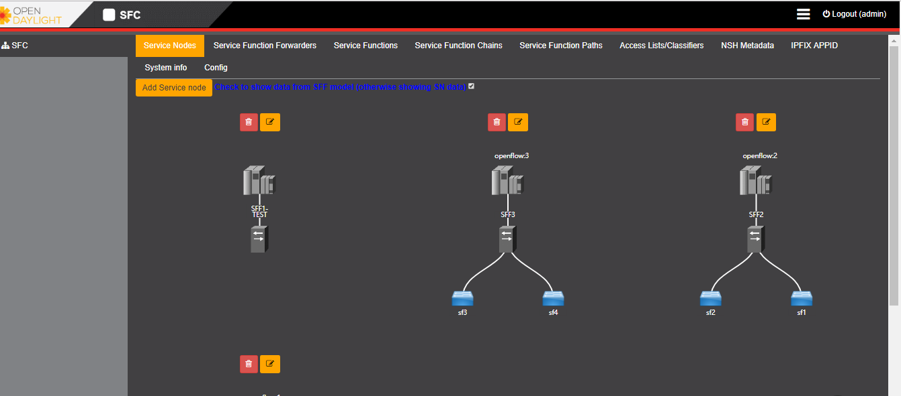

功能为创建一个service node ,并自动与SFF 和SF关联。

创建service node 的界面为

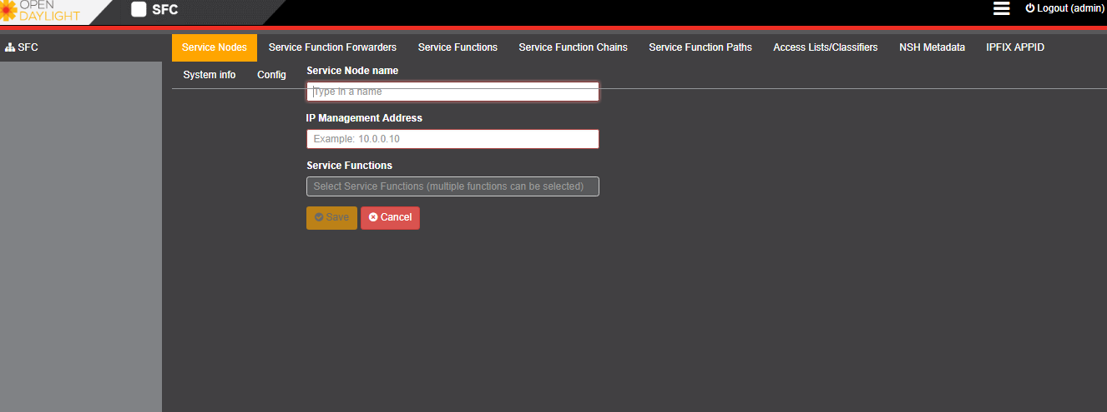

必须配置的参数为

“name”：

**ip-mgmt-address**”:

“service -function”: list

同时获取service function forwarder信息关联SFF。

2.2 service function forwarder

2.2.1 参考rest api为

2.2.2 参考界面设计

列表图

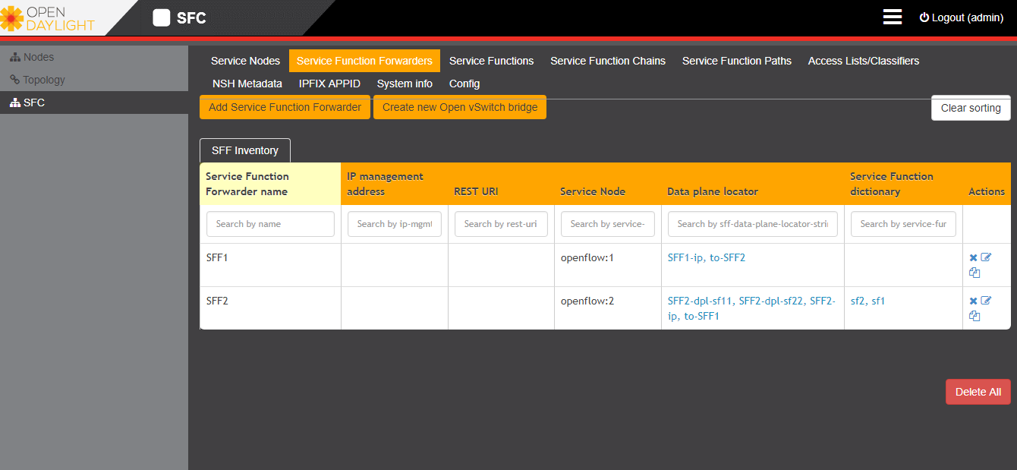

增加sff时，参考界面如图

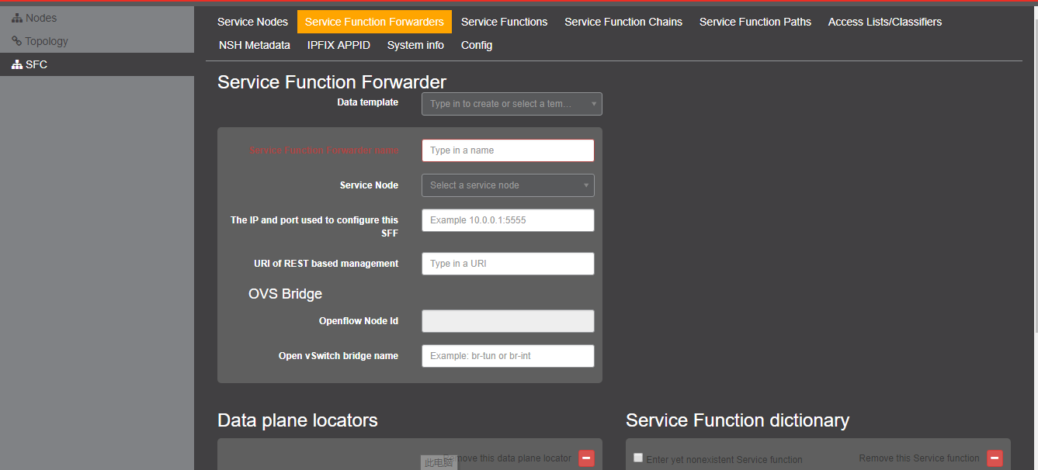

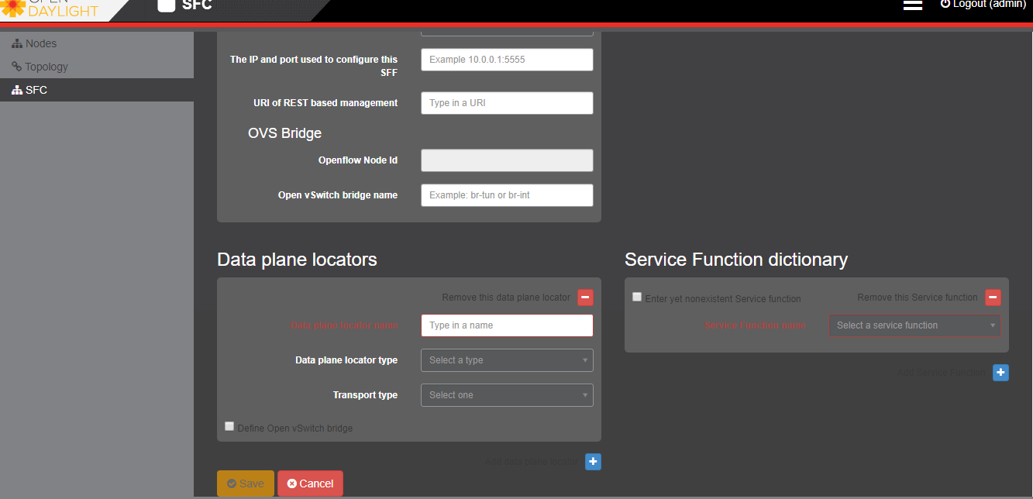

其中，data plane locators中

Locator type

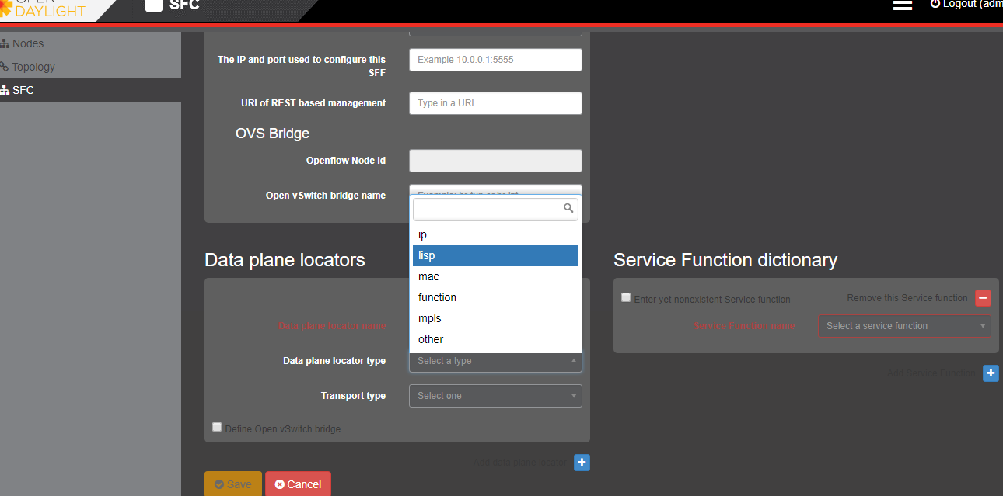

Locator type为ip时

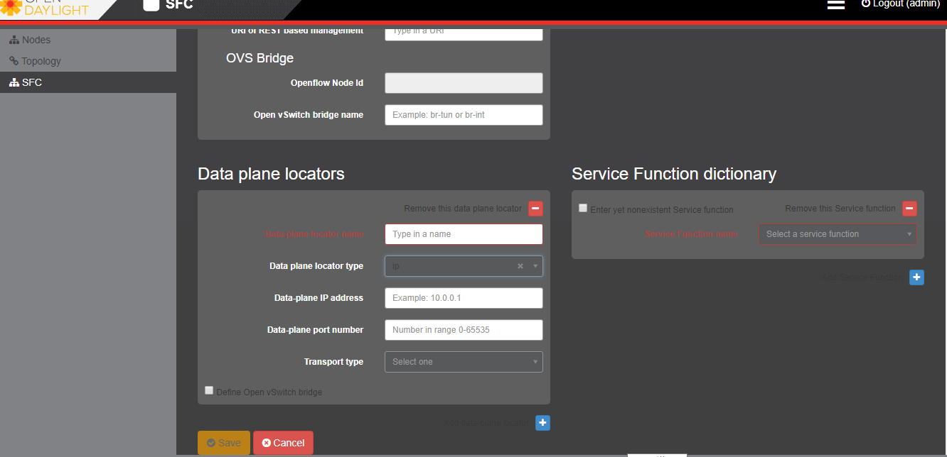

为lisp时

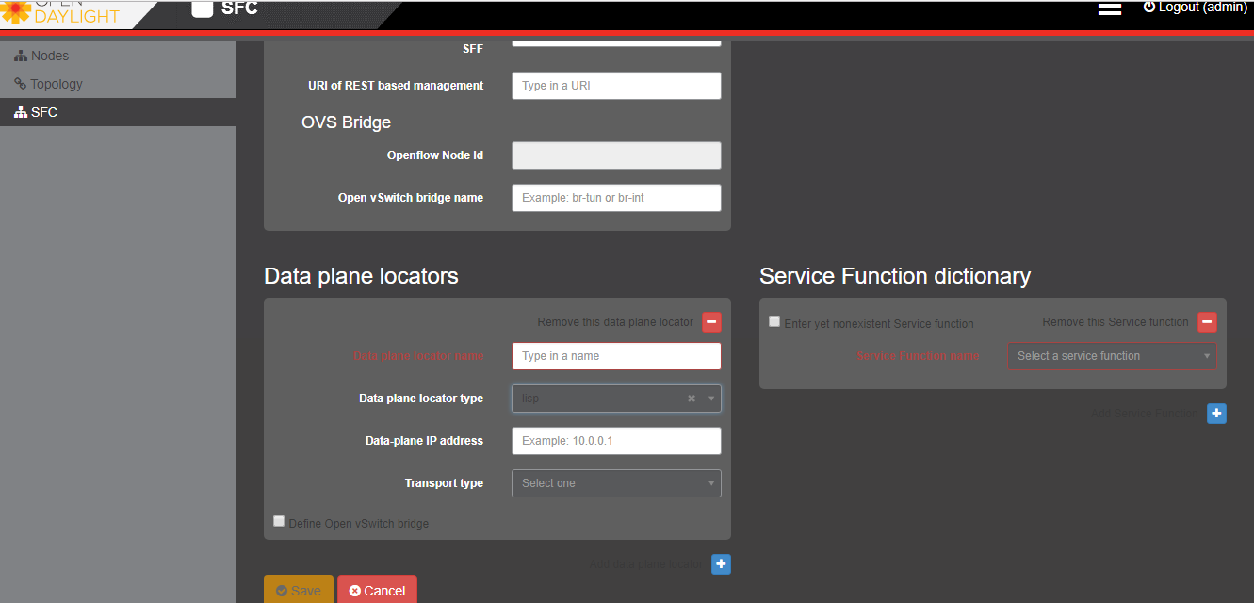

为mac时

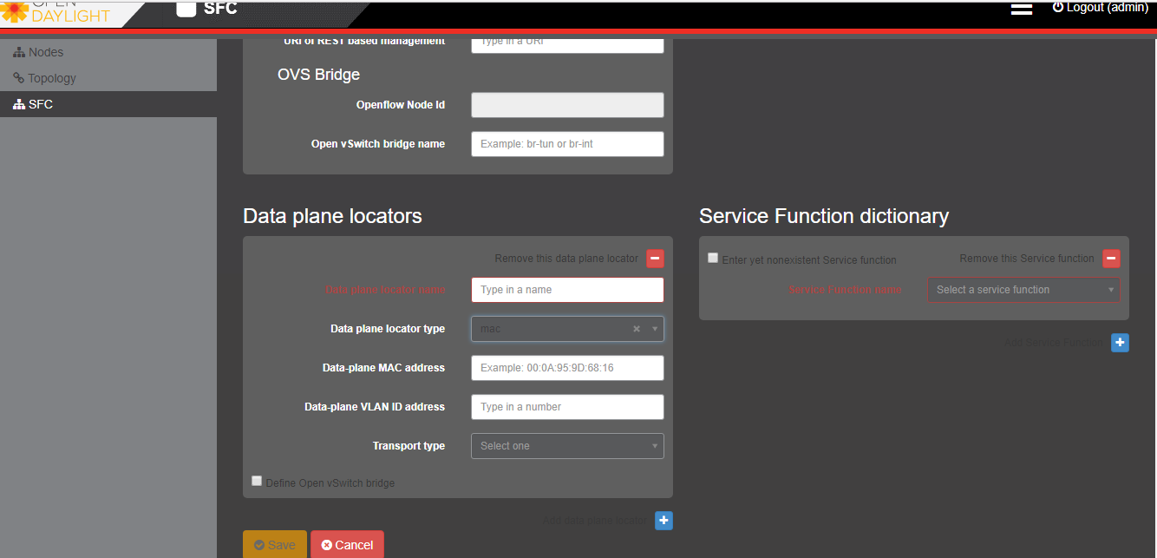

为mpls

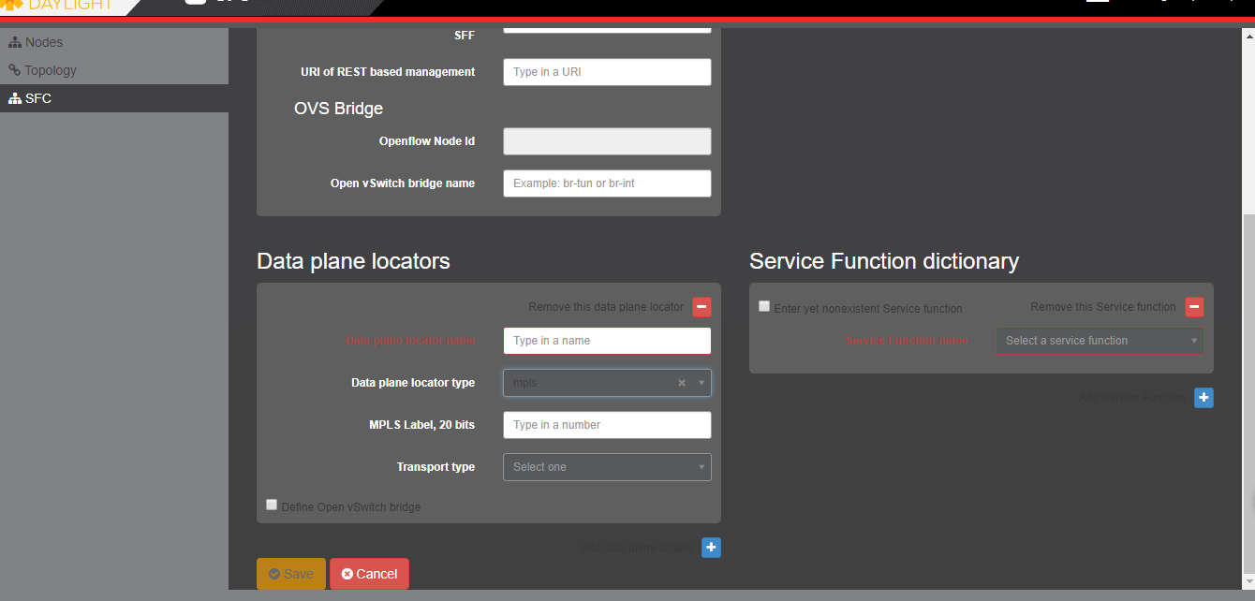

为other时

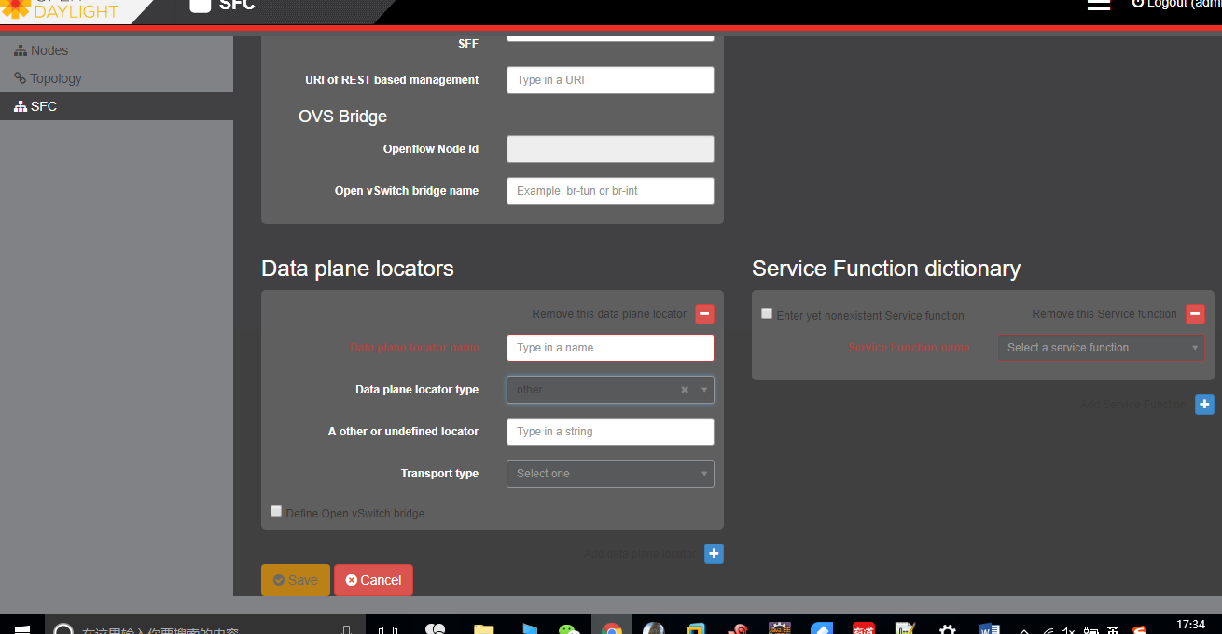

Transport type为

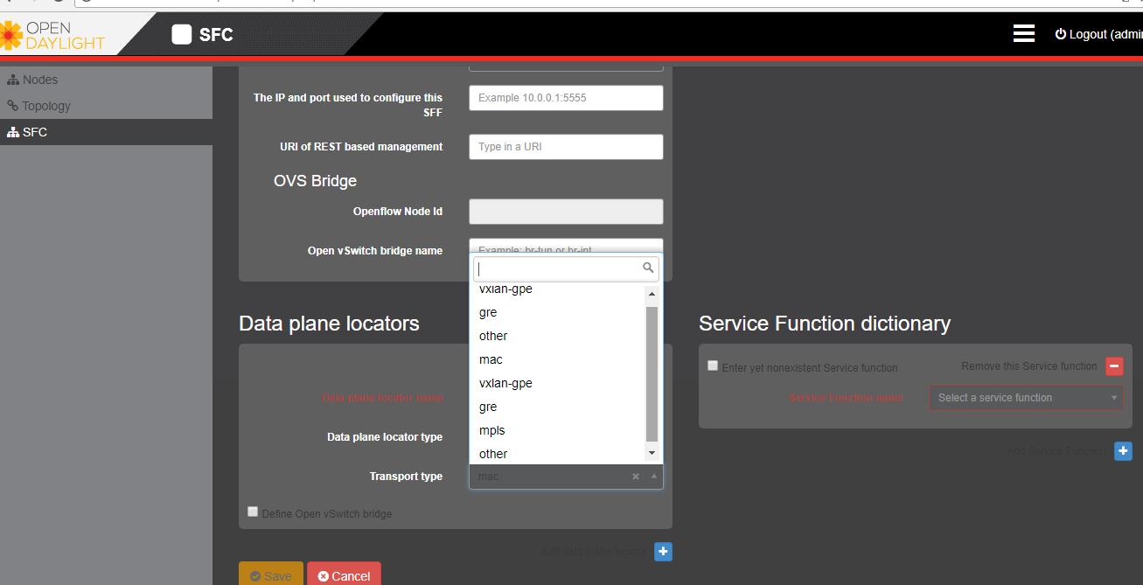

Service function dictionary

主要填写与该sff相连的sf

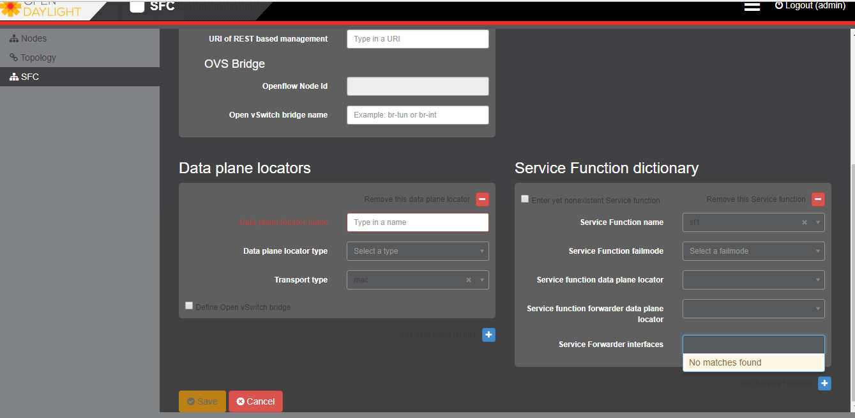

其中data plane locator 中有sf种配置的data plane locator

1. service function

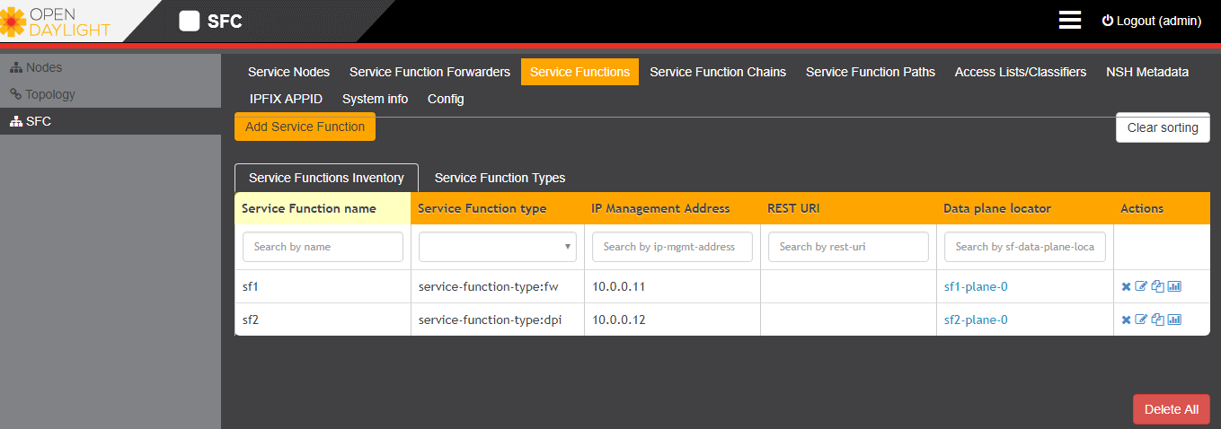

点击 Add Service Function，页面如下图：

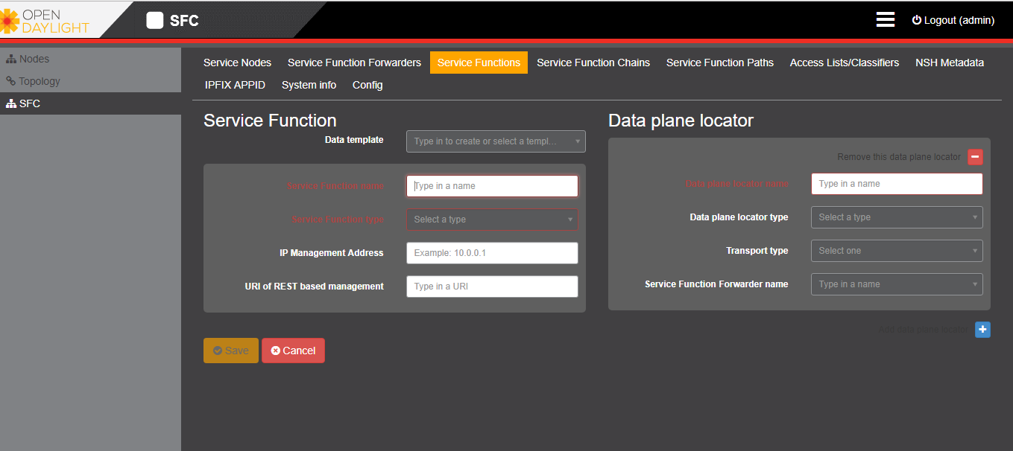

其中 service function type为

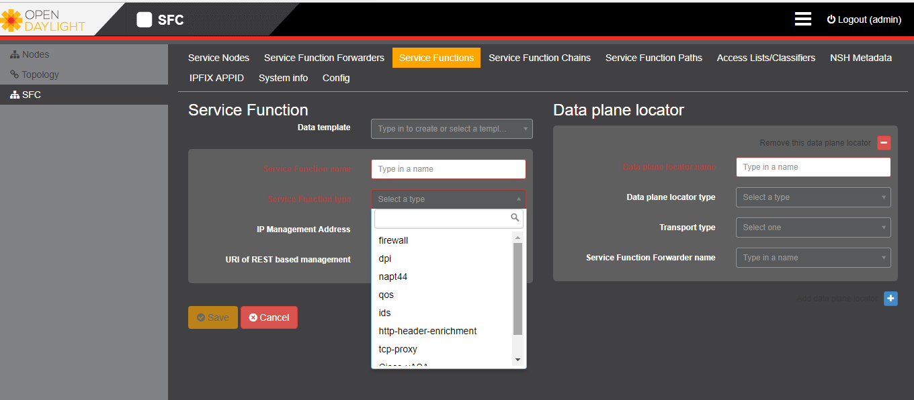

Data plane locator type为

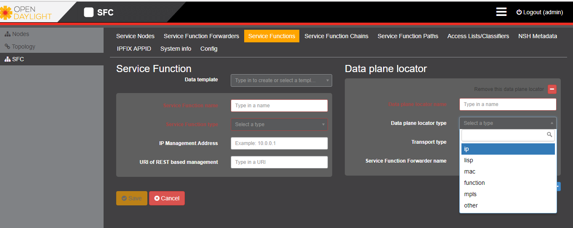

为ip时，界面是

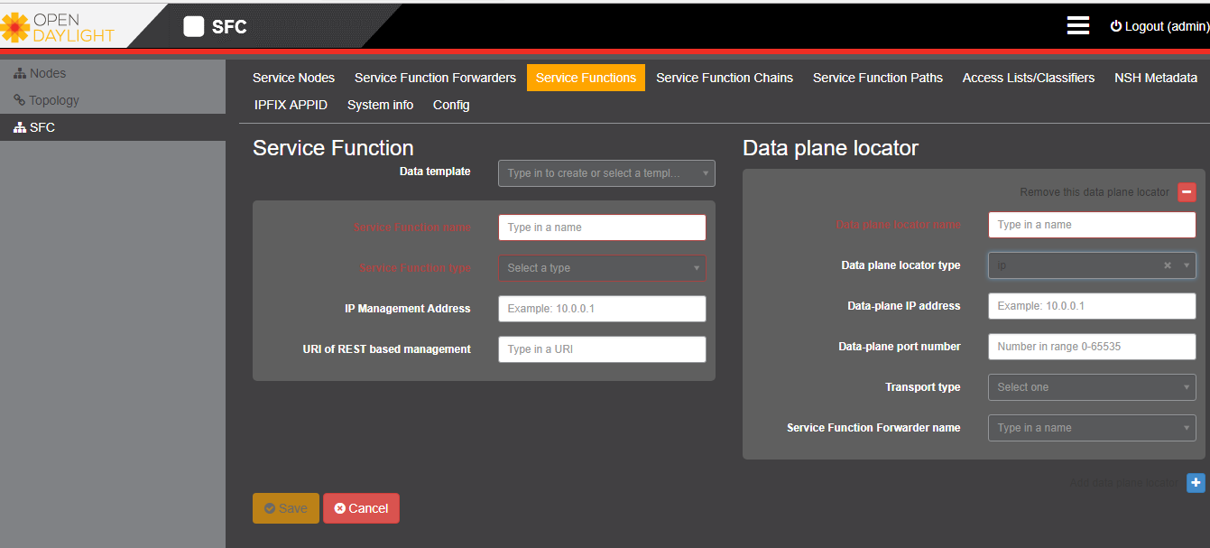

为lisp时

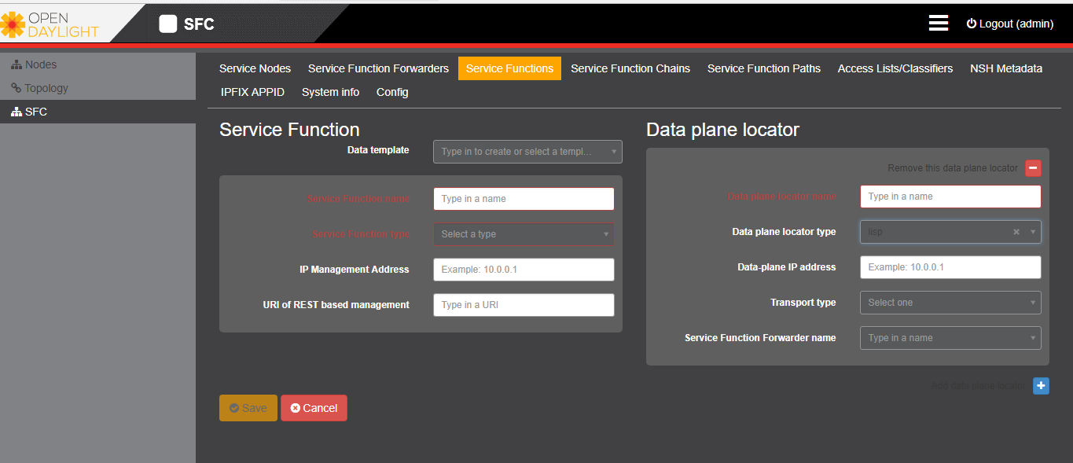

为mac时

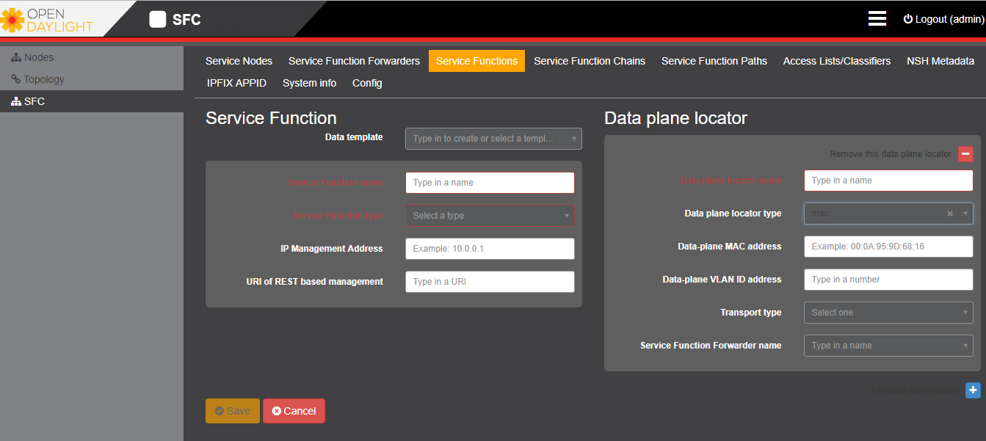

为mpls时

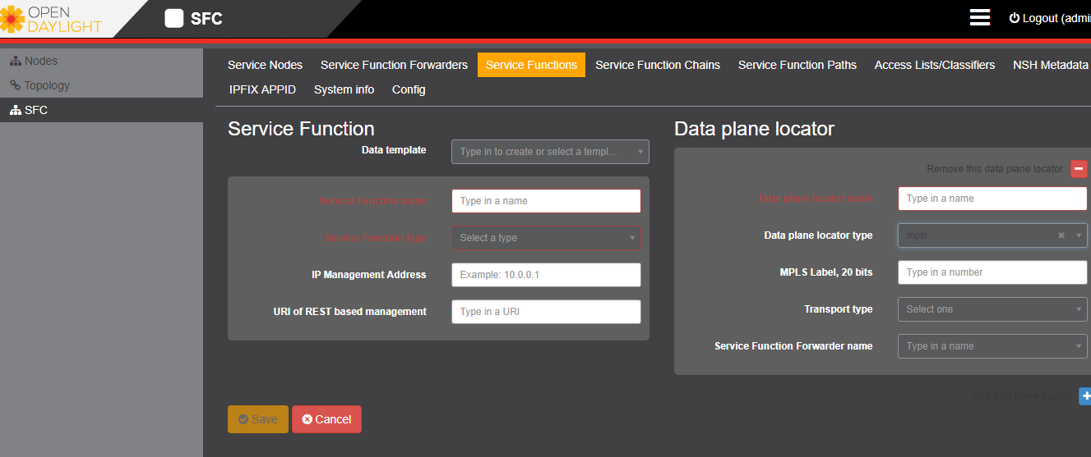

Data planer locator transport type

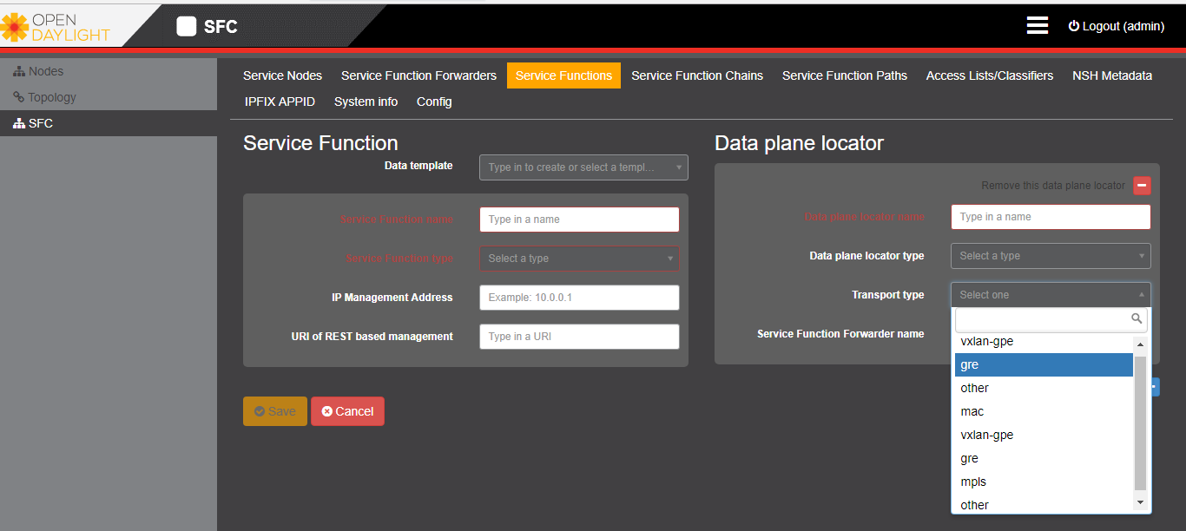

* 1. service function
     1. api
     2. 参考界面设计

1. 
2. 点击 Add Service Function，页面如下图：
3. 
4. 其中 service function type为
5. 
6. Data plane locator type为
7. 
8. 为ip时，界面是
9. 
10. 为lisp时
11. 
12. 为mac时
13. 
14. 为mpls时
15. 
16. Data planer locator transport type
17. 

1.4 service function chain

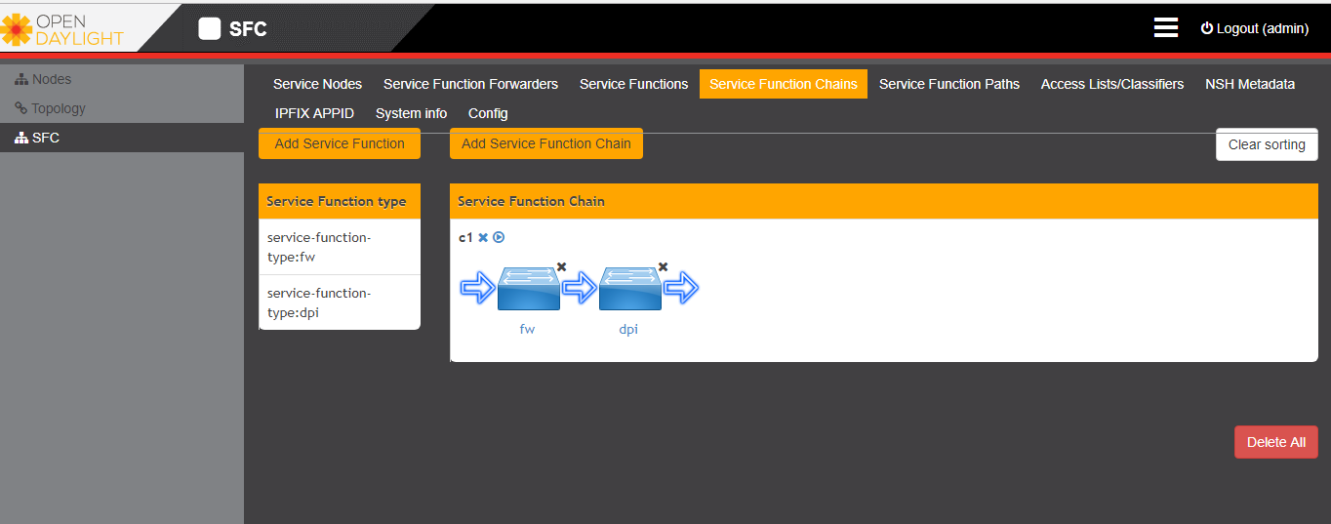

创建完service function 后，将左侧的function type拖动构建service function chain.

拖动之后如下图所示

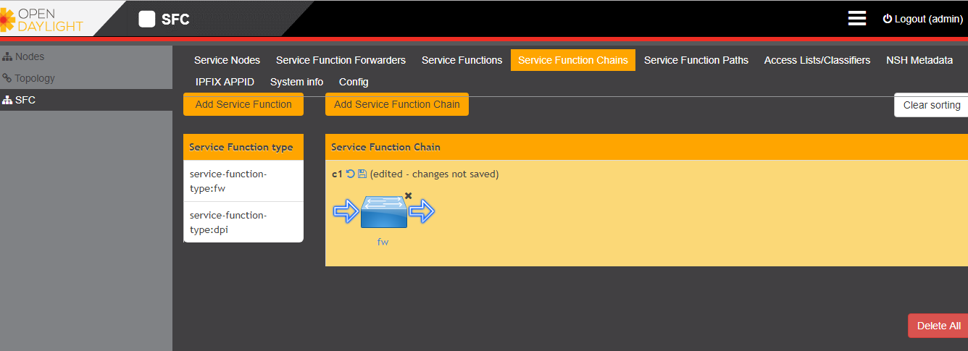

点击可撤回改动。点击可保存，保存后如图

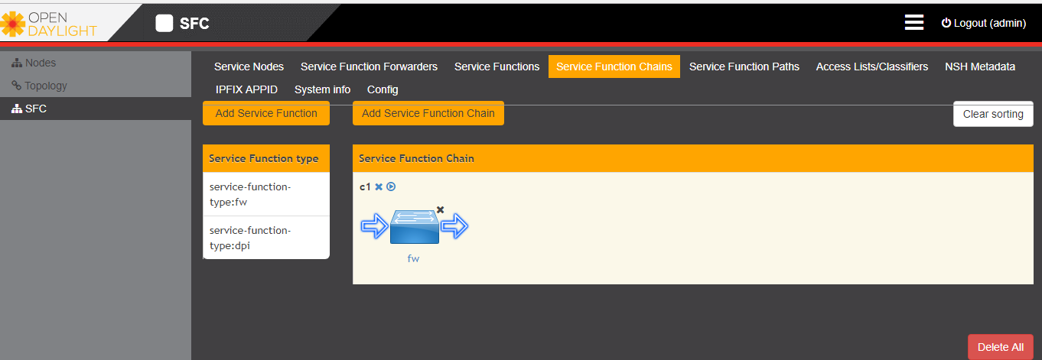

点击部署该service chain,生成 service function path

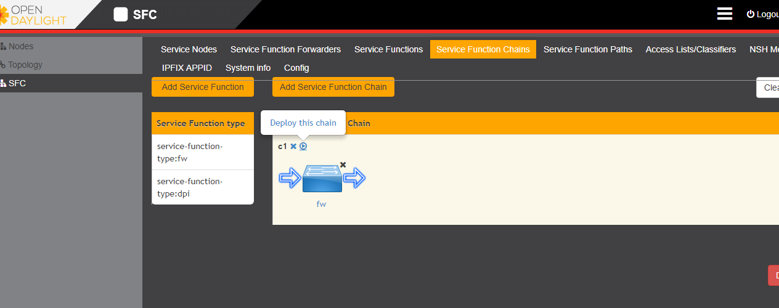

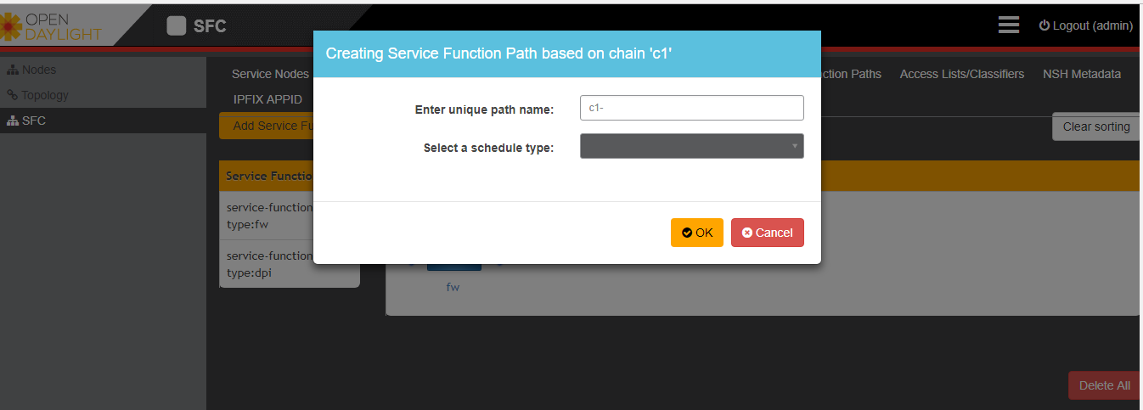

选择schedule type

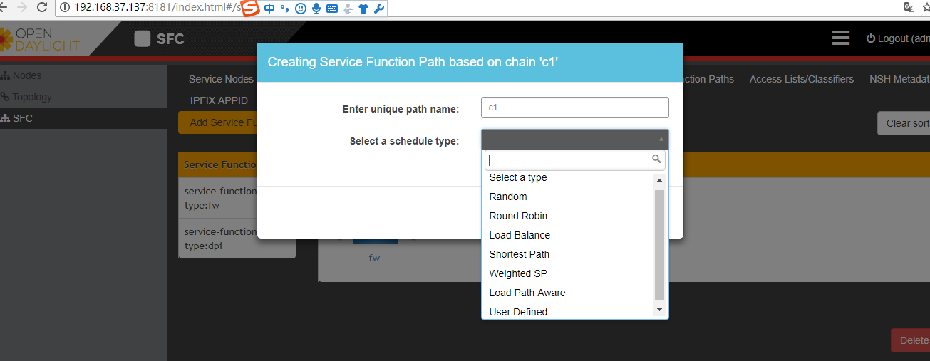

完成后生成service function path.

1.4 service function path

经过第三步骤后，生成service function path

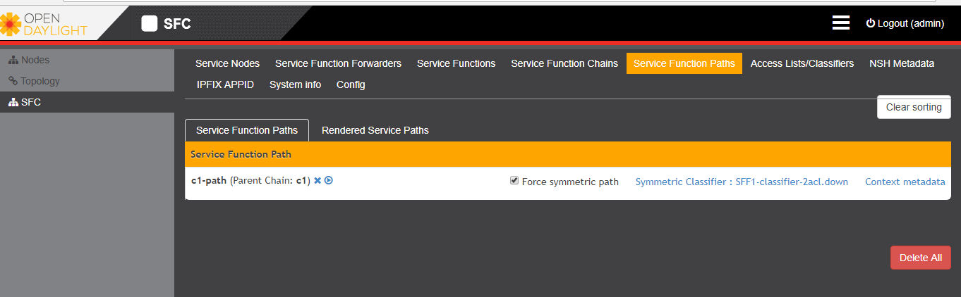

点击部署 rendered service path。

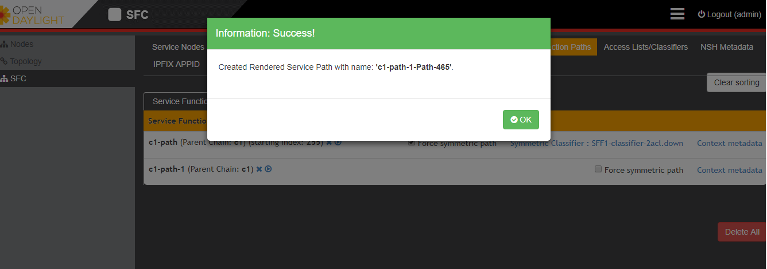

点击同时再生成一条反向的路径。

点击选择classfier，如果未创建classifier可先不填，再创建classifier时把相应的path名字填入即可。

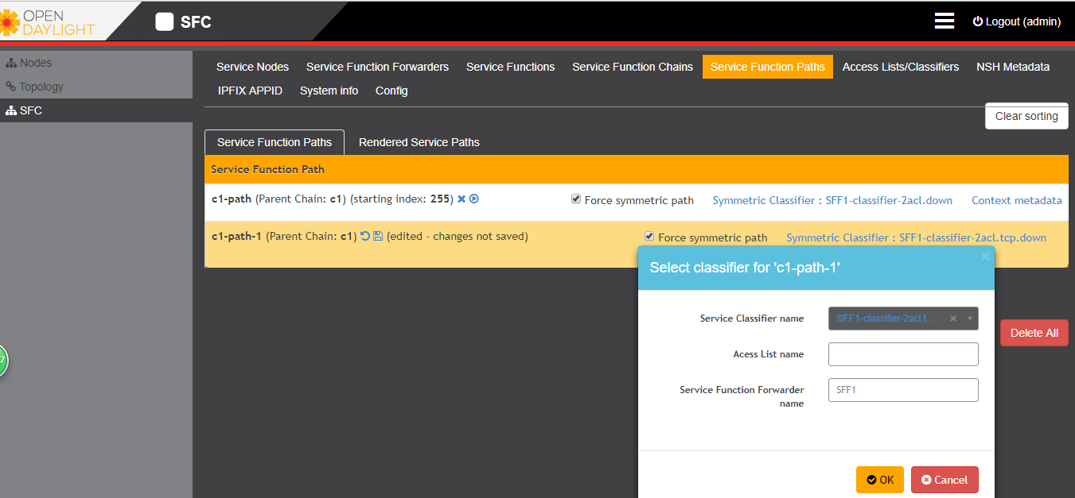

生成rendered service path后 ，如图所示

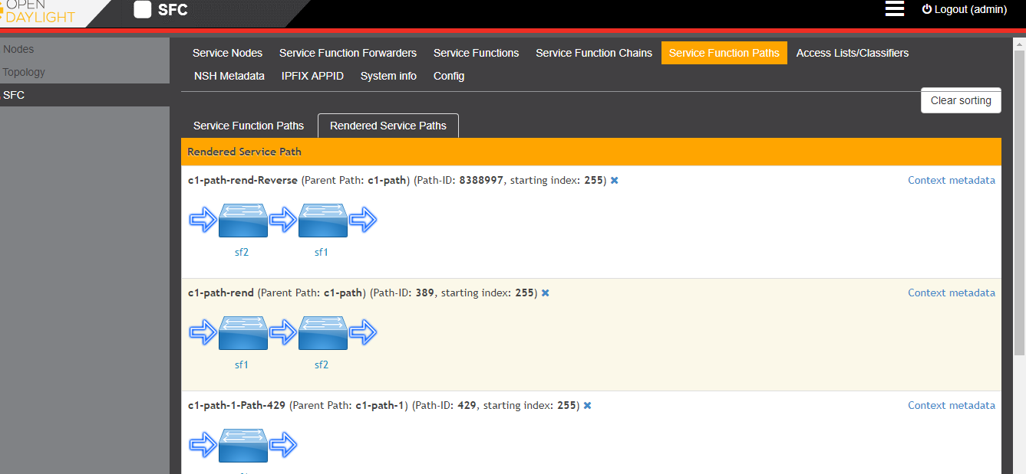

1.5