目 录

* **Beginner’s Guide**
  + Membership
  + Smart Contract
* **Game Rule**
  + Soccer
  + E-sports
  + Basketball
  + Baseball
  + Tennis
  + Volleyball
  + Snooker
  + Darts
  + Lottery
  + In-play
  + 串关
* **Terms of Use**
* **Privacy Policy**
* **Token Disclaimer**

# 新手引导

* **Membership：**

**Step 1: Register an accout**

Users can register the accounts on the Coingame or choose the other login methods to register.

1. Register the account on the Coingame

1. Enter to the homepage of Coingame, click the “Sign Up” at the top right corner of the page;
2. Follow the prompts to finish the registration information;
3. After read and agreed the terms & conditions, click on ”Next Step”;
4. Click to ”Validation code”, and enter the validation code, click on ”Next Step”;
5. Set 6-digit fund password, click the “Confirm”, and finish the  registration process.

2. Register the account by the other login methods

1. Enter to the homepage of Coingame, click the “Sign Up” at the top right corner of the page;
2. Select any login mode (Facebook, Twitter, Google) at the bottom of the login page and jump to the third party login page;
3. Confirm to login and jump to the homepage of Coingame, and enter the email and validation code, click to the “ Confirm”;
4. Set 6-digit fund password, click the “Confirm”, and finish the  registration process.

**Step 2: Register an accout**

1. Click the account at the top right of the homepage, expand the drop-down box, and click the “Deposit & More” to enter the personal deposit interface；

2、The wallet currency is the default currency for predictions. Select the icon of digital currencies from the top corner of the page to switch currencies；

3、Copy the deposit address, or use the exchange wallet, to scan the QR code and transfer your preferred currency to your Coingame account from the exchange or your private wallet. You can check your assets on the left side of the page.

**Step 3: Go to forecast**

1. Click “Game” or “Match” or “Lottery” to select the option you would like to predict on;

2. If you select the “Match” to predict on, you can click the directory at the left side of the page to select the option you would like to predict on;

3. Select the game you want to predict on. After acknowledging the User Agreement, you can find the game you want to predict on in the “Prediction Order” column on the left side of the page.；

4. After entering the prediction amount, select the digital currencies which you would like to prediction, click the “Quick Predict” button to predict;

5. After making your prediction, click Assets Center, to check updates to your predictions under “Prediction History”.

**Step 4: Withdraw from the account**

1. Click “Assets Center” at the top right corner of the page to access the personal withdrawal interface;

2. The wallet currency is the default currency for predictions. Select the digital currencies from the top right corner of the page to switch currencies;

3. Select the icon of digital currencies which you would like to withdraw, and follow the prompts to finish;

4. Click “Withdrawal History” from “Deposit & More” page to check your withdrawal details;

5. Open the public chain website and enter the withdrawal address to check the withdrawal progress.

* **Smart Contract：**

NB: Never transfer ETC directly from an exchange to a prediction contract. Please ensure that you send ETC from your personal wallet only as winnings will not be forwarded to you by the exchange.

Step 1: How to get digital currency

1.Become a registered user

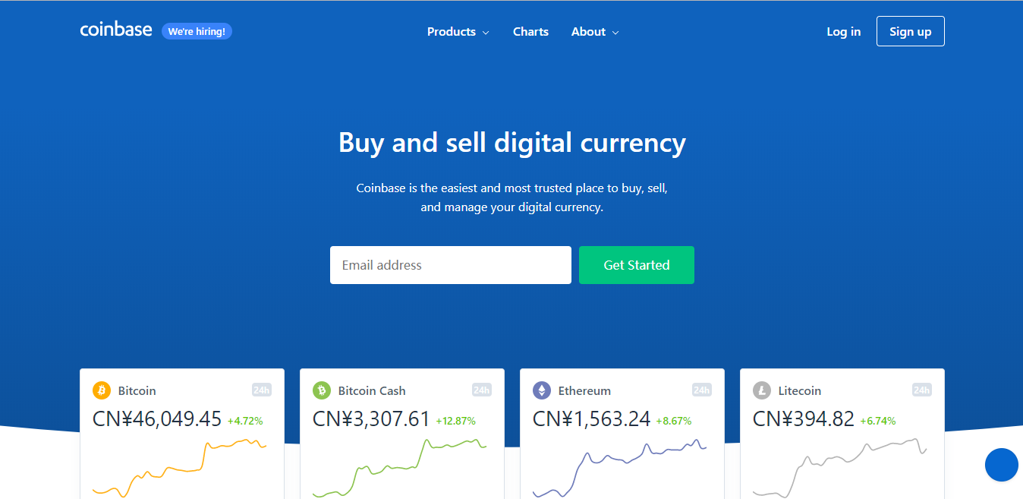

Register and logon Coinbase: https://www.coinbase.com/

2. Buy the coin and place the order

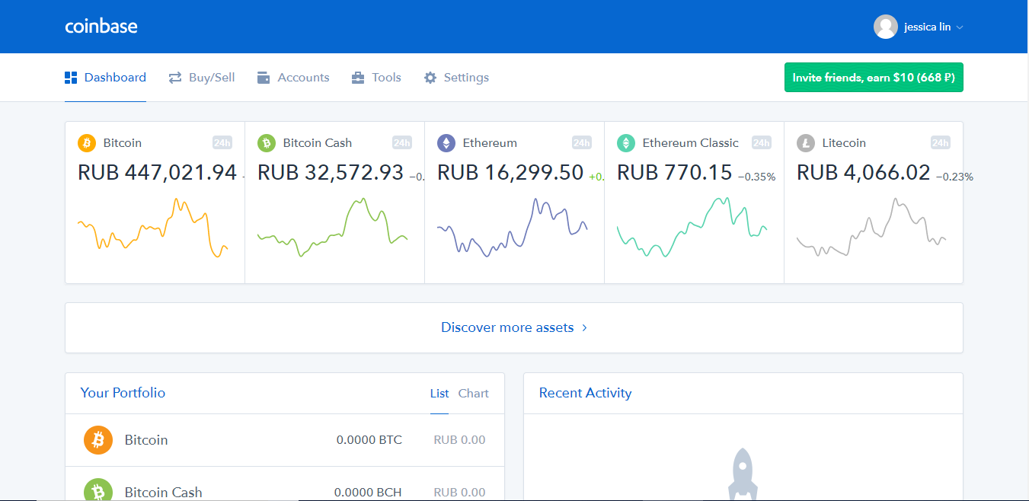

Click Buy/Sell to select ETH or ETC; and buy ETC or ETH following Coinbase’s instructions.

Wait for the transfer of the coins.

3. Transfer the funds out

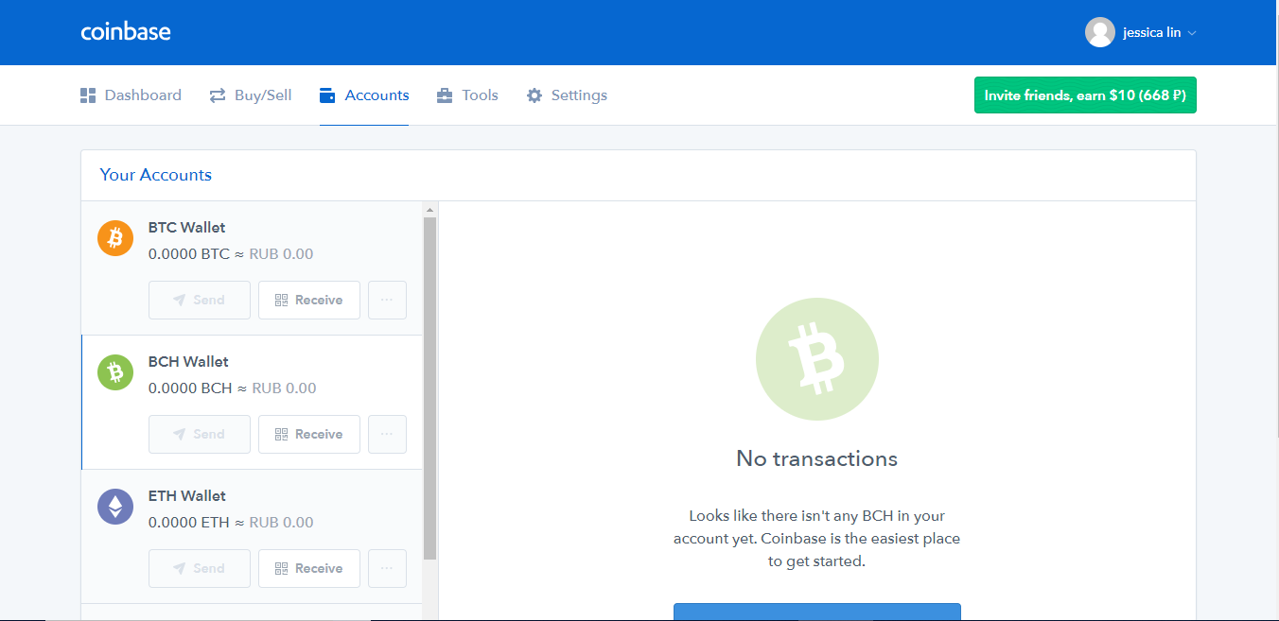

You can check your ETC or ETH at your “Account” after the transfer!

If you want to transfer your coins out of Coinbase, click “send” and transfer your coins to your personal/private wallet

Recommended ETH wallet: Metamask

Address: <https://metamask.io/>

Recommend ETC wallet: ClassicEtherWallet

Address: <https://ethereumproject.github.io/etherwallet/>

If you know how to purchase ETH and ETC, please proceed to the next step for instructions on transferring your preferred currency to the wallet.

**Step 2: Wallet user guidance**

* ETH wallet user guide

ETH address: <https://metamask.io/>



Open the official website, click “GET CHROME EXTENSION”, download and install Metamask wallet in compatible with your computer system.

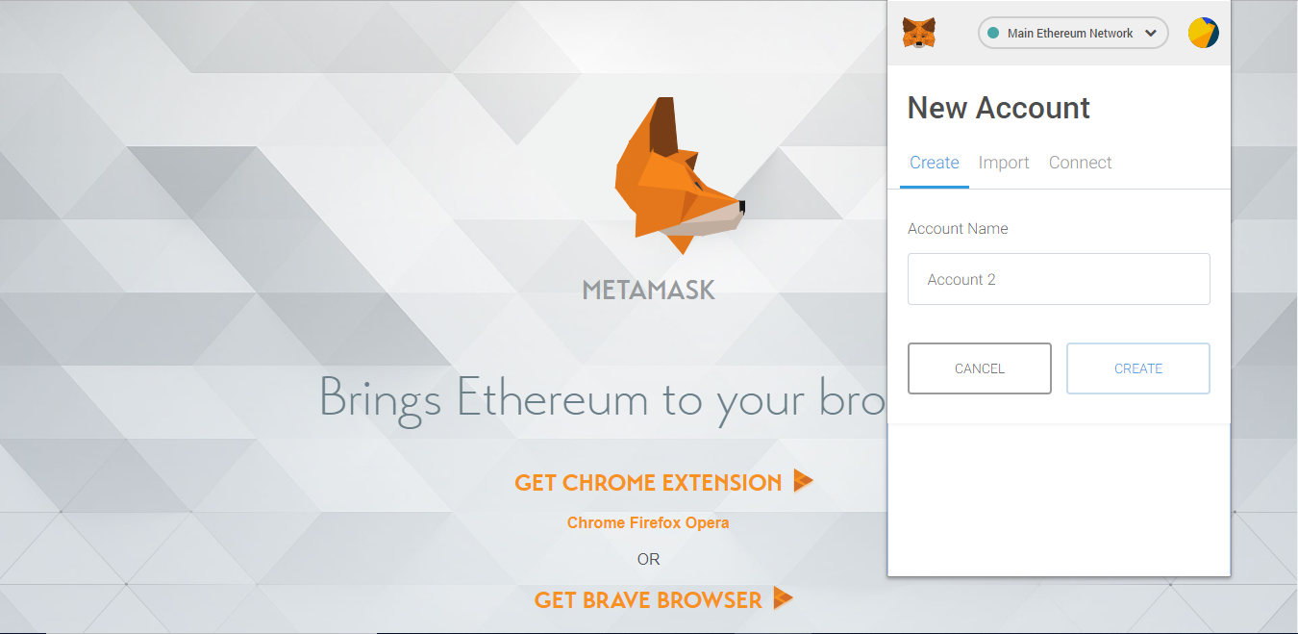

1. Set password

Set the password with at least 8 digits and don’t forget your password!

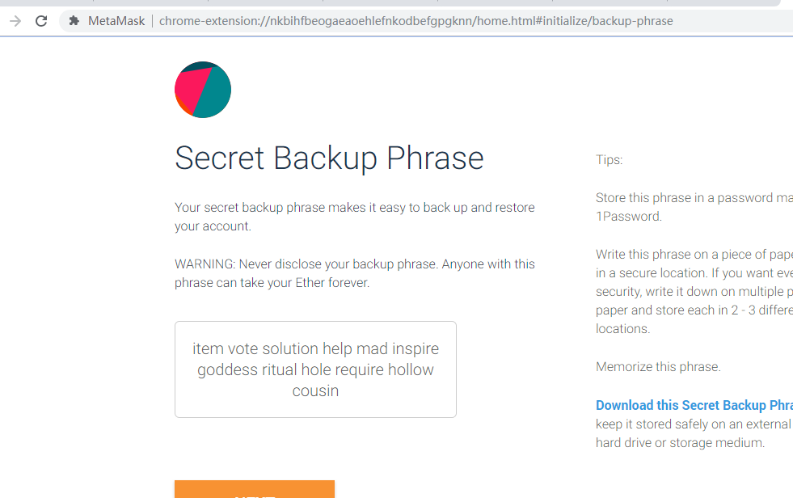

2. Maintain your word string

Don’t share the word string with anyone and don’t lose it. It will help the user to get back the digital assets held with your wallet.

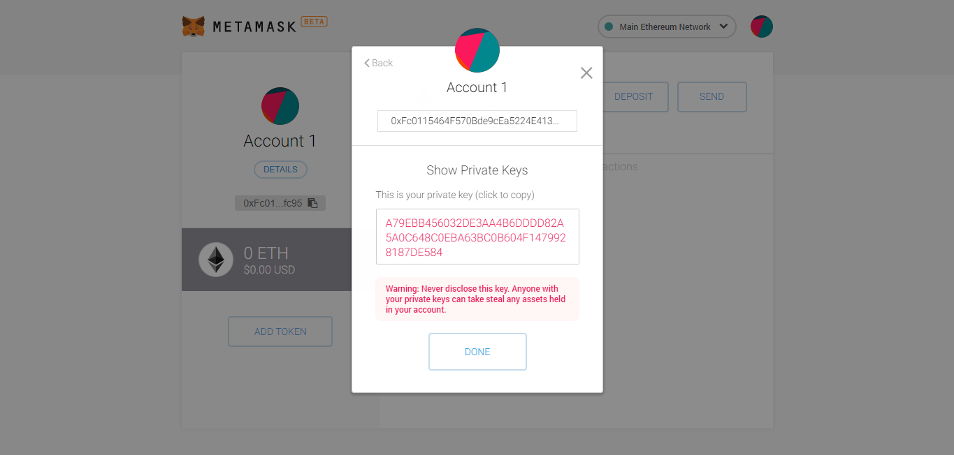

3. Keep your private key

Don’t share the private key with anyone and don’t lose it. It is the most important document to get back the wallet.

You can now use your personal/private wallet. Last step! Predict!

* ETC wallet user guide

ETC address: <https://ethereumproject.github.io/etherwallet/>

Open the official website, select your preferred language, select New wallet, follow the instructions to open a wallet.

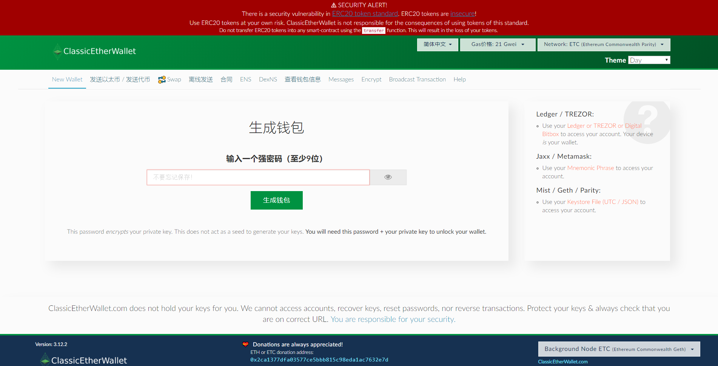

1. Set password

Set the password with at least 9 digits and don’t forget your password!

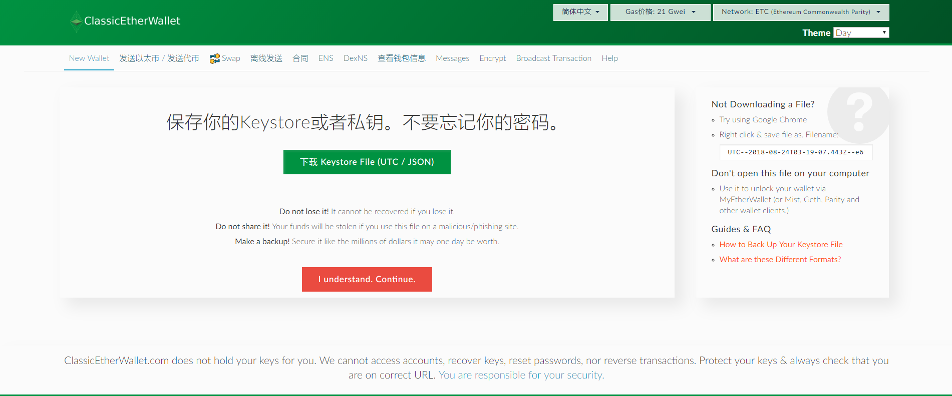

2. Save your Keystore File.

Do not share your Keystore File with anyone and do not lose it. It is the most important file that you need to retrieve your wallet.

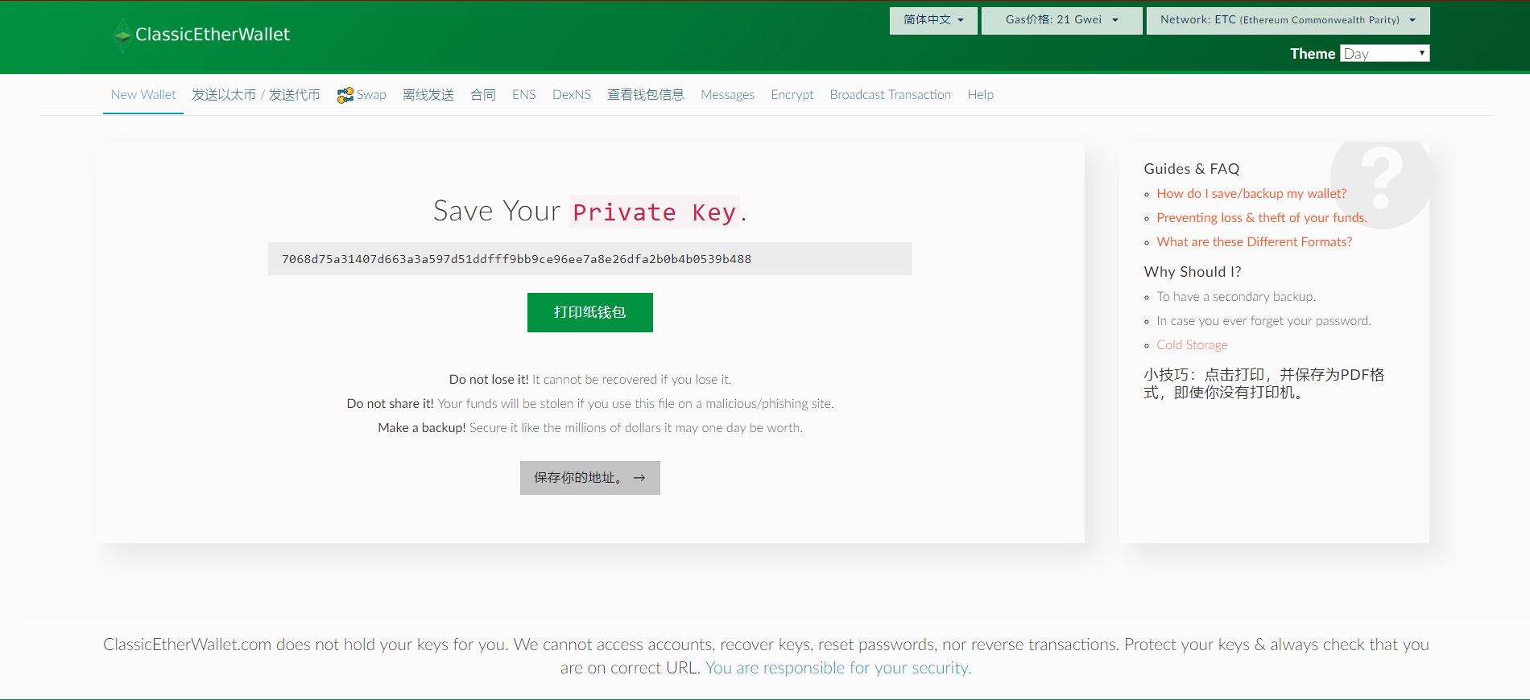

3. Safely store the private key to your wallet

Do not share the key with anyone and do not lose it as it is required to access your funds.

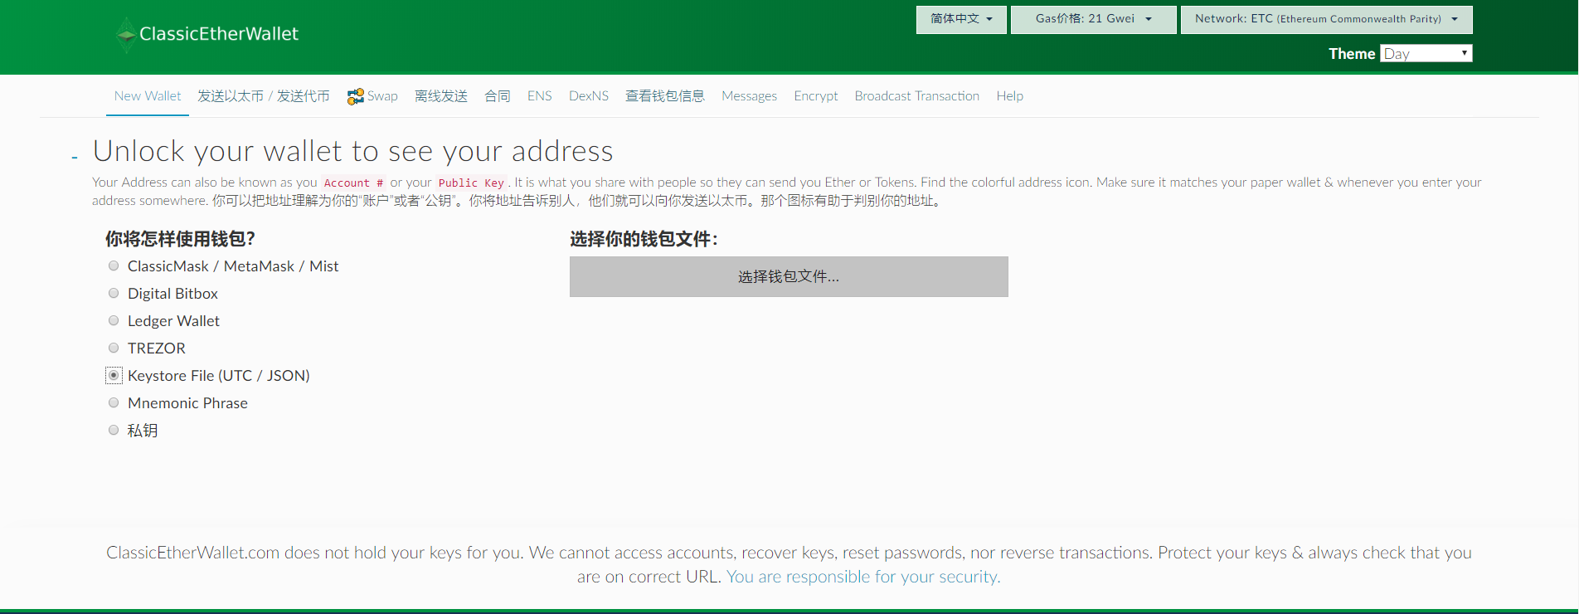

4. Unlock your wallet

It is suggested that you use your Keystore File and password to unlock your personal/private wallet.

You can now use your personal/private wallet. Last step! Predict!

**Step 3: Forecast Guide**

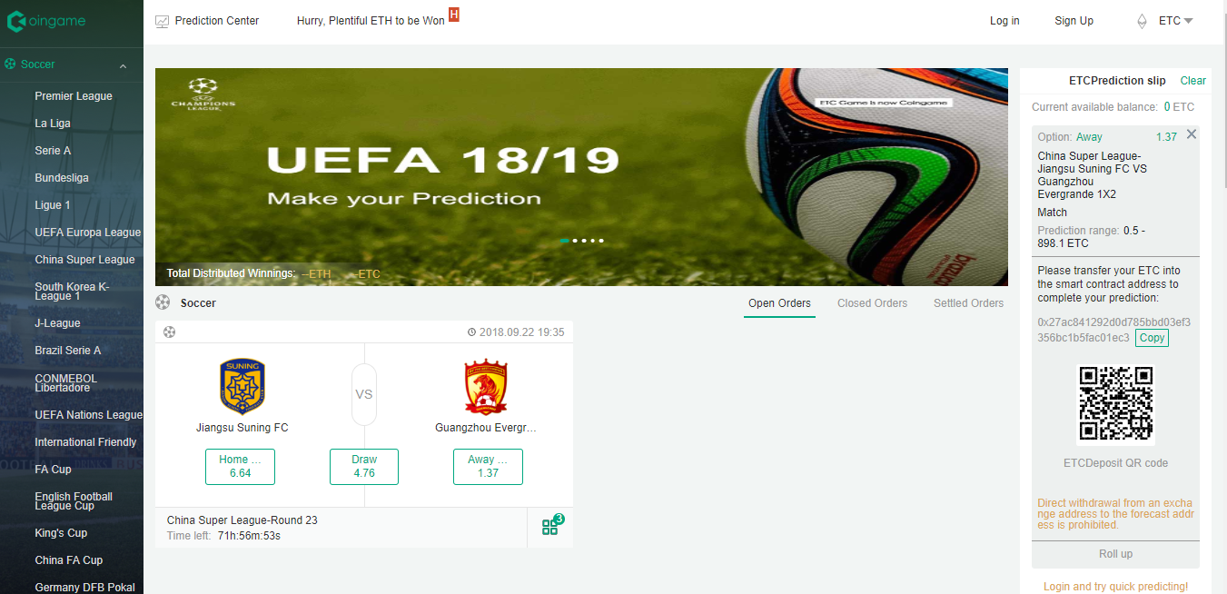

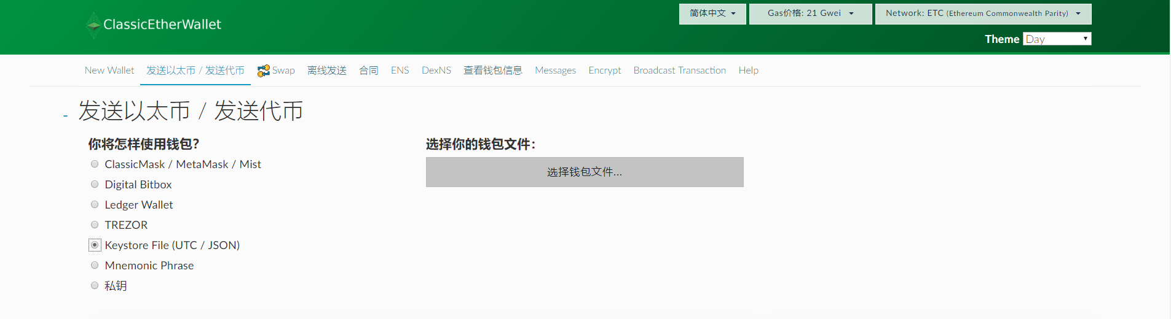

1. Enter the homepage of Coingame, select the option you would like to predict on

2. Click the currency in the forecast slip on the right side of homepage（The default preferred currency for prediction is ETH）;

3. Copy the forecast deposit address

4. Return to the wallet of ETC, select “send” (It is suggested that you use your Keystore file)

5. Paste the copied forecast deposit address here! Enter the ETC you want to deposit to complete your prediction! (Please set an appropriate Gas Limit of 150,000 to successfully transfer ETC to the prediction forecast address.)

6. Wait for the forecast results to be announced! After completion of the event, any winnings will be automatically transferred to your wallet. In case of unpredictable circumstances, such as cancellation of the game, the funds will be refunded to the user’s wallet.

# 预测细则

**Coingame**

**A Next Generation Prediction Platform**

Coingame is a revolutionary new platform allowing crypto enthusiasts to predict event outcomes securely with Ethereum Classic. The platform uses smart contracts, which are transparent, unalterable, and tamper-proof, ensuring that participants do not have to trust a third party to honor the prediction.

Soccer

* **1x2**

Also known as three-way prediction, this is often used for games which can result in a home win, draw or away win.

For example, let’s say you want to make a prediction on the England vs Germany match, you would be able to predict that either England or Germany wins, or that the match will end in a draw. Each result carries its own multiple.

* **正确比分**

预测正常赛时结束时的比分。

* **半场比分预测（半场正确比分及首个得分球员）**

如果球员是在一个进球得分已经产生后进场、或没有参加上半场比赛、或上半场进球全部为乌龙球，则预测将按照半场正确比分盘口的单注进行结算，且使用比赛开始时的相应倍数。

* **半场赛果，包括滚球**

若赛事在上半场结束前被中止，投币作废。

* **半场正确比分**

若赛事在上半场结束前被中止，投币作废。

* **双胜彩**

该投币盘有以下选项：

1或X - 如果主队胜出或者两队打和，该选项投币为赢。

X或2 - 如果客队胜出或者两队打和，该选项投币为赢。

1或2 -如果主队胜出或客队胜出，该选项投币为赢。

进行投币结算时，如果比赛是在中立场举行，列在前面的球队将被视为主队。

* **Asian Handicap**

This form of prediction takes the skills of the soccer teams into consideration and applies a handicap to the stronger team. This means that the stronger team must not only win, but also exceed the weaker team by a prescribed number of goals. This precludes the match from ending in a draw, leaving the prediction as a binary choice with a near 50/50 chance of success.

For grading purposes, when placing a Live Soccer Asian Handicap wager, the handicap and price displayed are for the match from the point the wager is accepted. Goals/Corners/Bookings scored previously (ie. current score) are ignored for a Live Asian Handicap wager. Unless otherwise specified, all Live Soccer Asian Handicap wagers will be settled based on the goals scored in the remainder of the match during Regulation Time. All goals/corners/bookings scored before the wager is accepted are not included.

* **Handicap and outcomes are as follows:**

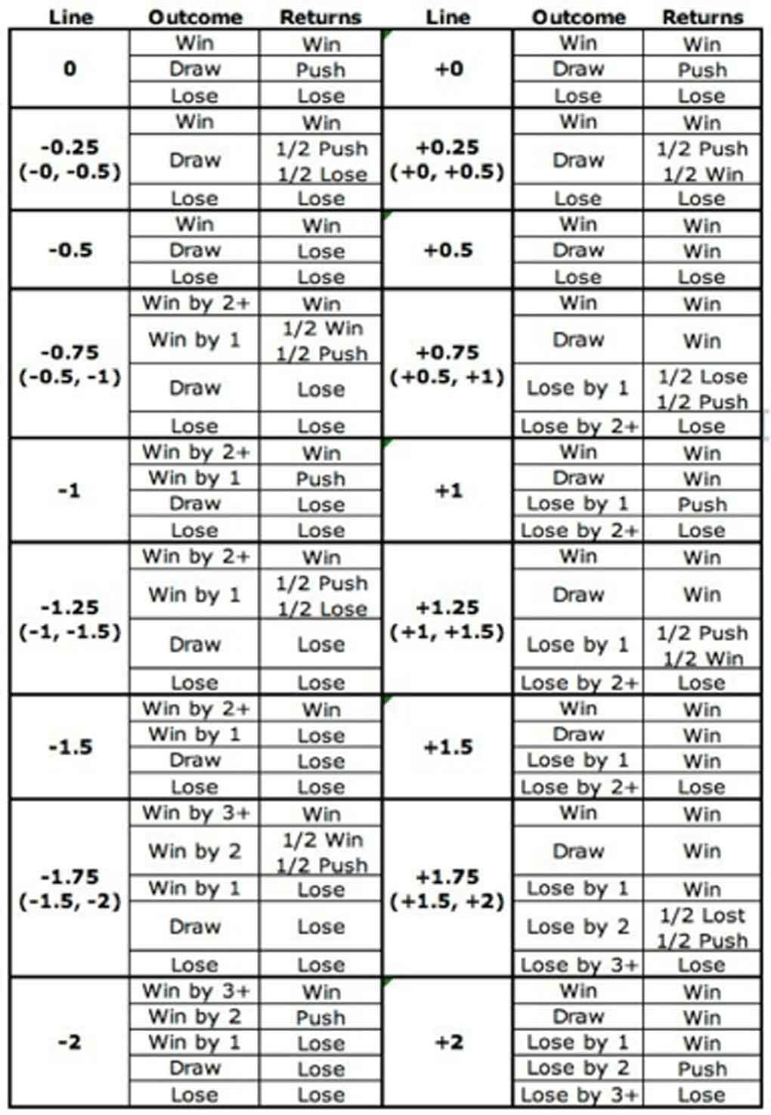

NB: The plus signs in the Team Outcome columns indicate 'or more', e.g., '2+' means 'by 2 goals or more'.

In the unlikely event that a whole number is used for the handicap, the handicap-adjusted final score could result in a draw. This situation is not a draw, but a push. In the event of a push, all participants have their original wagers returned as there is no winner.

Introduction:

**1、Handicap Line 0 ball**

If either team wins by any margin, they (the winning team) are to be considered as the winning selection. In the event of a draw, all predictions are void and stakes are refunded.

**2、Handicap Line 0, 0.5 ball**

A. Team giving a 0, 0.5 ball start:

Win by any score - All predictions on this selection are winners.

Draw - Half the stake is refunded on this selection. The other half of the stake is classified as a loser.

ose by any score - All predictions on this selection are losers.

B. Team receiving 0,0.5 ball start:

Win by any score - All predictions on this selection are winners.

Draw - Half the stake is settled at the price of the chosen selection. The other half is refunded to the customer.

Lose by any score - All predictions on this selection are losers.

**3、Handicap Line 0.5 ball**

1. Team giving a 0.5 ball start:

Win by any score - All predictions on this selection are winners.

Draw - All predictions on this selection are losers.

Lose by any score - All predictions on this selection are losers.

1. Team receiving a 0.5 ball start:

Win by any score - All predictions on this selection are winners.

Draw - All predictions on this selection are winners.

Lose by any score - All predictions on this selection are losers.

**4、Handicap Line 1 -0.5, 1 ball:**

A. Team giving a 0.5,1 ball start:

Win by 2 or more - All predictions on this selection are winners.

Win by exactly 1 - Half the stake is settled at the price of the chosen selection. The other half is refunded to the customer.

Draw or lose by any score - All predictions on this selection are losers.

B.Team receiving a 0.5,1 ball start:

Draw or win by any score - All predictions on this selection are winners.

Lose by exactly 1 - Half the stake is refunded to the customer. The other half is classed as a loser.

Lose by 2 or more - All predictions on this selection are losers.

**5、Handicap Line 1 ball**

A. Handicap Line 1 ball:

Win by 2 or more - All predictions on this selection are winners.

Win by exactly 1 - All predictions on this selection are void and refunded to the customer.

Draw or lose - All predictions on this selection are losers.

1. Team receiving a full ball start:

Win by any score or draw - All predictions on this selection are winners.

Lose by exactly 1 - All predictions on this selection are void and refunded to the customer.

Lose by 2 or more - All predictions on this selection are losers.

* **O/U Big or Small**

Big or Small will predict a number for a statistic in a given game (usually the combined score of the two teams), and participants predict that the actual number in the game will be either higher or lower than that number.

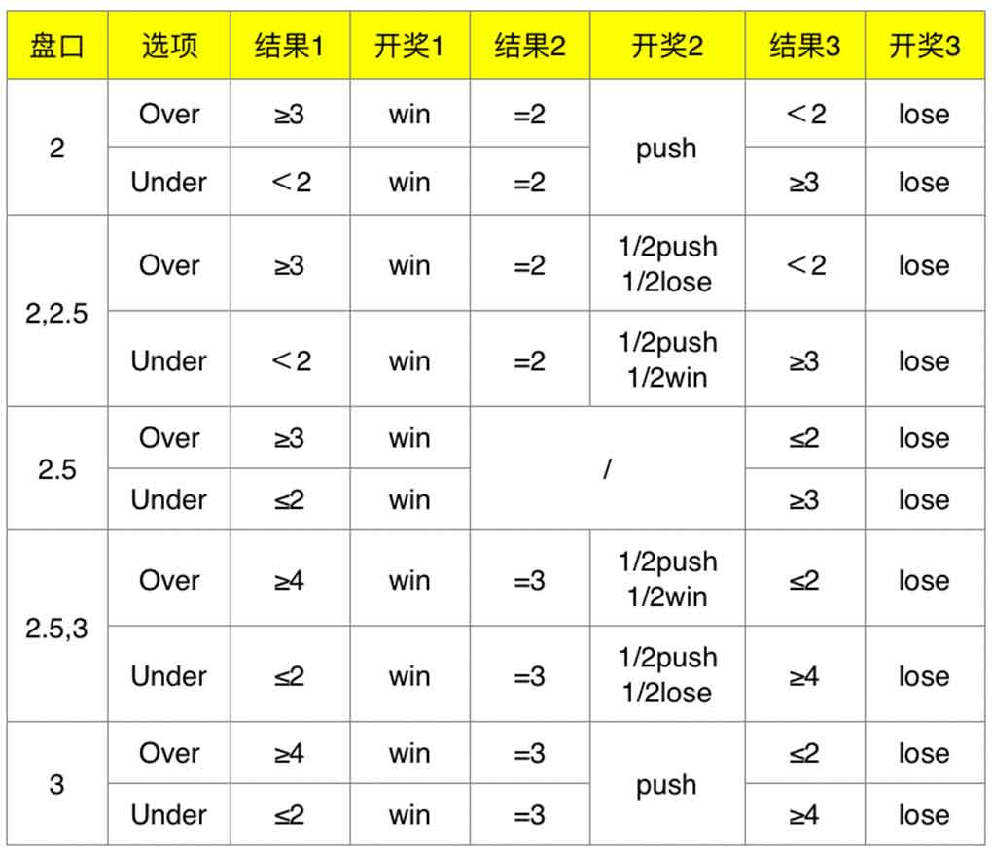

Introduction:

**1、When the O/U line is 2**

A. <2 goals

If there is no goal or only one goal, this prediction wins.

If there are two goals, the wager will be returned.

If there are 3 or more goals, this prediction loses.

B. >2 goals

If there are three or more goals, this prediction wins.

If there are 2 goals, the wager will be returned.

If there is no goal or only 1 goal, this prediction loses.

**2、When the O/U line is 2, 2.5**

A. <2, 2.5 goals

If there is no goal or only 1 goal, this prediction wins.

If there are 2 goals, half the wager is treated as a win, and the other half will be returned.

If there are 3 or more goals, this prediction loses.

B. >2, 2.5 goals

If there are 3 or more goals, this prediction wins.

If there are 2 goals, half the wager will be returned and the other half treated as a loss.

If there is no goal or only 1 goal, this prediction loses.

**3、When the O/U line is 2.5**

A. <2.5 goals

If there is no goal or 1 or 2 goals, this prediction wins.

If there are 3 or more goals, this prediction loses.

B. >2.5 goals

If there are 3 or more goals, this prediction wins.

If there is no goal or only 1 or 2 goals, this prediction loses.

**4、When the O/U line is 2.5, 3**

A. <2.5, 3 goals

If there is no goal or only 1 or 2 goals, this prediction wins.

If there are 3 goals, half the wager will be returned and the other half treated as a loss.

If there are 4 or more goals, the prediction loses.

B. >2.5, 3 goals

If there are 4 or more goals, this prediction wins.

If there are 3 goals, half the wager will be returned and the other half treated as a win.

If there is no goal or only 1 or 2 goals, this prediction loses.

**5、When the O/U line is 3**

A. <3 goals

If there is no goal or only 1 or 2 goals, this prediction wins.

If there are 3 goals, the wager will be returned.

If there are 4 or more goals, this prediction loses.

B. >3 goals

If there are 4 or more goals, this prediction wins.

If there are 3 goals, the wager will be returned.

If there is no goal or only 1 or 2 goals, this prediction loses.

* **Outright**

Outright prediction is placed on the outcome of an entire league or competition rather than on an individual game. Outright predictions are usually placed before the season starts but are also available even during the course of the competition. Each country carries its own multiple.

* **Settlement of Wagers**

If the results of the competition cannot be formally confirmed, the platform reserves the right to retain or delay the payout until an official confirmation is obtained.

If a prediction is made after the result of a competition, the platform reserves the right to void such a prediction.

If the multiple are obviously wrong, the platform reserves the right to cancel the relevant prediction. This includes more than one multiple error than the average market multiple.

If the live broadcast is paused but the competition is not affected, all prediction types will be awarded based on the official results. When the results of the competition of a certain prediction type cannot be formally confirmed, the platform reserves the right to void the prediction.

The platform reserves the right to correct wrong payouts at any time.

If the event is not based on a formal form (such as unusual time, statistical steps, event formats, etc.), the platform reserves the right to void the prediction.

If the rules, or format of an event, differ from the standards accepted by the platform, the platform reserves the right to void the prediction.

All prediction types will be based on the regular time of competition unless otherwise indicated.

If the event cannot be completed or continued (for example, due to disqualification, distraction, withdrawal from the game, lottery change, etc.), all undetermined prediction types shall be deemed invalid. If there are other items not covered by the rules, the platform will reserve the right to make final decisions to ensure fairness and justice.

All prediction types (except for halftime, first half, overtime, penalty kicks) will be based on the regular time of the competition. If a competition is disrupted, but resumes within 48 hours of the kickoff, all valid predictions will be awarded based on the final result and all undetermined predictions will be void. Regular 90 minutes: unless otherwise stated, the settlement of the soccer prediction will be based on the regular completion time. This includes injury time but does not include overtime and penalty kicks.

If the competition or market results cannot be found, the prediction will be invalid 24 hours after the kickoff.

Competition time, data and results will be obtained from reputable third parties.

E-sports

* **General Rules**

Forecast settlement will be based on official results announced by the relevant regulatory agencies that specify the event, broadcast or game API. Forecast for void/no results/no participation will be considered void. If the outcome of the event does not allow for a draw, the outcome of the overtime will be considered the result of the final effective result. All eSports forecasts are based on the outcome on the official final time, unless otherwise stated.

Based on some unpredictable circumstances - such as cheating - organizers can overturn the results and all predictions on the event are voided and refunded. If the organizer overturns the result but the platform has already announced the awards when being informed of the replay, the result in sync with such announcement shall be regarded as the final effective result of the forecast. If the organizer announces that the result is walkover-i.e. the match never starts and the team wins-then all predictions are void. If a team or team members withdraw during the game, a valid and completed prediction will be awarded based on the official results. If the type of prediction is a “win or lose” prediction, the result of the handicap and the total score will be void unless the match is fully completed. In the event that only one team plays or the other team withdraws, all undetermined prediction types are void.

For the purposes of settlement, an unplayed or postponed match will be considered void/no result/no participation unless the relevant match can be played within 48 hours of the scheduled start time. The replay will be handled separately.

If the listed event is incorrect, the forecast will be considered void.

The platform reserves the right to void predictions if the number of standard events is changed or different from the number provided by the prediction station.

If a team changes its name due to the team leaving the association, joining another association or officially changes its name, all forecasts will remain effective.

If the match is held before the scheduled start date/time, all forecasts made after the actual start time will be considered void. All forecasts made before the actual start time are still valid.

* **The “Outright” prediction item**

The “Outright” prediction item is the pre-prediction of the final result after the end of the full season, such as the league title, the winning team, the final standing of the players and the competition, elimination in which round, or the ranking of a team or a player. The “Outright” prediction item only has two outcomes: winning the awards or failing the forecast.

* **Win the game/win the map (both current and next)**

Win the game/win the map (both current and next) - If a match or map battle is replayed due to a draw, the replayed match or map battle will be treated separately. If the match or map battle begins but is not completed, all forecasts will be considered void unless the player is disqualified after the start of such match. In this case, for the purpose of settlement, the player/team entering the next round or being awarded by the governing body of the designated event, broadcast or game API will be regarded as the winner.

If the player/team receives at least one map battle before the start of the match, i.e. a walkover, all forecasts will be considered void.

If a match or map battle is replayed due to a disconnected or non-player related technical issue, the pre-match forecast will be established on the map of the replay and settled based on official results.

* **Handicap Forecast / Map Total Forecast / Correct Score Forecast / "Get First" Map**

Handicap Forecast / Map Total Forecast / Correct Score Forecast / "Get First" Map - If the specified number of maps is changed or different from the one provided, all forecasts will be considered void for settlement purposes. If the match starts but is not completed, all forecasts will be considered void unless the results have been determined.

* **Win at least one map**

Win at least one map - If the match starts but is not completed, all forecasts will be considered void unless the results have been determined.

* **LOL**

Match forecast: If there is a draw, the "Win Match" line will be considered void.

"First kill (First blood)" line: Only counted when killed by the opponent team / player.

"Kill" line: Will be settled subject to official scoreboard, broadcast or game API.

" Baron"&” Drake” line: Will be settled subject to official scoreboard, broadcast or game API.

"Building" line: For settlement purposes, all destroyed buildings are counted as being destroyed by the opponent team, regardless of whether the last blow came from a hero or a minion, or the building has been refreshed.

In the event of a surrender, the final number of towers and inhibitors destroyed will be settled based on the minimum number of towers and crystals required to win the game upon surrender. These additional buildings will be considered destroyed by the winning team, but only up to five towers and one inhibitor.

In the event of a surrender, the forecast on the "Next Destroyed Building" line will be considered void.

All time-based forecasts will be settled based on the in-game clock and do not include the time before the minions are refreshed. If the match starts but is not completed, all forecasts will be considered void unless the results have been determined.

* **DOTA2**

Match forecast: If there is a draw, the "Win Match" line will be considered void.

"First kill (one blood)" line: Only counted when killed by the opponent team / player.

"Kill" line: Will be settled subject to official scoreboard, broadcast or game API.

"Creep" line: Will be settled subject to official scoreboard, broadcast or game API.

"Monsters" line: Will be settled subject to official scoreboard, broadcast or game API. The result is subject to killing Roshan rather than picking up the Aegis of the Immortal.

"Building" line: For settlement purposes, all destroyed buildings are counted as being destroyed by the opponent team, regardless of whether the last blow came from a hero or a creep. The number of the barracks is subject to the destroyed ranged and melee barracks.

In the event of a surrender, the forecast on the “Destroy a Building” line will be considered void.

All time-based forecasts will be settled based on the in-game clock and do not include the time before the creeps are refreshed. If the game starts but is not completed, all forecasts will be considered void unless the results have been determined.

* **CS:GO**

In the case of overtime, it will be included in the line settlement; unless the draw forecast is listed in the designated line where the settlement will only be subject to the regular time.

Map/Round Forecast - If the specified map/round number is changed or different from the one provided, all forecasts will be considered void for settlement purposes.

Round Forecast - If the round is re-launched due to a disconnected or non-player related technical issue, the pre-game forecast will be established on the replay round and settled based on official results. The replayed round will be treated separately.

"Kill" line: Will be settled subject to official scoreboard, broadcast or game API.

"Bomb" line: Will be settled subject to official scoreboard, broadcast or game API.

* **StarCraft II**

Match forecast: If there is a draw, the "Win Match" line will be considered void.

Win the game/ Winning Player’s Nationality: If the game begins but is not completed, all forecasts will be considered void unless the result has been determined.

Basketball

* **Wagers of Basketball**

Predictions before the start of the game will include the total score for overtime which shall prevail unless otherwise indicated.

All matches must be played on the specified date (local stadium time), otherwise the prediction will be void. If the venue of the game changes, as long as the home team position has not changed, all predictions placed remain effective. If the match between the home team and away team in the listed event is changed to the away team’s site, the prediction will still be effective as long as the home team is still the official "home team", otherwise the prediction will be void.

In particular, three-on-three, street basketball and Big3 games will be settled according to official rules. If the event has already started but not completed, the prediction will be void unless the outcome of the relevant line has been determined. Unless otherwise stated, the draw rule shall apply in two lines. A single prediction will be refunded, and this option will be considered void/no result/no participation in the all-up prediction.

* **Individual Player Props:**

In a proposition offered prior to an NBA game (as opposed to our live NBA proposition offering) concerning an individual's total points, rebounds, assists, blocked shots, or any other similar statistic (or combination of these statistics), the specific player must start the game for action.Any proposition which refers to a 3 point shot refers to a shot made/attempted behind the 3 point arc.A "Double Double" for purposes of Basketball props means ten or more in at least two of the following categories: Points, Rebounds, Assists, Blocks or Steals. A "Triple Double" for purposes of Basketball props means ten or more in at least three of the following categories: Points, Rebounds, Assists, Blocks or Steals. If you want to bet that the player will get a Double Double in the game you would wager on over 1/2 Double Double (or under 1/2, if you think he will not get a Double Double). The same would hold true regarding the procedure for wagers on a Triple Double.In live propositions offered during NBA games concerning an individual's total points, rebounds, assists, blocked shots, or any other similar statistic (or combination of these statistics), the specific player will be indicated as either "must play" or "must start" in the wording of the propositions.

* **NBA Finals MVP Props:**

For NBA Finals MVP propositions, if there are co-MVP’s, any bet related would be paid at full odds. If there is yes/no wagering on NBA Finals MVP and a named player is a co-MVP, then yes will be declared winner and paid at full odds.If two players from the “the field” are co-MVPs, “the field” is graded as the winner and wagers paid one time.

* **NBA Season MVP Props:**

For NBA Season MVP propositions, if there are co-MVP’s, any bet related would be paid at full odds. If there is yes/no wagering on NBA Season MVP and a named player is a co-MVP, then yes will be declared winner and paid at full odds.If two players from the “the field” are co-MVPs, “the field” is graded as the winner and wagers paid one time.

* **NBA All Star Props:**

1. General Rules

For All-Star game propositions for a specific player, that player only need to play in the All-Star game for action unless we specify that the player must start.

1. NBA Allstar MVP

For NBA Allstar MVP propositions, if there are co-MVP’s, any bet related would be paid at full odds. If there is yes/no wagering on NBA Allstar MVP and a named player is a co-MVP, then yes will be declared winner and paid at full odds.If two players from the “the field” are co-MVPs, “the field” is graded as the winner and wagers paid one time.

1. Dunk Contest Specific

For wagers to have action on a specific player, that player must attempt at least one dunk.In head to head match-ups, both players must attempt at least one dunk for any wager to have action.

4、Three point contest

In a head to head match-up both players must attempt at least one shot for wagers to have action.In a head to head match-up, if players are tied for the most points, all wagers are graded no action and refunded.

For wagers to have action on a specific player, that player must attempt at least one shot.

* **Settlement and Cancellation**

The prediction settlement will be based on the data published by the official score provider or official website of the relevant competition or event. When the official score provider or official website does not exist or there is significant evidence proving that the official score provider or official website data is incorrect, we will conduct the settlement based on the relevant independent information.

If the match is disturbed or delayed and the game is not resumed within 48 hours since the beginning of the game, the prediction will be void. If the multiple are opened in the incorrect game time (more than 2 minutes), the company reserves the right to cancel the prediction. If the prediction type accepts the prediction and the performance is incorrect and has a significant impact on the price, the company reserves the right to void the prediction. If the game is not ended with a draw, but there is overtime for the qualifying round, the prediction will be awarded according to the results of the statutory game.

Baseball

* **Definition of different Moneylines Wagers**

Money-line wagers on baseball will be accepted in the following manner:

1. Action - team against team, regardless of the starting pitchers. When listed pitchers are offered and there is a pitching change prior to the game, the moneyline will be re-adjusted and "action" wagers will be graded using the opening price for the new pitcher.

2.Listed Pitchers - if both starting pitchers are not as specified at the time of the prediction, the wager will be deemed "no action".

3.One Listed Pitcher - this is a wager on or against one specified pitcher, regardless of the other starting pitcher. If the specified pitcher does not start, the wager is deemed "no action". (examples: "the Red Sox versus Helling" indicates a wager against Helling. "Helling against the Red Sox" indicates a wager on Helling).

Please Note: Typographical errors in a pitcher's name will not be grounds for wager cancellation.

* **Treatment of pitching changes**

When listed pitchers are offered, wagers on total runs (over/under) and team totals (over/under) and Run Line (handicap) and Alternate Run Line (alternate handicap) will have no action if a pitcher change occurs prior to both listed pitchers throwing at least one pitch.

A pitcher is deemed a starter after throwing the first pitch to the opponent's first batter.

* **Treatment for date or venue change**

If an event is not played on its scheduled date all wagers on the event will have no action.

If an event venue is changed all wagers on the event will have no action.

* **Treatment if event does not come to its natural conclusion**

If a game is called or suspended, the winner is determined by the score after the last full inning unless the home team scores to tie, or takes the lead in the bottom half of the inning, in which case the winner is determined by the score at the time the game is called. Monies will be refunded if the home team ties the game and it is then suspended. Events will not carry over to the following day unless otherwise specified.

If a game is called or suspended in extra innings, the score will be determined after the last full inning unless the home team scores to tie, or takes the lead in the bottom half of the inning, in which case the score is determined at the time the game is called.

In the case of a suspended playoff game that will be resumed in a span of 96 hours after its suspension, all wagers have action and will be graded after the completion of the game. If the game is not completed within the 96 hours following the time of suspension, then all predictions have no action.

For wagers on Live Baseball all games must go 9 innings (8.5 innings if the home team is leading) and be played to completion within 7 days of the start time to have action (except “Mercy Rule” games, see below). This rule applies to wagers on the Moneyline, Runline and Totals. Example: A live game is suspended in the 7th inning and is not resumed in 7 days. All wagers on Moneyline, Runline and Totals have no action even if the outcome of a wager is already determined. A wager on the Over 7 runs at a score of 5-8 is considered no action.

For wagers on Pregame or Live Baseball on a specific inning or a group of innings those wagers have action if the specific timeframe is completed, regardless if the entire game has concluded.

Wagers made prior to the start of a game in the live trading folder will be cancelled if that game is postponed after not starting on its scheduled day.

* **Treatment of Mercy Rule games in Live**

Games in which a mercy rule is invoked (such as World Baseball Classic games) will have all wagers graded based upon the final score at the time of the rule’s invocation.

* **Treatment for double header games**

Every effort will be made to denote double header games as G1 and G2(Game 1 and Game 2).

A wager made on a game with a G1 or G2 designation, will strictly apply to that specific game of the double header. For example, if you wager on the G1 Dodgers to beat the G1 Nationals with listed pitchers of Kershaw and Scherzer, then you'll only have action if Kershaw and Scherzer both start Game 1. If Kershaw and/or Scherzer were to start Game 2, then your wager, in this case, would not have action.

If on a day where a double header is played and neither G1 nor G2 is designated on our site at the time of the wager, the following rules shall apply:

A. Any listed pitcher wager, with no G1 or G2 designation, will have action on the game(either first or second of double header) that those listed pitchers start.

B. An action wager will have action on the specific game(either first or second), if the listed pitchers on the site start that specific game.

C. An action wager will have action on the first game of the double header, if the listed pitchers on the site don't face each other in either of the games of the double header.

* **Minimum time (length of event) needed for action**

The result of a game is official after 5 innings of play unless the home team is leading after 4.5 innings. When wagering on either runlines, total runs (over/under) or team totals (over/under) the game must go 9 innings (8.5 if the home team is ahead) to have action.

In the case that a Run Ahead or Mercy Rule is invoked, games will be considered to be complete. Games wagers on runlines, totals, team totals and money line will have action.

First half MLB wagers on Money Line and Spread must go 5 innings for action, or 4.5 innings if a game is ended early and called official with the home team declared the winner.

If a game does not go a full five innings, all first-half wagers on the total will have no action.

When pitchers are offered for the game, all first-half wagers (5 innings) must list both pitchers. If either listed pitcher does not start, wagers on the first half (5 innings) will have no action.

* **MLB Regular Season Wins Props:**

MLB regular season win predictions will be graded when the following two things occur:

A. The team, mathematically, cannot win the number of games indicated in the prediction.

B. The team, at the time of grading, is expected to play at least 160 games. In other words, there is no indication that the season will be shortened at the time of grading.

For grading purposes, no extra tiebreaker games for wildcard or division will count toward the regular season win total.

If there is any doubt that the season will be less than 160 games for a team, we will wait to grade regular season win predictions until after the 160th game. However, once a regular season win prediction has been graded, it will not be changed, even if the team ends up playing less than 160 games.

* **Grand Salami (Away Runs vs Home Runs):**

The Grand Salami will be decided by the total runs scored in all games of the specific league scheduled for that day.

All scheduled games must play at least 9 innings (8.5 if the home team is leading) for wagers on the Grand Salami to have action and all games must be started on their scheduled date. The Salami will have action if all scheduled games meet the above requirement, even if there is a game(games) that is suspended after 9 innings are complete. The Salami will be graded the night of that date's games. Runs scored in the re-start of a suspended game on a future date will have no affect on the grading of a Salami wager in the regular season.

For the Grand Salami (Away Runs vs Home Runs) , the home team runs will be the runs scored by the teams batting 2nd in their first inning. On rare occasions, a team batting second will not be playing at their home stadium. In these instances, the team batting 2nd will still be considered as a home team for this proposition.

* **MLB Hits, Runs and Errors ( MLB H-R-E):**

All MLB R-H-E wagers will be graded using the sum of Runs, Hits and Errors as grading factors. For example:

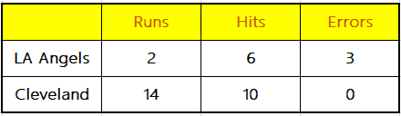

will result in a MLB H-R-E score of LA Angels 11, Cleveland 24

When wagering on MLB H-R-E totals (over/unders) or MLB H-R-E spreads, the game must go 9 innings (8.5 if the home team is leading) to have action.

If a game is called or suspended in extra innings, the score will be determined after the last full inning unless the home team scores to tie in the bottom half of the inning in which case the score is determined at the time the game is called.

For all MLB H-R-E wagers both listed pitchers must start, if pitchers are offered for the game. A pitcher is deemed a starter after throwing the first pitch to the opponent's first batter. If a listed pitcher doesn't start all wagers are no action.

* **MLB Prop Rules:**

On any prop, the player(s) must start, and either throw one pitch(if pitchers), or have one plate appearance (if position players) in the designated game for the wager to have action.

For which team will score first props, the prop will be decided and graded as soon as either team scores, regardless if the game eventually becomes official. Both listed pitchers must start for action.

All props regarding just the outcome of the first inning will be decided and graded at the end of the first inning, regardless if the game eventually becomes official. Both listed pitchers must start for action.

On Total Bases Propositions, listed players must start. A batter is only credited for total bases if he hits a single (1 base), a double (2 bases), a triple (3 bases) or a home run (4 bases). A walk, hit by pitch, error, balk, fielder’s choice, or passed ball do not count for Total Bases Propositions.

Pitcher propositions "Total Runs Allowed" include both earned and unearned runs.

Any MLB proposition using the phrase "innings pitched" will be graded using the box score number.

For example, a visiting starter who pitches five complete innings and then faces three batters in the top of the sixth, but records no outs. This would be graded as 5.0 innings pitched.

Or a home starter pitched five complete innings and did not throw a pitch in the bottom of the sixth. This would be graded as 5.0 innings pitched.

A "pick-em" match-up between these two pitchers for most innings pitched would be graded a tie.

For Division Winner wagers, if two teams have the same record after 162 games, the winner of the Division will be 1) the winner of the tiebreaker game, or 2) the team declared the winner by the MLB tiebreaker system for seeding playoff teams.

For the Proposition "Player to hit most Home Runs in MLB?", if there is a tie at the conclusion of the regular season, the player with the highest batting average, among those tied, will be declared the sole winner.

For the Proposition "Player to hit most Home Runs in MLB?", if there is a tie at the conclusion of the regular season, the player with the highest batting average, among those tied, will be declared the sole winner.

For individual player prop predictions to have action that player must start and the game must go at least 9 innings (8.5 innings if home team are ahead). If the game is suspended, it must be restarted on the following day, if it's not restarted on the following day, wagers will be refunded. This applies to all over/under stats for an individual. For example, if Mike Trout hits a home run and the game officially ends in the 7th inning, then Mike Trout will still have no action on his Home Runs for that game(since the game didn't go 8.5 innings).

For head to head player props for a specific game, all wagers will have action as long as those players start and the game becomes official.

* **MLB Season Long Player Props:**

For season long over/under propositions for players' or groups of players' statistics for the entire season, each field player must play in the first game his team plays for action. For pitchers, that pitcher must pitch in one of his team's first eight games played for action. His team must play at least 155 games for action.

* **MLB General Props:**

For MLB General Props, the result of a game is official after 5 innings of play unless the home team is leading after 4.5 innings.

MLB General Props do not require any specific pitcher to start a game.

If there are 10 or more games scheduled on a given day, all games or all games but one must go to completion for MLB General Props to have action. No more than one game may be shortened or postponed.

If there are 9 or fewer games scheduled on a given day, all of them must go to completion for MLB General Props to have action. No game may be either shortened or postponed.

Only the statistics of games declared official will be used for purposes of scoring MLB General Props. If a shortened game is declared official and MLB General Props have action, then statistics of this shortened game will be included with regard to grading.

For the prop "How many players will hit more than 1 HR today?" - This prop will refer to any player hitting more than one HR in a single game. If a player hits 1 HR in each game of a double-header, that does NOT count as more than 1 HR for the day. He must hit 2 or more HR's in a single game for it to be considered more than 1 HR.

For MLB General Props, if a team plays more than one game on a given day (e.g. double header), the statistics of each game will be considered independent. (e.g. "Most runs scored by one team", Philadelphia plays two games, scoring 4 runs in game one and 5 runs in game two. Either the 4 runs or 5 runs will be used but they will NOT be combined as 9 runs.)

* **MLB Futures: Player vs Player Season Props:**

For baseball player vs. player season props, if either or both players start the season on the disabled list, not on the active roster or is sent to the minors, wagers have no action.

* **Regular Season Baseball Series Wagers:**

Wagers on baseball series are based on the first three games played ofeach series.

At least two of the first three series games must be played for wagers to have action.

If only one of the first three games is postponed or canceled, series wagers stand as written.

If two of the first three games are postponed or canceled, all wagers on that series will be graded as No Action and the monies refunded.

A called game will count toward a series wager provided it is officially declared a regulation game.

Pitchers cannot be listed for series wagers; all wagers will have action regardless of the starting pitchers.

* **PlayOffs / World Series Pick 4:**

Each combination lists the exact order of finish of the final four Major League teams in the playoffs, specified by the order of names as follows:

1. The winner of the World Series.

2. The loser of the World Series.

3. The loser of the American League Championship Series.

4. The loser of the National League Championship Series.

Example: Suppose we have the following result in the playoffs:

* The Dodgers beat the Braves in the National League Championship Series.
* The Twins beat the Angels in the American League Championship Series.
* The Dodgers then win the World Series against the Twins.

In that case, the winning combination would be: Dodgers/Twins/Angels/Braves.

* **Japanese Baseball:**

When wagering on total runs (over/under) the game must go 9 innings (8.5 if the home team is ahead) to have action. If a game is called, suspended or declared a tie in extra innings, the score will be determined after the last full inning unless the home team scores to tie, or takes the lead in the bottom half of the inning, in which case the score is determined at the time the game is called.

Rules for Run Line (handicap) and Alternate Run Line (alternate handicap) wagers are the same as those for Japanese baseball totals.

* **World Baseball Classic Rules:**

All spread, money line, and total wagers will have action in games stopped early due to the mercy rule.

All predictions taken on a suspended game (one that started), will have action for 72 hours from the start time, as long as the WBC governing body recognizes an eventual winner. Money line wagers will only have action as long as the game goes at least 4.5 innings. Spread and total wagers will only have action if the game goes at least 8.5 innings (except in mercy rule games, see rule above).

All predictions taken on a postponed game will not have action. Once the postponed game is rescheduled, normal wagering rules apply.

Pool Wagering - In the event of a tie between 2 or 3 teams within a pool, whoever wins the tiebreaker according the world baseball classic (whichever team is considered the number 1 team from that pool in the next round) is considered the winner.

* **Little League World Series:**

Any game ending early as a result of a mercy rule will have action on all wagers in the Little League World Series.

Wagers on postponed or suspended games will have action as long as the game is completed within 60 hours of its originally scheduled time in the Little League World Series.

We make no guarantees that the team listed on the bottom of our fixtures is the home team in Little League World Series games.

4.Money Line Wagers will have action in all official games (4 innings or 3.5 innings if the home team is ahead). In order for wagers on totals and run lines to have action, the game must go 6 innings (5.5 innings if home team ahead), except for mercy rule games (see rule #1).

* **Settlement of Wagers**

All predictions will be settled after the time and dates specified in the prediction.

Market trading data and results will be obtained from reputable third parties.

If the market does not have valid data based on technical issues, or the data cannot be confirmed, the platform has the right to retain the delayed payout until it is confirmed by a trusted third party.

In the absence of consistent, independent evidence or in the presence of significant conflicting evidence, bets will be settled based on our own statistics.

Tennis

* **The prediction items of the relevant events will continue to be valid if:**

1. Time or date change

2. Location or venue change

3. Change of indoor to outdoor, and vice versa

4. Change of court surface (either before or during the game)

* **Match Betting Including In-Play:**

If the match is not completed after it begins, all predictions will be void. Unless the player is disqualified after such beginning (the player/team advanced to the next round will be considered to win and govern the settlement).

* **Line prediction:**

If the number of games is not completed or changed, all predictions will be void. The match must be completed and the prediction is valid. All predictions will be void if the player is disqualified or withdraws from the match.

* **Player wins:**

If a player is disqualified or withdraws from the match, all predictions will be void unless the prediction has been determined.

* **Win the championship prediction / quarterfinal prediction / semi-final prediction:**

The player must score at least 1 point in the tournament and the prediction is valid. Predictions on any player who does not participate in the tournament will be considered void.

* **Settlement of Wagers**

All predictions will be settled after the time and dates specified in the prediction.

Market trading data and results will be obtained from reputable third parties.

If the market does not have valid data based on technical issues, or the data cannot be confirmed, the platform has the right to retain the delayed payout until it is confirmed by a trusted third party.

Volleyball

* **Wagers of Volleyball：**

1. The following markets will be void if the match is not completed, unless the specific market outcome is already determined:

A. To Win Match

B. Match Total Odd/Even

C. Correct Set Score

D. Double Result (Outcome of 1st Set and Match)

E. Match Handicap - Sets

F. Match Handicap - Points

G. Total Points

H. Team Total Points

2. For individual set markets, in the event of the set not being completed bets will be void, unless the specific market outcome is already determined:

A. First Set Winner

B. First Set Total Odd/Even

C. First Set Handicap

D. First Set Total Points

E. First Set Winning Margin

F. First Set Correct Score

G. First Set to Go to Extra Points

H. Score After 2/3 Sets

In the event of referee enforced point deductions, official results will be used for settlement purposes, on all markets.

If a match venue is changed then bets already placed will stand providing the home team is still designated as such. If the home and away team for a listed match play the fixture at the away team venue then bets will stand providing the home team is still officially designated as such, otherwise bets will be void.

For competitions where two legged ties have a Golden Set to decide which team progresses (in the event of the tie being tied in matches won), then for settlement purposes the Golden Set does not count.

To Qualify will be settled on the team progressing to the next round of the specified competition, and includes the outcome of a Golden Set if played.

An unplayed or postponed match will be treated as a non-runner for settling purposes unless it is played within 48 hours of the original start time.

* **Settlement of Wagers**

All predictions will be settled after the time and dates specified in the prediction.

Market trading data and results will be obtained from reputable third parties.

If the market does not have valid data based on technical issues, or the data cannot be confirmed, the platform has the right to retain the delayed payout until it is confirmed by a trusted third party.

Snooker

* **Wagers of snooker：**

Match-up prediction is based upon correctly selecting the player who officially wins the match. In the event of a match starting – with the break for the first frame - but not being completed for whatever reason, the player progressing to the next round (or being declared winner of the competition/championship) will be deemed the winner. In the event of a match not starting at all, all predictions are refunded.

Frame prediction is based upon correctly selecting the final score of a snooker match. In the event of a match starting but not being completed for whatever reason or a match not starting at all, all predictions are refunded.

For multi-way markets of the type "Multiple to win the Championship" wagers on a non-starting player will be graded as a loss.

For Snooker matches that contain multiple sessions, Pinnacle may offer multiple at the start of each session. All wagers placed on Snooker matches are graded based on the outcome of the entire match, not on the outcome of an individual session.

* **Settlement of Wagers**

All predictions will be settled after the time and dates specified in the prediction.

Market trading data and results will be obtained from reputable third parties.

If the market does not have valid data based on technical issues, or the data cannot be confirmed, the platform has the right to retain the delayed payout until it is confirmed by a trusted third party.

Darts

When prediction on the outright tournament winner, all wagers have action; there are no refunds. Should a player withdraw before a tournament begins, any predictions on that player to win the tournament will be graded as losses.

* **Match Wagers**

The player progressing to the next round will be deemed the winner, providing one of the players has thrown a dart at the start of the first leg. If the first dart is not thrown, all predictions will be void.

* **Sets Wagers**

The full number of sets required to win the match must be completed. If for any reason the match is awarded to a contestant before the full number of sets are completed, all Sets wagers on the match will be void.

* **Settlement of Wagers**

All predictions will be settled after the time and dates specified in the prediction.

Market trading data and results will be obtained from reputable third parties.

If the market does not have valid data based on technical issues, or the data cannot be confirmed, the platform has the right to retain the delayed payout until it is confirmed by a trusted third party.

Lottery

* **Settlement of Predictions**

All lotto predictions are based on the numbers that are drawn from the respective lottos.

If the results of the lottery cannot be formally confirmed, the platform will have the right to retain the delayed payout until an official confirmation is obtained.

If the multiple are obviously wrong, the platform reserves the right to cancel the prediction. This includes more than one multiple error than the average market multiple.

If the live broadcast is paused and the lottery results are not affected, all prediction types will be awarded based on the results. When the result of a prediction type cannot be formally confirmed, the platform reserves the right to void the prediction.

The platform reserves the right to correct the wrong payouts at any time.

If the rules or format of a lottery is different from the standard accepted by the platform, the platform reserves the right to void the prediction.

If the results of the lottery cannot be found, the prediction will become invalid after 24 hours of the result announcement.

* **Reputable Third Parties**

Lottery data and results will be obtained from reputable third parties.

China Welfare Lottery, the lottery information can be found at http://www.cwl.gov.cn.

South Korea Lotto, the lottery information can be found at http://www.nlotto.co.kr.

US PowerBall, the lottery information can be found at https://www.powerball.com/.

Finance Prediction

* **Settlement of Wagers**

All predictions will be settled after the time and dates specified in the prediction.

Market trading data and results will be obtained from reputable third parties.

If the market does not have valid data based on technical issues, or the data cannot be confirmed, the platform has the right to retain the delayed payout until it is confirmed by a trusted third party.

If the market cannot find data confirmation from a trusted third party, the prediction will be invalid and the stake will be refunded.

The platform reserves the right to correct wrong payouts at any time.

If the multiple are obviously wrong, the platform reserves the right to cancel the relevant prediction.

* **Digital Asset Market Price Up/Down**

The closing time is based on 00:00 UTC. The closing price is calculated based on the weighted average of the volume of each market.

Prediction selections only have two outcomes: up or down; if there is 0% up/down, the prediction will be refunded.

Market trading data and results are obtained from https://coinmarketcap.com/

In-play Prediction

In-play prediction means predicting on an event that is in progress. Prediction orders are continuously accepted during the event until the prediction closes.

* **The followings are general rules for in-play predictions：**

1. All predictions will be determined on full-time results of the events.

2. Coingame has full discretion over the availability of predictions. There is no guarantee of continuous availability during the event.

3. Coingame reserves the right to cancel prediction orders with obviously wrong multiples.

4. In addition, in-play orders will be accepted according to the rules made by Coingame for any certain type of event.

Parlay

A parlay is a single order that involves two or more sport events. The whole order will only be considered as “Win” when every selected option in the parlay wins. If one of the options wins, its payout will be aded to the next one until every selected option in the parlay wins or any option loses.

If one or more options in the parlay are cancelled, the parlay order will still be valid, but the multiple of the cancelled options will be counted as 1.

* **General Rules for Parlays:**

1. One parlay order can contain up to 10 options.

2. All sport events included in the parlay order should all apply to Coingame's rules of predictions.

3. The parlay cannot contain options of the same sport event or interactional options.

4. Even if the events take place at different time, all selected options in the parlay cannot contain the same team or player.

5. Lotteries, Special Events and all In-Plays are not available for parlays.

6. Coingame reserves the right to determine the parlay availability of relevant sport events.

**If you have any concerns, please contact customer service at: support@coingame.com.**

# 使用条款

Terms of Use

**General**

1. These following terms and conditions are applicable to the website https://www.coingame.com, mobile site and/or mobile application owned, operated or hosted by the same company. (collectively the 'Site').

2. CoinGame is referred to as “the Site ” or “ We”. All references to “you”, “your” or the “user” mean the person or persons, using the Site or using the Site.

3. Digital Currency means Ethereum or Ethereum Classic or any other blockchain-based currency accepted by the Site. You acknowledge that the digital currency is merely treated as common tokens used in the forecast activities on the Site.

4. The following terms and other agreements, or documents provided or posted on the Site constitute the Entire Agreement between the users and the Site. All the users who log in, browse, use any items or services provided by the Site, shall be regarded as having irrevocably agreed to comply with the Entire Agreement.

5. a) You recognize and acknowledge that you (1) are at least eighteen (18) years old or of legal age as determined by the laws of the country where You live (whichever is higher); are an eligible subject of legal age to agree to the terms of the Site; (2) have full capacity to enter into the Entire Agreement with us and you are not restricted by any form of limited legal capacity (3) have not been suspended or refused to use the services provided by the Site in the past.

b) You further state and guarantee that, if you use the Site, on behalf of a corporate body, (1) the corporate body is legally organized and validly existing under the applicable laws of the jurisdiction of the organization; (2) you are officially authorized by such corporate body to do activities on behalf of it.

6. Underage Forecast

The Site does not allow you (under 18 years of age) to be involved in forecast activity. The Site takes every possible precaution to prevent violation of this rule. The Site guarantees that the advertisements, sponsorship and marketing campaigns posted on the Site does not contain information targeted to person or persons under 18 years of age.

7. Forecast addiction prevention. No advertising campaign or promotion misleads Users, nor do they distort the nature of the services for potentially susceptible Users. Users are informed about the chances of winning as well as the potential risks. Services are provided based on the amount paid and excessive spending is not encouraged. Please answer the questions below. If you say 'yes' to all questions, you are likely to have a Forecast addiction problem:

* + Do you have uncontrolled spending?
  + Are you borrowing money or stealing in order to forecast?
  + Have you noticed that you spend less time with your family?
  + Do you react badly to other people’s opinion about your online forecast game?
  + Have you lost interest in hobbies or usual leisure pursuits?
  + Do you feel depressed or even suicidal because of your forecast failures?
  + Have you ever lied to cover up the amount of money or time you have spent gaming or forecast activity?

8. It is hereby stated that the Site will be amended, expanded, updated, and improved from time to time. Subject to the applicable law, the Site reserves the right to amend or remove portions of the Terms of Use or Forecast Rules or other terms or policies constituting the Entire Agreement at any time without prior notice, in our sole and absolute discretion. Such changes to these provisions will be posted on the Site for users’ reference and not be applied retroactively. We do advise users to check the Site frequently to be aware of the valid provisions and changes. The Site will not be responsible for any damages, losses to users due to the foregoing changes. If users do not agree to any term of the Entire Agreement, please do not log in, browse and use the Site.

9. The membership services provided by the Site will be applied, where the registration process is completed.

Forecast items

10. The Site will publish specific rules applicable to each forecast activity ('Forecast Rules'), the address to receive the digital currency for each forecast result option (“Forecast Address”), the effective period for users to make the forecast. All users participating in the forecast items on the Site should comply with the relevant Rules.

11. The users participating in the forecast activity shall transfer the designated type (s) of digital currency(ies) to the Forecast Address, within the effective period as published on the Site (“Forecast Effective Period”) for making the forecast (placing predictions). The users should not place predictions any other types of digital currencies which are not designated by the Site, nor should the users use any country's legal tender (fiat money) for forecast.

12. The Forecast Rules may stipulate that after certain conditions are met, the forecast activity will not accept the users to transfer further digital currency to participate in the forecast, in addition, the Site has the right to issue a notice to terminate the Forecast Effective Period applicable to a specific forecast activity at any time. After the Forecast Effective Period for a forecast activity is expired or terminated in advance, if a user transfers further digital currency for that forecast activity, such transfer will be regarded as being used for an invalid forecast and therefore the losses suffered by the user shall be borne on its own.

13. A prediction, which has been placed and accepted, cannot be amended, withdrawn or cancelled by users.

14. The Site has the right to issue a notice to cancel a forecast activity at any time, under such circumstances, the forecast activity will be cancelled upon the publication of such cancellation notice on the Site. If the user has already transferred digital currency to that forecast activity, such transfer would be automatically sent back to the user’s original digital currency remitting address.

15. The relevant information shown in the source as stipulated by the Forecast Rules should be the only criterion for judging a successful forecast, and the users should not raise any objection to this. The users hereby agree that if they fail to make a successful forecast, all of the digital currency transferred by them will be remitted by the Site to the users who make a successful forecast.

16. The Site does not promise to pay any return or interest on the digital currency temporarily stored by users. Where the users participate in a forecast activity on the basis of smarts contracts, the proceeds of a successful forecast after deducting the service fee payable to the Site, should be sent back to the original digital currency remitting address of the users who make such successful forecast, on the basis of smart contract. Where the users participate in a forecast activity on the basis of membership scheme, the proceeds of a successful forecast after deducting the service fee payable to the Site, should be transferred to the member account of the users who make such successful forecast. However, the Site reserves the right to set aside any proceeds should there be any suspicion of criminal activities or any manipulation that may have affected the result.

17. The minimum and maximum stake are dependent on the amount the Site accepts at the time of your prediction.

18. Should users receive excess revenue due to any failure or other reasons, users agree to fully reimburse the Site for any such overdrawn amounts.

19. We reserve the right to block / delay processing of withdrawal requests on the basis of applicable law.

20. Should there be a break in communication after the user places the prediction and/or the user receive no visual confirmation that a prediction has been confirmed validly, but the prediction is correctly received on our servers, the prediction shall be deemed as valid and accepted. You will be informed whether you have obtain or lost once communication is re-established and result determined. If the prediction is not received correctly on our servers due to a communication error, it shall not be regarded as valid and accepted; and the failed prediction shall be returned to your account balance.

21. The users who make a successful forecast shall be solely responsible for any tax obligations arising out of proceeds obtained by him/her from the forecast activity on the Site in accordance with the applicable laws. The users agree that the Site is not responsible for determining any taxes payable on digital currency transaction, declaring, withholding or exempting any tax liability for trading digital currency of any kind.

**Assumption of Risk**

22. The users accept and acknowledge that in the event of any use of the services on the Site or participation in any items, the users shall be solely responsible for the risk of losing all funds, including funds deposited in the member's account.

23. The users accept and acknowledge that there are risks with the use of the Site, including but not limited to the risk of failure hardware, software and the connection of internet, the risk of malicious software introduction, and the risk of unauthorized access to the information stored within your account by any third party. You accept and acknowledge that the Site will not be responsible for any communication failures, disruptions, errors, distortions or delays experienced by you when you use the services, however caused.

24. You accept and acknowledge that there are risks with using any network, including, but not limited to, the risk of unknown vulnerabilities in or unanticipated changes to the network protocol. You acknowledge and accept that the Site has no control over any cryptocurrency network and will not be responsible for any harm occurring as a result of such risks.

25. Transactions or communications between a user and a third party shall only be confined to such user and such third party. The Site does not undertake the liability for any loss or damage arising out of such transaction and the user should be aware that he/she should be solely accountable for any risk resulting from the use of any content provided by a third party or any interaction with such third party.

26. The users recognize and accept that the bankruptcy of the Site or its affiliates or other unforeseen issues (such as changes in regulatory policies and requirements of regulators or an attack on the Site) may cause the damages or losses to users. The damages, losses, costs or expenses, arising out of such unforeseen issues shall be undertaken on users’ own.

27. The Site shall not be regarded as providing the users with any guidance, analysis, recommendation or decisions for any forecast activity. The Site shall not be responsible for users’ forecast results. Users receive the proceeds and bear the losses and risks of participating in the forecast activities. In the event that the users who are the citizens of states listing in the term 34，insist on participating in the forecast activities post on the Site, such users should accept and acknowledge all terms stipulated under the Entire Agreement, such as being responsible for the losses ad risks of forecast results and the losses to the users due to the regulation pertaining to the applicable law.

Limitation of Liability

28. The Site will do efforts to verify the accuracy of any information on the Site, however, the Site will not make any express or implied, statutory or otherwise warranty, including the contents of the Site, information and functions made accessible through the Site, any hyperlinks to third party websites, or the security associated with the transmission of information through the Site or any website linked to the Site.

29. A third party may be permitted by the Site to place cookie through the Site, to analyze or to provide advertising services for users. The use of cookie by third parties cannot be controlled by the Site, and the Site is not responsible for any actions taken by third parties.

30. The Site will not be responsible or liable to you for any loss attributed to utilizing the Site, including but not limited to: (1) users’ errors such as improperly constructed trades or actions, or mistyped the digital currency address; (2) server errors or failure, or data loss; (3) any unauthorized activities done by third parties, including but not limited to the use of viruses, phishing, brute forcing or other types of attack against the Site.

31. The Site hereby will not make warranty that the Site are without viruses, errors, mistakes, that the content of the Site is accurate, that the Site will not be interrupted, or that the defects will be corrected or rectified. In addition, the Site will not be responsible for any type of any loss, including the loss attributed to the activities done in reliance on the information or materials on the Site.

32. The users agree that the Site is not responsible for any error, omission, interruption, deletion, defect, delay in operation or transmission, communications line failure, theft or destruction or unauthorized access to, or alteration of data or information and any direct or indirect loss arising from these occurrences. The Site does not undertake the liabilities for any problems or technical malfunction of any network or lines, Wi-Fi, Bluetooth, computers, systems, servers or providers, computer equipment, software or email on account of technical problems or traffic congestion on the internet or at any web site, mobile site or mobile application. Additionally, the Site shall not be responsible or liable to users in the event of systems or communications errors, bugs or viruses relating to the Site or which will result in damage to users’ hardware and/or software and/or data.

33. Users agree to exempt the Site (including each of employees, directors, representatives, agents and affiliates) from the indemnity, claim, demand，action, damage, loss, cost or expense (including but not limited to reasonable legal expenses) arising out of the following: a) Users using the service provided by the Site or conducting activities related to the service provided by the Site; b) Users breaching any clause of the Entire Agreement; c) Infringement of the rights of other entities.

34. The Site may receive and collect users’ information whenever users log in, browse, use the Site. Such information may be disclosed to fulfill the governing laws, regulations, governmental policies or legal processes. Therefore, the Site is not responsible for maintaining the confidentiality of any information of users provided, or collected by foregoing methods.

35. Users should ensure the correctness and completeness of any information they provide. The Site is not responsible for errors in the operation of digital currency transfers by users. For example, the user enters the wrong password or provides the wrong information.

36. The Site is not responsible for any action done by users. The user should understand and ensure by herself or himself that, his/ her participation in the forecast activities on the Site shall comply with the laws and regulations of his country of nationality and the country where he makes the forecast, and all the risks and responsibilities in relation to the above shall be assumed by the user himself/herself, which are irrelevant to the Site. For clear and further clarification, it is hereby expressly disclaimed and refused to accept the following responsibilities: a) Anyone who violates the anti-money-laundering, counter-terrorist financing or other regulatory requirements of any country in the use of the Site or processing in forecast activities. b) After careful consideration, the Site decides not to accept the participation of citizens or residents of the United States, Iraq and mainland China in the forecast.

**Termination of Services**

37. The Site reserves the right to immediately suspend or terminate a user’s privilege to access and use the Site and services and delete or deactivate your account and any and all relevant information and documents for any reasons which may include, for example, a user breaching any clause of the Entire Agreement. The Site is not responsible for advanced notice and shall not be liable for the termination of service.

38. By browsing or using the Site or its services, the user agrees not to engage in any conduct which may violate any governing law in the jurisdiction of the country of nationality and/or applicable to the transaction. In addition, the user shall be solely accountable for the consequences of using the service. Without prejudice to the generality of the foregoing, the user agrees that he/she will not: a) Use the services provided on this Site to pay, support or otherwise participate in any illegal activity, including but not limited to illegal gambling, fraud, money laundering or terrorist activities. b) Use any robot or other automated means or interface not provided by the Site to access the Site or services, or otherwise extract data. c) Unauthorized use or attempt to use another user’s wallet. d) Provide incorrect, inaccurate or misleading information. e) Encourage or induce third parties to participate in activities prohibited by the Entire Agreement. f) Introduce any virus, trojan, worm, logic bomb or other harmful substance to this Site.

39. The Site is entitled to claim damages against the user for his/her breaching any clause of the Entire Agreement or other actions which have caused such damage to the Site, including but not limited to reputational damage. Failure to promptly taking legal actions against such user shall not be deemed as a waiver of any rights.

Intellectual property

40. The property of all content posted on the Site, including without limitation, texts, trademarks, and charts on the Site belongs to the Site or its suppliers and is protected by relevant laws which preserve intellectual property and ownerships. Users shall agree to observe and abide by all copyrights and other proprietary notices, legends or other restrictions contained in any such content and not make any changes thereto. Users also promise not to amend, disclose, spread, reserve engineering, make derivative work and take part in any transfer or sale or exploit any of content on the Site, in whole or in part.

**Miscellaneous**

41. Users recognize that no joint venture, partnership, employment, or agency relationship between users and the Site exists as a result of the Entire Agreement or use of the Site. The Site performs the Entire Agreement pursuant to effective laws and legal process. If any portion of the Entire Agreement is determined to be invalid or unenforceable according to governing law, the invalid or unenforceable clause will be deemed superseded by a valid, enforceable clause that most closely matches the intent of the original clause and the remainder of the Entire Agreement shall continue in effect.

42. Additionally, users shall indemnify the Site from and against all claims, liabilities, losses and expenses, arising out of or with regards to any breach of the Entire Agreement by users, and any other duties caused by using the Site. Failure to claim promptly shall not be regarded as a waiver of any right.

43. Users should take legal action pertaining to any claim or dispute arising out of the use of the Site or the forecast activity within one (1) year upon the occurring of the dispute.

44. If you have any query about the Site, please kindly contact【support@coingame.com】.

# 隐私声明

Privacy Policy

1. The Privacy Policy lays out how your personal information is handled and we ask that you please kindly read through it carefully. If you log in, browse, or use services on the Site, you are deemed to accept and abide by any and all terms of the Policy.

2.  Personal information means any information which enables to recognize your identity, including your name, address, date of birth, payment details and any information you would like to provide or to be collected. We will take measures to ensure the use of your personal information in line with the data protection rules and privacy policy where we operate. This Privacy Policy applies to the personal information obtained or collected when you use the services provided by the Site or when you interact with us.

3. We may use your personal information in order to contact your from time to time to introduce you to our products or any events, activities, projects, plans, developments, undertakings and special offers that are taking place or being promoted or supported us.

4. When you supply us with your personal information, you are agreeing that you are subject to the Privacy Policy and you do not consider our use of such personal information in accordance with this Privacy Policy as any breach of your rights.

5. We can carry out physical, electronic and managerial procedures to safeguard the security of the data you provide to us, with the exception where we may be required by applicable law, regulation, government policy or legal process to disclose your personal information to relevant authorities.

6. You accept and acknowledge that we may use the collected user information for the purposes including but not limited to the following: a) Provide our services to you; b) When you use our services, we may use your information for identity verification, recording and backup, user service, security monitoring, risk prevention, etc.; c) You agree that we may send you a notification of marketing campaigns, electronic commercial information, and advertisement relating to you; d) you acknowledge and agree that we are entitled to authorize your personal information to a third-party credit reporting agency or data service agency to verify the authenticity of your information or to provide other service; e) Report to relevant organs of power as required.

7. All internet-based communication is not absolutely secure. We kindly advise you to take any and all precautions you can to protect your personal data while using the Internet.

8. You have the right to use any information we hold about you at any time. You can sign in to the Site using your username and password at any time and review your account page. You can also update your information.

9. A cookie is a data packet which is used solely for web analytic purposes. The Site uses cookies to recognize visitors and facilitate the login process. Cookies used by the Site are only set with your consent. When you browse the Site next time, specific site content would be sent to provide a better user experience.

10. The Privacy Policy is subject to change at any time and it is advised that you review the Privacy Policy periodically to check for changes.

11. If you have any requests or comments, please contact us through the contact information released on the Site. This shall be the only effective way to communicate with us.

# 币种声明

Important Disclaimer

Coingame provides only entertainment content to cryptocurrency users, including but not limited to sports, games, events and other related gameplay. And Coingame has no direct interest with any cryptocurrency (including major ones) project team, thus any situation with the project itself is irrelevant to Coingame, including but not limited to main net security issues, price fluctuations, project changes and other factors. Coingame provides only deposit and withdrawal services for multiple cryptocurrencies. Once any project has any of the following situations, Coingame will immediately delist the corresponding cryptocurrency. Please properly assess project risks, and feel free to offer supervisions and reports.

**1. Project and Team Factors**

1.1 Significant changes to the project team, product or business model. It’s required to notify Coingame and go through review process again. If the changes happen without prior notification, Coingame will directly delist the project.

1.2 Whether the project team has unethical and fraudulent acts, such as: fake personal information of founder, co-founder, advisor, etc., alleged involvement in market manipulation, individual with serious legal issue or other legal matters.

1.3 Project criticized by judicial departments, supervisors or regulators of any country or region for violation of laws and regulations.

**2. Technical Development, Main Net and Smart Contract Factors**

2.1 Security risks in the main net of the project.

2.2 Security vulnerabilities in smart contract codes such as overflow exploits.

2.3 The project encounters or has potential possibility of a 51% attack problem.

2.4 Project development is not carried out in accordance with the roadmap planned in the white paper, and progress gets delayed or even faked with no announcement on the official website.

2.5 Source code of public blockchain / protocol project not updated for long on GitHub; Product version of application type project not updated for long.

**3. Community Building and Operations Factors**

3.1 Seriously deviated information disclosures, deceiving investors and exchanges.

3.2 Inaccessible website & confusing information, social media & communities left unmaintained for long.

3.3 No disclosure of any project progress for over one month on social media or official website (e.g. development progress, version updates, team actions, etc.).

3.4 Project publicity involves trading suggestions, price manipulation or other acts that will seriously harm the interests of the community.

3.5 Project team deliberately conceals any significant event that may seriously affect the price.

3.6 Addresses of team and foundation never disclosed on social media or official website; token locking not implemented as planned; or unplanned token transaction occurs with no disclosure of usage.

**4. Other Factors**

4.1 No reply or response to community queries.

4.2 Not cooperating with Coingame on regular checks.

4.3 Other unethical, fraudulent or illegal acts.

4.4 Parallel operations and participation in multiple projects, affecting the healthy and sustainable development of blockchain industry ecosystem.

Coingame Operations Team

July 1st, 2019