jupyter-contrib-nbextensions.readthedocs.io/en/latest/nbextensions/snippets/README.html

正确路径：C:\Users\lium\AppData\Roaming\jupyter\nbextensions\snippets

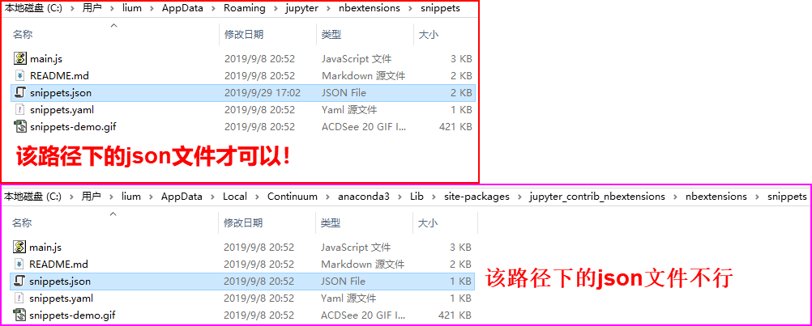

这两个文件不要混淆！