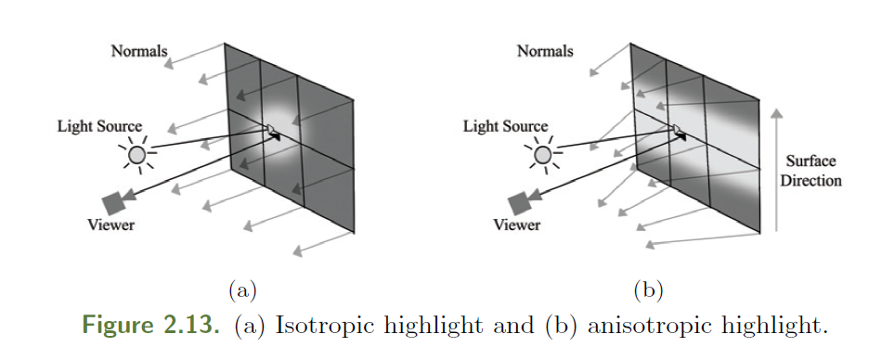

From “Implementing Fur Using Deferred Shading” – Shader Pro2