**Lab Report: Calculating Areas and Volumes using Functions**

Lab Title:

Java Methods for Mathematical Operations

Name: Naldrelle Yuan M. Briones

Course: BSECE – 1

Date Performed: October 25, 2024

1. Objectives:

The objective of this lab is to develop various mathematical functions in Java and practice defining and using methods.

1. **Problem Statement:**

You are tasked with developing five different Java methods that perform mathematical operations. Each method will take appropriate inputs, return the correct results, and be tested within the main() method.

1. Pseudocode / Algorithm:

BEGIN PlaneAndSolidMensuration

WHILE loop IS true

DISPLAY menu options

INPUT Fx

SET result TO 0

SET r, length, width, base, height, angle, a, b, anglec TO 0

SET numb1, numb2, numb3 TO ""

SET swit TO Integer.parseInt(Fx)

SWITCH swit

CASE 1

INPUT numb1 "Input radius to calculate the area of the Circle."

SET r TO Double.parseDouble(numb1)

SET result TO Math.PI * Math.pow(r, 2)

DISPLAY "Area of Circle = " + result

CASE 2

INPUT numb1 "Input Length to calculate the area of the rectangle."

INPUT numb2 "Input Width to calculate the area of the rectangle."

SET length TO Double.parseDouble(numb1)

SET width TO Double.parseDouble(numb2)

DISPLAY "Area of Rectangle = " + length * width

CASE 3

INPUT numb1 "Input base to calculate the area of the triangle."

INPUT numb2 "Input height to calculate the area of the triangle."

SET base TO Double.parseDouble(numb1)

SET height TO Double.parseDouble(numb2)

DISPLAY "Area of Triangle = " + 0.5 * base * height

CASE 4

INPUT numb1 "Input radius to calculate the volume of the Sphere."

SET r TO Double.parseDouble(numb1)

DISPLAY "Volume of Sphere = " + calculateSphereVolume(r)

CASE 5

INPUT numb1 "Input radius to calculate the volume of the Cylinder."

INPUT numb2 "Input height to calculate the volume of the Cylinder."

SET r TO Double.parseDouble(numb1)

SET height TO Double.parseDouble(numb2)

SET result TO Math.PI * Math.pow(r, 2) * height

DISPLAY "Volume of Cylinder = " + result

CASE 6

INPUT numb1 "Input radius to calculate the area of the segment of a circle."

INPUT numb2 "Input angle to calculate the area of the segment of a circle."

SET r TO Double.parseDouble(numb1)

SET angle TO Double.parseDouble(numb2)

DISPLAY "Area of Circle Segment = " + calculateCircleSegmentArea(r, angle)

CASE 7

INPUT numb1 "Input Side a to find the side c."

INPUT numb2 "Input Side b to find the side c."

INPUT numb3 "Input angle C to find the side c."

SET a TO Double.parseDouble(numb1)

SET b TO Double.parseDouble(numb2)

SET anglec TO Double.parseDouble(numb3)

DISPLAY "Length of side c = " + calculateTriangleSide(a, b, anglec)

CASE 8

INPUT numb1 "Input radius to calculate Sphere Surface Area."

SET r TO Double.parseDouble(numb1)

DISPLAY "Sphere Surface Area = " + calculateSphereSurfaceArea(r)

DEFAULT

DISPLAY "Invalid option. Please select a number between 1 and 8."

END WHILE

END PlaneAndSolidMensuration

1. Java Code:

https://github.com/DotYohan/LABORATORY-3/blob/main/PlaneAndSolidMensuration.java

5. Sample Output:

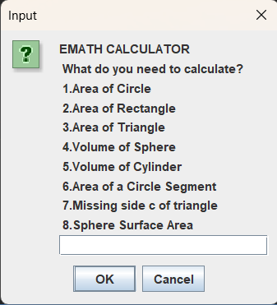 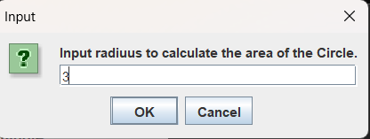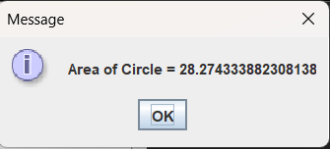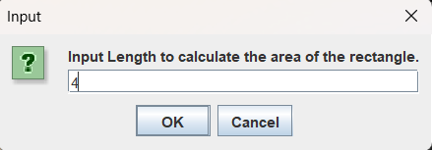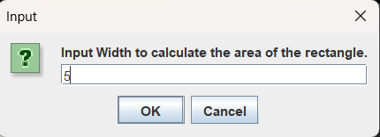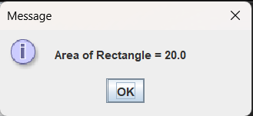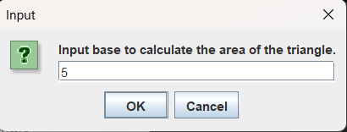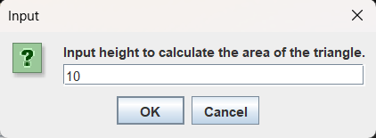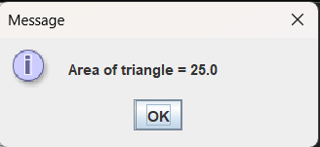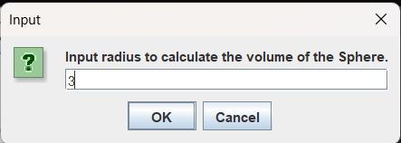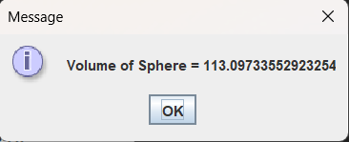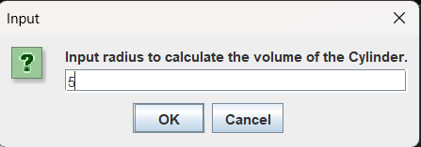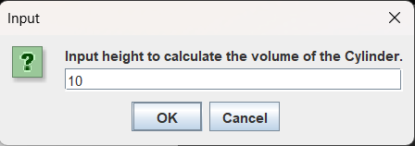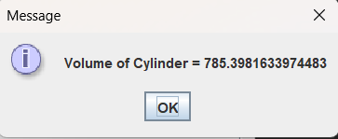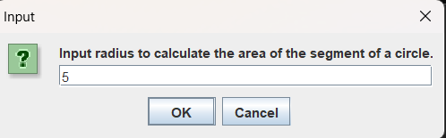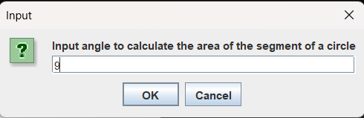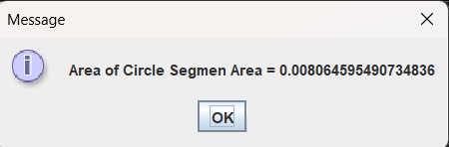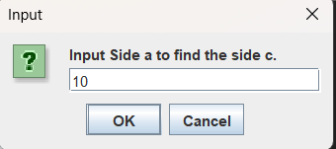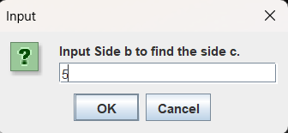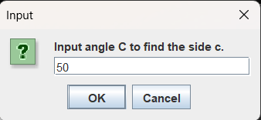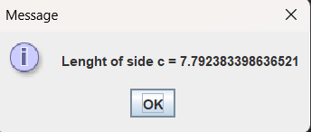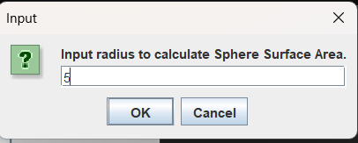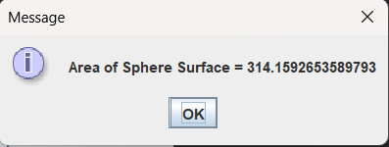

1. Test Cases:

|  |  |  |
| --- | --- | --- |
| Test Cases | Input | Expected Output |
| Calculate area of a circle | Radius: 5 | Area of Circle = 78.54 |
| Calculate area of a rectangle | Length: 4, Width: 5 | Area of Rectangle = 20 |
| Calculate area of a triangle | Base: 4, Height: 5 | Area of Triangle = 10 |
| Calculate volume of a sphere | Radius: 3 | Volume of Sphere = 113.10 |
| Calculate volume of a cylinder | Radius: 3, Height: 5 | Volume of Cylinder = 141.37 |
| Calculate area of a circle segment | Radius: 4, Angle: 60 | Area of Circle Segment = 4.19 |
| Calculate missing side of a triangle | Side a: 3, Side b: 4, Angle C: 90 | Length of side c = 5.0 |
| Calculate surface area of a sphere | Radius: 3 | Sphere Surface Area = 113.10 |
| Invalid radius for circle | Radius: -1 | Error message: "Radius must be non-negative numbers." |
| Error message: "Radius must be non-negative numbers." | Radius: 3, Angle: -60 | Error message: "Angle must be non-negative numbers." |

1. Discussion:

Developing a set of Java methods to perform various mathematical operations requires clear planning and structured implementation. The task involves creating five distinct methods, each tailored to handle specific mathematical computations. These methods need to accept appropriate inputs, perform the necessary calculations, and return accurate results. Implementing these methods in Java ensures that they can be tested efficiently within the main() method, allowing for comprehensive validation of their functionality. One of the initial challenges is determining the sequence of implementation and ensuring each method is self-contained yet easily integrable into the main program. Testing each method individually and in combination with others ensures robust performance and accurate results. Proper error handling and input validation are crucial to manage potential issues and edge cases, making the application reliable and user-friendly.

1. Conclusion:

The process of developing five Java methods for mathematical operations involves systematic planning, coding, and testing. By ensuring each method is well-defined, accurately performs its designated function, and is thoroughly tested within the main() method, the project achieves its objective of creating reliable and reusable mathematical tools. Overcoming challenges such as input validation and method integration through careful planning and iterative testing results in a robust and effective application. This approach guarantees that the methods work correctly individually and collectively, providing accurate and dependable results for various mathematical operations.