1、在浏览器中访问 <http://fanyi.youdao.com/>

2、在浏览器进行分析

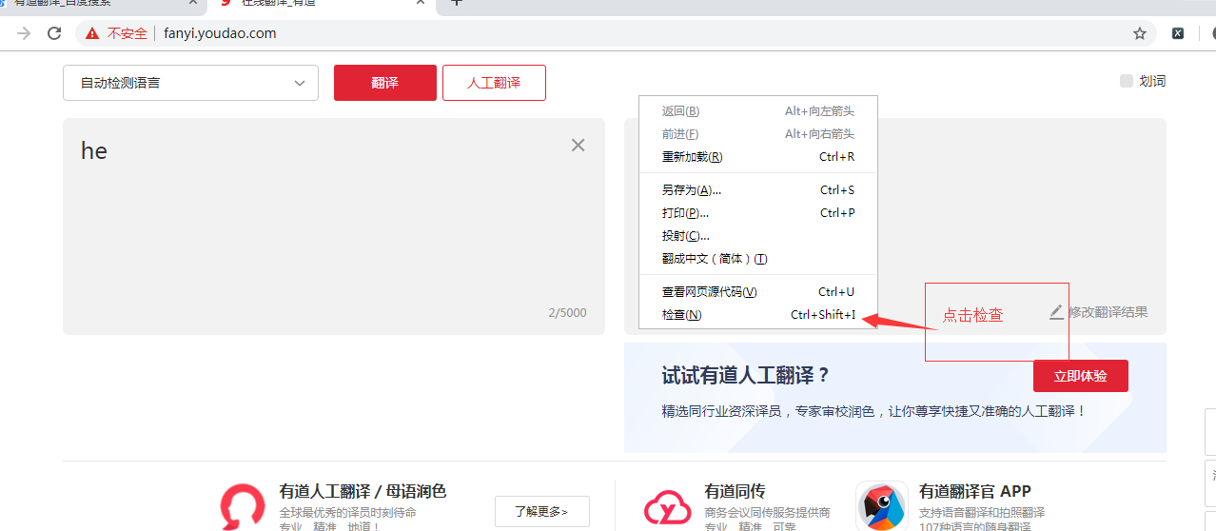

3、查看network

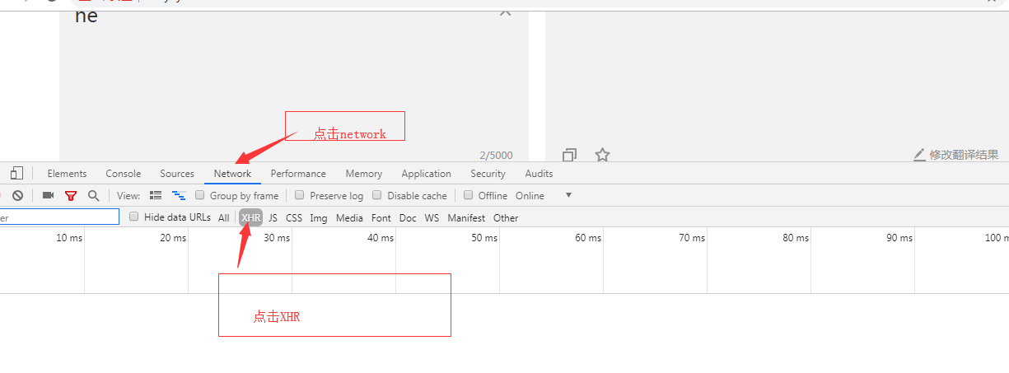

4、查看ajax请求

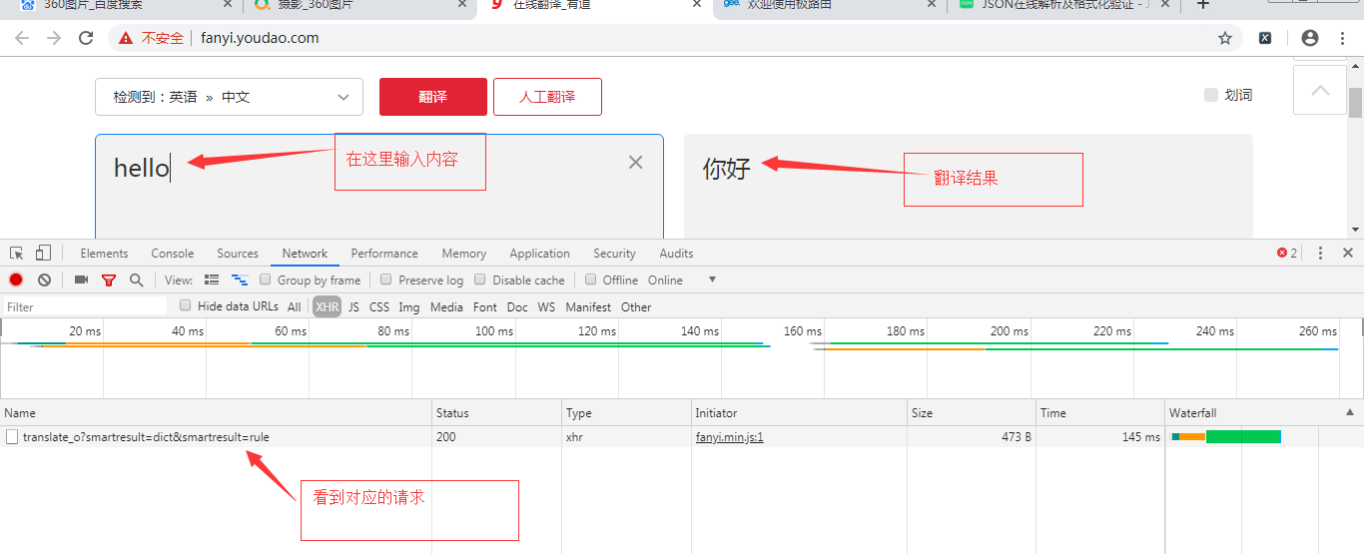

5、点击查看相关信息

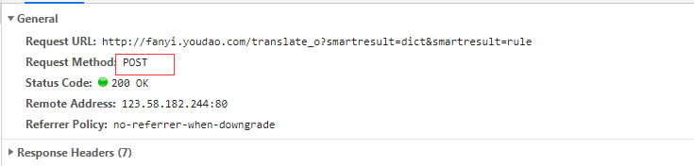



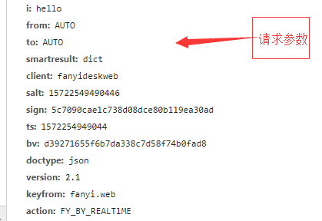

经过分析之后我们要开始写代码：

1、编写基本的请求

|  |
| --- |
| *#导入库* **from** urllib **import** request,parse *#产生随机数* **import** random **import** json ua_list = [  **'Mozilla/5.0 (Windows NT 6.1; WOW64) AppleWebKit/535.1 (KHTML, like Gecko) Chrome/14.0.835.163 Safari/535.1'**,  **'Mozilla/5.0 (Windows NT 6.1; WOW64; rv:6.0) Gecko/20100101 Firefox/6.0'**,  **'Mozilla/5.0 (Windows NT 6.1; WOW64) AppleWebKit/534.50 (KHTML, like Gecko) Version/5.1 Safari/534.50'**,  **'Opera/9.80 (Windows NT 6.1; U; zh-cn) Presto/2.9.168 Version/11.50'**,  **'Mozilla/5.0 (compatible; MSIE 9.0; Windows NT 6.1; Win64; x64; Trident/5.0; .NET CLR 2.0.50727; SLCC2; .NET CLR 3.5.30729; .NET CLR 3.0.30729; Media Center PC 6.0; InfoPath.3; .NET4.0C; Tablet PC 2.0; .NET4.0E)'**,  **'Mozilla/4.0 (compatible; MSIE 7.0; Windows NT 6.1; WOW64; Trident/5.0; SLCC2; .NET CLR 2.0.50727; .NET CLR 3.5.30729; .NET CLR 3.0.30729; Media Center PC 6.0; InfoPath.3; .NET4.0C; .NET4.0E; SE 2.X MetaSr 1.0)'**,  **'Mozilla/5.0 (compatible; MSIE 9.0; Windows NT 6.1; WOW64; Trident/5.0; SLCC2; .NET CLR 2.0.50727; .NET CLR 3.5.30729; .NET CLR 3.0.30729; Media Center PC 6.0; InfoPath.3; .NET4.0C; .NET4.0E)'**,  **'Mozilla/5.0 (Windows NT 6.1) AppleWebKit/535.1 (KHTML, like Gecko) Chrome/13.0.782.41 Safari/535.1 QQBrowser/6.9.11079.201'**, ] **def** loadPage(url):  *#从列表中随机选取一个useragent* UserAgent = random.choice(ua_list)  *#构造请求头* headers ={  **"User-Agent"**:UserAgent  }  rep = request.Request(url=url,headers=headers)  *#进行相应* resp = request.urlopen(rep,data=data) *#读取内容* html = resp.read().decode(**'utf-8'**) **return** html  **if** __name__ == **'__main__'**:  url =**'http://fanyi.youdao.com/translate_o?smartresult=dict&smartresult=rule'** html = loadPage(url) |
| 输出的结果为：{"erroCode":50} |

2、加请求参数form-data 修改请求方式为post

|  |
| --- |
| *#导入库* **from** urllib **import** request,parse *#产生随机数* **import** random **import** json ua_list = [  **'Mozilla/5.0 (Windows NT 6.1; WOW64) AppleWebKit/535.1 (KHTML, like Gecko) Chrome/14.0.835.163 Safari/535.1'**,  **'Mozilla/5.0 (Windows NT 6.1; WOW64; rv:6.0) Gecko/20100101 Firefox/6.0'**,  **'Mozilla/5.0 (Windows NT 6.1; WOW64) AppleWebKit/534.50 (KHTML, like Gecko) Version/5.1 Safari/534.50'**,  **'Opera/9.80 (Windows NT 6.1; U; zh-cn) Presto/2.9.168 Version/11.50'**,  **'Mozilla/5.0 (compatible; MSIE 9.0; Windows NT 6.1; Win64; x64; Trident/5.0; .NET CLR 2.0.50727; SLCC2; .NET CLR 3.5.30729; .NET CLR 3.0.30729; Media Center PC 6.0; InfoPath.3; .NET4.0C; Tablet PC 2.0; .NET4.0E)'**,  **'Mozilla/4.0 (compatible; MSIE 7.0; Windows NT 6.1; WOW64; Trident/5.0; SLCC2; .NET CLR 2.0.50727; .NET CLR 3.5.30729; .NET CLR 3.0.30729; Media Center PC 6.0; InfoPath.3; .NET4.0C; .NET4.0E; SE 2.X MetaSr 1.0)'**,  **'Mozilla/5.0 (compatible; MSIE 9.0; Windows NT 6.1; WOW64; Trident/5.0; SLCC2; .NET CLR 2.0.50727; .NET CLR 3.5.30729; .NET CLR 3.0.30729; Media Center PC 6.0; InfoPath.3; .NET4.0C; .NET4.0E)'**,  **'Mozilla/5.0 (Windows NT 6.1) AppleWebKit/535.1 (KHTML, like Gecko) Chrome/13.0.782.41 Safari/535.1 QQBrowser/6.9.11079.201'**, ] **def** loadPage(url):  *#从列表中随机选取一个useragent* UserAgent = random.choice(ua_list)  *#构造请求头* headers ={  **"User-Agent"**:UserAgent  }  *#构造form_data* data ={  **"i"**: **"hello"**,  **"from"**: **"AUTO"**,  **"to"**: **"AUTO"**,  **"smartresult"**: **"dict"**,  **"client"**: **"fanyideskweb"**,  **"salt"**: **"15722503603964"**,  **"sign"**: **"dc51ee2395f1bc847784ebcdab2093ce"**,  **"ts"**: **"1572250360396"**,  **"bv"**: **"d39271655f6b7da338c7d58f74b0fad8"**,  **"doctype"**: **"json"**,  **"version"**: **"2.1"**,  **"keyfrom"**: **"fanyi.web"**,  **"action"**: **"FY_BY_REALTlME"** }  *#发送请求* rep = request.Request(url=url,headers=headers)  *#转换data格式* data = parse.urlencode(data).encode(**'utf-8'**)  *#进行相应* resp = request.urlopen(rep,data=data)  *#读取内容* html = resp.read().decode(**'utf-8'**)  **return** html **def** loadres():  url =**'http://fanyi.youdao.com/translate?smartresult=dict&smartresult=rule'** html = loadPage(url)  *#转换格式* res_json = json.loads(html)  print(res_json[**"translateResult"**][0][0][**"tgt"**]) **if** __name__ == **'__main__'**:  loadres() |

作业：1、修改代码实现自动输入识别的单词或者是汉字（比如：输入hello - 你好，再次输入hi - 嗨）

2、当输入的字符为qt的时候程序退出