EDA Rural group

Luvuyo Magwaza

2022-08-02

library(tidyverse)

## ── Attaching packages ─────────────────────────────────────── tidyverse 1.3.1 ──

## ✔ ggplot2 3.3.6 ✔ purrr 0.3.4  
## ✔ tibble 3.1.7 ✔ dplyr 1.0.9  
## ✔ tidyr 1.2.0 ✔ stringr 1.4.0  
## ✔ readr 1.4.0 ✔ forcats 0.5.1

## Warning: package 'tidyr' was built under R version 4.0.5

## ── Conflicts ────────────────────────────────────────── tidyverse_conflicts() ──  
## ✖ dplyr::filter() masks stats::filter()  
## ✖ dplyr::lag() masks stats::lag()

Char_choice <- read_csv("~/Google Drive/USF Semesters /Semesters/2022 Fall/Rural Group Summer Work / Char_choice.csv")

##   
## ── Column specification ────────────────────────────────────────────────────────  
## cols(  
## Giving_Task = col_character(),  
## Mean = col_double(),  
## Sd = col_double(),  
## Se = col_double(),  
## CI = col_double()  
## )

Norm_choice <- read_csv("~/Google Drive/USF Semesters /Semesters/2022 Fall/Rural Group Summer Work / Norm_choice.csv")

##   
## ── Column specification ────────────────────────────────────────────────────────  
## cols(  
## Giving_Task = col_character(),  
## Mean = col_double(),  
## Sd = col_double(),  
## Se = col_double(),  
## CI = col_double()  
## )

rural_group_few <- read_csv("~/Google Drive/USF Semesters /Semesters/2022 Fall/Rural Group Summer Work / rural_group_few.csv")

##   
## ── Column specification ────────────────────────────────────────────────────────  
## cols(  
## .default = col_double(),  
## Finished = col_logical(),  
## Country_living = col_character(),  
## Residential_area = col_character(),  
## Residential_live = col_character(),  
## Level_of_education = col_character(),  
## Hh_income_pa = col_character(),  
## Gender = col_character(),  
## Race = col_character(),  
## Family_size = col_character(),  
## Religion = col_character(),  
## SubjectiveSES_1 = col_character()  
## )  
## ℹ Use `spec()` for the full column specifications.

### Average given in giving tasks

# Creating charitable choice graph   
  
Char_choice %>%   
 mutate(Giving_Task = fct_reorder(Giving_Task, Mean)) %>%   
 mutate_if(is.numeric, round, digits = 2) %>%   
 ggplot(aes(x = Giving_Task, y = Mean)) +   
 geom_bar(stat = "identity", fill= "steelblue4", alpha=0.9) +   
 ylim(0, 100) +   
 geom_errorbar(aes(x = Giving_Task, ymin = Mean - CI, ymax = Mean + CI), color = "black", size = 0.4, width = 0.4) +  
 geom_text(aes(label = Mean), vjust = -0.3, color = "black", position = position_nudge(y = -2.0)) +  
 coord_flip() +   
 labs(title = "Personal Donation Choice: Rural Group ",   
 subtitle = "How much do you want to donate?",  
 y = "Percentage Given to Charity B",   
 x = "")

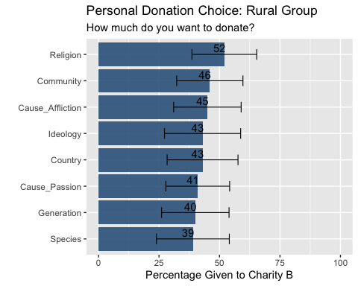

# Creating norms choice graph  
Norm_choice %>%   
 mutate(Giving_Task = fct_reorder(Giving_Task, Mean)) %>%   
 mutate_if(is.numeric, round, digits = 2) %>%   
 ggplot(aes(x = Giving_Task, y =Mean)) +   
 geom_bar(stat = "identity", fill= "steelblue4", alpha=0.9) +   
 ylim(0, 100) +   
 geom_errorbar(aes(x = Giving_Task, ymin = Mean - CI, ymax = Mean + CI), color = "black", size = 0.4, width = 0.4) +   
 geom_text(aes(label = Mean), vjust = -0.3, color = "black", position = position_nudge(y = -2.0)) +  
 coord_flip() +   
 labs(title = "Norms Donation Choice: Rural Group ",   
 subtitle = "How much do people think you ought to donate?",  
 y = "Percentage Given to Charity B",   
 x = "")

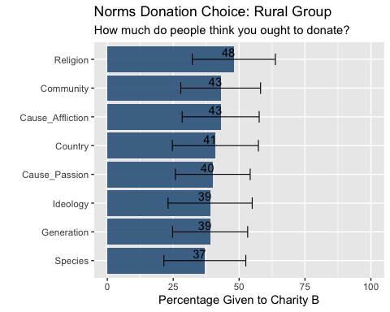

### General generosity in norms and personal choice

rural_group_few %>%   
 ggplot(aes(x = N_generosity,  
 y = Char_Generosity )) +  
 geom_point() + geom_smooth(method = lm, se = TRUE, span = 0.2)

## `geom_smooth()` using formula 'y ~ x'

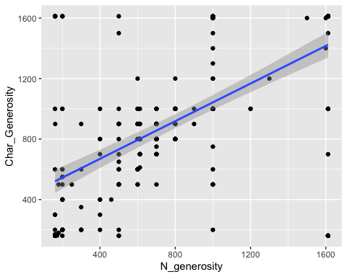

# we can see that there is a strong directly proportional relationship between norm generosity and personal choice generosity.

### Giving by hh income

rural_group_few %>%   
 group_by(Hh_income_pa) %>%   
 summarise(Personal_gen = mean(Char_Generosity)) %>%   
 mutate(Hh_income_pa = fct_reorder(Hh_income_pa, Personal_gen)) %>%   
 ggplot() + geom_bar(aes(x = Hh_income_pa, y = Personal_gen), stat = "identity", fill= "steelblue4", alpha=0.9 ) +  
 ylim(0, 1612) +   
 coord_flip()

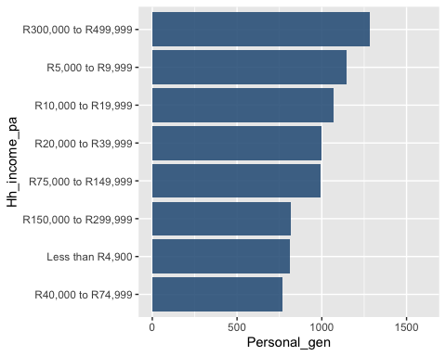

# below is everything I did above but in percentage form  
rural_group_few %>%   
 group_by(Hh_income_pa) %>%   
 summarise(Personal_gen = mean(Char_Generosity)/1612) %>%   
 mutate_if(is.numeric, round, digits = 2) %>%   
 mutate(Hh_income_pa = fct_reorder(Hh_income_pa, Personal_gen)) %>%   
 ggplot(aes(x = Hh_income_pa, y = Personal_gen)) + geom_bar(stat = "identity", fill= "steelblue4", alpha=0.9 ) +  
 ylim(0, 1) +   
 geom_text(aes(label = Personal_gen), vjust = 0.5, color = "black", position = position_nudge(y = -0.05)) +  
 coord_flip()

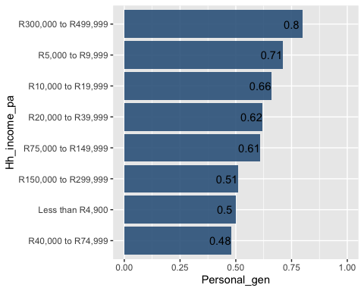

### Giving by gender

rural_group_few %>%   
 group_by(Gender) %>%   
 summarise(avg_donation = mean(Char_Generosity)) %>%   
 mutate_if(is.numeric, round, digits = 2) %>%   
 mutate(Gender = fct_reorder(Gender, avg_donation)) %>%   
 ggplot(aes(x = Gender, y = avg_donation)) +  
 geom_bar( stat = "identity", fill = "steelblue4", alpha = 0.9, width = 0.5) +  
 ylim(0, 1612) +  
 geom_text(aes(label = avg_donation), vjust = 1.5, color = "black")

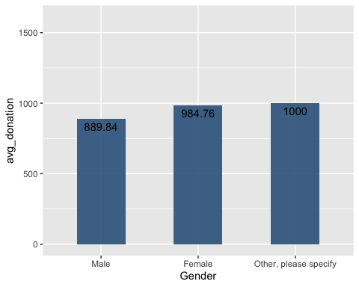

### Age demographics

rural_group_few %>%   
 group_by(Gender) %>%   
 summarise(avg_age = mean(Age)) %>%   
 ggplot() +  
 geom_bar(aes(x = Gender, y = avg_age), stat = "identity", width = 0.5, fill = "steel blue")

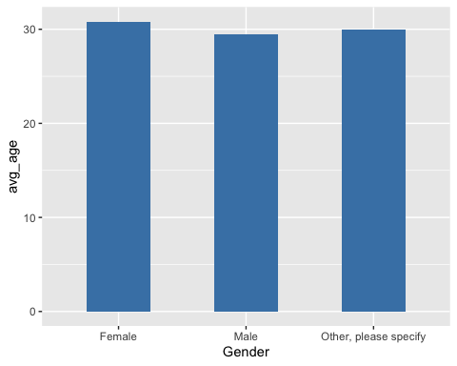

rural_group_few %>%   
 group_by(Gender) %>%   
 summarise(count = n()) %>%   
 ggplot() +  
 geom_bar(aes(x = Gender, y = count), stat = "identity", width = 0.5, fill = "steel blue")

