Review on State of Art Data Mining and Pattern Recognizing Models for Identifies Inherited Diseases
Lahiru Iddamalgoda¹ and Achala Aponso²
¹Department of Computing, Informatics Institute of Technology, University of Westminster, Colombo, Sri Lanka.
lmanohara99@gmail.com
²Department of Computing, Informatics Institute of Technology, University of Westminster, Colombo, Sri Lanka.
ach.chathuranga@gmail.com

Abstract
Data mining and pattern recognizing methods reveal interesting findings in genetic studies, specifically on the inherited diseases. Various researchers have proposed data mining models for biomedical approaches to find pathogenesis of inherited disease. The main challenges in genetic inherited disease predict is correctly classifies the genetic factor.
The main aim of the paper is review state-of-art data mining and pattern recognizing models for identifies inherited diseases. Binary classification methods and scoring based prioritization methods are explained in order to provide the scientific background of the problem. There are different approaches are reviewed in this paper such as SNP based binary classification, scoring based genes prioritization, in order to identifies inherited diseases.

Keywords
Inherited Diseases, data mining, Machine Learning, nonsynonymous single nucleotide polymorphisms (nsSNPs), protein-protein interaction,

Introduction
The diseases are main threat to the human life. Inherit factor acts as a main role of the diseases paradigm. Advancement of technology and science contributes to identify inherited diseases based on DNA. There are various methods introduced in many researches to identify inherited disease based on DNA /genetic variations in DNA sequences (1) prioritize candidate genes and identify inherited diseases(3) and Single nucleotide based genetic mapping method for complex diseases(4).
It is a challenging task to identify inherited diseases without applying bioinformatics techniques and algorithms(5).Finding the inherited disease gene from human genome is one of the most major tasks in bioinformatics research (6).Data mining techniques in genetic studies are helpful to identify inherited diseases (2).
We study following areas,in order to better understanding of the DNA contribution of inherited diseases.
- Single Nucleotide Polymorphism (SNP).
- (Non-synonymous single nucleotide polymorphisms nsSNPs).
- Gene ontology for inherited genes.
- Protein-protein interaction network.
Evaluation will be discussed through advantages and disadvantages of previous work to find appropriate solution for identify inherited diseases based on DNA system.

Single Nucleotide Polymorphism based approaches for identify inherited diseases
Single Nucleotide Polymorphism (SNP)s are genetic variants in single bases of DNA sequence(1). It has been suggested that different traditional classification methods and novel data mining techniques are applied to classification problem andalso explains effectiveness of identifying the disease associate with SNPs and performance of the different algorithms.
SNPs in protein coding further categorized them into synonymous SNPs whose occur will not alter encoded amino acids and nonsynonymous SNPs(nsSNPs) is single base alternations leading alternate to the amino acid sequence of the encoded protein(1, 7, 8).In protein level, nsSNPs supply amino acid substitutions, which potentially cause protein system and functions, and further affects human diseases(7). They believed nsSNPs that are associated with the diseases from group of candidate nsSNPs as a binary classification problem. To solve this problem they used different classification algorithms.
Jiaxin, Wangshu (1) assert that LogitBoost ensemble learning approach achieve the best performance among all the other method such as AdaBoost, Random forest, L2boosting , stochastic gradient regression with two common classification method decision tree, and support vector machines. The five ensemble learning approaches and two classification methods are briefly explained as follows.
- AdaBoost
Adaboosting (adaptive boosting) is one of the most popular boosting algorithms. This algorithm is characterized by its adaptive changes to fit sample weights during the boosting process, according to the weighted classification error identify from the last training. In each iteration, a sample-based “weak” classifier is constructed, and the weights of each incorrectly classified sample are become grater (or other way, the weights of the each correctly classified sample are become smaller), as a result driving new classifier to focus more on those “hard” samples, Otherwise classifier not correctly classified with previous weakly classified samples. This is working with sequence of weighted samples, and then final classifier defined to be a linear combination of the classifiers from each stage. Adaboost algorithm can be combined with many other learning algorithms to gain its performance as a Meta algorithm. It has been largely used with decision tree is “the best off-the-self classifier in the world”(9). So this research takes the advantage of the decision tree as the basic “weak” classifier (1).Figure 1 shows the flow of the Adaboosting algorithm working with Naïve Bayes classifier.
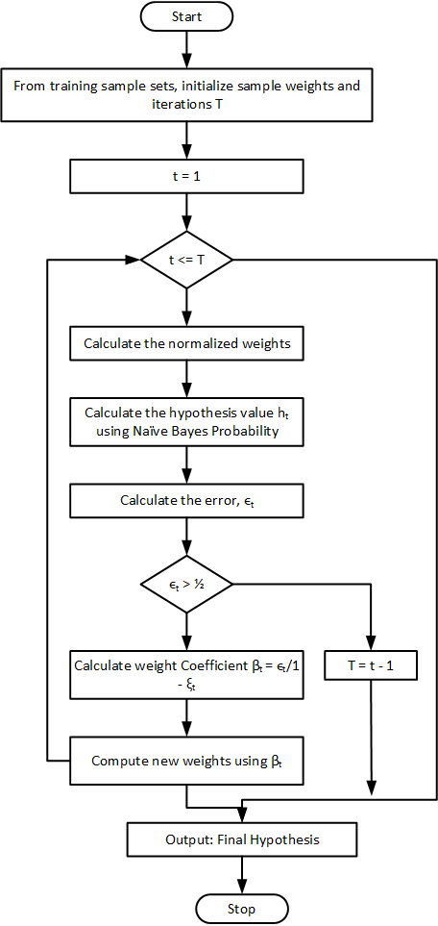
Figure 1 Flow chart of the Ada-Boost Algorithm(10)

- LogitBoost
Logiboost is an improved version of the AdaBoost algorithm. The difference between Adaboost and Logiboost is that Logiboost confidence on the binomial log-likelihood as a loss function, which is a more natural basis in binary classification than the exponential basis underlying the Adaboost algorithms. Compared with Adaboost, LogitBoost is more strongly work in noisy problems, easy to implement and does not require tuning and model or kernel selection like neural networks or support vector machines.LogitBoost can work with Logit models, decision stump, or decision trees(1, 11).

- Random Forest trees
Random forest is a boosting method implemented for vote most popular tree after grown many classification trees. In large data set this method will show outstanding efficiency, few parameters to be adjusted, no over-fitting problem, fast computational speed, and a strong ability of anti-noise characteristics. Also, Random forests have a build in method to estimate the importance of features. This method is usefully to prioritize the features by their importance and reduce the feature set in order to improve the computational complexity (1).

- L2booting
L2boosting is a gradient boosting algorithm for optimizing arbitrary loss functions where component based liner models are make a use of based leaners. It is shown batter performance with stumps (tree with two terminal nodes) and other more common competitors, particularly when the predictor space is multi-dimensional. In addition, L2boosting is working with both regression and classification problems. It shows competitive performance classification relative problems like LogitBoost (1).

- Stochastic gradient regression
Stochastic gradient is regression prediction method. This method uses regression tree as base learner. The optimization of the gradient descent, stochastic gradient regression utilizes the pseudo-residuals result from negative gradient of loss function to set up iterative regression tree. According to idea of Bagging, this algorithm randomly selects part of the pseudo-residual to make regression tree instead of the whole pseudo-residuals. This model can be linear combination of some regression trees (1).

- Support Vector Machines
Support Vector Machine (SVM) also known as “Support Vector Network” which is a machine learning method for two-group classification problems. The idea behind the support vector machine is to map input vectors to infinite dimensional feature space. In this feature space a linear decision environment is built. Special properties of the decision environment ensure about high generalization ability of how to learn a machine. The idea behind the support vector network is previously implemented with some method for the restricted case where training data can be separated without errors, extend this result to non-separable training data(12).

- Decision trees
Decision tree uses to solve complex decisional problems with significant uncertainty. This method applies to scenarios which specified decision alternative cannot be predicted with certainty.When making a decision a lot of different factor taken as inputs, may be useful to reduce uncertainty in decision by collecting additional information, and the decision maker’s behavior is going on to risk taking impact the relative advantageous of different alternatives(13).

Figure 2 and Figure 3 shows the performance of the algorithms. Four evaluation criteria are accuracy of the prediction (ACC), the area under receiver operating characteristic (ROC) curve (AUC), the balanced error rate (BER) and Mtatthew’s correlation coefficient (MCC). Generally, best classification method displays the smaller BER, larger ACC and MCC. The result shows the best method is Logitboost algorithm (1).

Figure 2. Four evaluation criteria (1)

Figure 3. Performance of the 7 approaches (1)
Acording to the results, all the classifiers perform well in disease nsSNPSs against natural nsSNPs. Howevere, when comparing four evaluation criteria of these classifiers, there are significant different from the random situations. The results of the decision tree more distinguished than the other ensemble classifiers, because the BER of the decision tree is higher than other classifiers and The best arrangement of the 7 classifiers are LogitBoost > Random forest > SVM > Adaboost > Stochastic gradient regression > L₂boosting (1).
Rui and Jiaxin (14) explain different approach to find nsSNPs associated with disease. The method is prioritizing candidate nsSNPs depends on the integrated use of two sequence conservation features and a domain-domain interaction network. In order to predict possible effects of nsSNPs, bioinformatics method such as PolyPhen(15), SIFT (16), KBAC (17) and MSRV (18) has been proposed. These methods and ensemble learning methods are binary classification methods. But Rui and Jiaxin (14) believes classification methods provide limited information to beneficiation of diseases associated nsSNPs.And also they argue multiple sequence alignment method is limiting to detect disease associated nsSNPs. But Jiaxin, Wangshu (1)used multiple sequence alignment method (MAS) to extract conserved protein domains the query protein sequence and purely relying on it. To overcome this limitation, in Rui and Jiaxin (14) introduce a method, integrate two conservation properties of amino acids and a domain-domain interaction network to calculate association score. Domain-domain interaction method briefly describe as follows.
- Data source
The proposed approach depends on the integrated use of tree categories of data 1). Annotations of nsSNPs extracted from the Swiss-Prot database(19), 2) annotation of the protein families and structural domains extracted from Pfam database(20), and 3) a domain-domain interaction network obtain from the DOMINE(21) and the InterDom database(22).

- Calculation of similarity score between nsSNPs
Following three similarity scores measure from a pair of two nsSNPs.
First equation corresponds to probability of occurrence of the original amino acid (Porg).
(14)

Second equation corresponds to probability of occurrence of the substituted amino acid (psub).
(14)
Third equation corresponds to calculation of diffusion kernel of the domain-domain interaction network

- Prioritization of candidate nsSNPs
After calculating single pairwise similarity measure of nsSNPs it has been applied it to prioritization a set of candidate nsSNPs done according to the “guilt-by-association principle”(23).Calculation of the association score for a candidate nsSNPs as the mean similarity value between the nsSNP and all seed nsSNPs, as
(14)
A(c) is the association score and S(d) the set of seed nsSNPs from query disease d.
- Integrating of multiple ranks
Applying “guilt-by-association” method to individual data source, it is given multiple ranking lists. Resorting purpose the Stouffer’s Z-score method for combine the ranks and obtain a single ranking list. Inverse normal transformation of the ranks in the list to contain corresponding Z-score, as

(14)
Then obtain a combined Z-score by adding up their corresponding Z-score, as
(14)

There are certainly several limitations in the proposed proof-of-concept search. This approach currently resort the Pfam database to extract conserved protein domain for candidate nsSNPs as because known protein domain variation are limited. To overcome the problem it can be use any other sequence alignment tool such as BLAST or PSIBLAST to extract sequence conservation features(24).Rui and Jiaxin (14) And Jiaxin, Wangshu (1) both have mentioned in their researches, mutation in other genome regions such as transcriptional-factor binding sites or promoter regions may also cause to human diseases.
The binary classification solution which is applied to identify diseases associated with nsSNPs, the Logitboost is the more accurate classification algorithm. But it is fully depends on the multiple sequence alignment. Combination of the multiple sequence analysis and domain-domain interaction method is best method to identify nsSNPs associate with diseases. Further enhancement can be added to domain-domain interaction model. There are other data source which can be used to evaluate functional similarity between two genes and their products. These data source contain gene expression profile, gene ontology annotations, protein-protein interaction, and many others (14).

Combination of SNPs and other methodologies
Fiaschi, Garibaldi (2) suggest that SNPs and other clinical contribute for the inherited diseases. The general framework is proposed to solve that problem and apply it to find pre-eclampsia, a progressive disorder which occurs during pregnancy and soon after the birth, affecting both the mother and their babies(25).Liangcai, Lina (26) argue mutated risk genes and jointly genetic and environmental factors, which are thought to be key importance(27).Proposed method is applicable for analysis risk pathway of the bipolar disorder(BD) and proved this method is correct(28).Wu, Yang (29)suggest detecting association between human genetic variant and their phenotypic involvement is a significant problem in understanding genetic bases human-inherited diseases. Most of the current system predicts association between nsSNPs and diseases based on features obtain from only protein sequence and/or structure information, and not given details about which specific disease in nsSNPs.
Fiaschi, Garibaldi (2)explain case and control study method. This method is created two different groups among the population. One group is labeled as ‘case’ (people with diseases or a condition) and the other group is labeled as ‘controls’. Case control analysis in SNPs studies widely used sub-class algorithm of the decision tree. In the study three algorithm taken in consideration: ID3(13), ADTree(30) , and C4.5(31).Figure 3 shows the explanation of the methodology step by step.Wu, Yang (29) argue nsSNP associated diseases are binary classification problem. Because new approached has been introduce to predict association between nsSNPs and diseases based on multiple similarity networks and diseases phenotype similarity networks. The basic assumption of the proposed method is that nsSNPs associated with phenotypically similar diseases would have similar properties. Therefore, some disease and a query nsSNPs, can be calculate a predictive score that indicates the stability of association between the diseases and the nsSNP by measuring the similarity between the query nsSNP and nsSNPs, that are some diseases identified that have significant phenotypic overlap with the diseases under study.
Further evaluate combination of methodologies, Liangcai, Lina (26)proposed method explains in Figure 4. This approach is different from other two apaches explained before in this literature. Method uses to analysis disease association of the SNPs and environmental factors in the same KEGG pathways. “KEGG pathway is the network of molecular wiring diagrams of interaction and reaction, it provides a reference knowledge base from linking genome to metabolic processes by mapping genes to REACTION and INTERACTION”(32).There are steps to calculate diseases risk in particular approach. First step is SNP significance analysis and the corresponding risk calculation. Data are count of case and control for each and calculate risk ratio from relationship between the SNP and complex diseases. Second step is “KEGG pathway reconstruction and the reconstructed network attribution analysis. KEGG pathway is a network where a node represents metabolite and one edge represents some enzyme or a gene cluster”.Whereas the third step is “SNPs screening and SNPs to reconstructed network G’ mapping” (33), the fourth involves “Calculation of the two integrated measurements of RS scoring and prioritize the pathway”. This method not only focusing on genetic factors which contain in the study of relationship between multiple genes and the diseases, but also the metabolic environment factors by researching the relationship between genes and pathways. The measurements algorithm of SPAM (A SNP pathway based Association Method) can be summarized as follows.
(26)
Or
(26)
“where RS(D, p_{i}) represents the relationship scoring between pathway p_{i} and the disease D, N is the number of gene clusters on pathway p_{i} and d(GS_{j}, p_{i}) demonstrates the complexity of gene cluster GS_{j} on pathway p_{i}. m is the number of the genes that p<0.05. M is the count of all the genes on pathway p_{i}.”

Attributes Choice
Prediction Class Choice
Missing Values Issue
Data Balancing
Medical Remarks

Figure 4. Sequence of steps of following in the pre-processing of a general dataset composed of medical and SNPs attributes. (2)

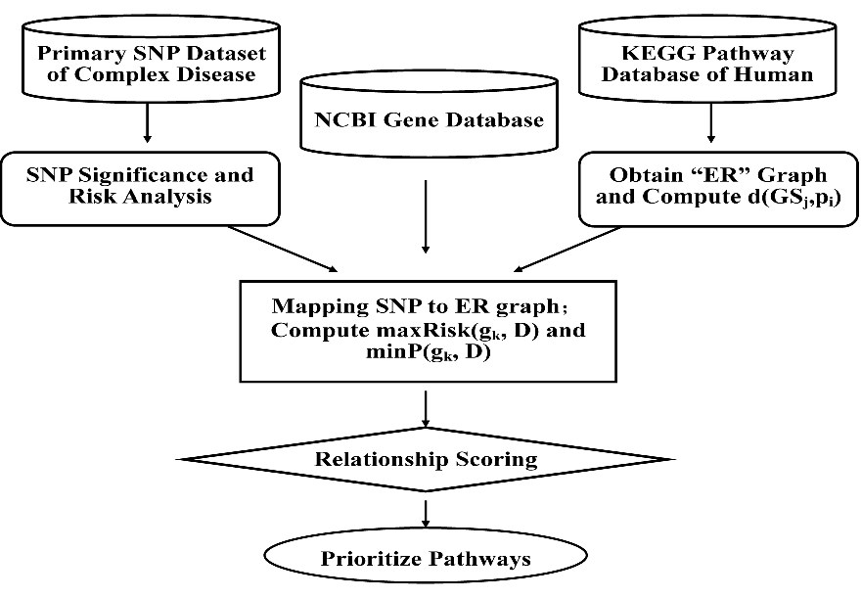
Figure 5. A SNP pathway based Association Method (SPAM) (26)
Fiaschi, Garibaldi (2), Wu, Yang (29) and Liangcai, Lina (26)explains in their researches, combination of SNPs analysis and other methods are more effective.Wu, Yang (29) proposed approach can used on both disease with partially known genetic based or unknown genetic bases. Also explains some limitation on their research, only getting nsSNPs data from one data based for analysis query protein sequence. To overcome this limitation will use other multiple sequence alignment methods, such as PSI-BLAST (24) or COBOLT (34).Feature selection method is not implementing in this approach. So further study, can implement a feature selection method to gain the performance of the proposed solution.Fiaschi, Garibaldi (2) suggests family history related data helps to identify and gain performance of the proposed solution. And also agree with Wu, Yang (29), the feature selection is a affect their solutions.Liangcai, Lina (26) and Wu, Yang (29) both mentioned in their researches some other genome region such as the transcriptional and promoter regions may also be associated with human diseases.
The combination methods are express and explain more about inherited diseases other than analyzing only SNPs. KEGG pathway is useful to analysis other environment factors with SNPs data. The phenotype data explain the more about given genotype data associated with disease. But there are some point in these researches can be affect to performance and accuracy of the proposed solution. Fiaschi, Garibaldi (2) mentioned their solution transforming categorical data to Boolean one according to the threshold value. Selection of the threshold can be huge effect to the accuracy of the solution.Wu, Yang (29) mentions in the proposed solution Canberra distance (35) algorithm is the best to calculate distance between pairwise nsSNPs. But some situation same distance in two similar pair can be in data set and it is hard to classify which is the nearest one to associate with diseases.

Gene prioritization and identify inherited diseases.
Xie, Agam (3) suggest prioritizing candidate genes and finding the best candidate whose gene contributing to disease is most important problems of genomics. Finally, proposed method uses to identify common heritable disorders such as autism(36), schizophrenia(37) and diabetes. He and Jiang (8) explain binary classification formulation proposed in their approach which has been used to prioritize the candidate genes. Tranchevent, Capdevila (5) mention that identifying the most relevant candidate genes is a challenging and time consuming task. Most of the time a biologist would have to go manually through the list of candidates and need to find it is relevant or not. There are 19 computational approaches has been evaluated by literature review. Some approaches are related to identify inherited disease from prioritizing the candidate genes methods as well. A similarity between all these methods are used ‘guilt-by-association’ concept. “The most relevant candidates will be the ones that are similar to the genes already known to be linked to the biological process of interest”(38), (39), (40).
Xie, Agam (3)He and Jiang (8)He and Jiang (8)Tranchevent, Capdevila (5)(41)Tranchevent, Capdevila (5).Shows general methodology of the prioritizing candidate genes and Table 1shows an overview of the input data required by the tools as well as the output produce.

Figure 6. Work flow of the proposed method (8).

Figure 7. Overview of gene prioritization tools(5).
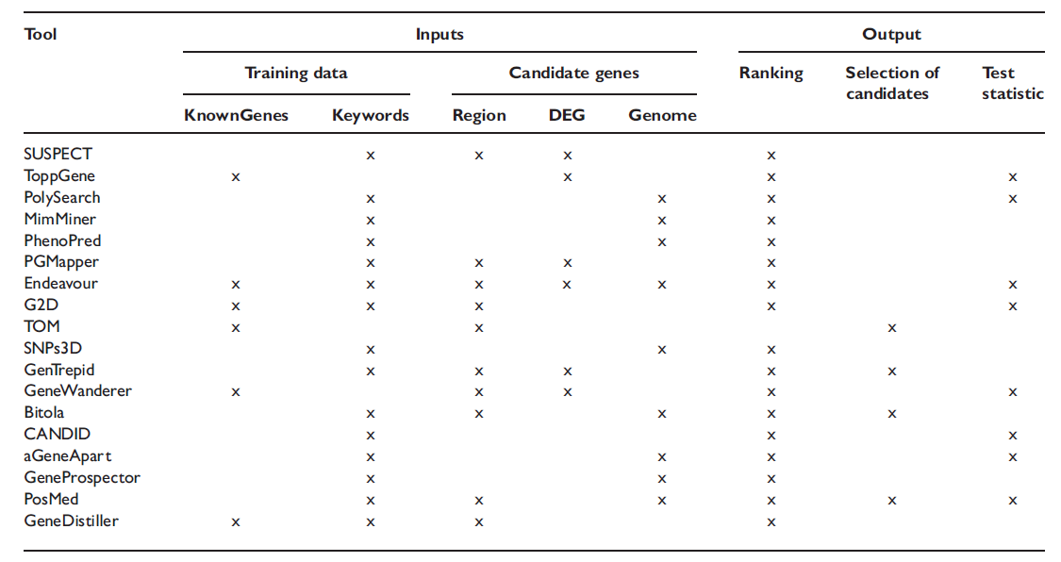
Table 1. Description of the inputs needed by the tools and the outputs produced by the tools(5).
According to He and Jiang (8) result is compared different algorithms such as Liner Regression, Random Forest and Support Vector Machine. According to Table 2, the results suggests the effectiveness of the proposed method in the prioritization candidate genes, according to Mean rank ratio (MRR) and Area under the ROC curve (AUC) logistic regression and support vector machine can achieve higher performance than the random forest. Xie, Agam (3)also agree support vector machine based gene prioritizing is preformed significant average accuracy. Support vector machine is working on the unbalance training data set as well. Tranchevent, Capdevila (5)Comparison study is about gene prioritizing tools that are available. These tools are following various type of input, data source used during the process of prioritization and the desired output. This study recommends tool called G2D to find the relation to inherited disease a combination of data mining on biomedical databases and gene sequence analysis (42).
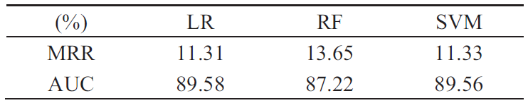
Table 2. Result of 10-fload cross validation experiments for prioritizing candidate genes (8).
Xie, Agam (3) and He and Jiang (8) both agreed with performance of the support vector machine to apply gene prioritizing process. Also agreed with prioritization method and other methods such as similarity profile of human disease analysis and enrichment based feature selection process perform well in identify inherited diseases. He and Jiang (8)suggest feature selection method and integrating more data sources uses with proposed solution can build a better prediction ability. Tranchevent, Capdevila (5) comparison study is more important to classify which tool is most relevant to research about gene prioritization areas such as identifies inherited diseases. Also help to identifies type of input, data source used during the process of prioritization and the desired output.

Protein – Protein interaction network and inherited disease
Xu and Li (6) suggest the availability of human genome-wide protein-protein interaction (PPIs open a path for discovering inherited disease genes by topological features in PPIs network.Jingchun, Leng (37) agree to protein-protein interaction network useful to identify inherited diseases called Schizophrenia (43). Furthermore, studies of proteins and their interaction are important to understand their dynamic roles within a cell. Mapping the schizophrenia genes into the whole human interaction network and then extract their sub networks make clear on the cellular mechanisms and biological processes related to the inherited disease. Xu and Li (6) argues “exploiting sequence based feature and found that for many of them there are significant differences between genes underlying human hereditary disease and those not known to be involved in diseases”. “Associated with a human disease preferentially interacted with other disease-causing genes significantly indicating heritable disease-genes might share some topological features in the PPIs network, whereas the non-disease genes do not” (44).
The proposed method steps are human PPIs dataset which were downloaded from Online Predicted Human Integration Database (OPID)(45),building training samples, define features set, classification algorithm and validation. K-nearest neighbors (KNN) algorithm used for classification. The KNN algorithm is a simple but powerful non parametric classification algorithm(46). The performance of the KNN classifier shows in Figure. According proposed method “if a gene shares more neighbors with known hereditary disease-genes in the PPIs network is should be more likely be a disease-gene too” (6).Jingchun, Leng (37) used the same method which is Xu and Li (6)proposed in their research. According to KNN based approach, Jingchun, Leng (37) find the properties of schizophrenia gene in human protein-protein network.
Figure 8.Performance of KNN classifier with adding new disease-genes (6).
PPI network is mostly important for identify heritable disease. Jingchun, Leng (37)used PPI network method for identify schizophrenia inherited diseases.Xu and Li (6) “proposed a KNN based classifier to explicitly and directly exploit the recent PPIs data”. This proposed method works with different human PPIs and achieved higher accuracy. “With increasing quantity and quality of human interaction and phenotypic data, the performance and utility of this approach in facilitating biologists to detect novel disease-genes should improve even further”. Suravajhala and Sundararajan (47) propose a method to validate the mapping between proteins. They were introduced a six points classification model to calculate the Total Reliability Score (TRS) using machine learning algorithms. Accuracy of six point classification model is 81.08% on Multilayer perception of neural network.

CONCLUTIONS
Most of the inherited diseases are based on the DNA variation called SNPs, gene which segment contain in DNA and protein-protein interaction network. Most of the researches are in inherited disease domain which related to SNPs (1),(29). Combination of the SNPs and the other methodologies is useful to identify the inherited diseases (2), (26),(14). Gene prioritization is a another best approach for the identify inherited diseases (8), (3). Human protein-protein interaction (PPIs) is a new opportunity for discovering inherited diseases(6), (37).
Most of the identify SNPs related to inherited diseases are binary classification problem(14),(1), (29).Jiaxin, Wangshu (1) prove in their research Logitboost is the best method to classify SNPs related to inherited disease. But some other most commonly used algorithms are Support Vector Machine, Decision tree and the Random forest (2).Gene prioritization methods are used scoring based mathematical model to calculate which genes are truly associate with the inherited diseases(8), (5).KNN classifier is most significant algorithm for analysis protein-protein interaction network based inherited diseases (6).
Some researches were used different cross validation method to prove accuracy, efficiency and the appropriation of the proposed method. Some proposed method were implemented as general framework for identify inherited diseases (26), (2).Researchers are also proposed some method for identifying specific inherited diseases such as neuropsychiatric disorders and Schizophrenia (37), (3). General framework based methods and other specific type inherited diseases exploration system are valuable for further study of the Identify Inherited Diseases based on DNA system(IIDDNA).

REFERENCES
1. Jiaxin W, Wangshu Z, Rui J, editors. Comparative study of ensemble learning approaches in the identification of disease mutations. Biomedical Engineering and Informatics (BMEI), 2010 3rd International Conference on; 2010 16-18 Oct. 2010.
2. Fiaschi L, Garibaldi JM, Krasnogor N, editors. A framework for the application of decision trees to the analysis of SNPs data. Computational Intelligence in Bioinformatics and Computational Biology, 2009 CIBCB '09 IEEE Symposium on; 2009 March 30 2009-April 2 2009.
3. Xie B, Agam G, Sulakhe D, Maltsev N, Chitturi B, Gilliam TC. Prediction of candidate genes for neuropsychiatric disorders using feature-based enrichment. Proceedings of the ACM Conference on Bioinformatics, Computational Biology and Biomedicine; Orlando, Florida. 2383022: ACM; 2012. p. 564-6.
4. Dawy Z, Sarkis M, Hagenauer J, Mueller JC. Fine-Scale Genetic Mapping Using Independent Component Analysis. Computational Biology and Bioinformatics, IEEE/ACM Transactions on. 2008;5(3):448-60.
5. Tranchevent L-C, Capdevila FB, Nitsch D, De Moor B, De Causmaecker P, Moreau Y. A guide to web tools to prioritize candidate genes. Briefings in Bioinformatics. 2010.
6. Xu J, Li Y. Discovering disease-genes by topological features in human protein–protein interaction network. Bioinformatics. 2006;22(22):2800-5.
7. Yates CM, Sternberg MJE. The Effects of Non-Synonymous Single Nucleotide Polymorphisms (nsSNPs) on Protein–Protein Interactions. Journal of Molecular Biology. 2013;425(21):3949-63.
8. He P, Jiang R, editors. Integrating multiple gene semantic similarity profiles to infer disease genes. Control Conference (CCC), 2012 31st Chinese; 2012 25-27 July 2012.
9. Vladimir V. Principles of Risk Minimization for Learning Theory. 1992:831--8.
10. Korada NK, Kumar N, Deekshitulu Y. Implementation of Naive Bayesian Classifier and Ada-Boost Algorithm Using Maize Expert System. International Journal of Information Sciences & Techniques. 2012;2(3).
11. Friedman J, Hastie T, Tibshirani R. Additive logistic regression: a statistical view of boosting (with discussion and a rejoinder by the authors). The annals of statistics. 2000;28(2):337-407.
12. Cortes C, Vapnik V. Support-Vector Networks. Machine Learning. 1995;20(3):273-97.
13. Breiman L, Friedman JH, Olshen RA, Stone CJ. Classification and Regression Trees: CRC Press, New York; 1999.
14. Rui J, Jiaxin W, editors. Integrating sequence conservation features and a domain-domain interaction network to detect disease-associated nsSNPs. Bioinformatics and Biomedicine Workshops (BIBMW), 2011 IEEE International Conference on; 2011 12-15 Nov. 2011.
15. Ramensky V, Bork P, Sunyaev S. Human non‐synonymous SNPs: server and survey. Nucleic Acids Research. 2002;30(17):3894-900.
16. Ng PC, Henikoff S. SIFT: predicting amino acid changes that affect protein function. Nucleic Acids Research. 2003;31(13):3812-4.
17. Liu DJ, Leal SM. A Novel Adaptive Method for the Analysis of Next-Generation Sequencing Data to Detect Complex Trait Associations with Rare Variants Due to Gene Main Effects and Interactions. PLoS Genet. 2010;6(10):e1001156.
18. Jiang R, Yang H, Zhou L, Kuo CCJ, Sun F, Chen T. Sequence-Based Prioritization of Nonsynonymous Single-Nucleotide Polymorphisms for the Study of Disease Mutations. The American Journal of Human Genetics. 2007;81(2):346-60.
19. Consortium TU. The Universal Protein Resource (UniProt) in 2010. Nucleic Acids Research. 2010;38(suppl 1):D142-D8.
20. Finn RD, Mistry J, Schuster-Böckler B, Griffiths-Jones S, Hollich V, Lassmann T, et al. Pfam: clans, web tools and services. Nucleic Acids Research. 2006;34(suppl 1):D247-D51.
21. Raghavachari B, Tasneem A, Przytycka TM, Jothi R. DOMINE: a database of protein domain interactions. Nucleic Acids Research. 2008;36(suppl 1):D656-D61.
22. Ng S-K, Zhang Z, Tan S-H, Lin K. InterDom: a database of putative interacting protein domains for validating predicted protein interactions and complexes. Nucleic Acids Research. 2003;31(1):251-4.
23. Altshuler D, Daly M, Kruglyak L. Guilt by association. Nat Genet. 2000;26(2):135-7.
24. Altschul SF, Madden TL, Schäffer AA, Zhang J, Zhang Z, Miller W, et al. Gapped BLAST and PSI-BLAST: a new generation of protein database search programs. Nucleic Acids Research. 1997;25(17):3389-402.
25. Roberts JM, Taylor RN, Musci TJ, Rodgers GM, Hubel CA, McLaughlin MK. Preeclampsia: An endothelial cell disorder. American Journal of Obstetrics & Gynecology. 1989;161(5):1200-4.
26. Liangcai Z, Lina C, Yan Z, Liangde X, Yukui S, Qian W, et al., editors. A SNP and KEGG Based Approach to Mine Risk Pathways Associated with Bipolar Disorder. Natural Computation, 2008 ICNC '08 Fourth International Conference on; 2008 18-20 Oct. 2008.
27. Risch N, Merikangas K. The Future of Genetic Studies of Complex Human Diseases. Science. 1996;273(5281):1516-7.
28. Hirschfeld RMA, Lewis L, Vornik LA. Perceptions and impact of bipolar disorder: How far have we really come? Results of the National Depressive and Manic-Depressive Association 2000 survey of individuals with bipolar disorder. Journal of Clinical Psychiatry. 2003;64(2):161-74.
29. Wu J, Yang S, Jiang R. Inferring non-synonymous single-nucleotide polymorphisms-disease associations via integration of multiple similarity networks. Systems Biology, IET. 2014;8(2):33-40.
30. Freund Y, Mason L, editors. The alternating decision tree learning algorithm. ICML; 1999.
31. Quinlan JR. C4. 5: programs for machine learning: Morgan kaufmann; 1993.
32. Kanehisa M, Goto S. KEGG: Kyoto Encyclopedia of Genes and Genomes. Nucleic Acids Research. 2000;28(1):27-30.
33. Hoh J, Ott J. Mathematical multi-locus approaches to localizing complex human trait genes. Nat Rev Genet. 2003;4(9):701-9.
34. Papadopoulos JS, Agarwala R. COBALT: constraint-based alignment tool for multiple protein sequences. Bioinformatics. 2007;23(9):1073-9.
35. Emran SM, Ye N, editors. Robustness of canberra metric in computer intrusion detection. Proc IEEE Workshop on Information Assurance and Security, West Point, NY, USA; 2001: Citeseer.
36. Kim JA, Szatmari P, Bryson SE, Streiner DL, Wilson FJ. The Prevalence of Anxiety and Mood Problems among Children with Autism and Asperger Syndrome. Autism. 2000;4(2):117-32.
37. Jingchun S, Leng H, Zhongming Z, editors. Schizophrenia Genes: Characteristics of Function and Protein Interaction Networks. BioMedical Engineering and Informatics, 2008 BMEI 2008 International Conference on; 2008 27-30 May 2008.
38. Smith NGC, Eyre-Walker A. Human disease genes: patterns and predictions. Gene. 2003;318(0):169-75.
39. Goh K-I, Cusick ME, Valle D, Childs B, Vidal M, Barabási A-L. The human disease network. Proceedings of the National Academy of Sciences. 2007;104(21):8685-90.
40. Jimenez-Sanchez G, Childs B, Valle D. Human disease genes. Nature. 2001;409(6822):853-5.
41. Zhang P, Zhang J, Sheng H, Russo JJ, Osborne B, Buetow K. Gene functional similarity search tool (GFSST). BMC bioinformatics. 2006;7(1):135.
42. Perez-Iratxeta C, Bork P, Andrade MA. Association of genes to genetically inherited diseases using data mining. Nat Genet. 2002;31(3):316-9.
43. What Is Schizophrenia? 2014 [cited 2014]. Available from: http://www.nimh.nih.gov/health/topics/schizophrenia/index.shtml.
44. Gandhi T, Zhong J, Mathivanan S, Karthick L, Chandrika K, Mohan SS, et al. Analysis of the human protein interactome and comparison with yeast, worm and fly interaction datasets. Nature genetics. 2006;38(3):285-93.
45. Brown KR, Jurisica I. Online predicted human interaction database. Bioinformatics. 2005;21(9):2076-82.
46. Franke L, Bakel Hv, Fokkens L, De Jong ED, Egmont-Petersen M, Wijmenga C. Reconstruction of a functional human gene network, with an application for prioritizing positional candidate genes. The American Journal of Human Genetics. 2006;78(6):1011-25.
47. Suravajhala P, Sundararajan VS. A classification scoring schema to validate protein interactors. Bioinformation. 2012;8(1):34.

Authors

LahiruIddamalgodais undergraduate student at University of Westminster. Currently, He is following a BEng Software Engineering degree.
AchalaAponso received the Bsc. Software Engineering degree from the University of Westminster.Currently, He is following a MSC Data mining degree at University of Moratuwa, Sri Lanka and also lecturing at Informatics Institute of Technology Sri Lanka.

