**CS430 Lecture 26 Activities**

Opening Questions

1. What is the difference between a tree and a graph?

2. Give a recursive definition for a tree.

3. In a weighted undirected graph, what is the difference between a minimum spanning tree and a shortest path in a graph?

4. Since shortest paths contain shortest sub-paths (optimal substructure), name an algorithmic approach that we might try to find a shortest path in a graph.

Minimum Spanning Trees

1. Give a definition of a Minimum Spanning Tree, and find a MST of the below graph.

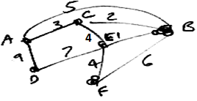

2. Prove a Minimum Spanning Tree has optimal substructure.

3. What are some possible greedy approaches to find a Minimum Spanning Tree? Prove correct or show counterexample

4. Demonstrate your MST algorithm on the following graph and write pseudocode.

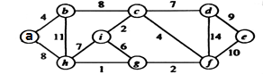

demo prim <http://en.wikipedia.org/wiki/File:Prim-algorithm-animation-2.gif>

demo kruskal <https://www.cs.usfca.edu/~galles/visualization/Kruskal.html>