**After lecture27 & lecture28 & lecture29 -** Answer any questions on HW7 (due today)

Practice Problems (all taken from previous exams)

1. How many shortest path solutions are available for a graph having negative weight cycle?  
a) One solution  
b) Two solutions  
c) No solution  
d) Infinite solutions

2. What is running time of Dijkstra’s algorithm using Binary min-heap method?

A O(V)

B O(VlogV)

C O(E)

D O(ElogV)

3. What approach is being followed in Floyd Warshall Algorithm?  
a) Greedy technique  
b) Dynamic Programming  
c) Linear Programming  
d) Backtracking

4. In the following table, the left column contains the names of standard graph algorithms and the right column contains the time complexities of the algorithms. Match each algorithm with its time complexity.

a. Bellman-Ford algorithm i. O(|E| log|E|)  
b. Kruskal’s algorithm ii. O(|V|^3)  
c. Floyd-Warshall algorithm iii. O(|V|*|E|)

d. Topological sorting iv. O (|V|+|E|)

A a→iii, b→i, c→ii, d→iv

B a→ii, b→iv, c→iii, d→i

C a→iii, b→iv, c→i, d→ii

D a→ii, b→i, c→iii, d→iv

5. Run the Bellman-Ford’s algorithm on the graph illustrated by Figure 1 to ﬁnd shortest paths (each for every other node) from node A to all other nodes of the graph.

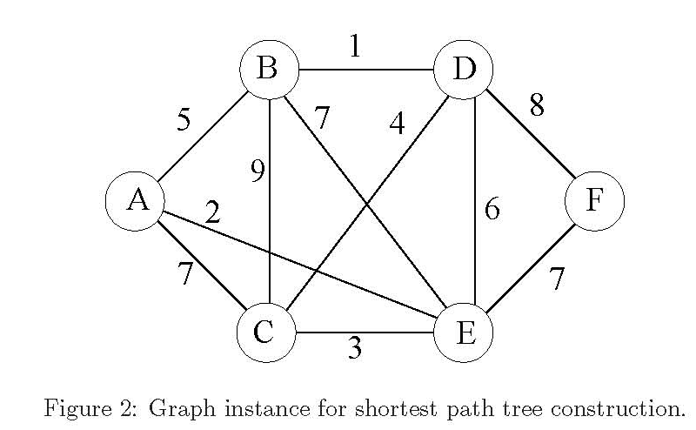

6. Your roommate has written a program to implement Dijkstra’s shortest path algorithm. Design and analyze a linear time algorithm to check your roommate’s algorithm’s results. That is, given a graph G = (V,E), a source vertex s, and your roommate’s values of v.d (shortest path weight from source to vertex v) and v.pi (predecessor to vertex v for shortest path from source to vertex v) for every vertex v ∈ V , your algorithm must verify their correctness or find a value that is wrong.

7. Give an example of a weighted undirected graph G (of at least 4 vertices, and with no negative weight cycles) and a starting vertex s in G such that the minimum spanning tree of G is not the same as the shortest path tree of G (starting from s). Remember, the edges used in any single source shortest path solution form a shortest path tree. Show both the minimum spanning tree of G and the shortest path tree of G. Explain which method you used to find the minimum spanning tree and which method you used to find the single source shortest path solution.

8. Draw the weighted graph, with vertices 1,2,3,4,5, represented by the adj. matrix.

|  |  |
| --- | --- |
| Adjacency Matrix (~ is infinity)  0 4 ~ ~ 4  ~ 0 5 3 ~  D(0) = -1 ~ 0 2 7  1 6 ~ 0 2  ~ -3 ~ ~ 0 | Predecessor Matrix (- means no predecessor)  - 1 - - 1  - - 2 2 -  Pi(0) = 3 - - 3 3  4 4 - - 4  - 5 - - - |

Compute D(1), D(2), D(3), D(4) and D(5) using Floyd-Warshall algorithm to compute minimum weight paths between all vertices in above graph. Also keep track of the predecessor vertices (last vertex in the shortest paths).