A short introduction to STEL (STGraph Expression Language)

Introduction
STEL (STGraph Expression Language) is the domain-specific language by which the quantitative side of the STGraph models is defined.
Models as graphs; variables as nodes; arrows as relations of functional dependence |  | A model in STGraph is qualitatively described as a directed graph, in which nodes are variables (o, as particular case, constants) and arrows are relations of functional dependence.  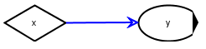  An arrow from the node x to the node y specifies that y depends functionally on x.  The analytical form of such dependence is written as an expression in STEL.  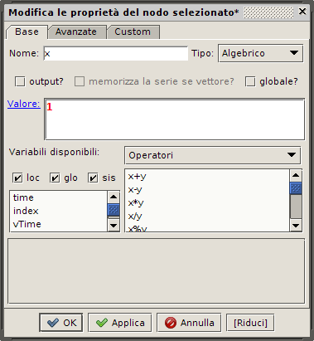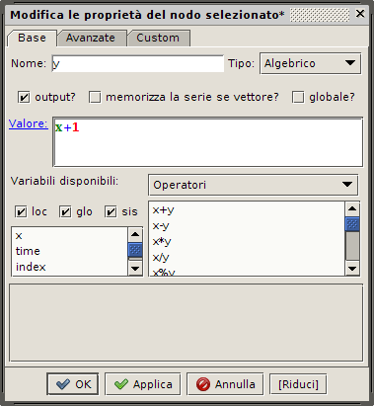  The configuration windows for the nodes of the previous Figure.  The content corresponds to the assignments x←1; y←x+1.  The fact that STGraph deals with three node types (algebraic, state, state with output) is not relevant for the language. Hence the presentation here will be generically on expressions in STEL, that may be expressions for either output functions, or initial state functions, or state transition functions.  A synthetic view of the main features of STEL
Functional language |  | STEL is a pure functional language (then it does not include “instructions” nor “commands”, but only, indeed, functions), based on the hypothesis that the only relations allowed among variables are those described by means of the graph arrows (in the example of the previous Figures, the function which defines y includes a reference to x, but the vice versa would not be possible given that there is not an arrow from y to x). The only exception is for variables declared as global.
No instructions / functions of value assignment |  | With the aim of making the environment perfectly free from side effects, STEL does not include any function to assign values to variables (but in the case of sub-expressions; see below): the value of a variable is always and only assigned by the expression associated to the node corresponding to the variable itself. In this way, each graph node corresponds to a computational micro-environment, open in input only through its incoming arrows and in output only through the value generated by the evaluation of its expression.
Scope of variables and submodels |  | This defines the default scope of variables. STGraph handles also models structured in submodels, corresponding to graphs in which one or more nodes are not associated to variables but to other graphs: lo scope is always restricted to submodels, and each (sub)model interacts with its submodels only through the input and output variables of such submodels – all and only the variables without incoming arrows are input variables; each variable can be declared to be an output variable).
Order of evaluation of variables |  | The evaluation order for the expressions of nodes in a graph is inferred by STGraph on the basis of the graph topology: this generates the possibility that, in principle, non mutually dependent nodes are evaluated in parallel (in presence of state variables, a graph may also include loops).  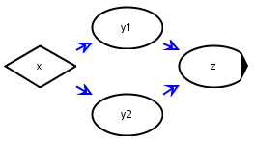  Graph in which the variables y1 and y2 might be computed in parallel.
Variables of a single type |  | Given its application domain and for reasons of simplicity, variables in STEL have all the same, implicit (because undeclared) base type, number, interpreted as integer, decimal, or logical (all strictly positive numbers are associated to the constant ‘true’) depending on the context.
Variables as arrays |  | Variables in STEL are all of a single structured type, array, which includes as specific cases scalars, vectors, matrices, and admits also tensors of higher dimension. Arrays are dynamic, and need not to be initialized.
Predefined functions and user defined functions |  | STEL is provided with a set of predefined functions (written in Java as STGraph) (some of them written in the usual infix operator notation), and with a function to define new functions in STEL, also recursively, both in graph nodes (in this case the scope is the graph itself) and in external XML file (in this case functions are visible to all graphs).
Polymorphism of one argument functions |  | Predefined functions are usually polymorphic with respect to the array order of their arguments. In the case of one argument functions, this corresponds, for example, to the fact that the function sqrt(x) has the following behavior (in these examples ‘=’ is the metalinguistic symbol for ‘has value’):  if x=4 then sqrt(x)=2  if x=[4,9] then sqrt(x)=[2,3]  if x=[[4,9],[16,25]] then sqrt(x)=[[2,3],[4,5]]  and so on.
Polymorphism of two argument functions |  | For two argument functions, polymorphism is guaranteed in all cases in which the evaluation is allowed. For example:  if x=1 and y=2 then x+y=3  if x=1 and y=[1:3] then x+y=[2,3,4]  if x=[[1,2],[3,4]] and y=[5,6] then x+y=[[6,7],[9,10]]  where the last case is to be intended as:  thus showing that vectors are interpreted as column vectors, and that higher dimension arrays are written in linear form so to maintain the most internal dimension as the last one, and that, when it applies, functions operate on the last dimensions of arrays.  Given that it does not include instructions, STEL does not have traditional control structures.
If |  | It is instead provided with a generalized conditional function, if(c₁,v₁,...,c_{n},v_{n},v_{n+1}), having an odd ≥3 number of arguments and such that arguments in odd position but the last one are conditions c_{i} and all other ones are values v_{j}: the first true condition select the immediately following value, and if all conditions are false then the last value is selected. For example:  if x=if(1,2,3) then x=2  where this function corresponds to the Java control structure:  if(1) {  x=2;  } else {  x=3;  }  but also:  if x=if(0,2,0,3,4) then x=4  indeed corresponding to:  if(0) {  x=2;  } else if(0){  x=3;  } else {  x=4;  }  and also, in polymorphic way:  if([1,0],2,3)=[2,3]
Time loops |  | Nei modelli di STGraph non è generalmente necessario introdurre in modo esplicito dei loop. Ciò è principalmente dovuto al fatto che nel corso della simulazione il tempo viene incrementato a passi discreti e quindi crea le condizioni perché, in linea di principio, l’espressione di ogni variable sia valutata in loop (in particolare nella funzione di transizione di stato locale di un nodo di stato, per esempio un’espressione come:  this+1  – dove this denota lo stato attuale – incrementa di 1 lo stato a ogni istante della simulazione).
Space loops |  | In the case it is required to operate in a synchronous loop over the elements of an array x (then with a “spatial” instead of temporal loop), if the function / operator f to be applied has two arguments (as shown above, one argument functions can be directly applied to array) STEL is provided with meta-operators that iterate the function evaluation over the array according to different logics:  - the expression f/x, where ‘/’ denotes the meta-operator reduction, corresponds, in the case x is a vector, to the scalar f(f(x[0],x[1]),x[2])...; for example:  +/[1:4]=((1+2)+3)+4=10  - the expression f\x, where ‘\’ denotes the meta-operator scan, corresponds, in the case x is a vector, to the vector [x[0],f(x[0],x[1]),f(f(x[0],x[1]),x[2]),...]; for example:  +\[1:3]=[1,1+2,(1+2)+3]=[1,3,6]  - the expression f|x, where ‘|’ denotes the meta-operator pairscan, corresponds, in the case x is a vector, to the vector [f(x[0],x[1]),f(x[1],x[2]),f(x[2],x[3]),...]; for example:  +|[1:4]=[1+2,2+3,3+4]=[3,5,7]  If applied to matrices or higher dimensions arrays, these meta-operators evaluate the function f along the last dimension. For example:  +/[[1,2,3],[4,5,6],[7,8,9]]=[1+2+3,4+5+6,7+8+9]=[6,15,24]  More generally, space loops over arrays x can be computed by means of the meta-function iter(x,e,z), where e is the expression to be iteratively evaluated over the elements of (the last dimension of) x and z is the “zero” of such expression. The evaluation is repeated as many times as the number of element of (the last dimension of) x. The expression e can include the system variables:  - $i, that at each iteration has the iteration index as value;  - $0, that initially has value z and at the iteration has the result of the evaluation of e as value;  - $1, that at each iteration has x[$i] as value.  For example, iter(x,$0+$1,0) evaluates the sum of the elements of (the last dimension of) x, and iter(x,$1#$0,[]) (‘#’ denotes the concatenation operator) produces a vector whose elements are in inverse order with respect to the one of x.
Sub-expressions |  | Even though it does not include functions for the assignment of values to variables, STEL provides a means to identify one or more sub-expression (up to 4) of the expression under evaluation, by delimiting them by curly brackets: {subexpression}. These sub-expressions are evaluated in the order of evaluation of the base expression, and the value of each of them is assigned to the system variables $wi, i=0,...,3, and therefore it can be used in subsequent parts of the base expression. For example:  if({order(x)}==0,1,$w0==1,@x,*/@x)  computes the number of the elements of the dell’array x, according to the logic:  - if x is a scalar, i.e., a 0-order array, the value is 1; in the meantime it computes the value of the sub-expression order(x) and assigns it to the system variable $w0;  - else if x is a vector, i.e., a 1-order array, the value is @x, i.e., the dimension of x;  - else, i.e., if x is a matrix or a higher order array, the value is */@x, i.e., the product of the dimensions of x.  Some examples
Vector product of two matrices x and y
array([numRows(x),numCols(y)],+/(x[[$i0],[]]*y[[],[$i1]]))

Scalar product of two vectors x and y
+/(x*y)

Range of vector x
max/(x)-min/(x)

Average of vector x
(+/x)/@x

Median of vector x
if(isEven({@x}),(get({sort(x)},$w0/2-1)+get($w1,$w0/2))/2,
get(sort(x),($w0-1)/2))

Standard deviation of vector x
sqrt((+/((x-mean(x))^2))/(lastDim(x)-1))

Vector obtained by removing the 0’s from the vector x
iter(x,if($1!=0,$0#$1,$0),[])

