- Given the provided data, what are three conclusions we can draw about Kickstarter campaigns?
  - When reviewing the data the Music category has the highest success rate and lowest failure / canceled rate of the available possibilities. Regardless of the category there is only a 53% chance of success. Failure / Cancellation is a real possibility at 46%
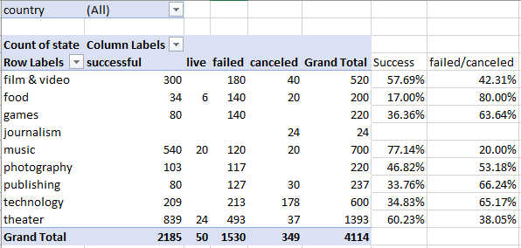
  - Using the Music category the beginning of the year seems to be the most popular for succeeding. It then begins a decline for the remainder of the year
  - Of the possible sub-categories of music, Rock is successful across all countries.
- What are some limitations of this dataset?
  - There is no breakdown on how much each backer gave. There is data without context such as spotlight and staff_pick. With the data only starting in 2009 it is difficult to get a long term analysis. So data will be more sporadic until the data is spread out along a longer time frame.
  - At what point was the Kickstart project successful. There is a start and end date but did it succeed in the first day or did it take the full length of time?
- What are some other possible tables and/or graphs that we could create?
  - We could graph the time vs success / failure. Do longer Kickstart projects become more successful?
  - Goal vs pledged. Do some category produce more pledges vs the goal needed for it to be successful?
- Bonus Statistical Analysis
  - For successful results the median seems to summarize the data more meaningful. The standard deviation is very high. So a midpoint seems more appropriate.
  - The failed outcome can use Mean to summarize the data. The standard deviation is much closer to the mean value. Indicating the average is much closer to all values.

