Information Visualization by Volkswagen

System Design Report – Configuration Application

Lukas Marschall

Contents

Summary 3

Used Technologies 4

ASP NET Core Version 2.0.3 4

Bootstrap 4.3.1 4

Fontawesome 5.6.3 4

JQuery 3.3.1 slim 4

Firefox 4

Models of the Configuration Application 5

Views of the Configuration Application 7

Controllers of the Configuration Application 8

Future Features 9

Visualization of the section choosing the model and the type of the car 9

WLTP Features 9

Progressive Web Application 9

Manage Users 9

# Summary

The task of the VW Coding Challenge was to visualize the product portfolio of the Volkswagen Group. With the OKAPI it is possible to access the latest product, emission and consumption data.

The key features of the VW Coding Challenge included the challenges:

1) Visualize the catalog data, so it will be accessible in a user-friendly way.

2) Propose a graphical insight about the versatility of product data and/or the data itself.

With this application the user can configure every product in the vehicle portfolio of the Volkswagen Group. He can access all countries currently available in the api, after this he chooses his brand and selects the model and the type of the car.

Now he can configure his car and add or remove options to his configuration. In addition, the user can check whether his current configuration is buildable and distinct. With the complete operation he can finish his configuration and receive a distinct configuration.

In the last configurations view the application user can access his last operations and continue his operations.

# Used Technologies

The Application was developed with open source software only, so its possible to manage this software with no need to spend money. In addition, the code is cross-platform deployable, so there is no need to choose a specific operation system for the servers.

The following technologies have been used in the development:

## ASP NET Core Version 2.0.3

<https://github.com/aspnet/AspNetCore>

## Bootstrap 4.3.1

<https://github.com/twbs/bootstrap>

## Fontawesome 5.6.3

<https://github.com/FortAwesome/Font-Awesome>

## JQuery 3.3.1 slim

<https://github.com/jquery/jquery>

## Firefox

<https://github.com/mozilla>

# Models of the Configuration Application

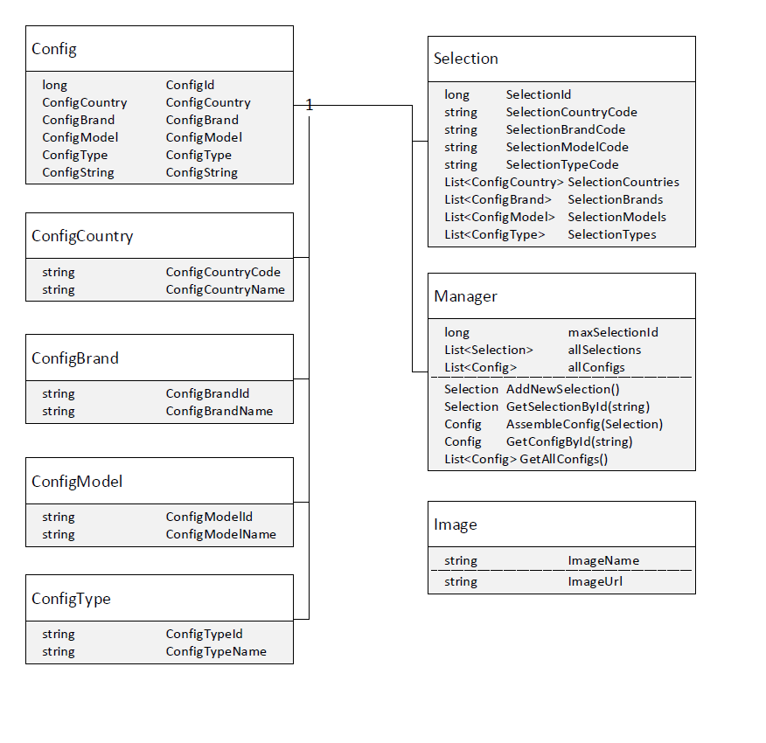

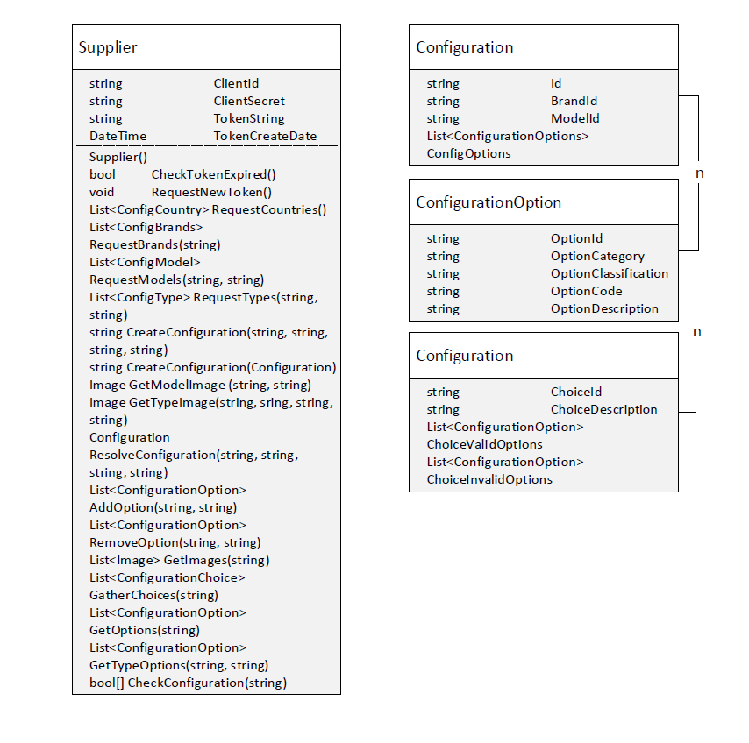

# Views of the Configuration Application

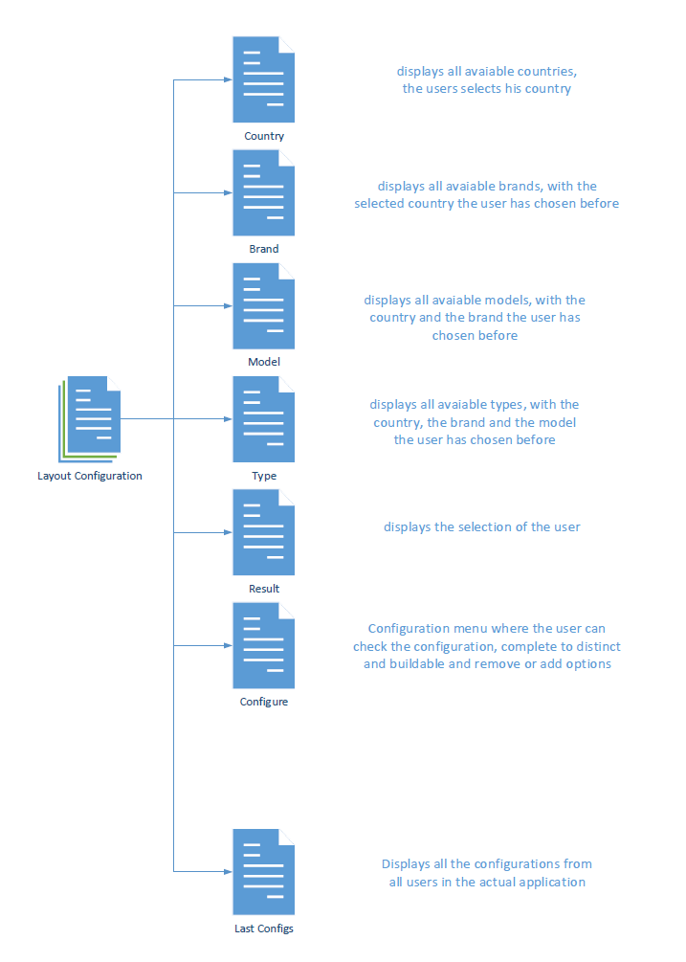

# Controllers of the Configuration Application

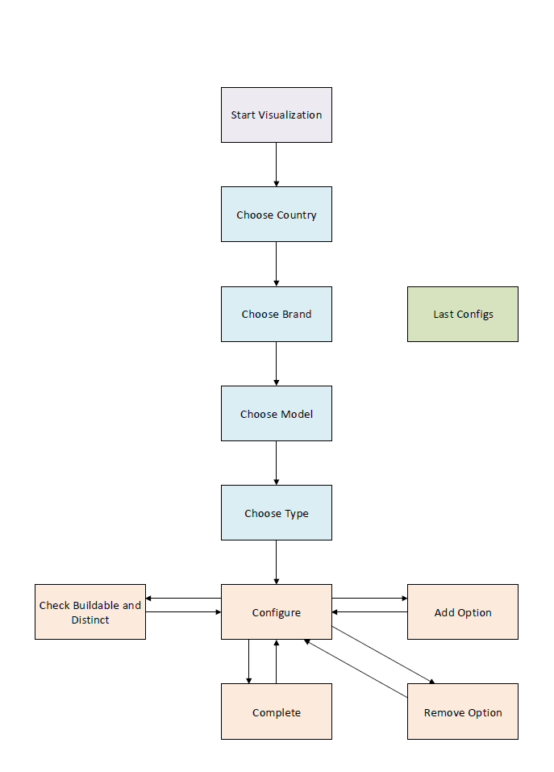

# Future Features

## Visualization of the section choosing the model and the type of the car

At the moment, it is not possible to get images from the vw api, with no configurationId, it would be great to get some, in order to give the user a visual feedback what model and type he is choosing at the beginning.

## WLTP Features

The current state of the website does not include the WLTP Report Feature, because the api does not deliver values for every configuration. This feature can be included, after better support from the api.

## Progressive Web Application

With the use of the ASP NET Core technology it is possible to build an progressive web application form the web application with very little effort. This would be a great feature expansion for mobile users.

## Manage Users

Users should be able to save their last configurations and revisit them later. Right now, it is only possible to visit the configurations of all users.