Computer Science PONG LAB – EXTENDING BALL

Lab Goal : This lab was designed to teach you more inheritance and object oriented programming while learning more about how to write a very simple game.

Lab Description : You will take your working Pong game and add some new dimensions to it. You are going to create some new Balls that are extensions of the original Ball class. BlinkyBall will change colors each time it moves and SpeedUpBall will speed up each time it collides with another object in the game.

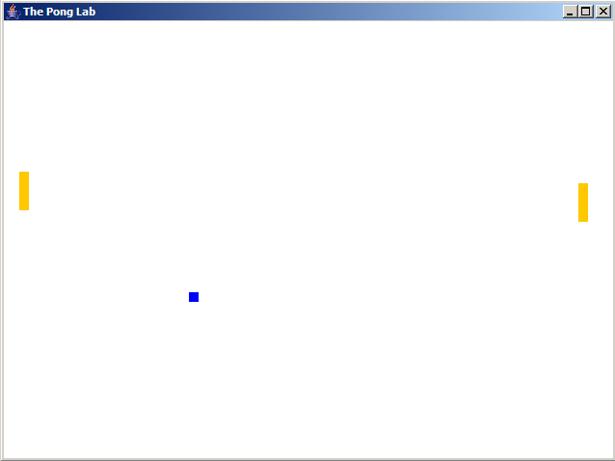

PONG GAME REQUIREMENTS

1. Open the BlinkyBall.java file and write the code for BlinkyBall. BlinkyBall will change colors every time it moves. You must
override some methods and make super calls.

2. Open the SpeedUpBall.java file and write the code for SpeedUpBall. SpeedUpBall will speed up every time it collides with a wall
or a paddle. You must override some methods and make super calls.

PONG GAME EXTENSIONS

1. Create a new Ball named InvisibleBall that will turn invisible randomnly. At random times, it will turn invisible for random
durations of time.

