BigData&DataAnalytics

Mauricio Carvajal

Alert Analytics

Set up Amazon Web Services

Table of contents

1. Introduction 3

2 AWS Console web page 3

3 Configured CLI 3

# Introduction

In this section we do the set up for Amazon Web services.

# 2 AWS Console web page

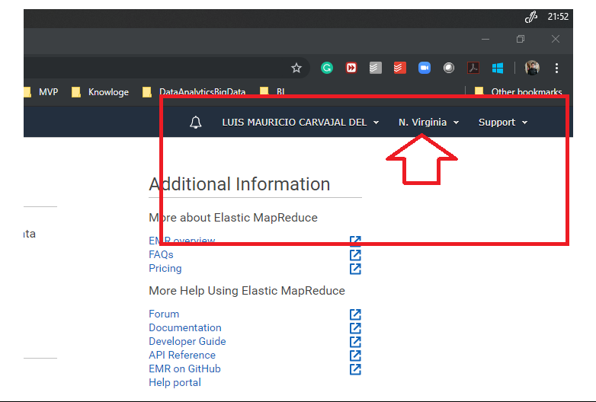

# 3 Configured CLI

For CLI I decided to install the latest version 2, but in case any issue we can also have version 1.

