BigData&DataAnalytics

Generation Luxe

Mauricio Carvajal

IOT Analytics

Evaluate information needs for a new project

Table of contents

1. Introduction 3

2. Proposal Feature 3

3. Analysis 3

3.1 Candidate brands will be the most popular in the coming season 4

3.1.1 Which brands are the most popular? 4

3.1.2 Which brands are our customers more likely to buy based on their attitudes toward the economy? 4

3.1.3 Which brands are trending upward in popularity? 4

3.1.4 Which brands are trending downward in popularity? 4

3.1.5 Which brands have an inconsistent trend in popularity? 4

3.1.6 Which of these brands look best on our customers? 4

3.1.7 Which brands are the most popular among fashion critics? 5

3.2 Items will be the highest sellers 5

3.2.1 For each product category (dresses, skirts, tops and pants) which brands carry the most popular items? 5

3.3 Aditional retails insihgs 5

3.3.1 Which retailer will be carrying the most exciting color combinations next season? 5

3.4 Special charactericts 5

3.4.1 What qualities do customers like about each brand? 5

3.4.2 What qualities do customers dislike about each brand? 6

3.5 Influences of celebraties 6

3.5.1 Which of the brands are popular because they are well liked by celebrities? 6

# Introduction

The following project can consist in support the decision making of 1 client in order thru sentimental analysis, and if the initial question is relevant, need modifications, are feasible, or need to be deleted.

The client is Generation Luxe, is a retailer of high-end, fashionable apparel targeted at young, affluent women. They have a number of stand-alone boutiques within selected department stores.

Julia Chan, the buyer for Generation Luxe, has approached Alert Analytics to explore how an analysis of web data may enable her to make better purchasing and marketing decisions for some emerging brands she is considering adding to next season’s collection.

# 2. Proposal Feature

After going over the plan attack and the analysis that is shown in the figure 3, this is the proposal for present project.

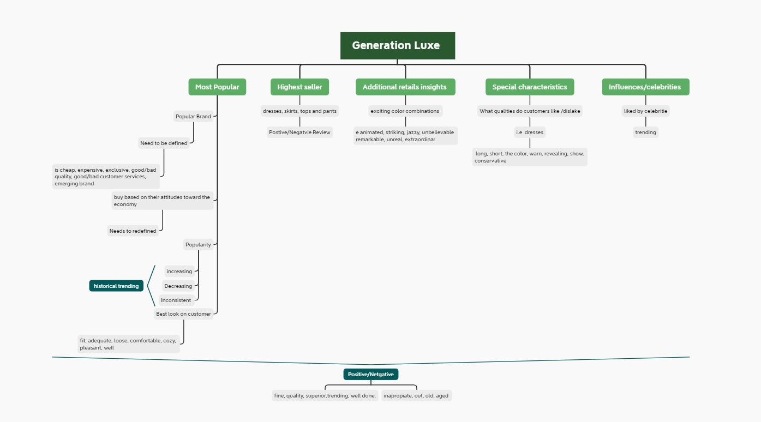

# 3. Analysis

For the following analysis the idea is to go over each question and provide with additional information about is the question is valid, can be improve, if there are any data patterns that can be found in order to do the analysis.

Also, the main idea is that all the question can be clearly explained, try to avoid any subjective and the recommendations.

## 3.1 Candidate brands will be the most popular in the coming season

In this first section is needed to understand which of the brands will be the most popular in order to take business decisions, i.e. continue with this brand, or move to another one that is more trending.

### 3.1.1 Which brands are the most popular?

To understand what is the most popular brand, is a very open questions, due to do business decisions, what is needed instead is **“what kind of popularity”,** the brand is popular due to is cheap, expensive, exclusive, good/bad quality, good/bad customer services, emerging brand. The proposal for this question is to narrow down, in order to have more detail what is expected to do the sentimental analysis.

In case of we only need to stablish is a positive/negative popularity, still open, but can consider a lot of works related to the topics below. i.e. positive, good quality, good materials, stylish, etc.

### 3.1.2 Which brands are our customers more likely to buy based on their attitudes toward the economy?

In this case, this question is more specify, but this still hard to be answer thru sentimental analysis. Due to the public that is aim this report is for young women, that is clearly want of the stage in which is more likely to spend on the clothing no matter what the economic situation of the country is.

### 3.1.3 Which brands are trending upward in popularity?

The popularity has been already discussed in the first question but taking into account that we are discussing positive and negative popularity overall, there is a lot of key features that can be used to do this analysis.

For example, if can be trying to find to social media like twitter, Facebook, Instagram, Pinterest what is the number of mentions that those brands have, and then use a lot classifier to determinate if that is a positive or negative popularity.

Overall is we can check the historical data of the brand, we can define provide a consistent suggestion/conclusion if the brand is increasing or decreasing of popularity, after define popularity as we already suggested.

### 3.1.4 Which brands are trending downward in popularity?

This question is highly linked to the previous one, same analysis can be done, just searching for the historical decrease.

### 3.1.5 Which brands have an inconsistent trend in popularity?

This question is also highly linked to the previous one, because this consist more on review the historical behavior of the brand. Can be that the popularity of the brand is always high, but switches between positive/negative, or between in/out fashion.

### 3.1.6 Which of these brands look best on our customers?

This question for sure is open question that needs to be redefined, due to define best is very subjective. But besides that, the sentimental analysis can be based on what type of public is design the brand. Is this for young/old, new designs, conservative.

Some key factor that can be found are fit, adequate, loose, comfortable, cozy, pleasant, well

### 3.1.7 Which brands are the most popular among fashion critics?

Once is identify who are the fashion critics, this can be perform with sentimental analysis, I can be found the information or opinions of those critics on the news, social media and base on that classified using works like fashion in/on, style, trend, vogue, and then using the previous proposal to determinate if those are positive or negative popularity.

## 3.2 Items will be the highest sellers

The idea of this section is to identify which items will be the highest sellers, in order to take business decisions in the inventory to maximize the profits.

### 3.2.1 For each product category (dresses, skirts, tops and pants) which brands carry the most popular items?

This question can be also be used in the sentimental analysis to evaluate what kind of popularity this item has, so base on that then with the historical data can be define which are more mentions, feedback etc. to evaluate what the best way to product with the inventory is.

In case that any of this item has positive/negative popularity give to the business the power to make the decisions based on data, which can be used as a powerful tool, instead or just using the expert judgment.

## 3.3 Additional retails insights

In this section the idea is to understand what additional insight the retailer can give, in order to have a better information.

### 3.3.1 Which retailer will be carrying the most exciting color combinations next season?

This question may be answers to sentimental analysis using works like **animated, striking, jazzy, unbelievable remarkable, unreal, extraordinary**. But again, this a very open question is very subjective, due defining exciting is very hard,

## 3.4 Special characteristics

The main idea consists in understand what are the specify characteristics that the customer value most for each brand, this will allow to take more accurate decision, improving the profits for the company.

### 3.4.1 about each brand?

Base on the brand that we want to the analysis, if can be found works like quality, level, grade, worth, status, and base on those question can be found is those have positive or negative concatenation.

For example, if the search is for dresses, can be search for long, short, the color, warn, revealing, show, conservative and base on that the decision can be added.

### 3.4.2 What qualities do customers dislike about each brand?

For this question can be use that is describe above, due to is changing the work for negative works

## 3.5 Influences of celebrities

The celebrities always play a critical role in our society, due to most people tend to use those people as a role model. So, the decision that they made, are followed by millions of persons. So, in case of fashion, is vital to understand what is the role that this influencers/celebrity plays.

### 3.5.1 Which of the brands are popular because they are well liked by celebrities?

This can be done thru the analysis on what the celebrities use and the what are the range of impact of those celebrities.

The first step is to choose, the celebrities for the market what is aimed to sell the products. Base on this can be defined on the news what are the comments on how look the celebrate, if is positive, negative.

It’s important that in most of the cases the celebrities tend to wear an exuberant cloth, but the what we need to understand what is the brand that tis require.