Let's tell a classical story (at least "classical" in GE's way of working...).
We have three teams that work together to create a product foobar:
- team A is in charge to develop a utility library
- team B is in charge to develop an annex library
- team C build the foobar product that uses both the util and annex libraries

Due to historical reasons, team A and team B are both using a same library thelib. But they have change in incompatible way the code of that library. How can we handle that with minimum impact on the code?

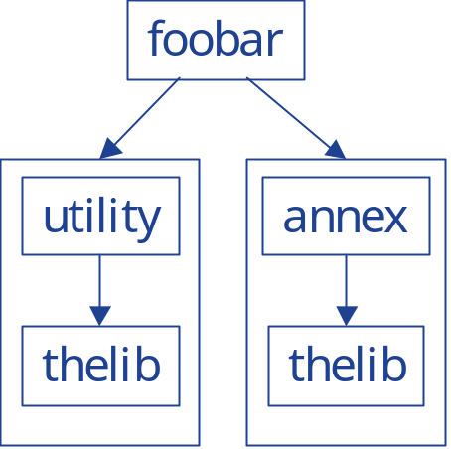

step 1:
team A recompiles the thelib library with a version tag:
g++ -shared teamA/thelib.c --version-script teamA/versionscript -o teamA/libthelib.so
where the file teamA/versionscript contains
VERSION {
TEAM_A_1.0 {
*;
};
}
It generates the utility library as usual:
g++ -shared -LteamA -lthelib teamA/utility.c -o teamA/libutility.so

step 2:
team B recompiles thelib with a version tag and renames the library (into thenewlib for example)
g++ -shared teamB/thelib.c --version-script teamB/versionscript -o teamB/libthenewlib.so
where the file teamB/versionscript contains
VERSION {
TEAM_B_1.0 {
*;
};
}
It generates the annex library as usual:
g++ -shared -LteamB -lthenewlib teamB/annex.c -o teamB/libannex.so

step3:
team C recompiles foobar as usual
g++ -LteamA -lutility -LteamB -lannex -Xlinker -rpath teamA -Xlinker -rpath teamB main.c -o foobar
and runs it
./foobar
and its works:
function 1 called in old version of the library with parameter "utilitary one"
function 2 called in old version of the library with parameter "utilitary one"
function 1 called in new version of the library with parameter "annex one"
function 2 called in new version of the library with parameters "annex one" and "annex two"

source code:

teamA/thelib.h
#if !defined(THELIB_H)
#define THELIB_H

extern "C" void function1(const char *arg1);
extern "C" void function2(const char *arg1);

#endif // THELIB_H

teamA/thelib.c
#include <stdio.h>
#include "thelib.h"

void function1(const char *arg1)
{
printf("function 1 called in old version of the library with parameter \"%s\"\n",arg1);
}

void function2(const char *arg1)
{
printf("function 2 called in old version of the library with parameter \"%s\"\n",arg1);
}

teamA/utility.h
#if !defined(UTILITY_H)
#define UTIITYL_H

extern void utilitary();

#endif // UTILITY_H

teamA/utility.c
#include "utility.h"
#include "thelib.h"

void utilitary()
{
function1("utilitary one");
function2("utilitary one");
}

teamB/thelib.h
#if !defined(THELIB_H)
#define THELIB_H

extern "C" void function1(const char *arg1);
extern "C" void function2(const char *arg1, const char *arg2);

#endif // THELIB_H

teamB/thelib.c
#include <stdio.h>
#include "thelib.h"

void function1(const char *arg1)
{
printf("function 1 called in new version of the library with parameter \"%s\"\n",arg1);
}

void function2(const char *arg1, const char *arg2)
{
printf("function 2 called in new version of the library with parameters \"%s\" and \"%s\"\n",arg1,arg2);
}

teamB/annex.h
#if !defined(ANNEX_H)
#define ANNEX_H

extern void annex();

#endif // ANNEX_H

teamB/annex.c
#include "annex.h"
#include "thelib.h"

void annex()
{
function1("annex one");
function2("annex one","annex two");
}

main.c
#include "teamA/utility.h"
#include "teamB/annex.h"

int main()
{
utilitary();
annex();
}

