Lean
reduce the waste

the seven types of waste
- processing
- waiting
- motion
- inventory
- moving things
- over-production
- defects and inspection

the three pillars
- Heijnuka
try to have less variation of production
- Jidoka
stop the production when there is a defect
but this is possible only if there are few defects
- Just-in-Time
single piece flow
pull production
TAKT time

The five steps to lean thinking
- specify value
- map the value stream
- establish flow
- implement pull
- work to perfection

Five levels of transformation
1 Basic Transformation
2 Supplementary Transformation
3 Ancillary Operation
4 Transportation
5 Storage

tools
- value stream map
- 7-flows
- 5S
a process for work area or data clean-up
- sort
- simplify
- sweep
- standardize
- sustain
- 3P
- production
- preparation
- process
- standard operations
same as SOP in Six Sigma
TAKT time
- work sequence
- ??? WIP ???
- Visual management
- Supermarket & Kanban

action work out
Kaizen evolutionary change
Kaikaku revolutionary change

5S (see also http://www.tpmonline.com/papakaizen/articls_on_lean_manufacturing_strategies/5s.htm)
- Step 1 - Sort: Eliminate all unnecessary items - those things which are not needed for present task
- Step 2 -Simplify: Organize the necessary items close to where they are needed and in such a way that any waste or abnormality is apparent
- Step 3 -Sweep: Keep the area clean
- Regular cleaning is a form of inspection
- Irregularities or malfunctions can be easily noticed when machine is clean
- Repetitive cleaning gives opportunity to implement improvements to cleaning procedures, which enhances efficiency
- Step 4 - Standardize
- Purpose:
- Revisit and maintain Sorting, Simplifying, and Sweeping. Develop
- Countermeasures to prevent dirt from occurring in the first place
- Constant adherence to the first three steps
- Objectives:
- Create and maintain a safe work environment
- Standardize cleanup activities so they are focused and easy to do
- Communicate:
- Share information between shifts
- Share information with internal customers and suppliers
- Post measurements:
- Takt Time/Cycle Time
- Standard Work/Standard WIP
- Output/Variance
- Open Action Items
- Self Discipline: Leadership Responsibility:
- Management at all levels must be committed to establishing and maintaining the 5S process
- Management at all levels must be committed to establishing and maintaining the 5S process
- Suggested cycles of review should include
- Cell Coordinators: daily review
- Business Leaders: weekly review
- Business Team Leaders: monthly review
- Use a checklist for monitoring adherence, quantifying results of cell inspections; a prominent display of each area’s results is a tool which management can use to help sustain the process
- Management must lead by example: Walk the Talk!
- When the first five Ss are practiced daily, safety issues are recognized and given priority. Make maintaining a safe workplace a part of your daily routine.

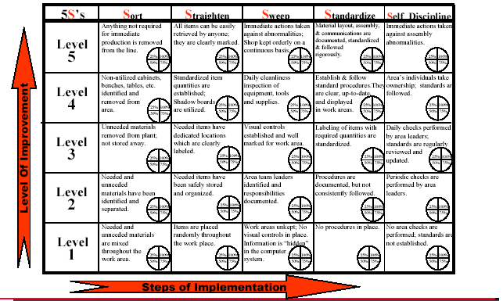

tools
- PQ Analysis / PR Analysis
- Single Piece Flow
- Pull Production
- Standard Work
- Material Presentation
- Visual Management
- The Three Ps
- Action Workout
- Set-Up Reduction
- Kanban System
- Total Preventive Maintenance

