# Pronóstico de Acciones

Ejecución: 20250504_205423

## AAPLD

### precio_cierre

|  |  |  |  |
| --- | --- | --- | --- |
| Fecha | Predicción | Lower | Upper |
| 2025-04-03 | 11.14 | - | - |
| 2025-04-04 | 11.13 | - | - |
| 2025-04-07 | 11.14 | - | - |
| 2025-04-08 | 11.17 | - | - |
| 2025-04-09 | 11.21 | - | - |
| 2025-04-10 | 11.18 | - | - |
| 2025-04-11 | 11.23 | - | - |
| 2025-04-14 | 11.29 | - | - |
| 2025-04-15 | 11.20 | - | - |
| 2025-04-16 | 11.03 | - | - |
| 2025-04-17 | 11.05 | - | - |
| 2025-04-18 | 11.08 | - | - |
| 2025-04-21 | 11.17 | - | - |
| 2025-04-22 | 11.17 | - | - |
| 2025-04-23 | 11.16 | - | - |
| 2025-04-24 | 11.27 | - | - |
| 2025-04-25 | 11.31 | - | - |
| 2025-04-28 | 11.48 | - | - |
| 2025-04-29 | 11.44 | - | - |
| 2025-04-30 | 11.38 | - | - |
| 2025-05-01 | 11.36 | - | - |
| 2025-05-02 | 11.39 | - | - |

Gráfico completo:

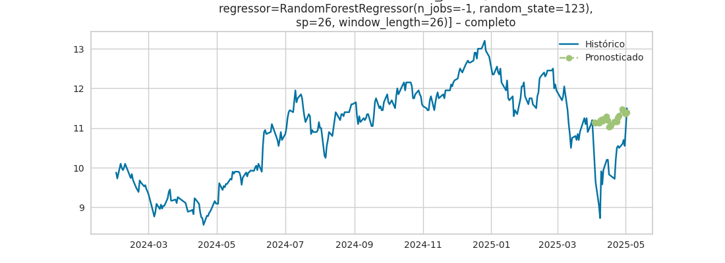

Gráfico últimos 30 días + forecast:

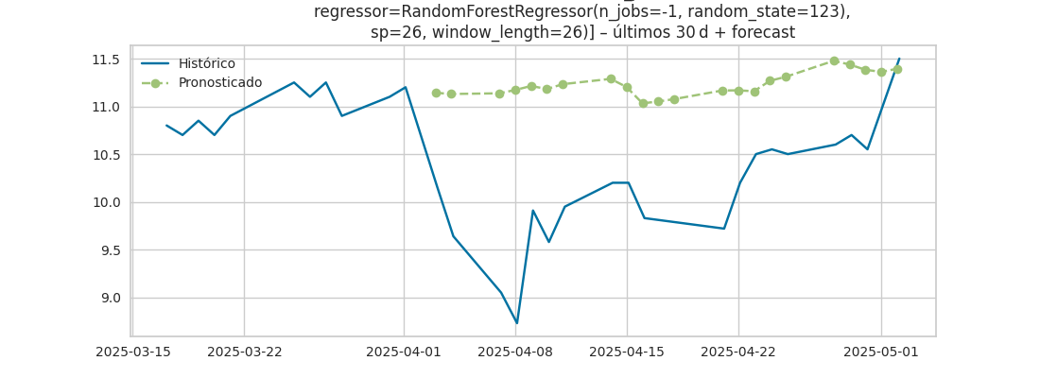

## DESPD

### precio_cierre

|  |  |  |  |
| --- | --- | --- | --- |
| Fecha | Predicción | Lower | Upper |
| 2025-03-31 | 18.80 | - | - |
| 2025-04-01 | 18.39 | - | - |
| 2025-04-02 | 19.11 | - | - |
| 2025-04-03 | 18.99 | - | - |
| 2025-04-04 | 18.96 | - | - |
| 2025-04-07 | 19.40 | - | - |
| 2025-04-08 | 19.32 | - | - |
| 2025-04-09 | 19.32 | - | - |
| 2025-04-10 | 19.25 | - | - |
| 2025-04-11 | 19.00 | - | - |
| 2025-04-14 | 18.76 | - | - |
| 2025-04-15 | 18.77 | - | - |
| 2025-04-16 | 19.43 | - | - |
| 2025-04-17 | 19.31 | - | - |
| 2025-04-18 | 19.28 | - | - |
| 2025-04-21 | 19.73 | - | - |
| 2025-04-22 | 19.64 | - | - |
| 2025-04-23 | 19.64 | - | - |
| 2025-04-24 | 19.57 | - | - |
| 2025-04-25 | 19.33 | - | - |
| 2025-04-28 | 19.08 | - | - |
| 2025-04-29 | 19.10 | - | - |

Gráfico completo:

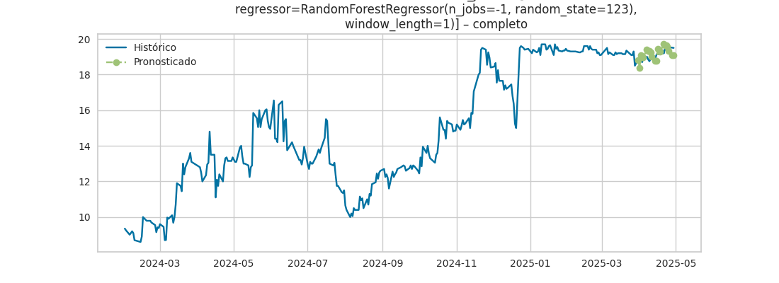

Gráfico últimos 30 días + forecast:

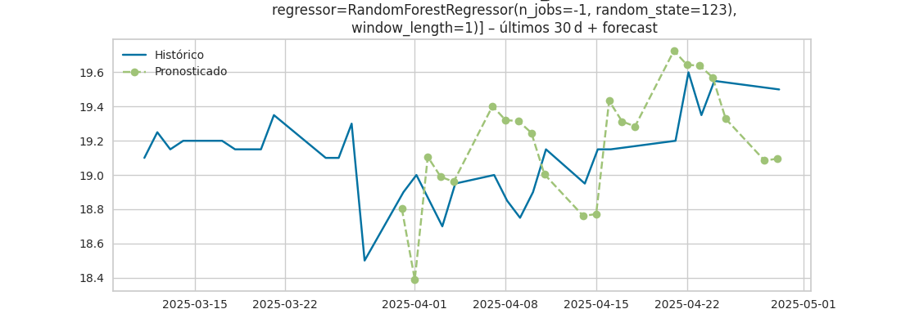

## KOD

### precio_cierre

|  |  |  |  |
| --- | --- | --- | --- |
| Fecha | Predicción | Lower | Upper |
| 2025-04-03 | 14.39 | - | - |
| 2025-04-04 | 14.37 | - | - |
| 2025-04-07 | 14.35 | - | - |
| 2025-04-08 | 14.33 | - | - |
| 2025-04-09 | 14.34 | - | - |
| 2025-04-10 | 14.33 | - | - |
| 2025-04-11 | 14.31 | - | - |
| 2025-04-14 | 14.32 | - | - |
| 2025-04-15 | 14.33 | - | - |
| 2025-04-16 | 14.34 | - | - |
| 2025-04-17 | 14.36 | - | - |
| 2025-04-18 | 14.36 | - | - |
| 2025-04-21 | 14.37 | - | - |
| 2025-04-22 | 14.38 | - | - |
| 2025-04-23 | 14.39 | - | - |
| 2025-04-24 | 14.39 | - | - |
| 2025-04-25 | 14.39 | - | - |
| 2025-04-28 | 14.40 | - | - |
| 2025-04-29 | 14.40 | - | - |
| 2025-04-30 | 14.40 | - | - |
| 2025-05-01 | 14.40 | - | - |
| 2025-05-02 | 14.40 | - | - |

Gráfico completo:

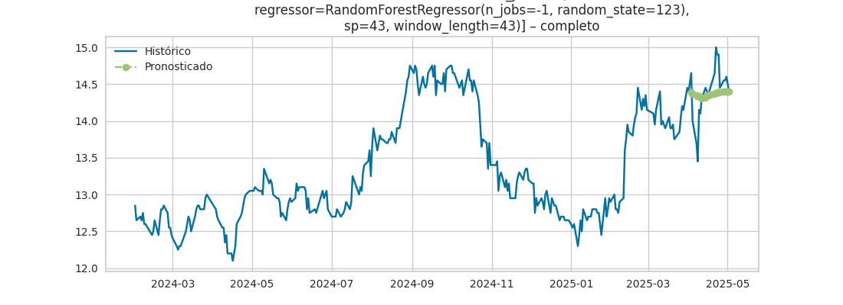

Gráfico últimos 30 días + forecast:

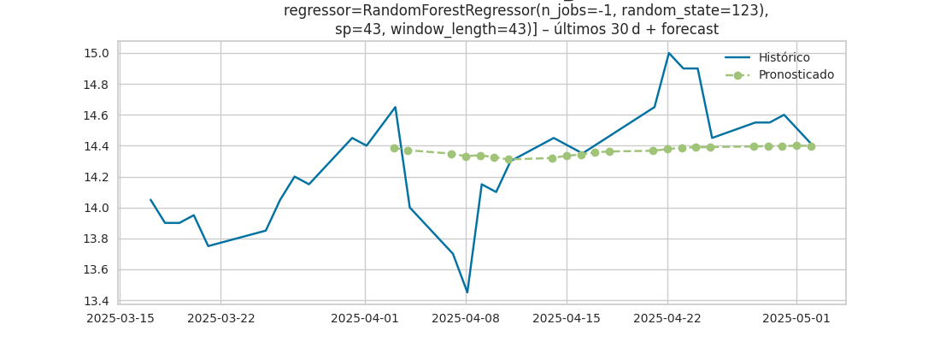

## MELID

### precio_cierre

|  |  |  |  |
| --- | --- | --- | --- |
| Fecha | Predicción | Lower | Upper |
| 2025-04-01 | 16.44 | - | - |
| 2025-04-02 | 16.43 | - | - |
| 2025-04-03 | 16.38 | - | - |
| 2025-04-04 | 16.23 | - | - |
| 2025-04-07 | 15.93 | - | - |
| 2025-04-08 | 15.92 | - | - |
| 2025-04-09 | 15.94 | - | - |
| 2025-04-10 | 16.02 | - | - |
| 2025-04-11 | 16.24 | - | - |
| 2025-04-14 | 16.48 | - | - |
| 2025-04-15 | 16.49 | - | - |
| 2025-04-16 | 16.57 | - | - |
| 2025-04-17 | 16.54 | - | - |
| 2025-04-18 | 16.54 | - | - |
| 2025-04-21 | 16.48 | - | - |
| 2025-04-22 | 16.53 | - | - |
| 2025-04-23 | 16.52 | - | - |
| 2025-04-24 | 16.43 | - | - |
| 2025-04-25 | 16.45 | - | - |
| 2025-04-28 | 16.48 | - | - |
| 2025-04-29 | 16.54 | - | - |
| 2025-04-30 | 16.32 | - | - |

Gráfico completo:

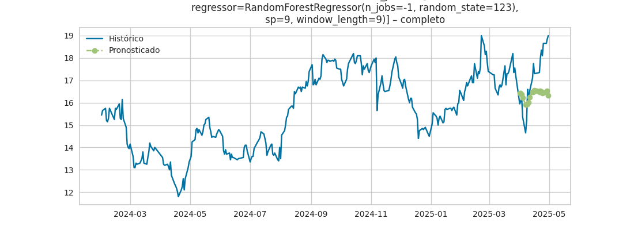

Gráfico últimos 30 días + forecast:

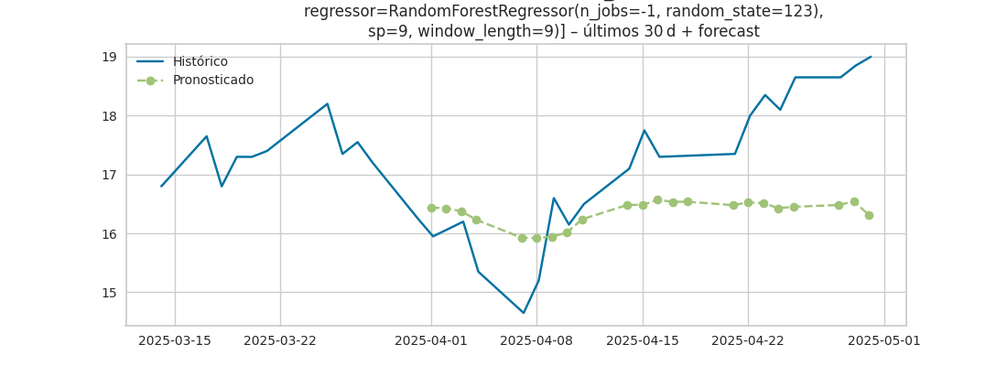

## MSFTD

### precio_cierre

|  |  |  |  |
| --- | --- | --- | --- |
| Fecha | Predicción | Lower | Upper |
| 2025-04-03 | 12.84 | - | - |
| 2025-04-04 | 12.88 | - | - |
| 2025-04-07 | 12.89 | - | - |
| 2025-04-08 | 12.89 | - | - |
| 2025-04-09 | 12.90 | - | - |
| 2025-04-10 | 12.89 | - | - |
| 2025-04-11 | 12.91 | - | - |
| 2025-04-14 | 12.95 | - | - |
| 2025-04-15 | 12.97 | - | - |
| 2025-04-16 | 12.98 | - | - |
| 2025-04-17 | 12.87 | - | - |
| 2025-04-18 | 12.83 | - | - |
| 2025-04-21 | 12.79 | - | - |
| 2025-04-22 | 12.75 | - | - |
| 2025-04-23 | 12.75 | - | - |
| 2025-04-24 | 12.76 | - | - |
| 2025-04-25 | 12.78 | - | - |
| 2025-04-28 | 12.79 | - | - |
| 2025-04-29 | 12.80 | - | - |
| 2025-04-30 | 12.78 | - | - |
| 2025-05-01 | 12.80 | - | - |
| 2025-05-02 | 12.83 | - | - |

Gráfico completo:

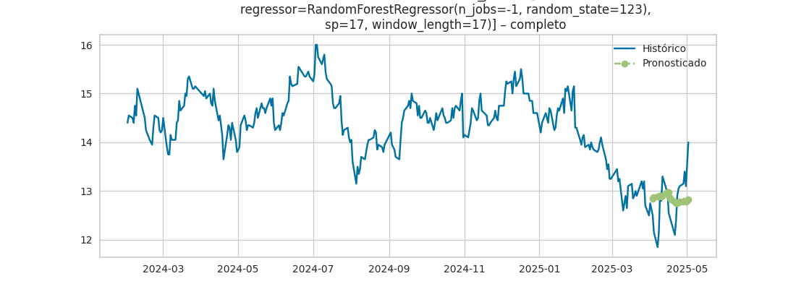

Gráfico últimos 30 días + forecast:

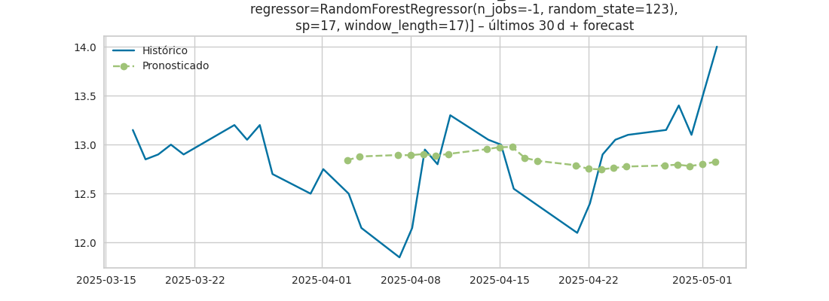

## NVDAD

### precio_cierre

|  |  |  |  |
| --- | --- | --- | --- |
| Fecha | Predicción | Lower | Upper |
| 2025-04-01 | 4.12 | - | - |
| 2025-04-02 | 3.84 | - | - |
| 2025-04-03 | 4.16 | - | - |
| 2025-04-04 | 2.98 | - | - |
| 2025-04-07 | 4.52 | - | - |
| 2025-04-08 | 4.89 | - | - |
| 2025-04-09 | 4.76 | - | - |
| 2025-04-10 | 4.66 | - | - |
| 2025-04-11 | 4.55 | - | - |
| 2025-04-14 | 4.44 | - | - |
| 2025-04-15 | 4.45 | - | - |
| 2025-04-16 | 4.13 | - | - |
| 2025-04-17 | 4.03 | - | - |
| 2025-04-18 | 4.05 | - | - |
| 2025-04-21 | 3.72 | - | - |
| 2025-04-22 | 3.63 | - | - |
| 2025-04-23 | 3.64 | - | - |
| 2025-04-24 | 3.31 | - | - |
| 2025-04-25 | 3.22 | - | - |
| 2025-04-28 | 3.23 | - | - |
| 2025-04-29 | 2.91 | - | - |
| 2025-04-30 | 2.81 | - | - |

Gráfico completo:

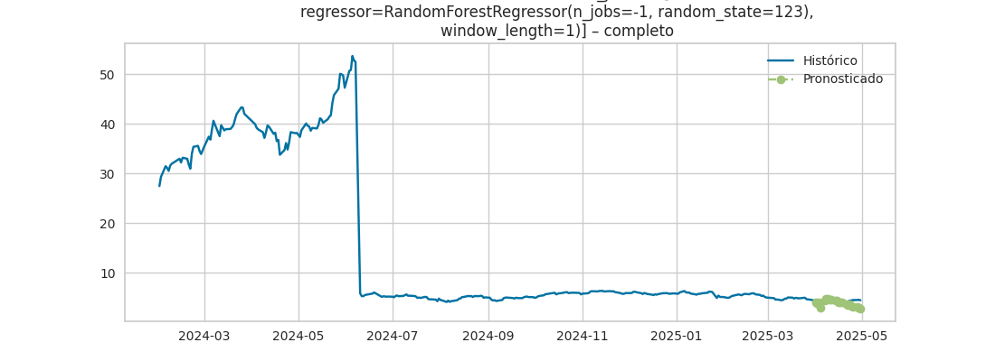

Gráfico últimos 30 días + forecast:

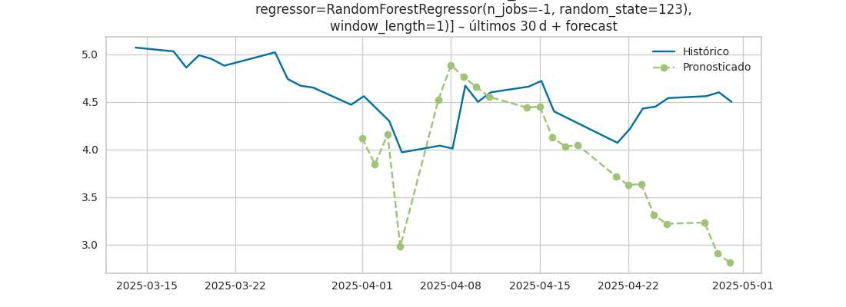

## TEND

### precio_cierre

|  |  |  |  |
| --- | --- | --- | --- |
| Fecha | Predicción | Lower | Upper |
| 2025-03-26 | 39.02 | - | - |
| 2025-03-27 | 39.71 | - | - |
| 2025-03-28 | 39.61 | - | - |
| 2025-03-31 | 39.56 | - | - |
| 2025-04-01 | 39.65 | - | - |
| 2025-04-02 | 40.54 | - | - |
| 2025-04-03 | 39.04 | - | - |
| 2025-04-04 | 39.73 | - | - |
| 2025-04-07 | 39.63 | - | - |
| 2025-04-08 | 39.59 | - | - |
| 2025-04-09 | 39.67 | - | - |
| 2025-04-10 | 40.56 | - | - |
| 2025-04-11 | 39.06 | - | - |
| 2025-04-14 | 39.75 | - | - |
| 2025-04-15 | 39.65 | - | - |
| 2025-04-16 | 39.61 | - | - |
| 2025-04-17 | 39.69 | - | - |
| 2025-04-18 | 40.58 | - | - |
| 2025-04-21 | 39.08 | - | - |
| 2025-04-22 | 39.77 | - | - |
| 2025-04-23 | 39.67 | - | - |
| 2025-04-24 | 39.63 | - | - |

Gráfico completo:

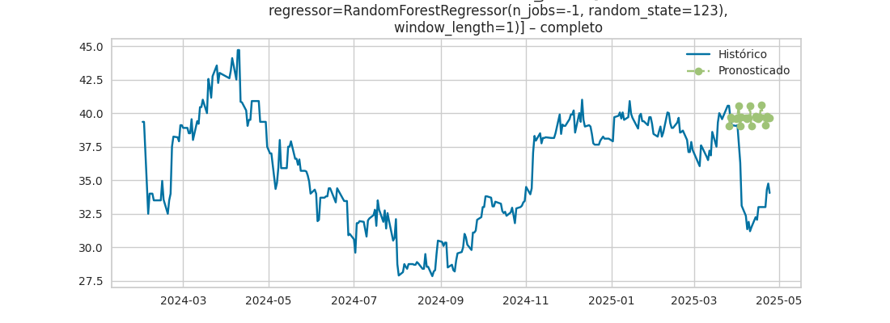

Gráfico últimos 30 días + forecast:

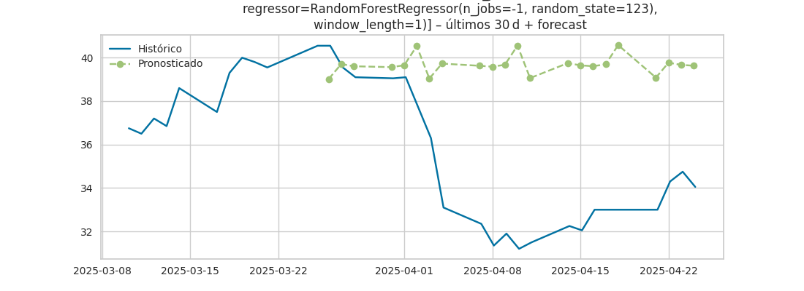

## VISTD

### precio_cierre

|  |  |  |  |
| --- | --- | --- | --- |
| Fecha | Predicción | Lower | Upper |
| 2025-04-03 | 15.61 | - | - |
| 2025-04-04 | 15.66 | - | - |
| 2025-04-07 | 15.45 | - | - |
| 2025-04-08 | 15.83 | - | - |
| 2025-04-09 | 15.67 | - | - |
| 2025-04-10 | 15.73 | - | - |
| 2025-04-11 | 15.51 | - | - |
| 2025-04-14 | 15.89 | - | - |
| 2025-04-15 | 15.74 | - | - |
| 2025-04-16 | 15.79 | - | - |
| 2025-04-17 | 15.58 | - | - |
| 2025-04-18 | 15.96 | - | - |
| 2025-04-21 | 15.80 | - | - |
| 2025-04-22 | 15.86 | - | - |
| 2025-04-23 | 15.65 | - | - |
| 2025-04-24 | 16.02 | - | - |
| 2025-04-25 | 15.87 | - | - |
| 2025-04-28 | 15.92 | - | - |
| 2025-04-29 | 15.71 | - | - |
| 2025-04-30 | 16.09 | - | - |
| 2025-05-01 | 15.93 | - | - |
| 2025-05-02 | 15.99 | - | - |

Gráfico completo:

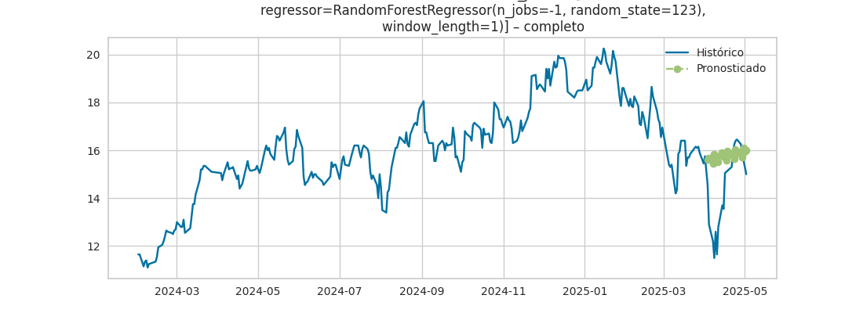

Gráfico últimos 30 días + forecast:

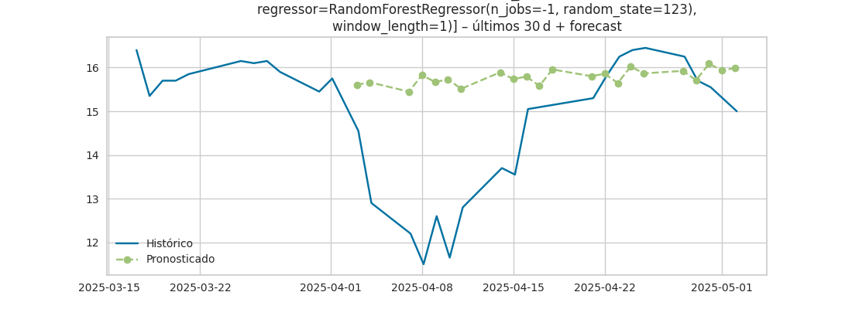

## XOMD

### precio_cierre

|  |  |  |  |
| --- | --- | --- | --- |
| Fecha | Predicción | Lower | Upper |
| 2025-04-01 | 11.88 | - | - |
| 2025-04-02 | 11.91 | - | - |
| 2025-04-03 | 11.92 | - | - |
| 2025-04-04 | 12.03 | - | - |
| 2025-04-07 | 12.00 | - | - |
| 2025-04-08 | 12.03 | - | - |
| 2025-04-09 | 12.05 | - | - |
| 2025-04-10 | 12.08 | - | - |
| 2025-04-11 | 12.09 | - | - |
| 2025-04-14 | 12.13 | - | - |
| 2025-04-15 | 12.23 | - | - |
| 2025-04-16 | 12.28 | - | - |
| 2025-04-17 | 12.44 | - | - |
| 2025-04-18 | 12.42 | - | - |
| 2025-04-21 | 12.48 | - | - |
| 2025-04-22 | 12.43 | - | - |
| 2025-04-23 | 12.45 | - | - |
| 2025-04-24 | 12.41 | - | - |
| 2025-04-25 | 12.40 | - | - |
| 2025-04-28 | 12.36 | - | - |
| 2025-04-29 | 12.37 | - | - |
| 2025-04-30 | 12.37 | - | - |

Gráfico completo:

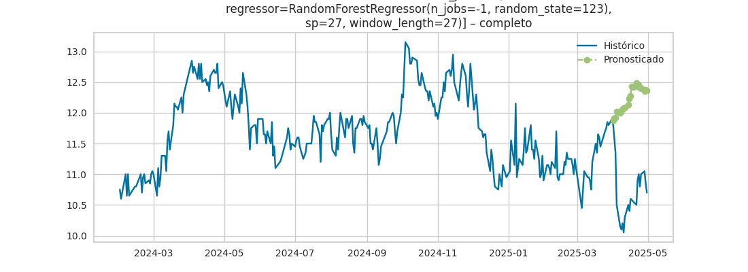

Gráfico últimos 30 días + forecast:

